**DAILY ONLINE ACTIVITIES SUMMARY**

|  |  |  |  |  |  |  |  |  |
| --- | --- | --- | --- | --- | --- | --- | --- | --- |
| **Date:** | **16/06/2020** | | | | | **Name:** | **Shilpa S.U** | |
| **Sem & Sec** | **VI & B sec** | | | | | **USN:** | **4AL17CS090** | |
| **Pre placement training Summary** | | | | | | | | |
| **Pre placement training** | | **9:15 am to 11:20 am - Programming in C**  **11:20 am to 1:30pm - Applications of python in DA and ML** | | | | | | |
| **Max. Marks** | | **-** | | **Score** | | | **-** | |
| **Course Summary** | | | | | | | | |
| **Course** | Workshop exercise solving | | | | | | | |
| **Certificate Provider** | | | **-** | | **Duration** | | | **-** |
| **Coding Challenges** | | | | | | | | |
| **Problem Statement:**   1. Write a Python program to check whether a given a binary tree is a valid binary search tree (BST) or not? 2. Write a C Program to perform the following operations on Triply Linked List (TLL)      |  |  | | --- | --- | |  |  |  |  |  | | --- | --- | |  |  | | | | | | | | | |
| **Status: completed** | | | | | | | | |
| **Uploaded the report in Github** | | | | | **Yes** | | | |
| **If yes Repository name** | | | | | Daily Status | | | |
| **Uploaded the report in slack** | | | | | **Yes** | | | |

**Programming in C**

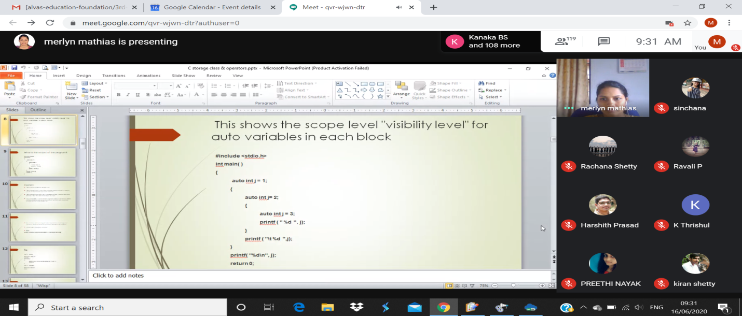

**Quiz Snapshots:**

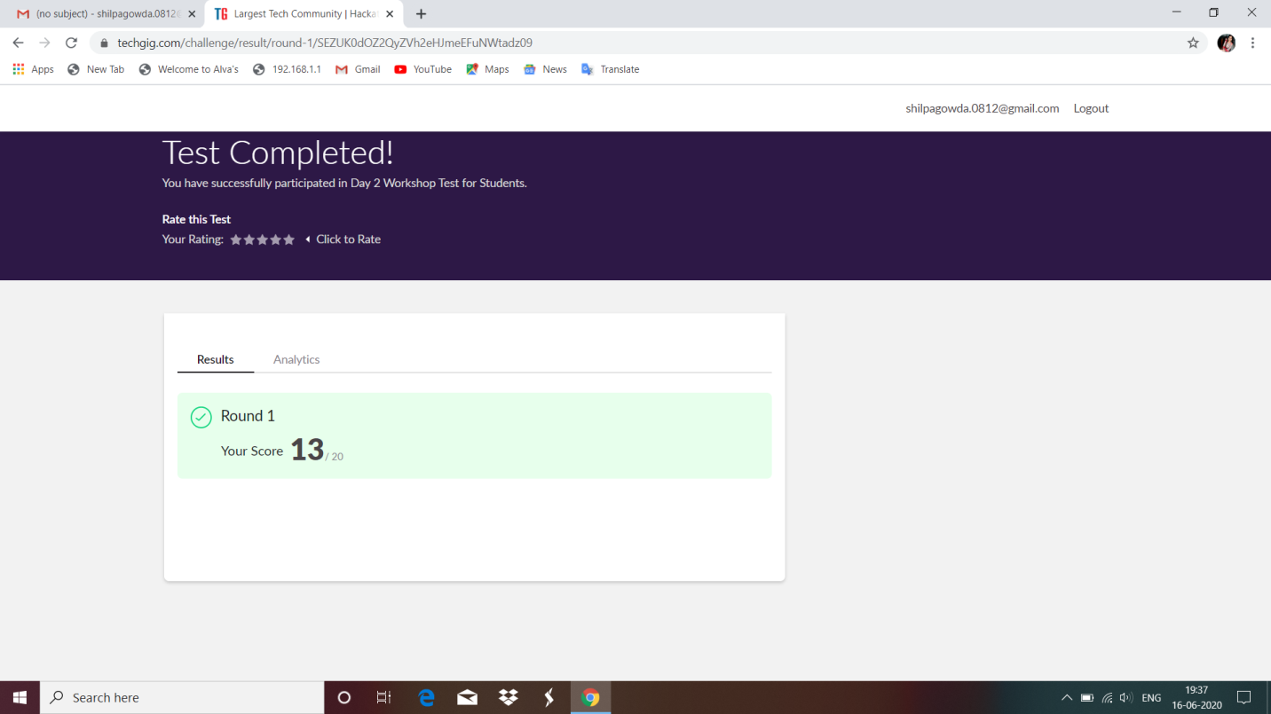

**Applications of python in DA and ML**

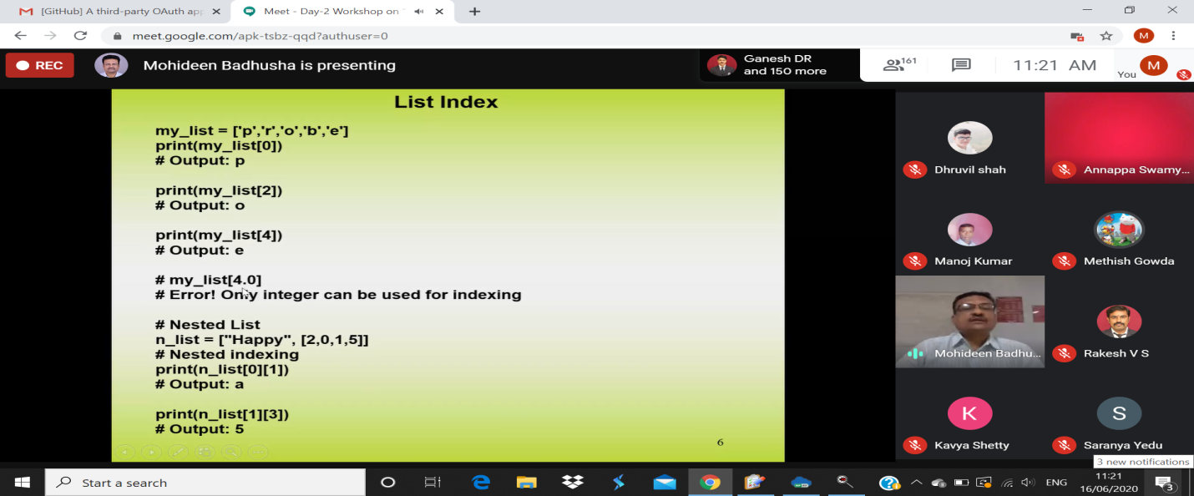

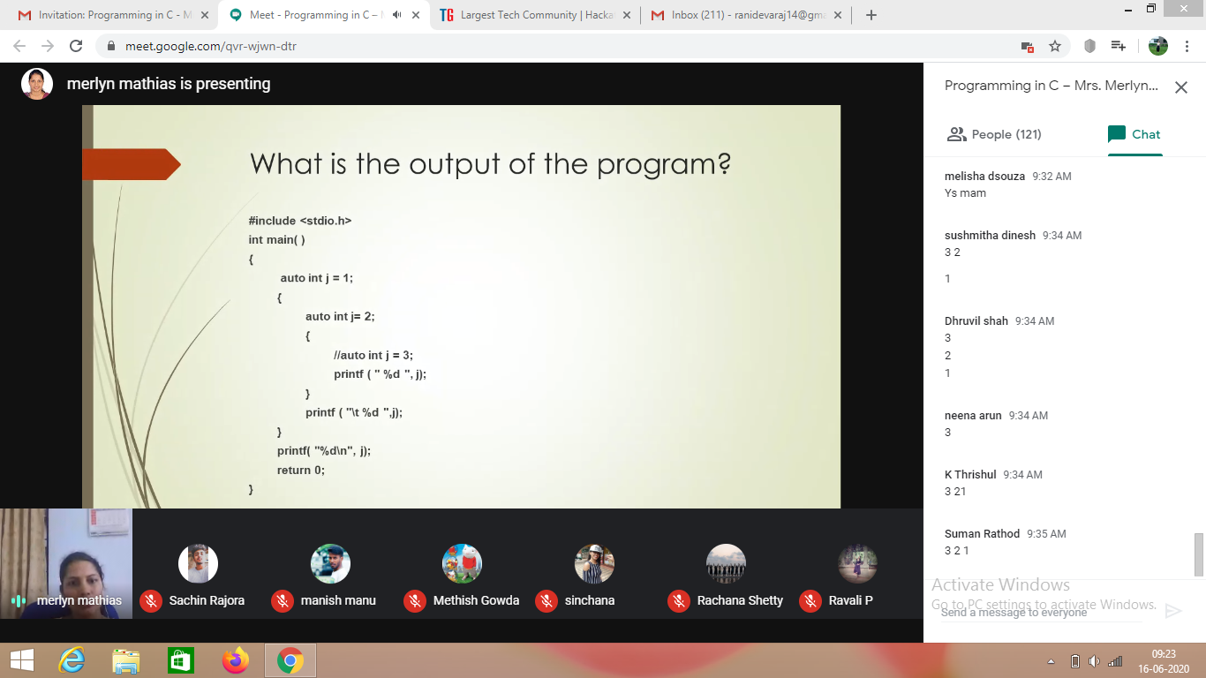

Refer the github link for example programs and exercise programs:

<https://github.com/ShilpaUddanna/Python_Application_in_DA_and_ML/tree/master/DAY2>

Coding Challenges Details:

1. Write a Java program to check whether a given a binary tree is a valid binary search tree (BST) or not?

