**DAILY ONLINE ACTIVITIES SUMMARY**

|  |  |  |  |  |  |  |  |  |
| --- | --- | --- | --- | --- | --- | --- | --- | --- |
| **Date:** | **2-06-2020** | | | | | **Name:** | **Shilpa S.U** | |
| **Sem & Sec** | **6 B** | | | | | **USN:** | **4AL17CS090** | |
| **Online Test Summary** | | | | | | | | |
| **Subject** | | **CGV** | | | | | | |
| **Max. Marks** | | **30** | | **Score** | | | **30** | |
| **Certification Course Summary** | | | | | | | | |
| **Course** | **TCS carrier edge** | | | | | | | |
| **Certificate Provider** | | | **TCS** | | **Duration** | | | **15 days** |
| **Coding Challenges** | | | | | | | | |
| **Problem Statement: 1.loop 2.sclicing 3.inversion** | | | | | | | | |
| **Status: Success** | | | | | | | | |
| **Uploaded the report in Github** | | | | | **Yes** | | | |
| **If yes Repository name** | | | | | **Daily Status** | | | |
| **Uploaded the report in slack** | | | | | **Yes** | | | |

Online Test Details: (Attach the snapshot and briefly write the report for the same)

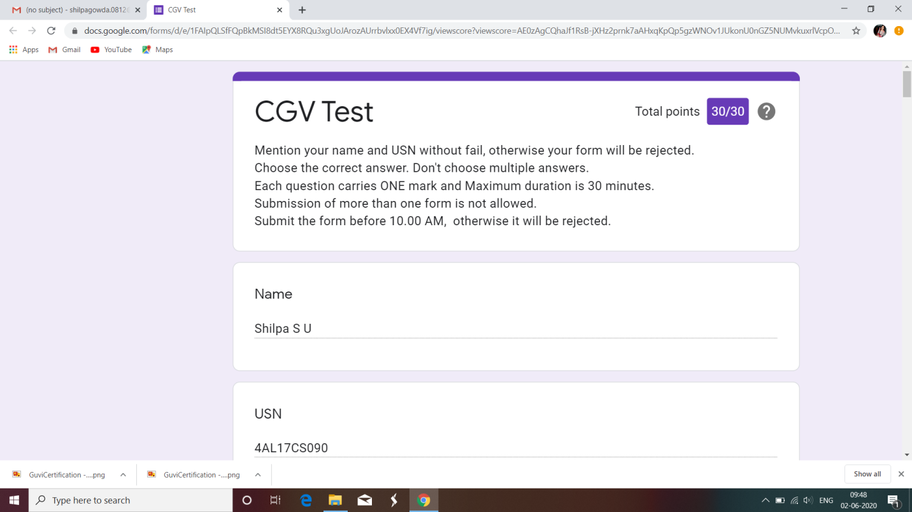

The test was held between 9:30 am to 10:00 am. It consisted of only 1 round and the total marks assigned was 30.The above snapshot is the output of my 3st IA test.

Certification Course Details: (Attach the snapshot and briefly write the report for the same)

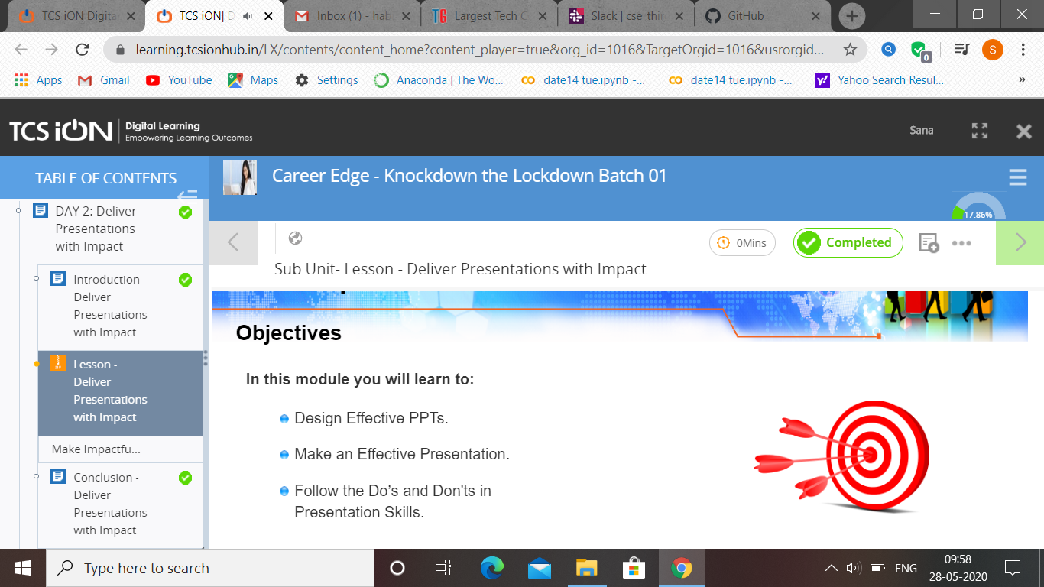

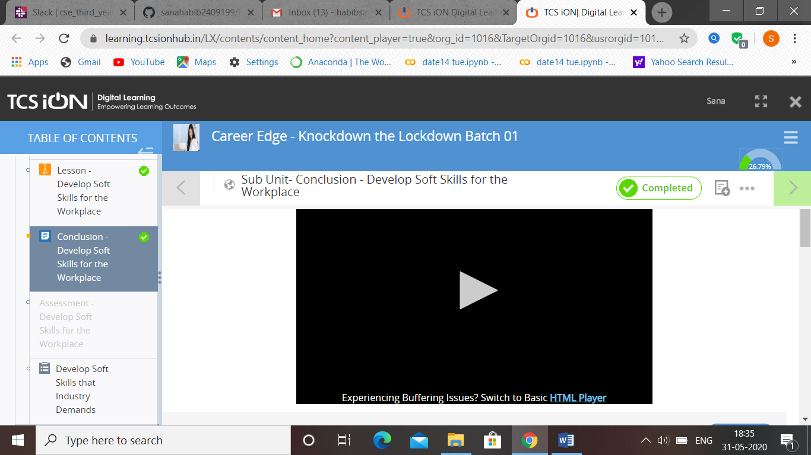

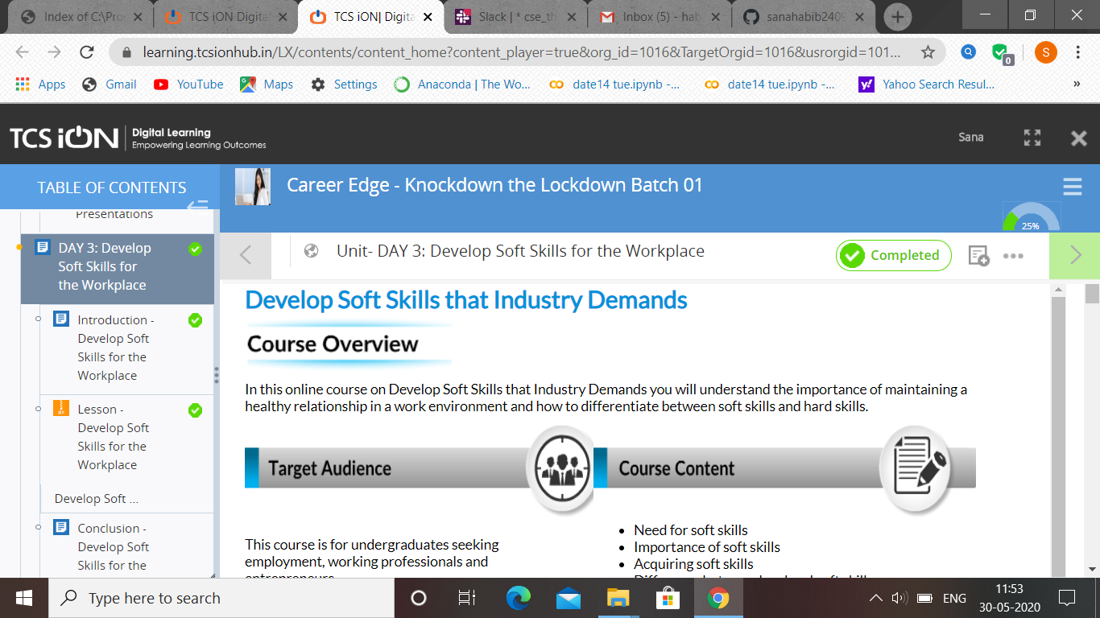

Coding Challenges Details: (Attach the snapshot and briefly write the report for the same)

