**DAILY ONLINE ACTIVITIES SUMMARY**

|  |  |  |  |  |  |  |  |  |
| --- | --- | --- | --- | --- | --- | --- | --- | --- |
| **Date:** | **21 MAY 2020** | | | | | **Name:** | **Shilpa S.U** | |
| **Sem & Sec** | **VI & B** | | | | | **USN:** | **4AL17CS090** | |
| **Online Test Summary** | | | | | | | | |
| **Subject** | | **Operating System** | | | | | | |
| **Max. Marks** | | **30** | | **Score** | | | **30** | |
| **Certification Course Summary** | | | | | | | | |
| **Course** | **Machine learning with python** | | | | | | | |
| **Certificate Provider** | | | **Cognitiveclass** | | **Duration** | | | **10 hours** |
| **Coding Challenges** | | | | | | | | |
| Problem Statement:  JAVA Program4-RR java program to implement round robin scheduling algorithm.Calculate AVG WT AND TAT. INPUT:NO OF PROCESSES,BURST TIME AND TIME QUANTUM. JAVA Program5 a simple applet java program to check whether the given number is armstrong number or not. JAVA program1 Java Program to Demonstrate a Basic Calculator using Applet Problem Description We have to write a program in Java such that it creates a calculator which allows basic operations of addition, subtraction, multiplication and division. PYTHON Program6 Python program in number right angled triangle sample outputenter the number of rows 5 4 3 2 1 4 3 2 1 3 2 1 2 1 1 SLL C Program2 C Program to create Singly Liked List with n elements and reverse the elements SLL C Program3 C program to construct a singly linked list by removing duplicate elements in the sorted linked list Sample output: Given list {1,2,2,3,3,3,4} Resulting list{4,3,2,1} | | | | | | | | |
| **Status:DONE** | | | | | | | | |
| **Uploaded the report in Github** | | | | | **YES** | | | |
| **If yes Repository name** | | | | | **Coding and certification progress** | | | |
| **Uploaded the report in slack** | | | | | **YES** | | | |

Online Test Details: (Attach the snapshot and briefly write the report for the same)

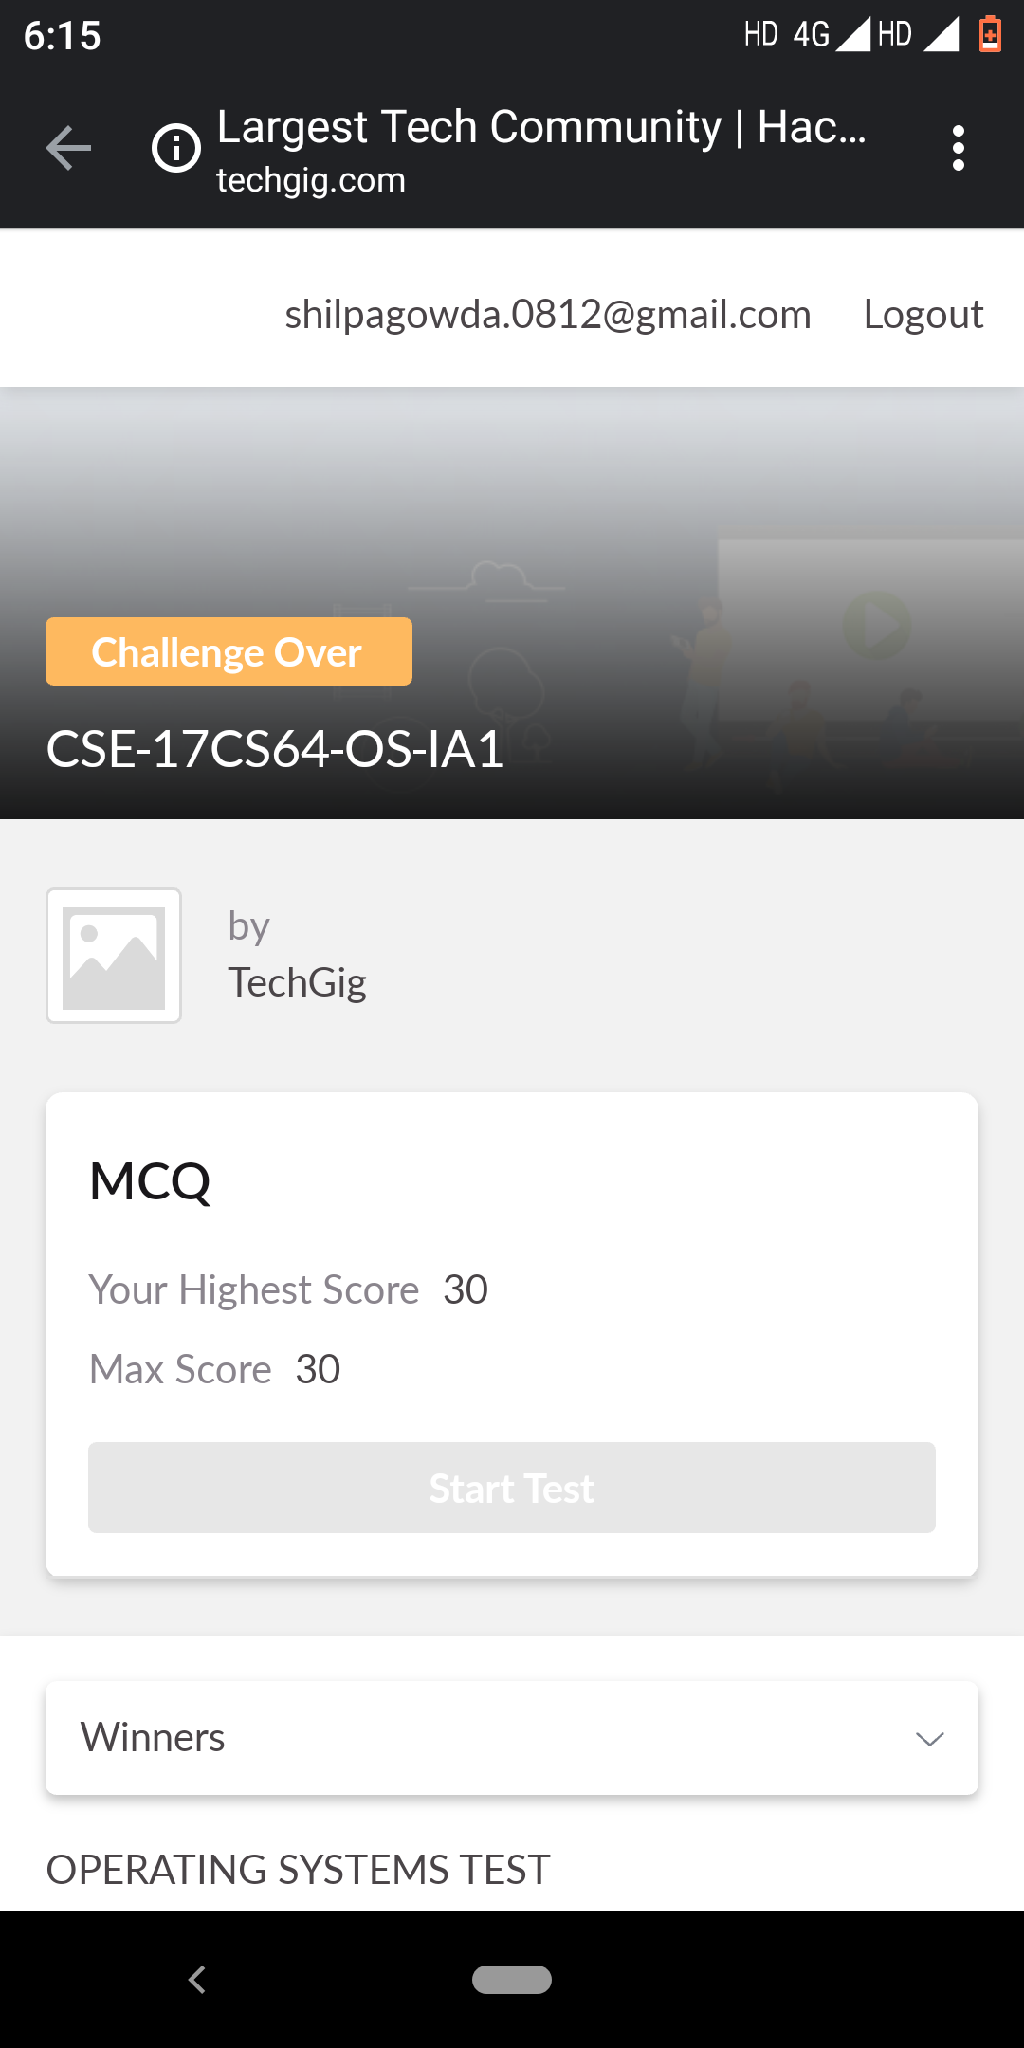

Certification Course Details: (Attach the snapshot and briefly write the report for the same)

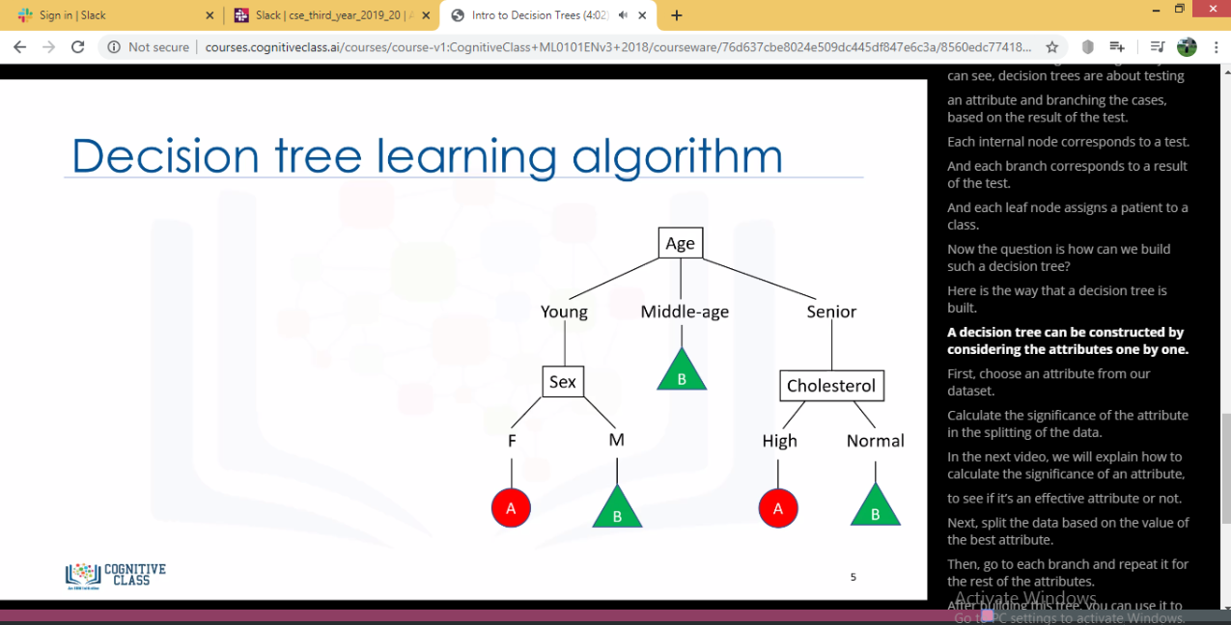

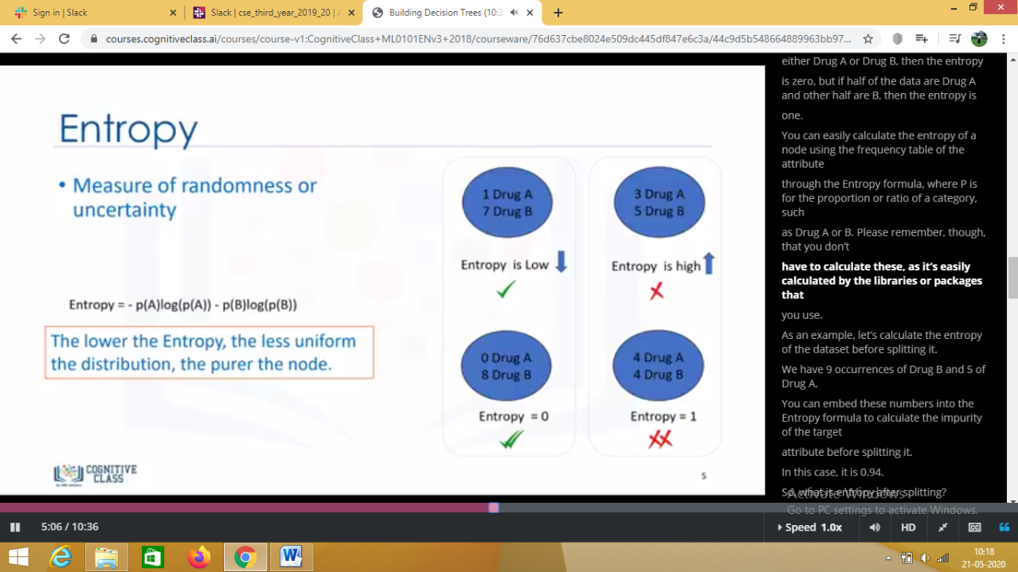

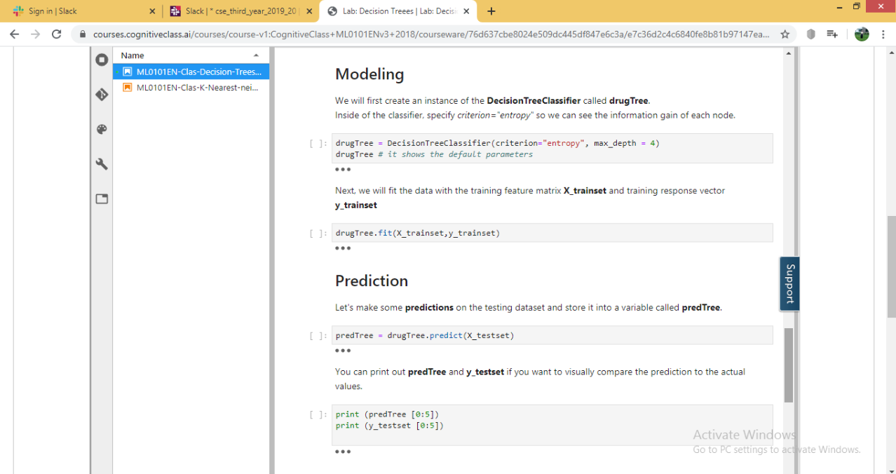

Today I learnt about Intro to decision tress, Building decision tress and performed lab programs of decision tree.

Coding Challenges Details: (Attach the snapshot and briefly write the report for the same)

