**DAILY ONLINE ACTIVITIES SUMMARY**

|  |  |  |  |  |  |  |  |  |
| --- | --- | --- | --- | --- | --- | --- | --- | --- |
| **Date:** | **22MAY2020** | | | | | **Name:** | **Shilpa S.U** | |
| **Sem & Sec** | **VI & B** | | | | | **USN:** | **4AL17CS090** | |
| **Online Test Summary** | | | | | | | | |
| **Subject** | | **Operation Research** | | | | | | |
| **Max. Marks** | | **30** | | **Score** | | | **30** | |
| **Certification Course Summary** | | | | | | | | |
| **Course** | **Machine learning with python** | | | | | | | |
| **Certificate Provider** | | | **Cognitiveclass** | | **Duration** | | | **10 hours** |
| **Coding Challenges** | | | | | | | | |
| 1. **Problem Statement:** C program for implement various operations of Singly Linked List Stack 2. Java program to separate the Individual Characters from a String 3. Java program to separate the Individual Characters from a String | | | | | | | | |
| **Status:Done** | | | | | | | | |
| **Uploaded the report in Github** | | | | | **YES** | | | |
| **If yes Repository name** | | | | | **Coding and Certification Progress** | | | |
| **Uploaded the report in slack** | | | | | **YES** | | | |

Online Test Details: (Attach the snapshot and briefly write the report for the same)

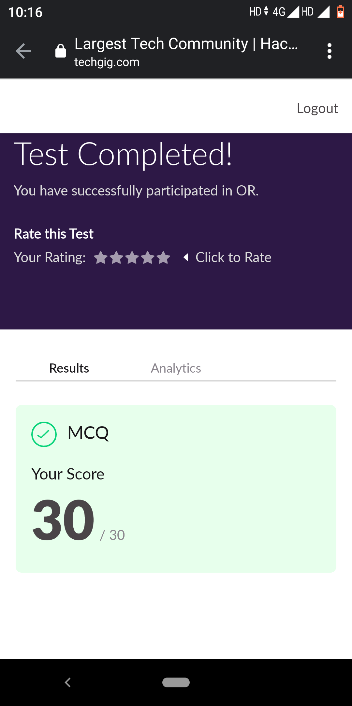

Certification Course Details: (Attach the snapshot and briefly write the report for the same)

1.

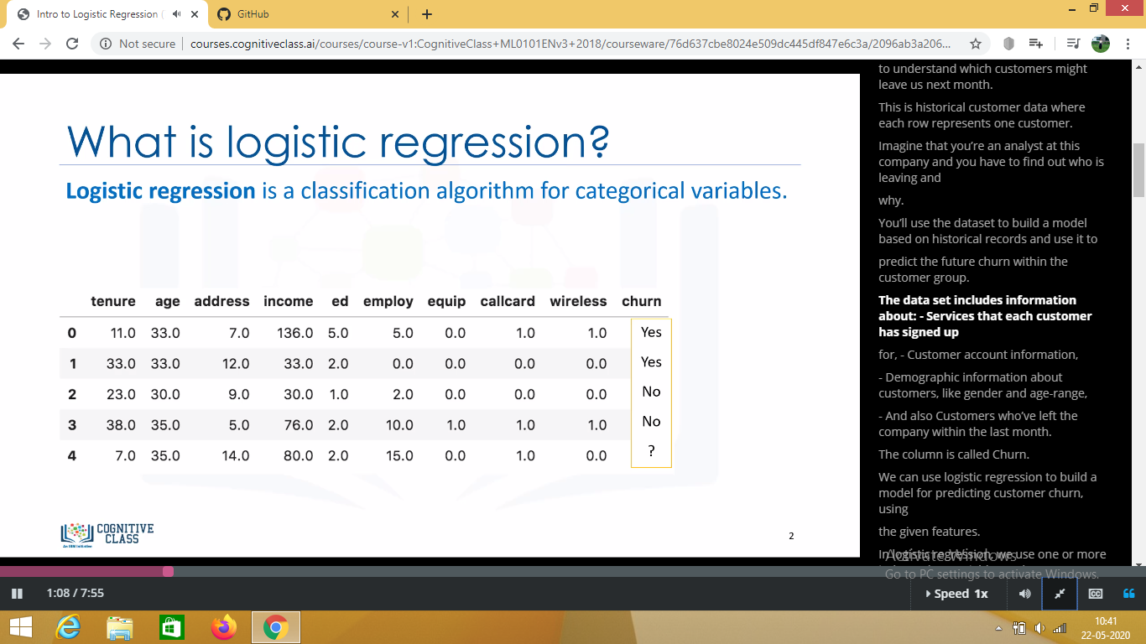

2.

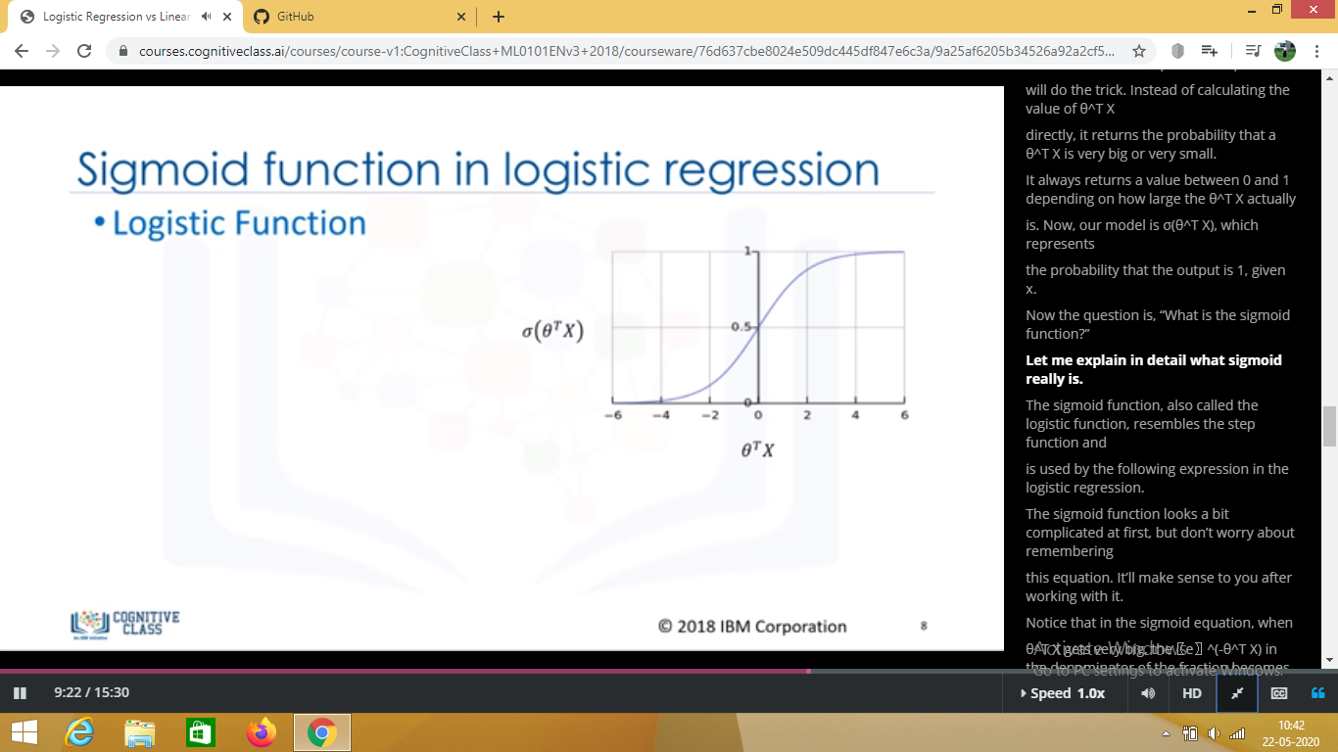

3.

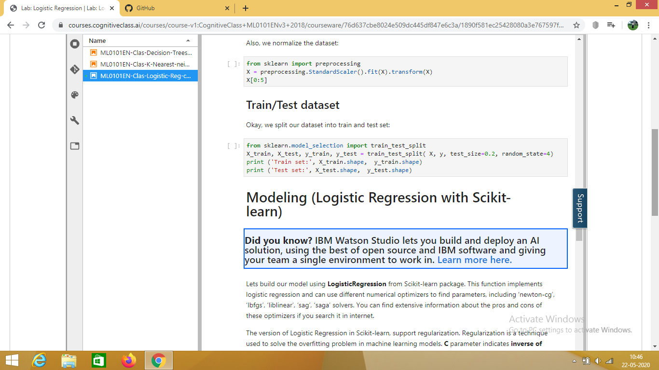

**BRIEF REPORT:**

**1**)Learning Objectives

* Intro to Logistic Regression
* Logistic vs Linear Regression
* Lab:Logistic Regression

2) Logistic regression is a statistical and machine learning technique for classifying records  
of a dataset, based on the values of the input fields.

3) Logistic regression is analogous to linear regression but tries to predict a categorical  
or discrete target field instead of a numeric one.  
*In linear regression, we might try to predict a continuous value of variables, such as the  
price of a house, blood pressure of patient, or fuel consumption of a car.  
*But, in logistic regression, we predict a variable which is binary, such as, Yes/No,  
TRUE/FALSE, successful or Not successful, pregnant/Not pregnant, and so on, all of which  
can all be coded as 0 or 1.  
*In logistic regression, dependent variables should be continuous; if categorical, they  
should be dummy or indicator-coded.  
*This means we have to transform them to some continuous value.

Coding Challenges Details: (Attach the snapshot and briefly write the report for the same)

1. C program output

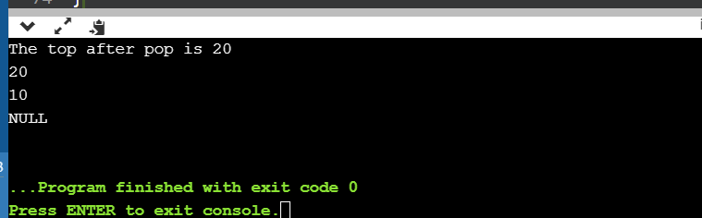

1. Java program output

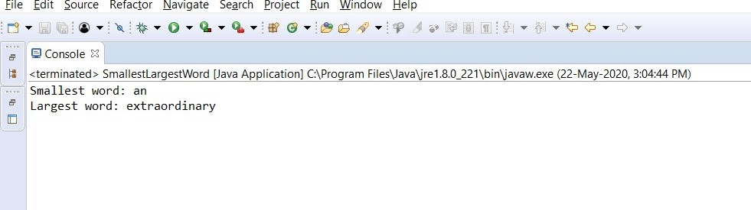

1. Java Program output

