**DAILY ONLINE ACTIVITIES SUMMARY**

|  |  |  |  |  |  |  |  |  |
| --- | --- | --- | --- | --- | --- | --- | --- | --- |
| **Date:** | **23MAY2020** | | | | | **Name:** | **Shilpa S.U** | |
| **Sem & Sec** | **VI & B** | | | | | **USN:** | **4AL17CS090** | |
| **Online Test Summary** | | | | | | | | |
| **Subject** | | **Python** | | | | | | |
| **Max. Marks** | | **30** | | **Score** | | | **12** | |
| **Certification Course Summary** | | | | | | | | |
| **Course** | **Machine Learning with python** | | | | | | | |
| **Certificate Provider** | | | **Cognitiveclass** | | **Duration** | | | **10 hours** |
| **Coding Challenges** | | | | | | | | |
| **Problem Statement:** Problem Statement: 1. Write a java program to implement round robin scheduling algorithm.Calculate AVG WT AND TAT. INPUT:NO OF PROCESSES,BURST TIME AND TIME QUANTUM.  2. Write a Java Program to separate the Individual Characters from a String | | | | | | | | |
| **Status: Done** | | | | | | | | |
| **Uploaded the report in Github** | | | | | **Yes** | | | |
| **If yes Repository name** | | | | | **Coding and Certification Progress** | | | |
| **Uploaded the report in slack** | | | | | **Yes** | | | |

Online Test Details: (Attach the snapshot and briefly write the report for the same) 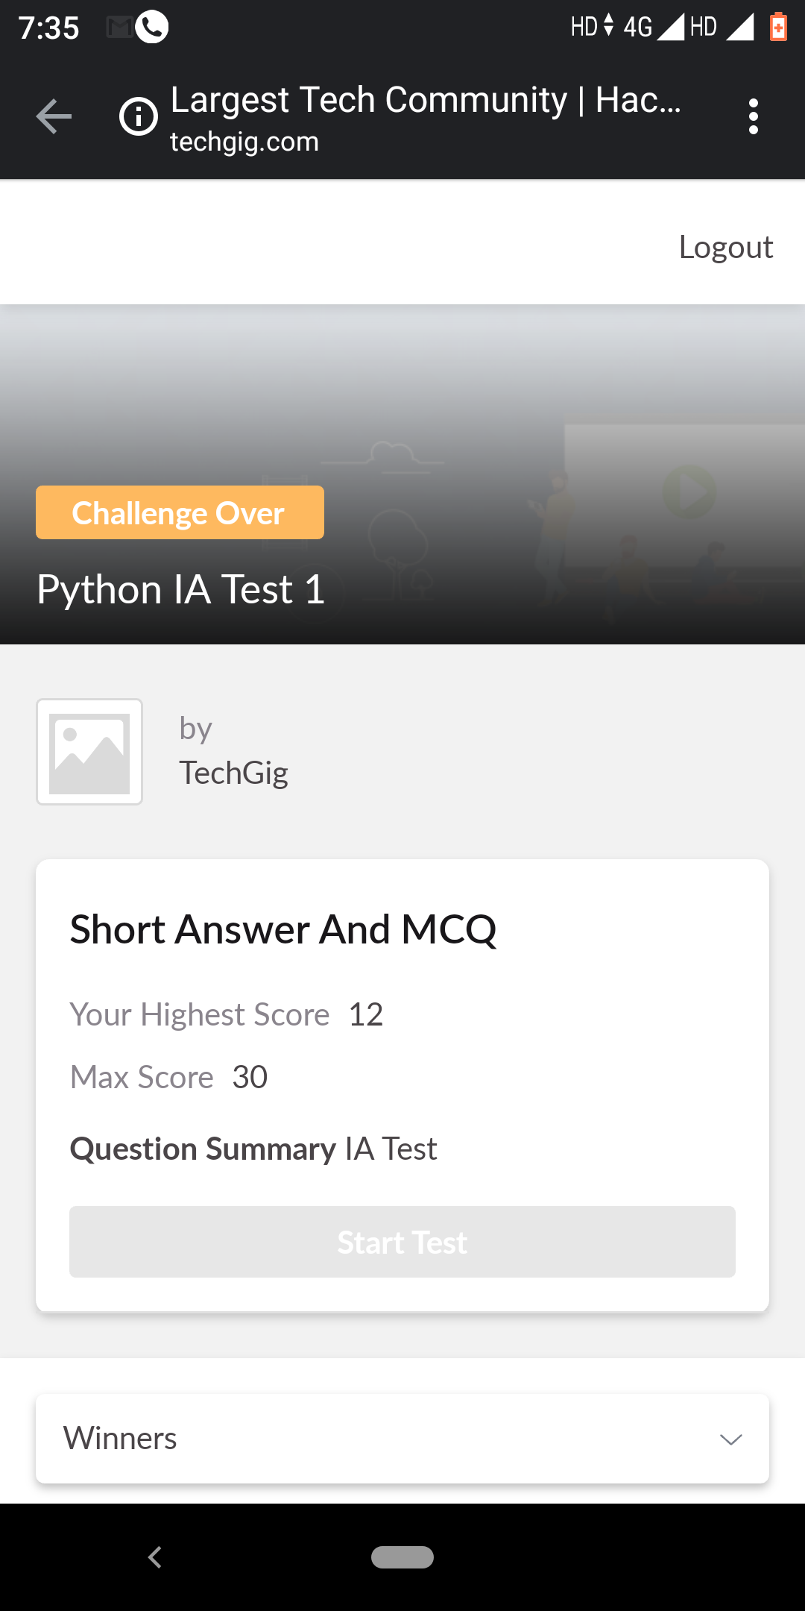

Certification Course Details: (Attach the snapshot and briefly write the report for the same)

1.

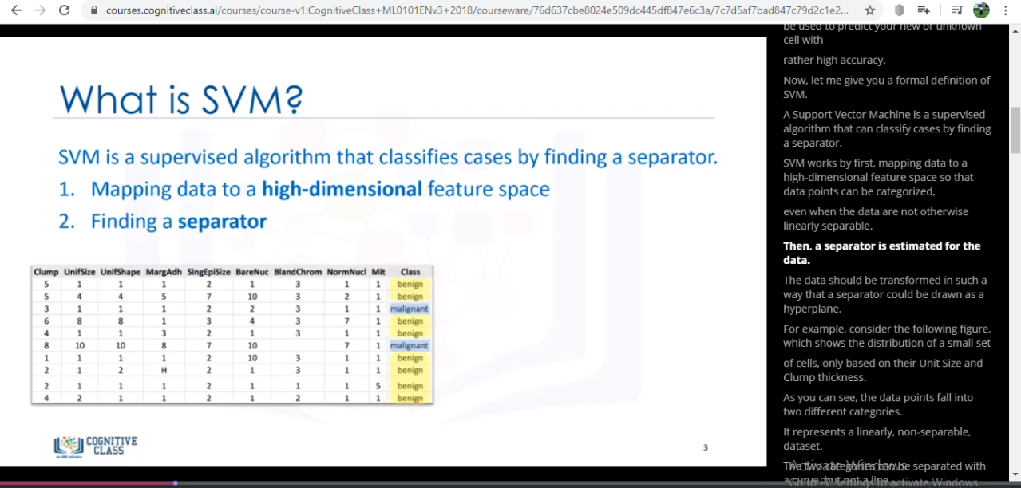

2.

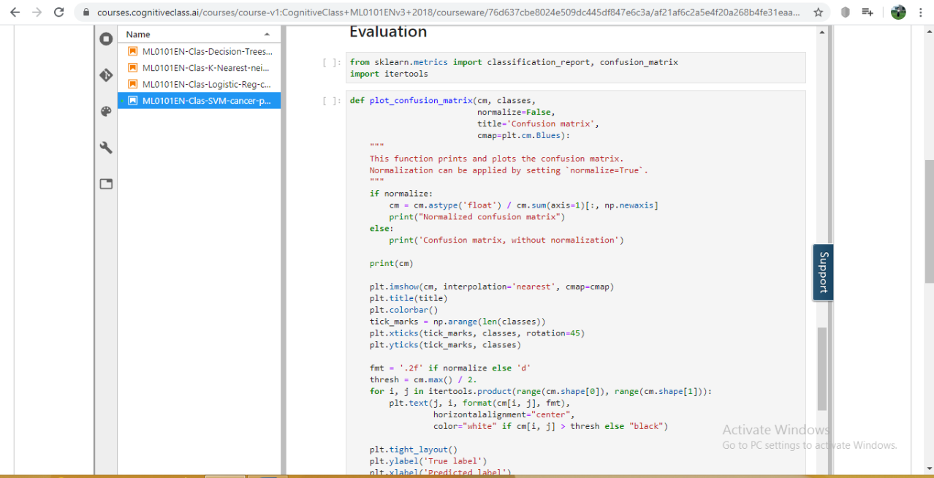

3.

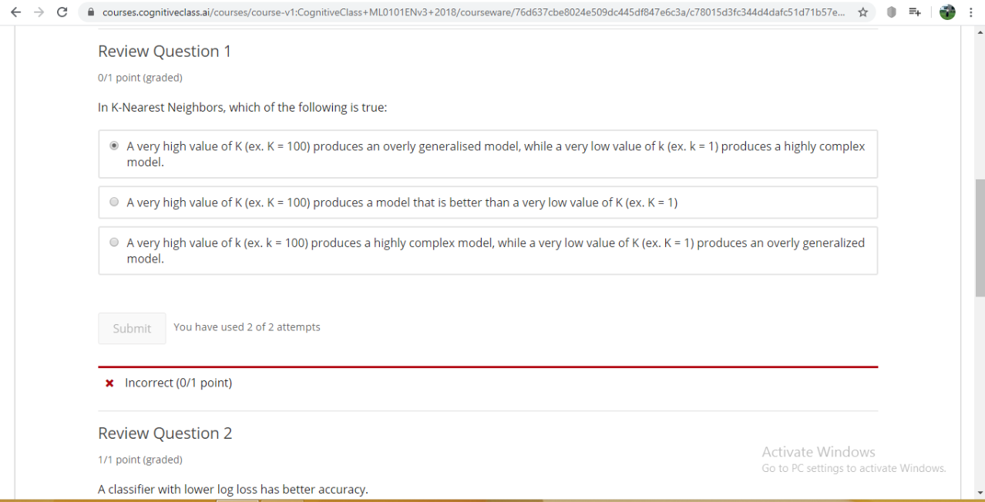

4.

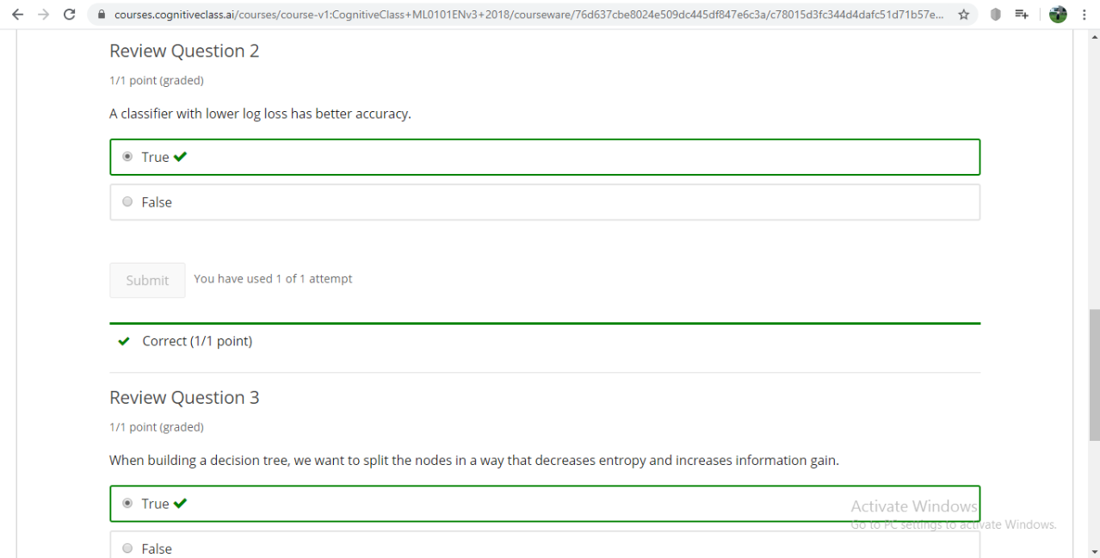

**BRIEF REPORT:**

**1).**The two main advantages of support vector machines are that they’re accurate in high  
dimensional spaces; and, they use a subset of training points in the decision function  
(called support vectors), so it’s also memory efficient.  
The disadvantages of support vector machines include the fact that the algorithm is prone  
for over-fitting, if the number of features is much greater than the number of samples.  
Also, SVMs do not directly provide probability estimates, which are desirable in most classification

**2).** SVM (Support Vector Machines) to build and train a model using human cell records, and classify cells to whether the samples are benign or malignant

**3)** Review Questions has been answered for above topics

Coding Challenges Details: (Attach the snapshot and briefly write the report for the same)

1.

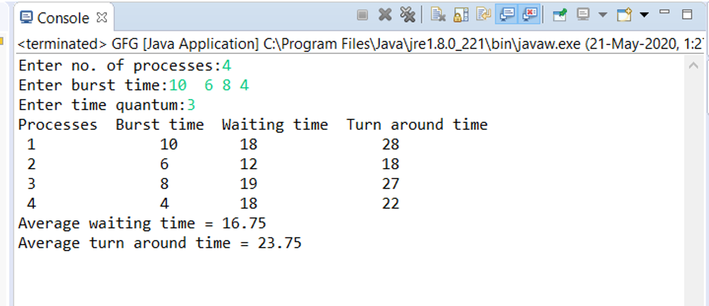

2.

