**DAILY ONLINE ACTIVITIES SUMMARY**

|  |  |  |  |  |  |  |  |  |
| --- | --- | --- | --- | --- | --- | --- | --- | --- |
| **Date:** | **27MAY2020** | | | | | **Name:** | **Shilpa S.U** | |
| **Sem & Sec** | **VI & B** | | | | | **USN:** | **4AL17CS090** | |
| **Online Test Summary** | | | | | | | | |
| **Subject** | | **System Software and Compiler Design** | | | | | | |
| **Max. Marks** | | **30** | | **Score** | | | **19** | |
| **Certification Course Summary** | | | | | | | | |
| **Course** | **Machine Learning with python** | | | | | | | |
| **Certificate Provider** | | | **Cognitive class** | | **Duration** | | | **10 hours** |
| **Coding Challenges** | | | | | | | | |
| 1. **Problem Statement:** Write a C program to sort a given elements one by one in ascending order using sorting algorithm. 2. Write a java program print various operation in binary tree such as inorder Traversal. | | | | | | | | |
| **Status: Done** | | | | | | | | |
| **Uploaded the report in Github** | | | | | **Yes** | | | |
| **If yes Repository name** | | | | | **Daily Status** | | | |
| **Uploaded the report in slack** | | | | | **Yes** | | | |

Online Test Details: (Attach the snapshot and briefly write the report for the same)

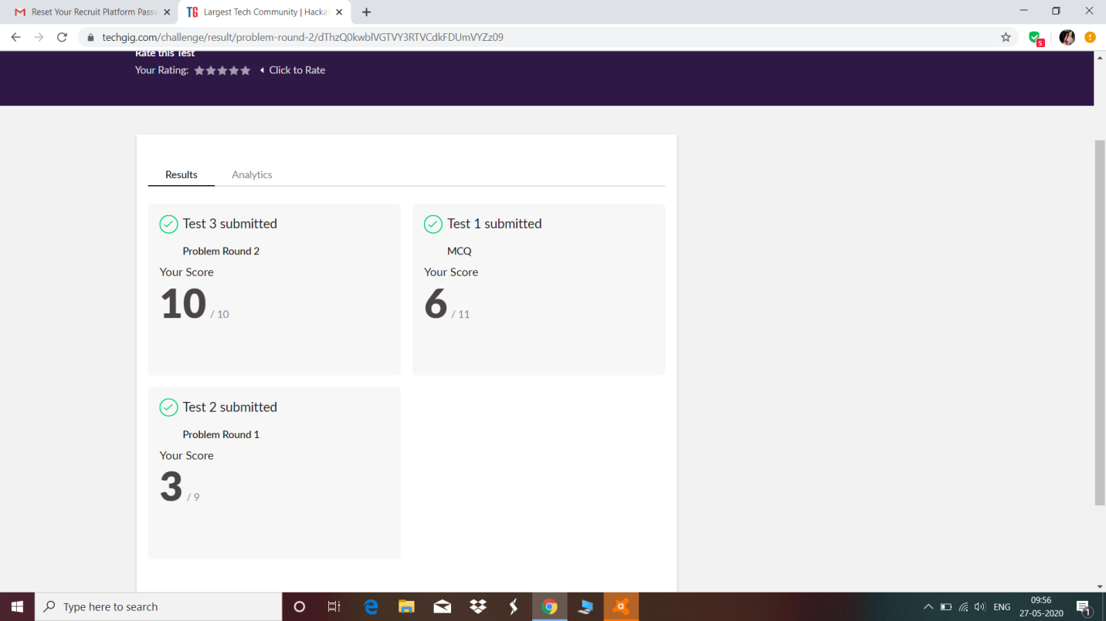

Certification Course Details: (Attach the snapshot and briefly write the report for the same)

1. 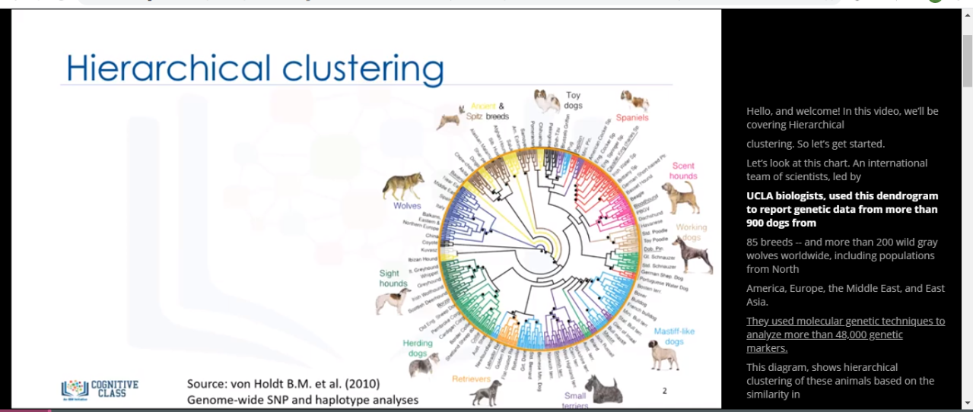

**2.**

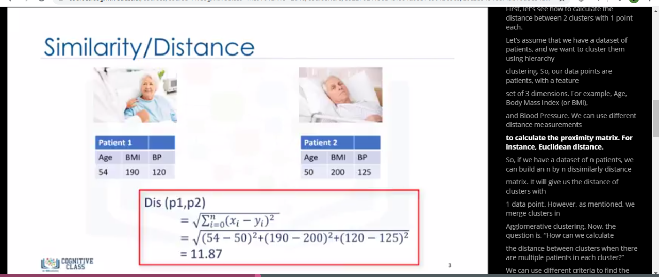

**3.**



**4.**

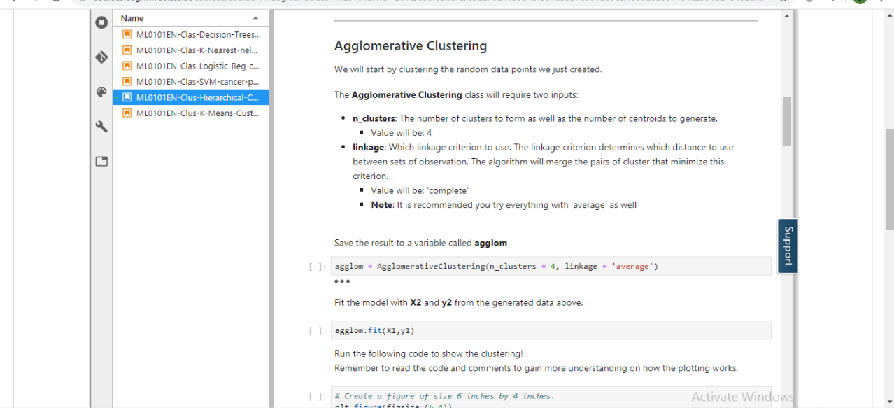

**BRIEF REPORT:**

**1)** Hierarchical clustering is typically visualized as a dendrogram as shown on this slide.  
* Each merge is represented by a horizontal line.  
* The y-coordinate of the horizontal line is the similarity of the two clusters that were  
merged, where cities are viewed as singleton clusters.  
* By moving up from the bottom layer to the top node, a dendrogram allows us to reconstruct  
the history of merges that resulted in the depicted clustering.  
* Essentially, Hierarchical clustering does not require a pre-specified number of clusters.  
* However, in some applications we want a partition of disjoint clusters just as in flat clustering.  
 In those cases, the hierarchy needs to be cut at some point.

**2)** There are 3 main advantages to using hierarchical clustering.  
* First, we do not need to specify the number of clusters required for the algorithm.  
* Second, hierarchical clustering is easy to implement.  
* And third, the dendrogram produced is very useful in understanding the data.  
* There are some disadvantages as well. First, the algorithm can never undo any previous  
steps.

**3)** DBSCAN stands for Density-Based Spatial Clustering of Applications with Noise.  
* This technique is one of the most common clustering algorithms, which works based on density of  
object. DBSCAN works on the idea is that if a particular  
point belongs to a cluster, it should be near to lots of other points in that cluster.  
* It works based on 2 parameters: Radius and Minimum Points.  
 R determines a specified radius that, if it includes enough points within it, we call  
 it a "dense area." M determines the minimum number of data points  
 we want in a neighborhood to define a cluster**.**

Coding Challenges Details: (Attach the snapshot and briefly write the report for the same)

1.

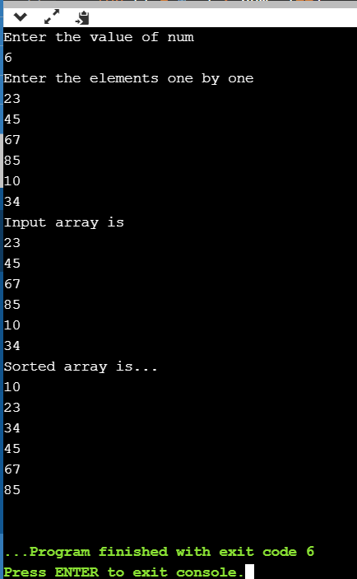

2.

