**DAILY ONLINE ACTIVITIES SUMMARY**

|  |  |  |  |  |  |  |  |  |
| --- | --- | --- | --- | --- | --- | --- | --- | --- |
| **Date:** | **28MAY2020** | | | | | **Name:** | **Shilpa S.U** | |
| **Sem & Sec** | **VI & B** | | | | | **USN:** | **4AL17CS090** | |
| **Online Test Summary** | | | | | | | | |
| **Subject** | | **Operating System** | | | | | | |
| **Max. Marks** | | **30** | | **Score** | | | **24** | |
| **Certification Course Summary** | | | | | | | | |
| **Course** | **Machine Learning with Python** | | | | | | | |
| **Certificate Provider** | | | **CognitiveClass** | | **Duration** | | | **15 hours** |
| **Coding Challenges** | | | | | | | | |
| **Problem Statement:** **1)Write a Java program to get to know the balanced bracket if its balanced it will print true or else print false.**  **2)Write a Python program to get the digit root of a given number until it becomes single digit.** | | | | | | | | |
| **Status: Done** | | | | | | | | |
| **Uploaded the report in Github** | | | | | **Yes** | | | |
| **If yes Repository name** | | | | | **Daily status** | | | |
| **Uploaded the report in slack** | | | | | **Yes** | | | |

Online Test Details: (Attach the snapshot and briefly write the report for the same)

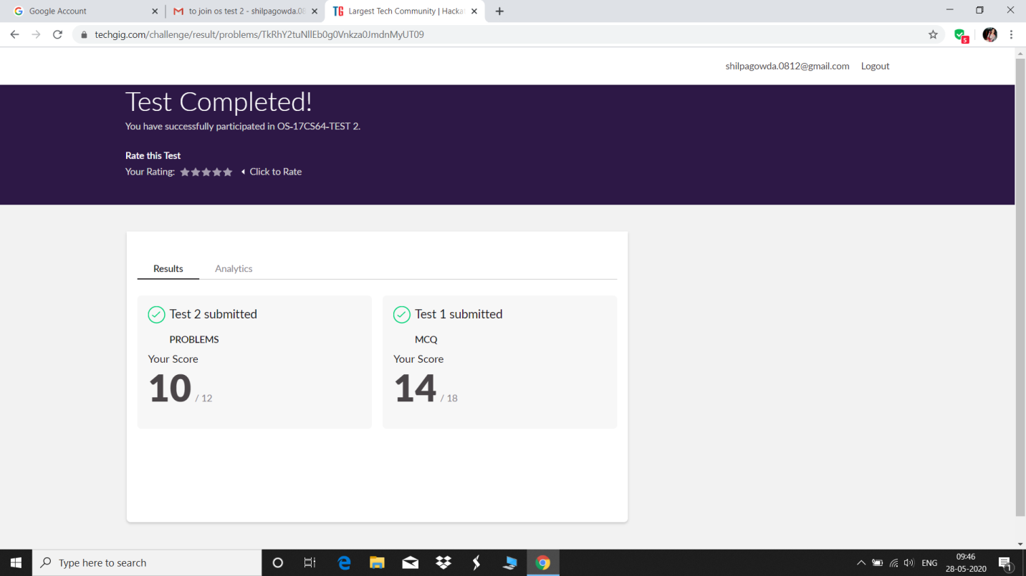

Certification Course Details: (Attach the snapshot and briefly write the report for the same)

1.

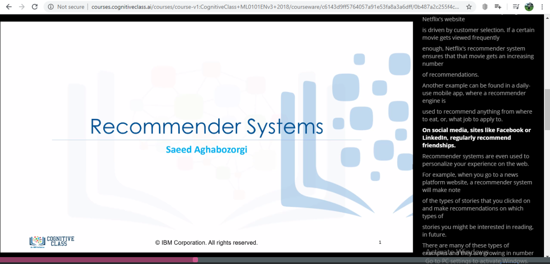

2.



3.

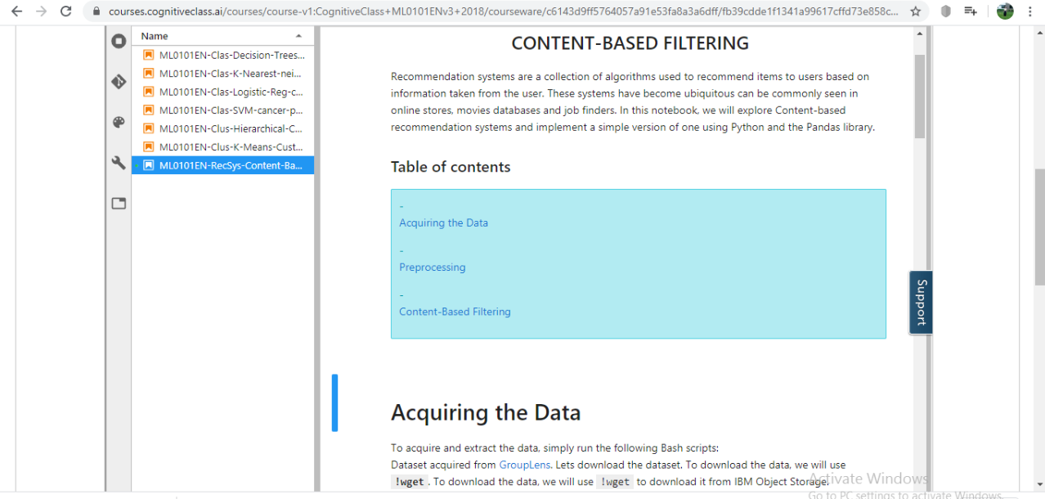

**BRIEF REPORT:**

1. Recommender systems try to capture these patterns  
   and similar behaviors, to help predict what else you might like.  
   * Recommender systems have many applications that I’m sure you’re already familiar  
   with. Indeed, Recommender systems are usually at  
   play on many websites. For example, suggesting books on Amazon and  
   movies on Netflix.
2. In fact, everything on Netflix’s website  
   is driven by customer selection. If a certain movie gets viewed frequently  
   enough, Netflix’s recommender system ensures that that movie gets an increasing number  
   of recommendations**.**
3. Recommendation systems are a collection of algorithms used to recommend items to users based on information taken from the user. These systems have become ubiquitous can be commonly seen in online stores, movies databases and job finders. In this notebook, we will explore Content-based recommendation systems and implement a simple version of one using Python and the Pandas library

Coding Challenges Details: (Attach the snapshot and briefly write the report for the same)

1

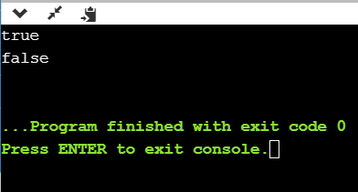

This program checks for equal no of brackets is open and closed if so it prints true or else return false

2.

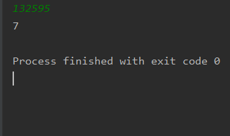

This python program is to get digitroot of the number where we give a random number and until it become complete single digit it goes on calculate

3.

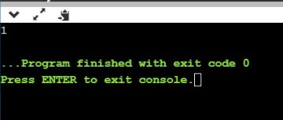

This c program prints last remaining element in array

4.

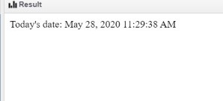

JSP program to print current date and time.

5.

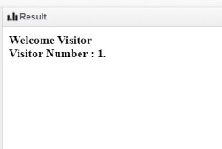

Jsp program to print number of visitor visited the site**.**