**DAILY ONLINE ACTIVITIES SUMMARY**

|  |  |  |  |  |  |  |
| --- | --- | --- | --- | --- | --- | --- |
| **Date:** | **04-06-2020** | | | **Name:** | **Shilpa S.U** | |
| **Sem & Sec** | **6th – B** | | | **USN:** | **4AL17CS090** | |
| **Online Test Summary** | | | | | | |
| **Subject** | **OS** | | | | | |
| **Max. Marks** | **30** | | **Score** | | **18** | |
| **Certification Course Summary** | | | | | | |
| **Course** | **TCS edge Carieer** | | | | | |
| **Certificate Provider** | | **TCS** | **Duration** | | | **15 Days** |
| **Coding Challenges** | | | | | | |
| **Problem Statement:1Java program 1 Python program** | | | | | | |
| **Status: Executed** | | | | | | |
| **Uploaded the report in GitHub** | | | **yes** | | | |
| **If yes Repository name** | | | Daily updates of online actvities | | | |
| **Uploaded the report in slack** | | | **Yes** | | | |

Online Test Details: (Attach the snapshot and briefly write the report for the same)

Third IA of OS

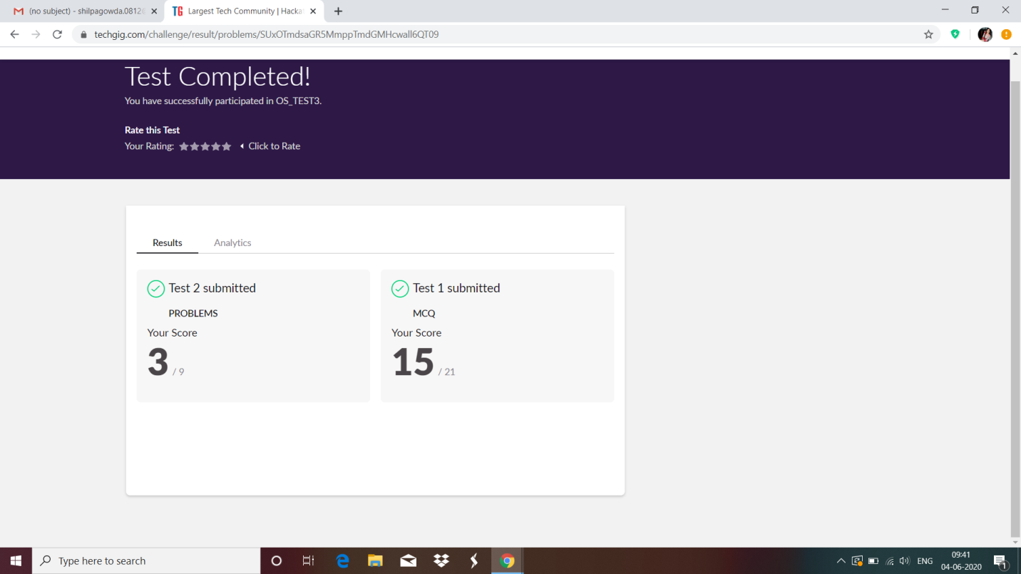

Certification Course Details: (Attach the snapshot and briefly write the report for the same)

­­

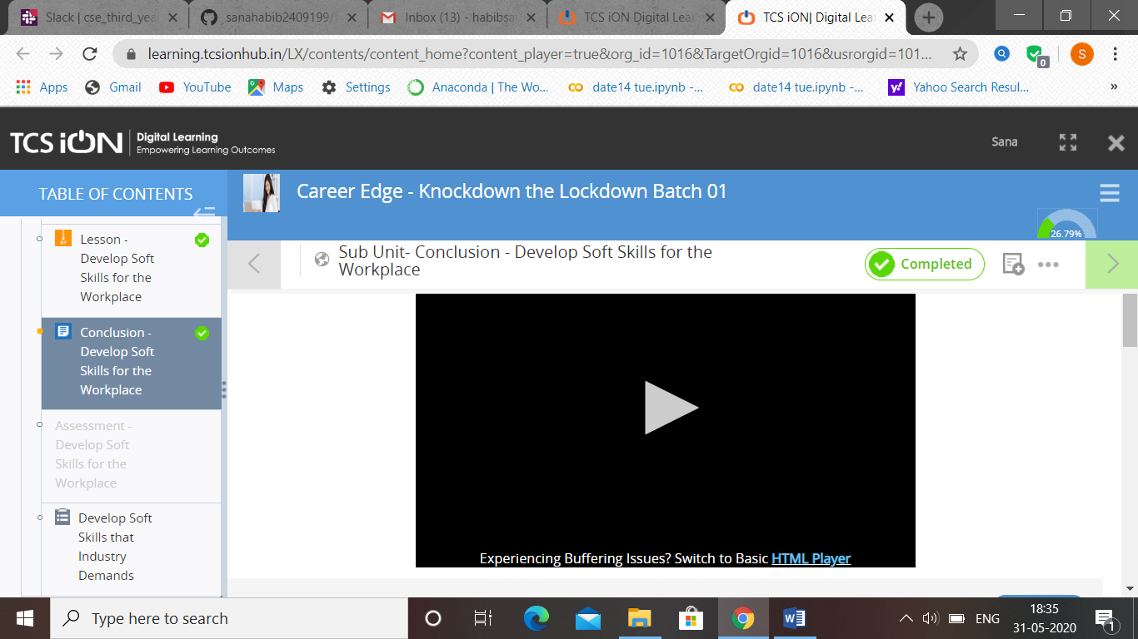



Coding Challenges Details: (Attach the snapshot and briefly write the report for the same

Output screen shots

Program 1: Write a python program to combine the strings.

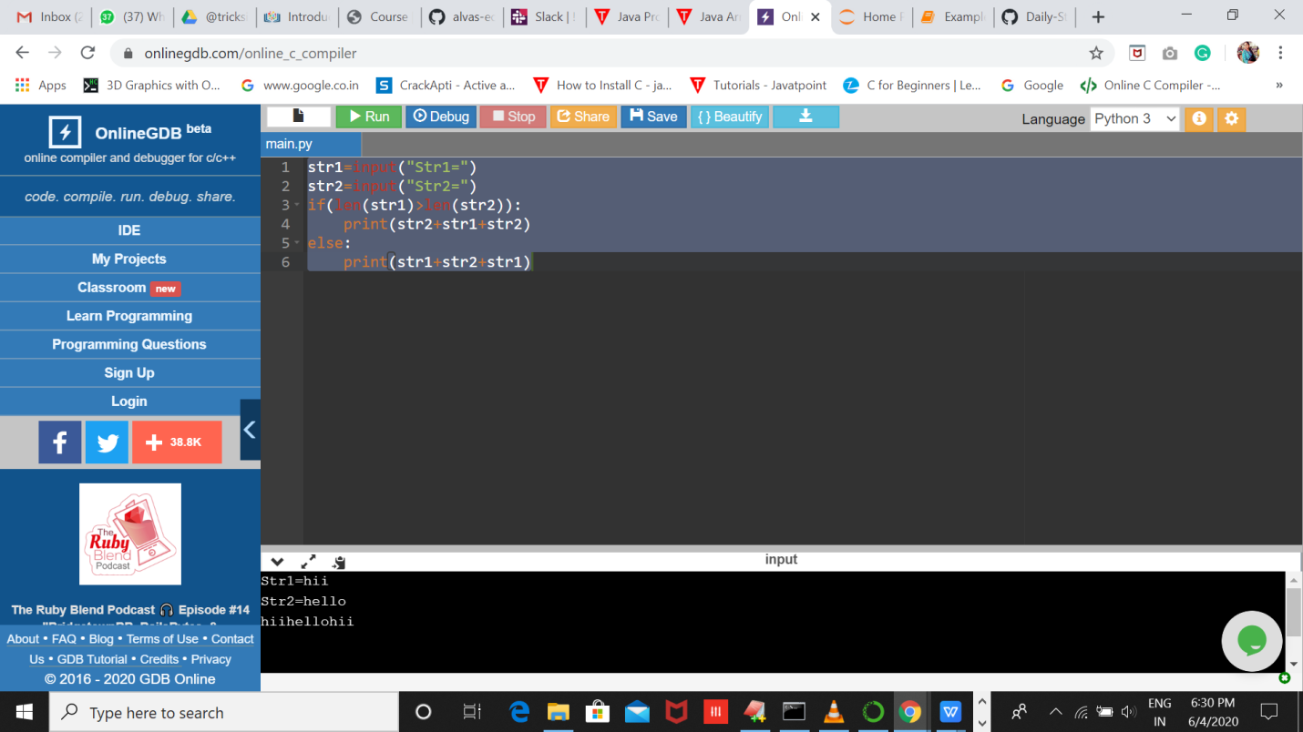

2.Write a Java program to implement Queue Using Array And Class.

.