**DAILY ONLINE ACTIVITIES SUMMARY**

|  |  |  |  |  |  |  |  |  |
| --- | --- | --- | --- | --- | --- | --- | --- | --- |
| **Date:** | **07-06-2020** | | | | | **Name:** | **Shilpa S.U** | |
| **Sem & Sec** | **VI B** | | | | | **USN:** | **4AL17CS090** | |
| **Online Test Summary** | | | | | | | | |
| **Subject** | | **SSCD IA Test** | | | | | | |
| **Max. Marks** | | **30** | | **Score** | | | **23** | |
| **Certification Course Summary** | | | | | | | | |
| **Course** | **TCS Carrier edge** | | | | | | | |
| **Certificate Provider** | | | **TCS** | | **Duration** | | | **15 days** |
| **Coding Challenges** | | | | | | | | |
| **Problem Statement:**  1.Python program to count number of strings.  Description:Write a Python program to count the number of strings, provided string length is 2 or more and the first and last character are same from a given list of strings.  2.Python program to square each odd number in the list  Description: Take a list of numbers and square each odd number in the list. Print output as comma separated sequence | | | | | | | | |
| **Status: Completed** | | | | | | | | |
| **Uploaded the report in GitHub** | | | | | **Yes** | | | |
| **If yes Repository name** | | | | | Daily updates of online activities | | | |
| **Uploaded the report in slack** | | | | | **Yes** | | | |

**Online test Detail:**

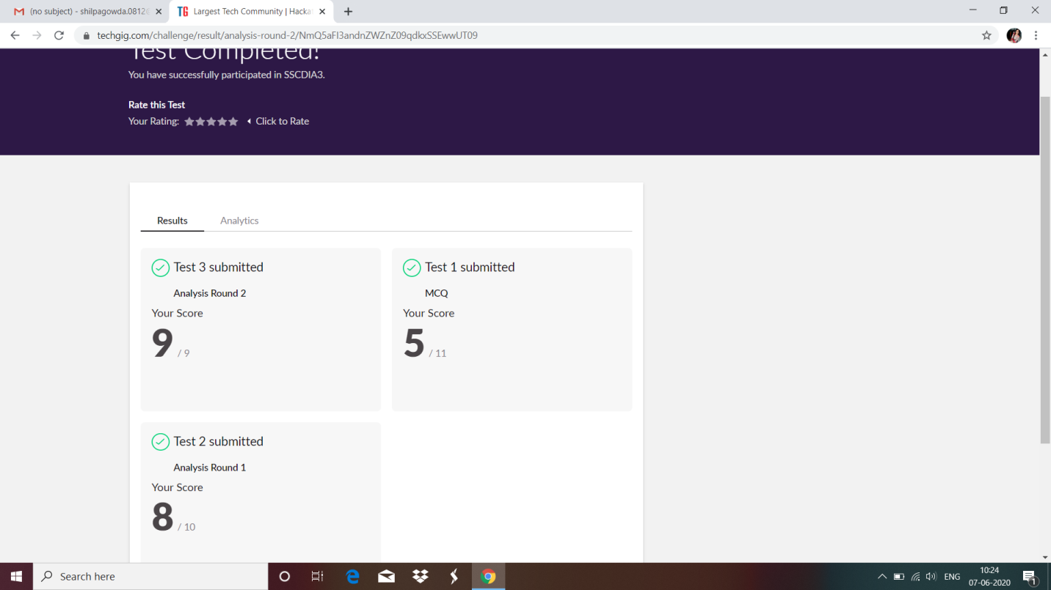

**Online Certification Details**

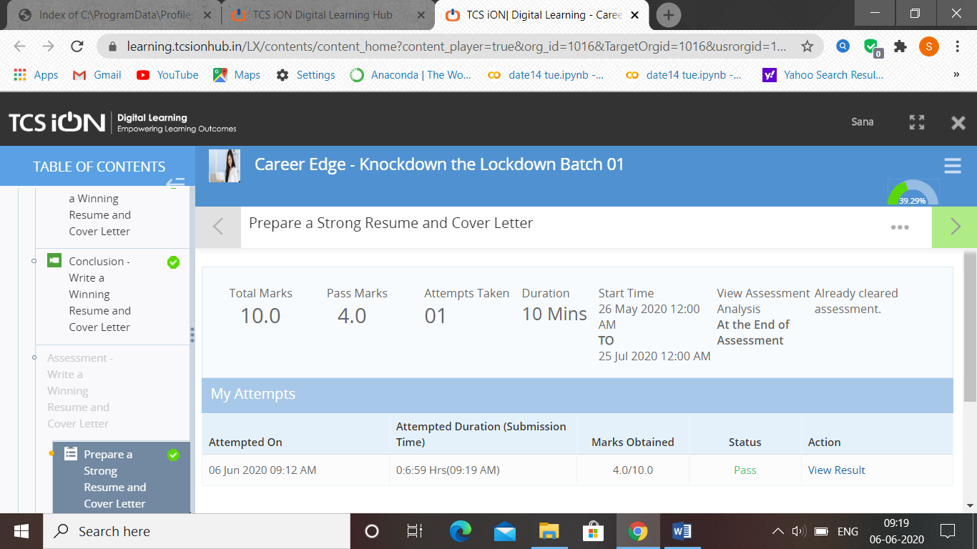

**Coding Challenge Details**

1.Python program to count number of strings.

Description: Write a Python program to count the number of strings, provided string length is 2 or more and the first and last character are same from a given list of strings.

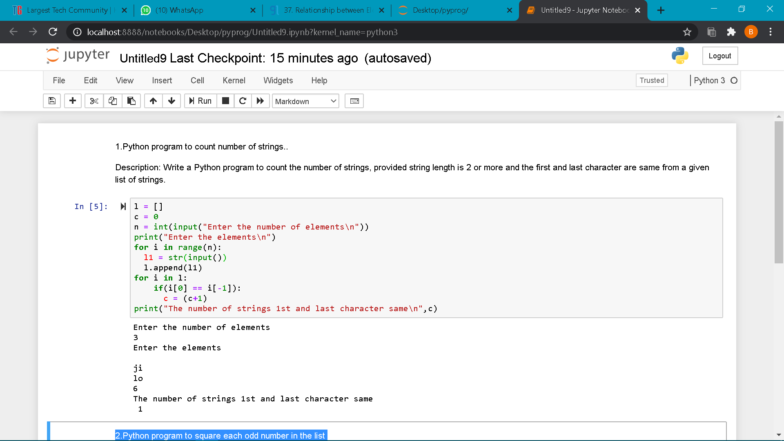

2.Python program to square each odd number in the list

Description: Take a list of numbers and square each odd number in the list. Print output as comma separated sequence

