**HR – Analytics SQL Queries**

1. use hr;

select * from hr_table;

select AVG(Age) as average_age from hr_table;

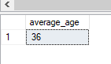

1. select sum(EmployeeCount) as total_employee from hr_table;

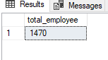

1. select sum(EmployeeCount) as total_female_employee from hr_table

where Gender = 'Female';

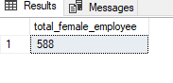

1. select sum(EmployeeCount) as total_male_employee from hr_table

where Gender = 'male';

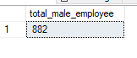

1. select sum(EmployeeCount) as total_married_employee from hr_table

where MaritalStatus = 'Married';

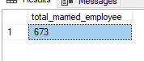

1. select sum(EmployeeCount) as total_single_employee from hr_table

where MaritalStatus = 'Single';

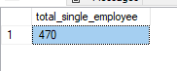

1. select sum(EmployeeCount) as total_divorced_employee from hr_table

where MaritalStatus = 'Divorced';

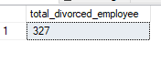

1. select sum(EmployeeCount) as sales_employee from hr_table

where Department = 'Sales';

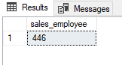

1. select sum(EmployeeCount) as RD_employee from hr_table

where Department = 'Research & Development';

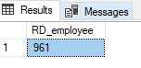

1. select sum(EmployeeCount) as HR_employee from hr_table

where Department = 'Human Resources';

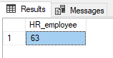

1. select sum(EmployeeCount) as medical_employee from hr_table

where EducationField = 'Medical';

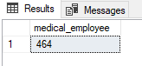

1. select count(Attrition) as total_attrition from hr_table

where Attrition = 1;

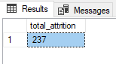

1. select count(Attrition) as total_attrition_sales from hr_table

where Attrition = 1 and Department = 'Sales';

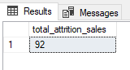

1. select count(Attrition) as total_attrition_in_RD_LS from hr_table

where Attrition = 1 and Department = 'Research & Development' and EducationField = 'Life Sciences';

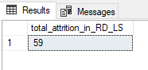

1. select SUM(EmployeeCount) - (select COUNT(Attrition) from hr_table where Attrition = 1) as active_employee from hr_table;

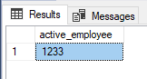

1. select SUM(EmployeeCount) - (select COUNT(Attrition) from hr_table where Attrition = 1 and Gender = 'Male') as active_male_employee from hr_table

where Gender = 'Male';

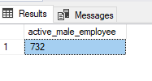

1. select Gender, COUNT(Attrition) as total_employee from hr_table

where Attrition = 1

group by Gender;

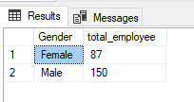

1. select Department, Count(OverTime) as overtime from hr_table

where OverTime = 1

group by Department;

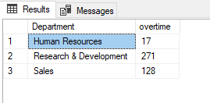

1. select (select COUNT(Attrition) from hr_table where Attrition = 1) / cast(SUM(EmployeeCount) as numeric)*100

as attrition_rate from hr_table;

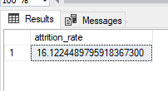

1. select Department, COUNT(Attrition) as attrition,

(cast(count(Attrition) as numeric) / (select Count(Attrition) from hr_table where Attrition = 1))*100 as attrition_rate

from hr_table

where Attrition = 1

group by Department;

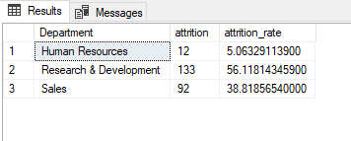

1. select Age, SUM(EmployeeCount) as total_employee from hr_table

group by Age

order by Age;

1. select JobRole , AVG(PercentSalaryHike) as average_pct_hike from hr_table

group by JobRole

order by average_pct_hike;

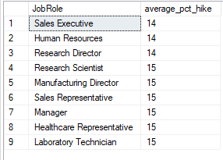

1. select Department, AVG(MonthlyIncome) avg_monthly_income from hr_table

group by Department

order by avg_monthly_income;

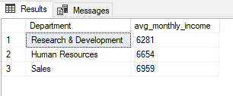

1. select BusinessTravel, SUM(EmployeeCount)as employee from hr_table

group by BusinessTravel;

