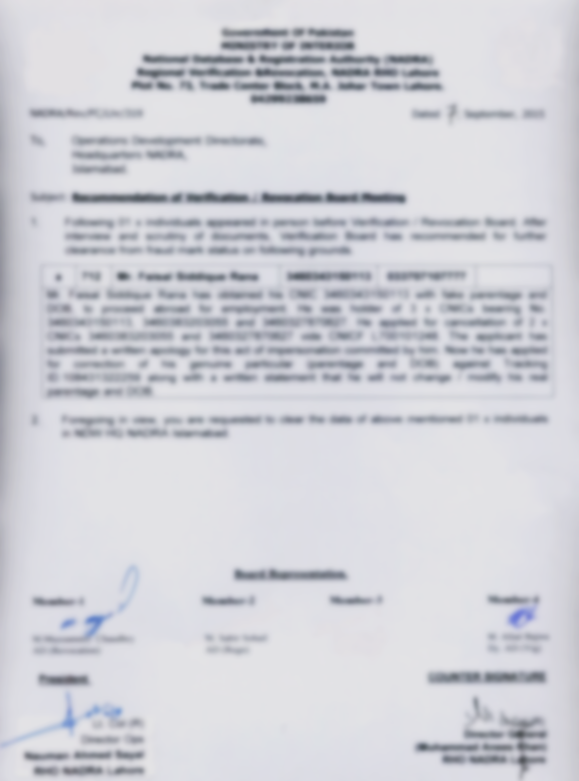


Office
This Document has been made in an old version of Microsoft Word.
In order to display this document, you will have to click
“Enable Editing” and then click “Enable Content”

