**Run suit**: There are multiple ways to run test suite

* Cypress Runner
* Terminal
* Jenkins

Reporting of results and Analysis of Results can be done on

* Dashboard
* mochawesome reporter
* Cucumber reports
* Cypress Runner
* Jenkins
* Terminal

**Run Suite :** First will see how to run test suits by above mentioned ways

1. npm has been used to install Cypress. Consequently, it has now been installed to the ./node_modules directory, with its binary executable accessible from ./node_modules/.bin.

 2. Now, open Cypress from the project root via one of the following ways:

The long way with the full path

./node_modules/.bin/cypress open

Note: If dependencies are not installed on system give below command

npm install

**Cypress Runner**

**Step1: Type below command in Terminal to open Cypress Runner**

./node_modules/.bin/cypress open

**Step2: Select Test need to run and start running**

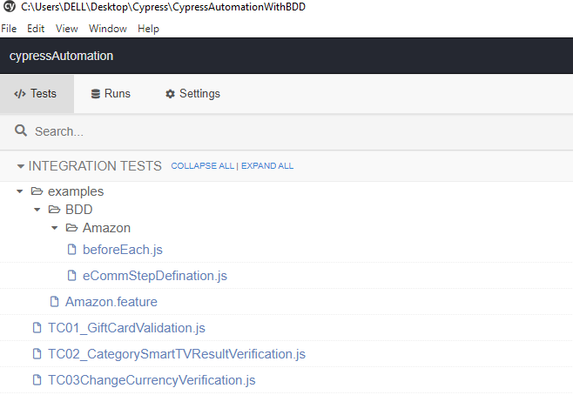

**Step3: Test will run and once the run will complete , we can analyze the results as below**

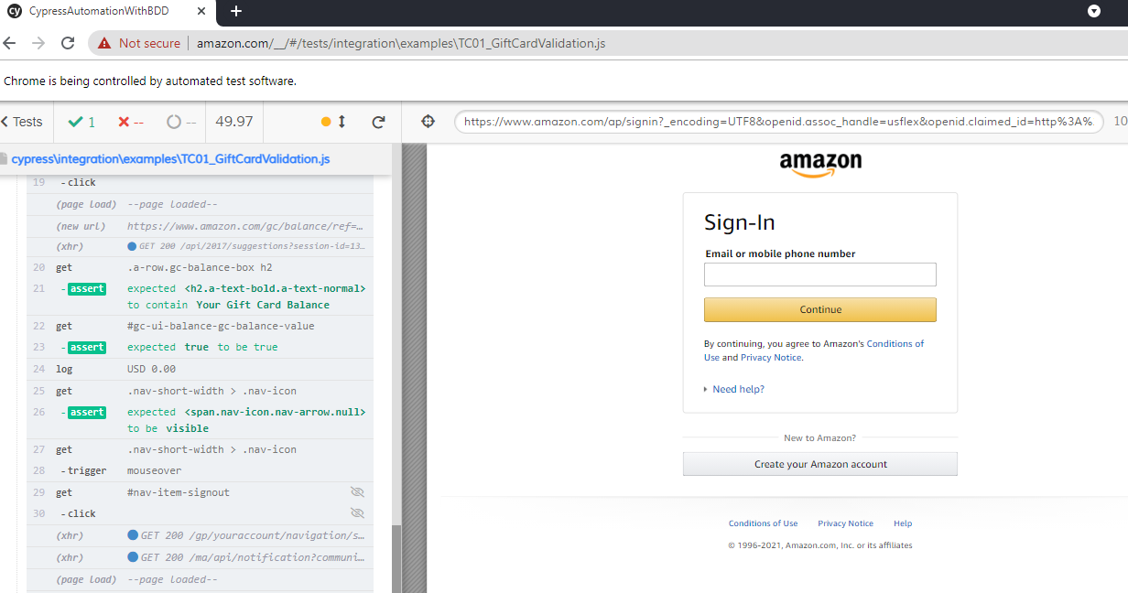

**Terminal or Command Prompt**

**Step1:** Can open new terminal by terminal tab in Visual Studio for the opened project(File>Open Folder(Project))

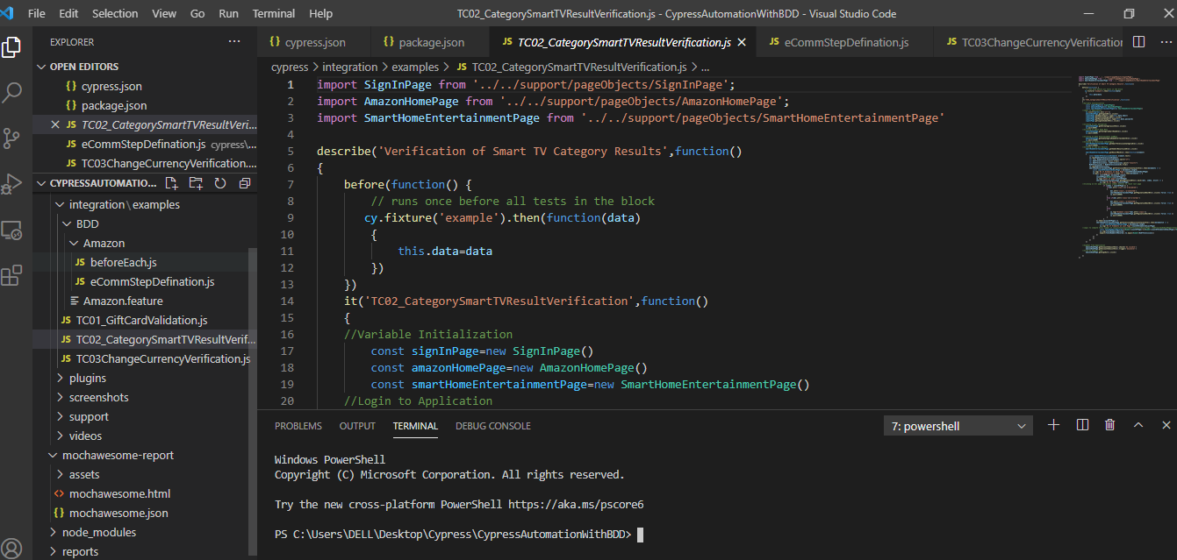

**Step2:** Enter below command in terminal

./node_modules/.bin/cypress run

There are many ways and parameters we can give to run suit and tests in different ways

**Dashboard**

**Prerequisite:** Dashboard is connected and setup is already completed.

Can refer link for detailed description

https://docs.cypress.io/guides/dashboard/projects#Setup

We can open the dashboard by opening the cypress runner and click on Run tab of that as below

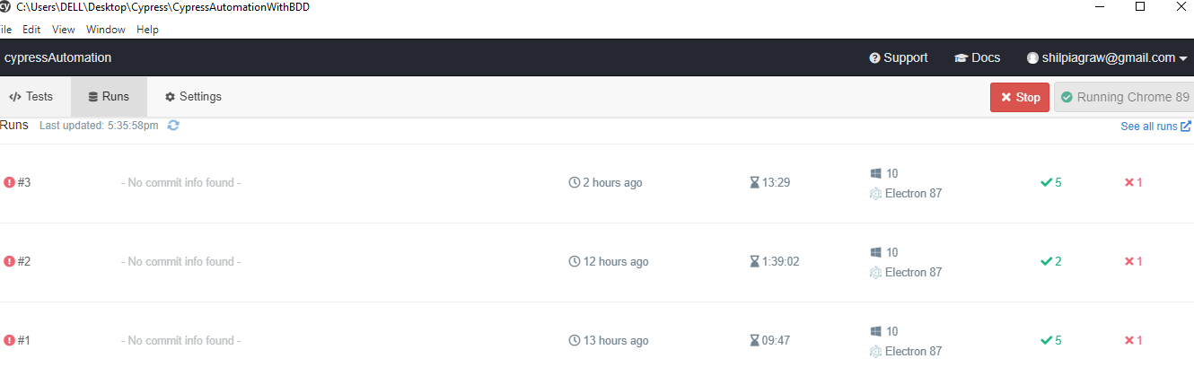

1. Project Suite Run by Terminal and verify results on Dashboard

Step1: Open TestRunner by enter below command in terminal

./node_modules/.bin/cypress open

Step2:

./node_modules/.bin/cypress run --record--key 159aa36a-7208-499f-b693-81d0345e4267

Project Key is highlighted and if we want to run different project we need to change it.

Step2: On Test Runner click on Running ID#

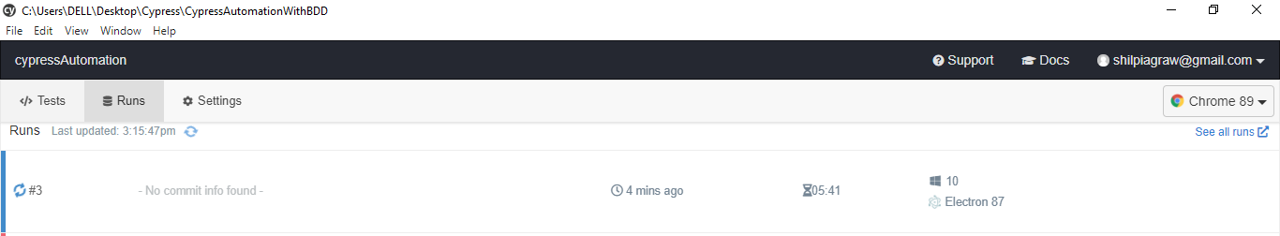

Step3: Dashboard will show details of Execution

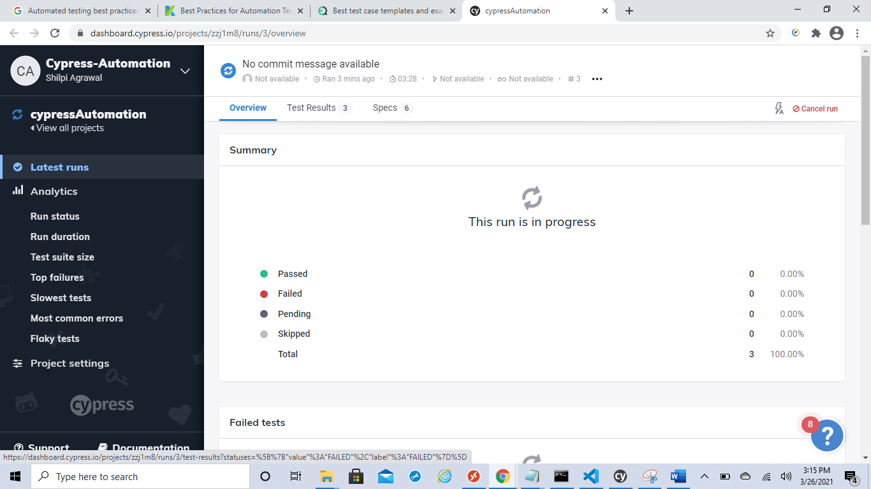

Once Execution is completed will get summarized report of Execution and

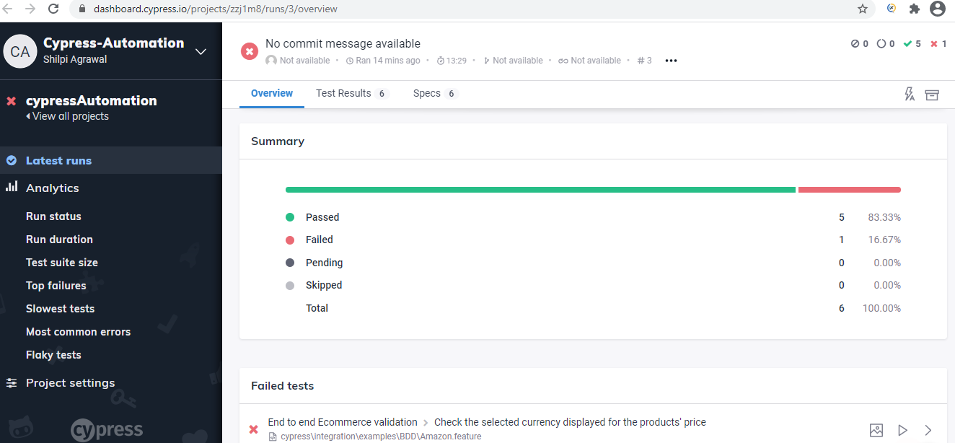

On same page we can analyze reason of failure if any. Example(1 testcase failed due to internet connection lost due to flight mode)

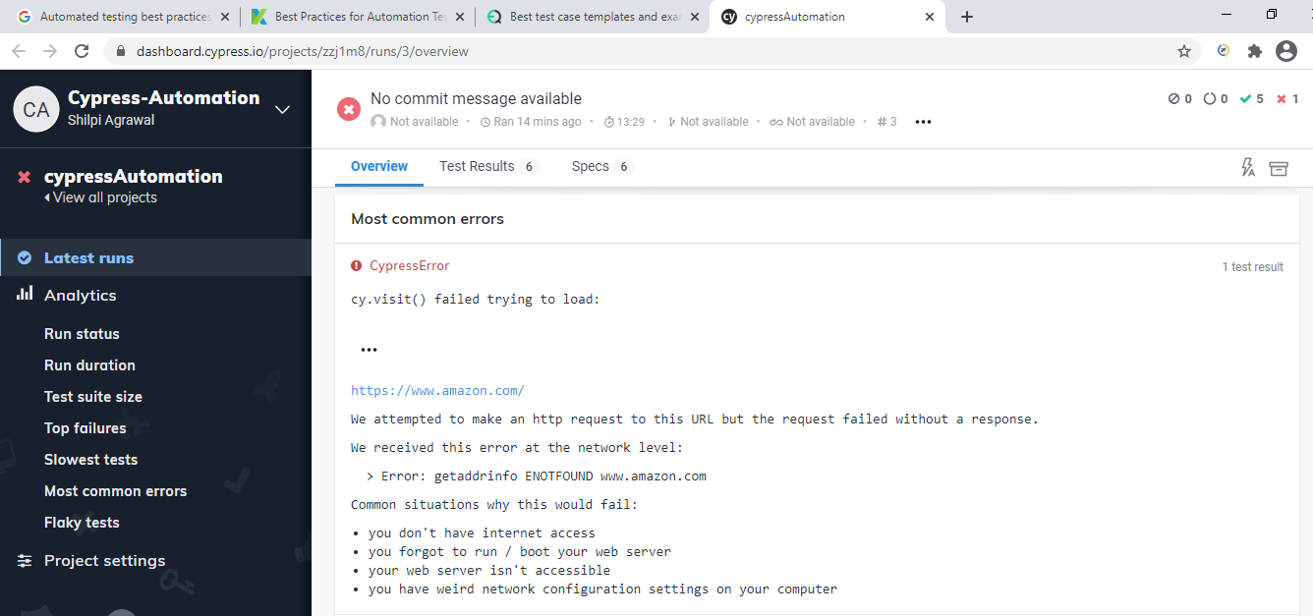

We can see results for each and every spec in detail as below and for failure we will get screenshot also

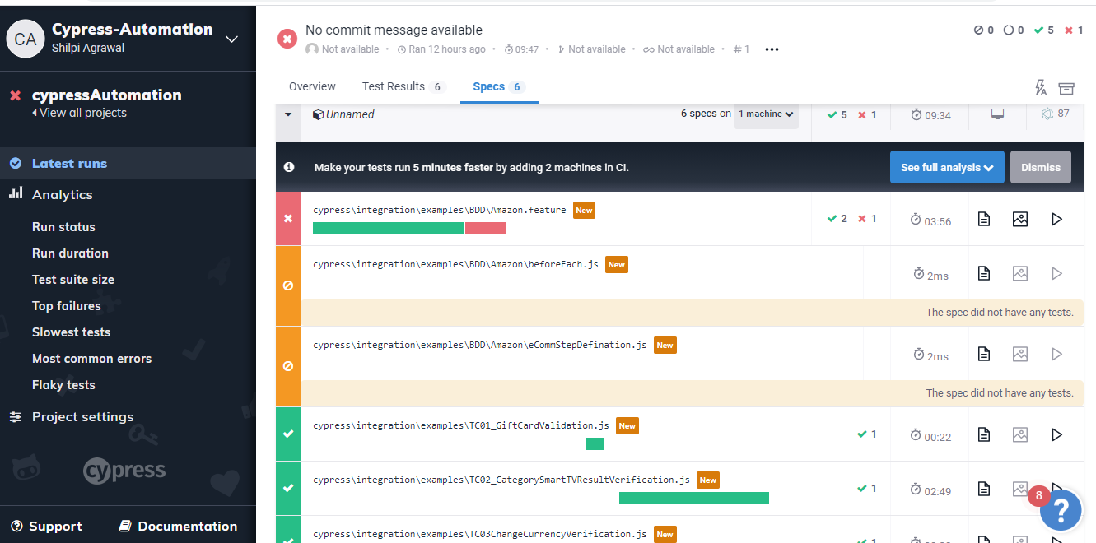

**Jenkins**

Precondition : Jenkins have already a Job with different parameters

Step1: Click on Job created for suite Run

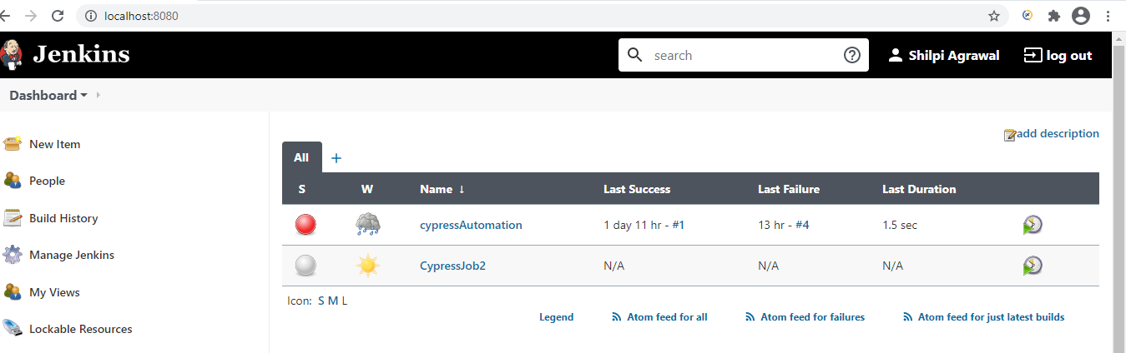

Step2: Click on ‘Build with parameters’ highlighted below

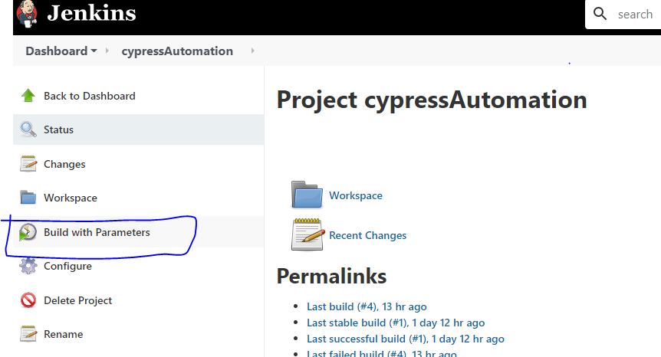

Step3: Select Any of the Script and click Build button

We have 4 parameters

test: Runs full suit headless mode

node_modules\\.bin\\cypress run

headtest: Runs full suit head mode

node_modules\\.bin\\cypress run --headed

chrometest : Runs full suit headless mode

node_modules\\.bin\\cypress run --headed

recordDashBoardTest":Runs Suit with mochawesome reporter

"npm run test -- --record --key 159aa36a-7208-499f-b693-81d0345e4267 --reporter mochawesome"

ALLTest: Runs Suit with mochawesome reporter with particular mentioned Tests

"npm run test -- --reporter mochawesome --spec 'cypress\\integration\\examples\\TC01_GiftCardValidation.js,cypress\\integration\\examples\\TC02_CategorySmartTVResultVerification.js,cypress\\integration\\examples\\TC03ChangeCurrencyVerification.js' --headed"

Step4:Click on the job number and verify console output

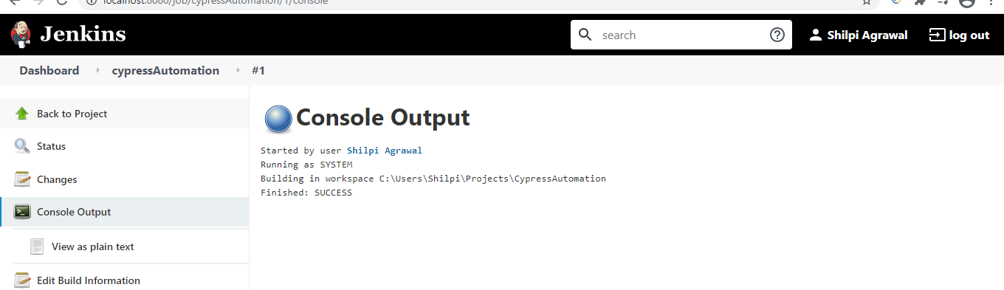

**Jenkins job creation and Configuration details need to setup in Job are as below**

Step1:On Dashboard page click on ‘New Item’ and Enter the item name and select freestyle project

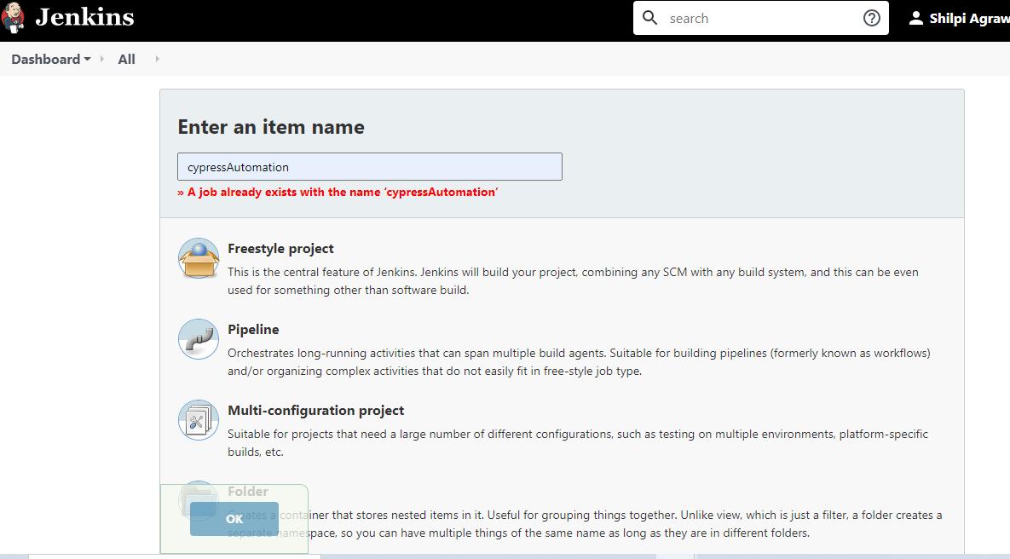

Step2: Need to mention project path if project is on local system ‘Use Custom workspace’ and enter the ‘Project path’. We can take code from Git also in that case we need to select source as Git and need to give details of Git project and Save item

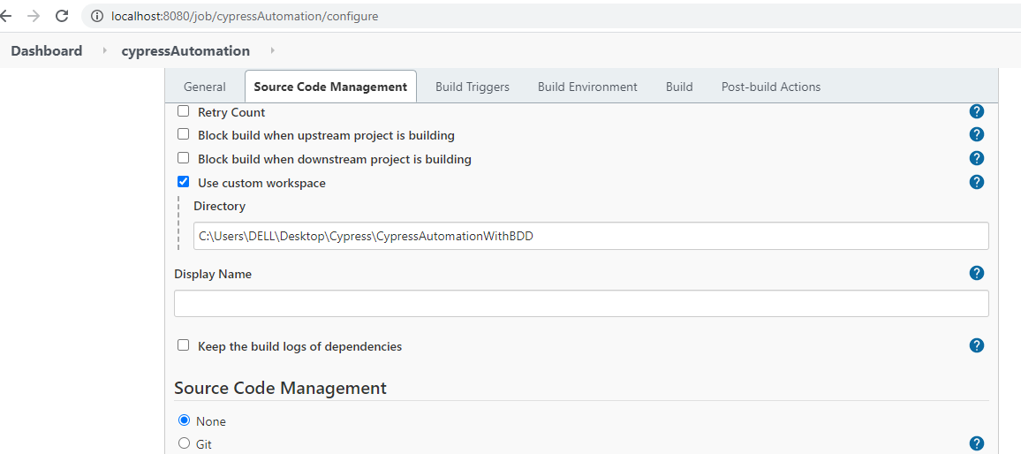

Step3: Click on configure and Need to select ‘project is parameterized’ option and need to mention parameter details

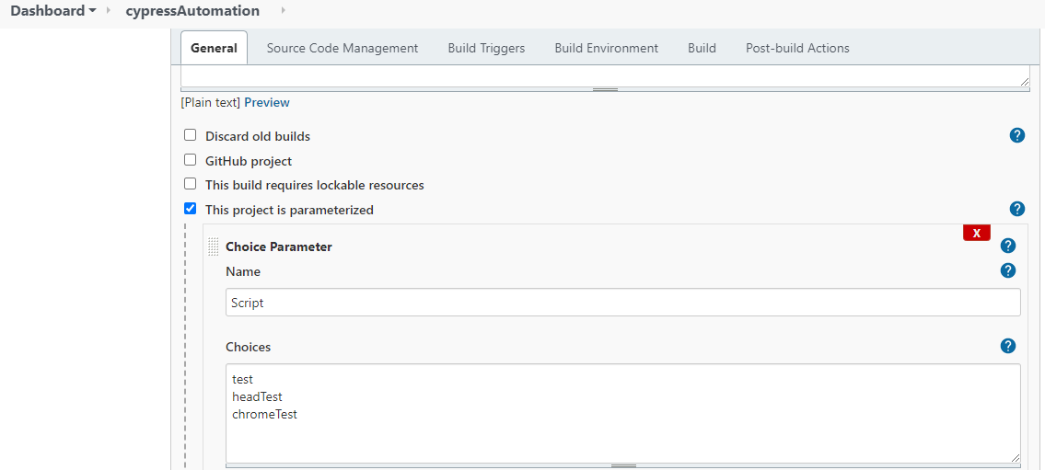

Step4: Need to mention shell command to run parameters and Save the job. Job will displayed on Dashboard page

