**Practical No 9 Date:** / /2022

**Title:** Create three classes: polygon (base class), rectangle and triangle (derived classes) having the same members: width, height, and functions set_values and area. Write a C++ program using run time polymorphism to implement it.

**Description:**

Polymorphism is a feature of OOP that allows the object to behave differently in different conditions

In C++ polymorphism is mainly divided into two types:

1) Compile time Polymorphism – This is also known as static (or early) binding

2) Runtime Polymorphism – This is also known as dynamic (or late) binding

Runtime Polymorphism is achieved using virtual functions.

Declare a pure virtual function inside the base class and redefine it in the derived classes

Class polygon

{

…

…

virtual void area()=0; // pure virtual function

}

Class rectangle: public polygon

{

…

…

}

Class triangle : public polygon

{

…

…

}

main()

{

Polygon is an abstract class, it can’t be instantiated. Only pointer object can be created for this class

….

…

}

**Program Code:**

#include <iostream>

using namespace std;

class Polygon {

protected:

int width;

int height;

public:

void set_values(int w, int h) {

width = w;

height = h;

}

virtual int area() {

return 0 ;// Base class area function, to be overridden in derived classes.

}

};

class Rectangle : public Polygon {

public:

int area() override {

return width * height;

}

};

class Triangle : public Polygon {

public:

int area() override {

return 0.5 * width * height;

}

};

int main() {

Polygon* shapes[2]; // pointers to polygon objects

Rectangle rect;

Triangle tri;

shapes[0] = &rect; // points to a Rectangle object

shapes[1] = &tri; // points to a Triangle object

shapes[0]->set_values(4.0, 5.0);

shapes[1]->set_values(3.0, 6.0);

for (int i = 0; i < 2; i++) {

cout << "Area of shape " << (i + 1) << ": " << shapes[i]->area() << std::endl;

}

return 0;

}

**Input and Output**

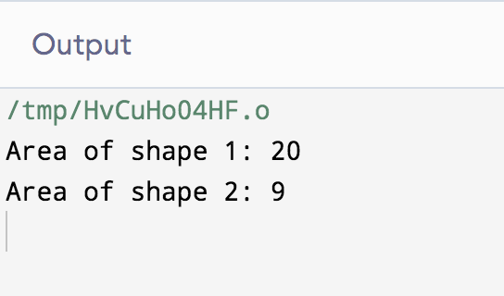

**Conclusion:** Thus we have implemented the concept of run time polymorphism in C++.

**Practice programs:** Consider a book shop which sells both books and video tapes. Create a class media that stores the title and price of a publication. Derive two classes from media, one for storing the number of pages in a book and another for storing playing time of a tape. Write a C++ program using run time polymorphism to implement it.