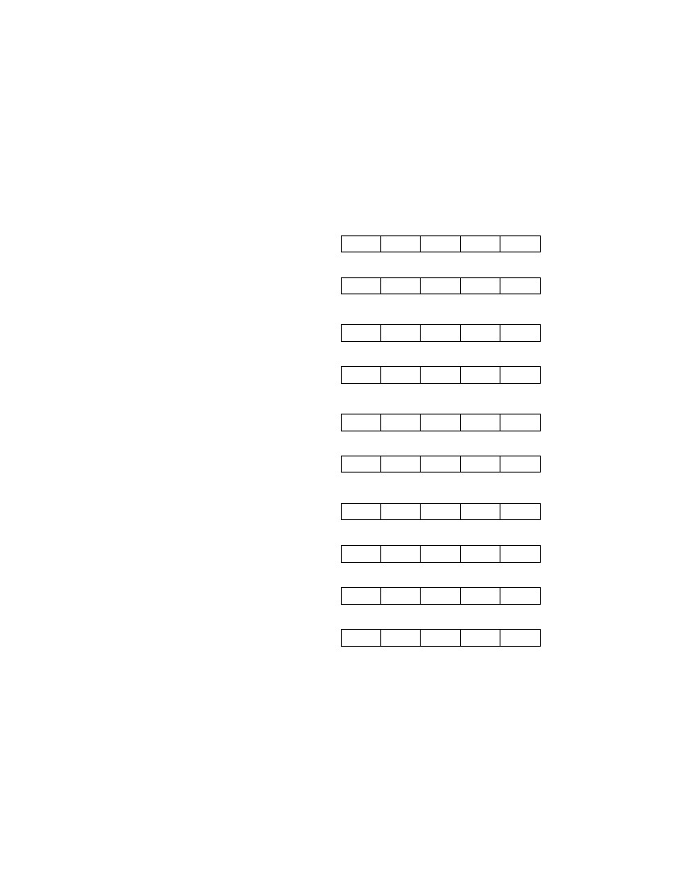
System Usability Scale
© Digital Equipment Corporation, 1986.
Strongly
disagree
1. I think that I would like to
use this system frequently
2. I found the system unnecessarily
complex
1
2
3
4
Strongly
agree
1
2
3
4
5
5
3. I thought the system was easy
to use
1
2
3
4
5
4. I think that I would need the
support of a technical person to
be able to use this system
5. I found the various functions in
this system were well integrated
1
2
3
4
5
1
2
3
4
5
6. I thought there was too much
inconsistency in this system
1
2
3
4
5
7. I would imagine that most people
would learn to use this system
very quickly
8. I found the system very
cumbersome to use
1
2
3
4
5
1
2
3
4
5
9. I felt very confident using the
system
1
2
3
4
5
10. I needed to learn a lot of
things before I could get going
with this system
1
2
3
4
5

