Essay Questions
- Please answer the following essay questions carefully and honestly (250 words maximum per question).
Please discuss why you have decided to apply to the MFE at this time and what career path you intend to pursue post MFE.

- If you have ever been placed on academic probation, been dismissed from a school, or received a failing grade (including non-graded courses for which you received an assessment of unsatisfactory or "not pass"), please explain. If not applicable, put N/A.

Supplemental Information
These questions address additional aspects of your application and should be answered as succinctly as possible (250 words maximum per question).(以下essay不强制提交）
What do you view as a particular strength of yours? What do you view as a particular weakness?

Do you feel that your academic record is an accurate reflection of your ability and potential? In comparison to your college friends and classmates, do you feel that you were particularly advantaged or disadvantaged? Please explain.

Provide an account of any gaps in your employment since your undergraduate degree.

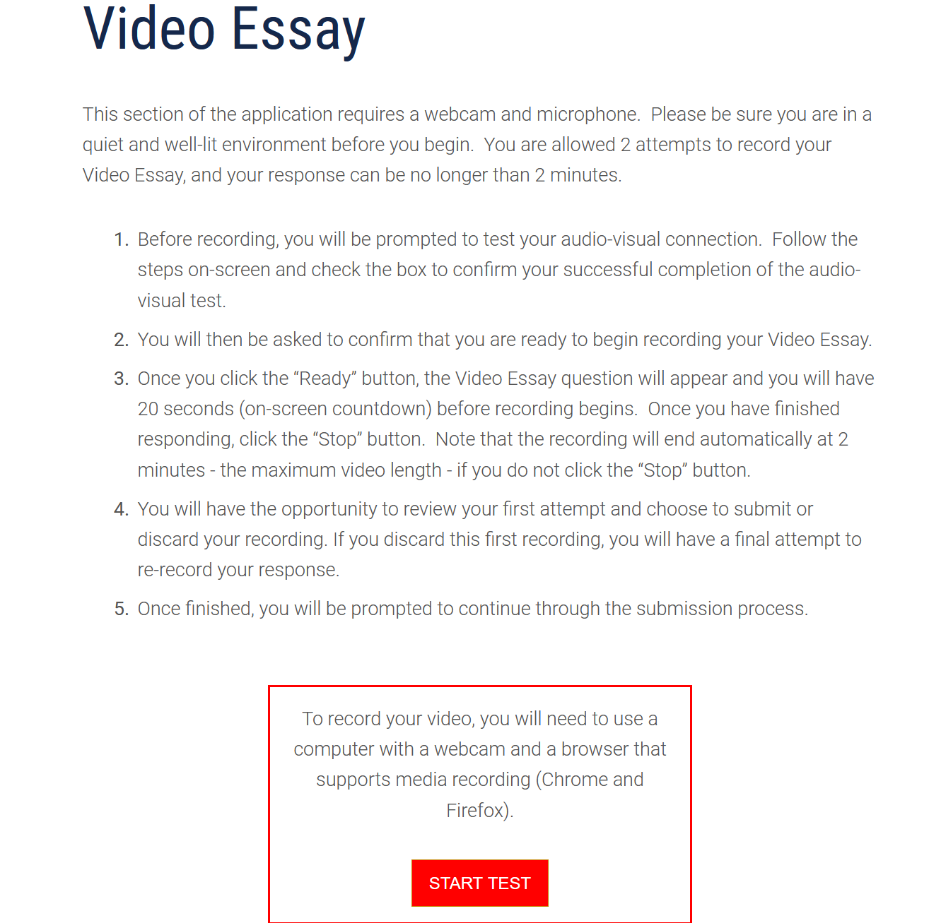
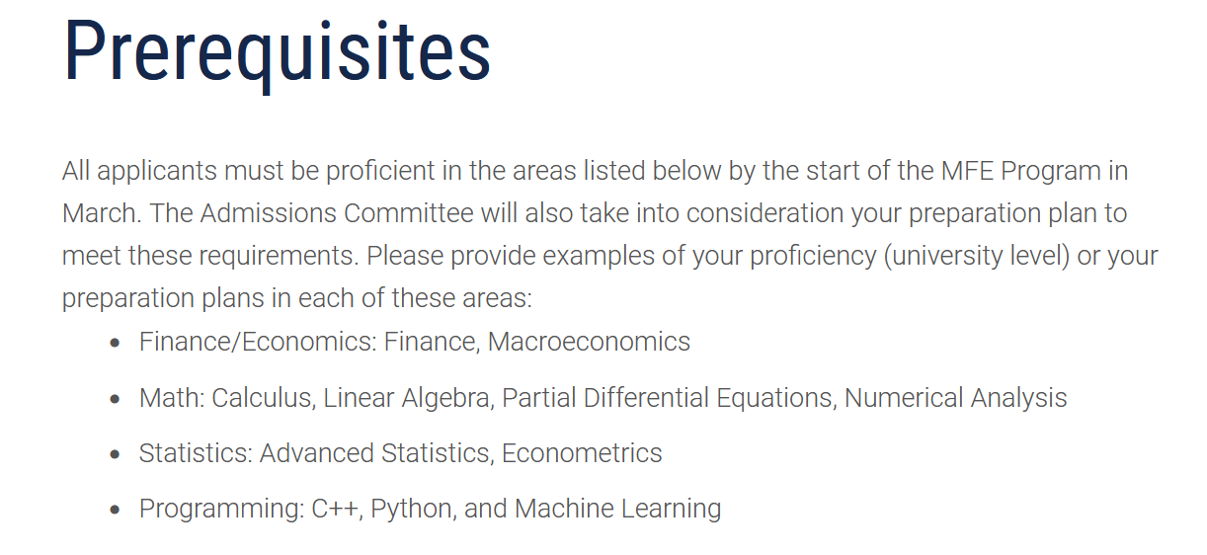
先修课程填入表格

网申系统的employment添加工作及实习经验的详细内容

