Essay Questions
- Please answer the following essay questions carefully and honestly (250 words maximum per question).
Please discuss why you have decided to apply to the MFE at this time and what career path you intend to pursue post MFE.
Ans:
I want to change path from Actuarial Science to Financial Engineering after undergraduate because I was impressed by a course called “Financial Principals for Actuarial Science” at university. Within five years after graduation, I want to be a quantitative analyst in Investment Bank. In the long term, I plan to work for hedge fund.

My passion for Financial Engineering stemmed from a summer course, “Financial Principles” which has exploited my knowledge of portfolio management, enhanced my execution ability, and further assured my confidence in digging into this field.

I am proud of the challenging portfolio management assignment I complete in this course, for which I got 93/100, showcasing my superior financial risk analytical skills, decision-making, and critical thinking ability. The project aims to manage risks for ten companies by mimicking real-world trading in financial derivatives. It was tricky to start because it was my first time working as a “risk manager” for companies. Following the pricing techniques in textbooks (i.e., beta pricing, CAPM, Black-Scholes, etc.) and their annual financial reports, I made hedge arrangements for companies that profit from downstream products, such as Tiffany. Regarding companies that live upon arbitrage opportunities, I speculated on the products of material supplier companies such as mining companies. The course professor acknowledged my analysis as a valid, rigorous, and insightful report.

After fulfilling my responsibilities as an “employee,” out of curiosity, I continued to work as a “trader” who has $200 million in a real-time trading platform called RPM (Rotman Portfolio Manager). To gain profit from the stock market, I first investigated the stock price trend for underlying assets (i.e., commodities, exchange rates, gold ETF, etc.) within one year, based on which I created portfolios containing call/put options, spreads, combinations, and futures. Then, I executed the designed strategies using the NASDAQ ticker symbol in my RPM account but ended up with a mediocre portfolio that balanced profit and loss. Not satisfied with the outcome, I conducted extensive research on several authoritative finance websites, such as Yahoo Finance. Throughout the investigation, I learned that economics inextricably intersects with politics, breaking news, and ongoing events from all walks of life. Therefore, my portfolio design should not only be based on “numbers” but on “humanity” and diversification. Doing so drastically increased my portfolio value, and the strategies helped me gain $42 million out of $200 million in one month. Due to the rapid increase, I was awarded the title of “Class Best Trader”. The satisfaction of designing portfolio strategies and the sense of accomplishment motivated me to take a further step in financial engineering. With advanced data analysis and coding skills (i.e., Python, R, SAS, etc.) accumulated in undergraduate study, I have confidence in succeeding in my future quantitative analyst journey.

The best next step for me is to complete the MSFE program at Columbia University. I look forward to unleashing my knowledge of financial investment methods to keep abreast of the latest developments in this field as a quantitative analyst in the long run, while as a trader in sell-side firms within five years after graduation. Wherever I end up working, whether it be a hedge fund or investment bank, I intend to integrate investment strategies into my practice. I am excited to have the chance to participate in financial engineering research with brilliant faculty members. For example, Dr. Derman concluded from a qualitative study that given a market term structure and resulting tree of short rates, the one-factor model can be used to value a bond option. This robust result shows that the possible values before expiration can be found by the same discounting procedure used to value the bond given the values of a call or put at expiration. I feel honored to work with such professors and contribute to the internship with CMC’s (Career Management Center) assistant.

Overall, the MSEF program at Columbia University fits my interests and ambitions very well due to its characteristics of being practical and career-oriented. The rigorous coursework, research opportunities and the career development program at your university will further sharpen my skills and help me reach my full potential. I feel it is a privilege to be a Columbia “lion”, contributing my professional insights, data-analysis knowledge, and conscientious nature to your program to make a difference. Thank you so much for your consideration of my application!

- If you have ever been placed on academic probation, been dismissed from a school, or received a failing grade (including non-graded courses for which you received an assessment of unsatisfactory or "not pass"), please explain. If not applicable, put N/A.
Ans: N/A
Supplemental Information
These questions address additional aspects of your application and should be answered as succinctly as possible (250 words maximum per question).
What do you view as a particular strength of yours? What do you view as a particular weakness?
Ans:
Strength: Ambitious (able to learn new skills such as C++, machine learning)
Weakness:
In my junior year, due to an interest in machine learning, I joined a research team to explore the relationship between heterogeneity described by a convolutional neural network (CNN) image features and the “between-group heterogeneity” of the dataset measured by population descriptors. The first challenge our team encountered was accessing and describing between-group heterogeneity, which was unfamiliar to us. Reckoning previous statistics courses, I proposed using Cochran’s Q as a metric to measure the deviation of each group’s mean deviation from the grand. The suggestion opened up new horizons for this project, and the data analysis process went smoothly. After that, we used the average pixel intensity of each image as the population descriptor and implemented K-means clustering analysis to record the predicted accuracy of each cluster. The predicted accuracy of the tested model result proved that Cochran’s Q was a solid measure in quantifying the between-group heterogeneity. The positive project results manifested my research capabilities and placed my analytical thinking and problem-solving skills to the test.

Do you feel that your academic record is an accurate reflection of your ability and potential? In comparison to your college friends and classmates, do you feel that you were particularly advantaged or disadvantaged? Please explain.
Ans:
Internship
The invaluable internship opportunities with The Wawanesa Mutual Insurance Company and Intact Financial Corporation in 2022 honed my data analysis-related skills learned from class, further expanded my mastery of Visual Basic for Applications (VBA), SAS, SQL, and prepared me for the challenging actuarial internship with Munich Reinsurance Company of Canada. On the one hand, it was arduous because I was recruited to the Reserving - IFRS 17 team, a hard-core, specialized team, and took charge of handling big data. The traditional software or method to deal with big data in our team was Excel which was time-consuming. To improve efficiency, I suggested using R to sum the loss of a particular granularity and Power BI to further visualize results. On the other hand, it was rewarding because the new “bundle” saved 80% of our time and was indeed a life-saver for our team. My enhanced ability in data science, teamwork, communication, and time management further assures my potential to succeed in your Financial Engineering program.

Provide an account of any gaps in your employment since your undergraduate degree.
Ans: n/a

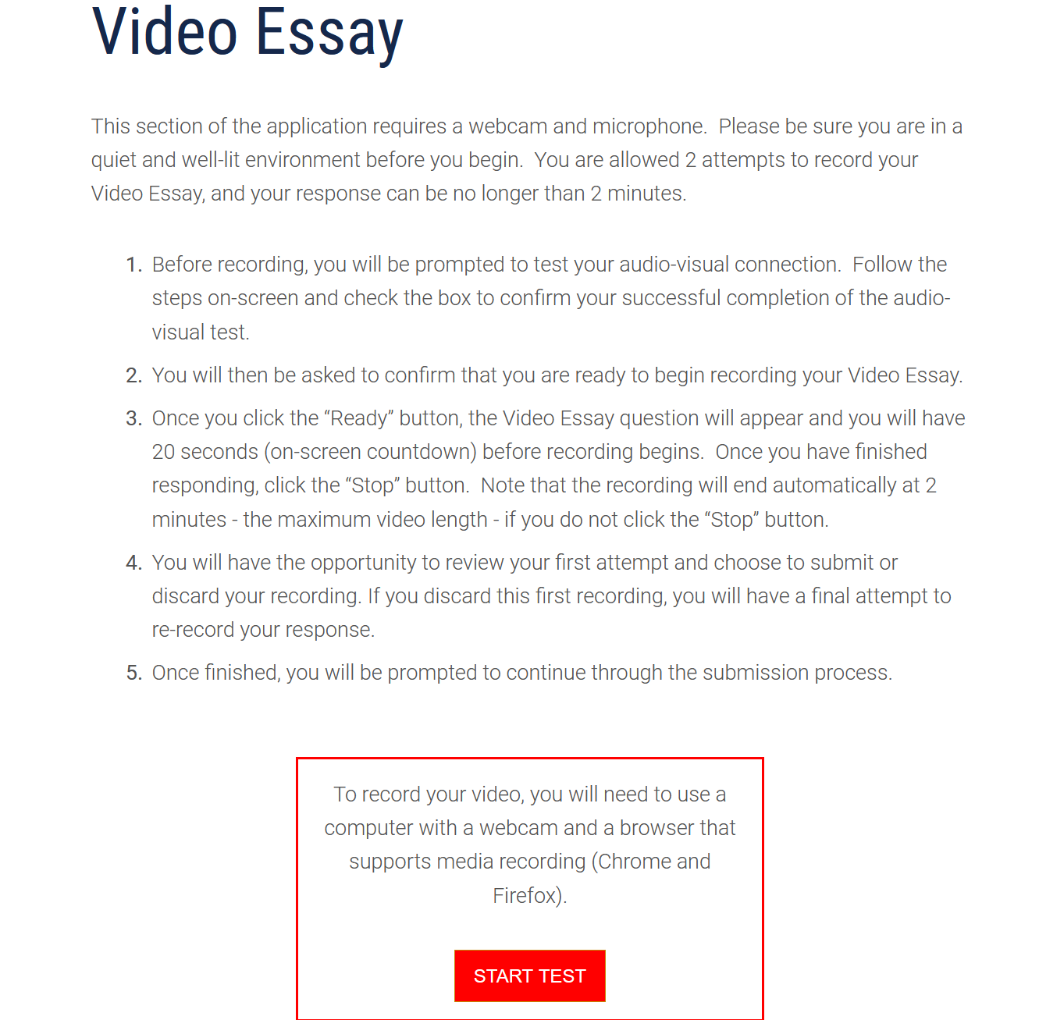
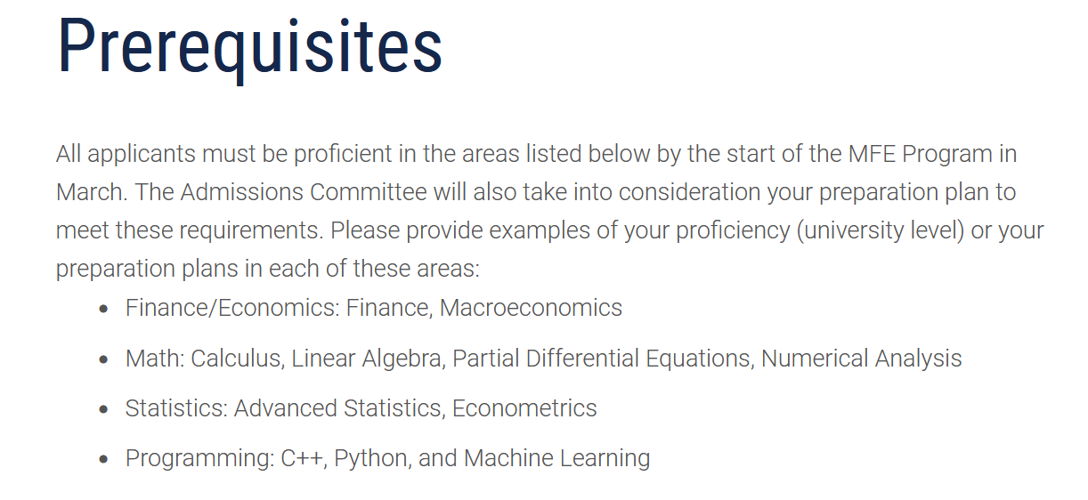
先修课程填入表格

网申系统的employment添加工作及实习经验的详细内容

