**Program**

#include<stdio.h>

#include<stdlib.h>

struct stack

{

int data;

struct stack *next;

};

typedef struct stack node;

void push();

void pop();

void peek();

void display();

node *newnode;

node *ptr;

node *top;

int main()

{

int ch;

do

{

printf("\n********MENU*********\n");

printf("1.Push\n2.Pop\n3.Peek\n4.Display\n5.Exit\n");

printf("Enter the choice:");

scanf("%d",&ch);

switch(ch)

{

case 1:push();

break;

case 2:pop();

break;

case 3:peek();

break;

case 4:display();

break;

case 5:printf("Exit\n");

break;

default:

printf("Wrong choice\n");

}

}while(ch!=5);

return 0;

}

void push()

{

int value;

newnode=(node*)malloc(sizeof(node));

if(newnode==NULL)

{

printf("Element cannot be inserted.");

}

printf("\n Enter the value:");

scanf("%d",&value);

newnode->data=value;

newnode->next=NULL;

if(top==NULL)

top=newnode;

else

{

newnode->next=top;

top=newnode;

}

printf("Element successfully inserted.");

}

void pop()

{

int del_elem;

if(top==NULL)

{

printf("\n Stack Underflow");

}

else

{

del_elem=top->data;

ptr=top;

top=top->next;

free(ptr);

}

printf("\nDeleted element is :%d",del_elem);

}

void peek()

{

if(top==NULL)

printf("\n Stack is empty");

else

printf("\n Element in the top of the stack is:%d",top->data);

}

void display()

{

ptr=top;

if(ptr==NULL)

printf("\n Stack is empty");

else

{

printf("\n Stack elements are:");

while(ptr!=NULL)

{

printf("%d \t",ptr->data);

ptr=ptr->next;

}

}

}

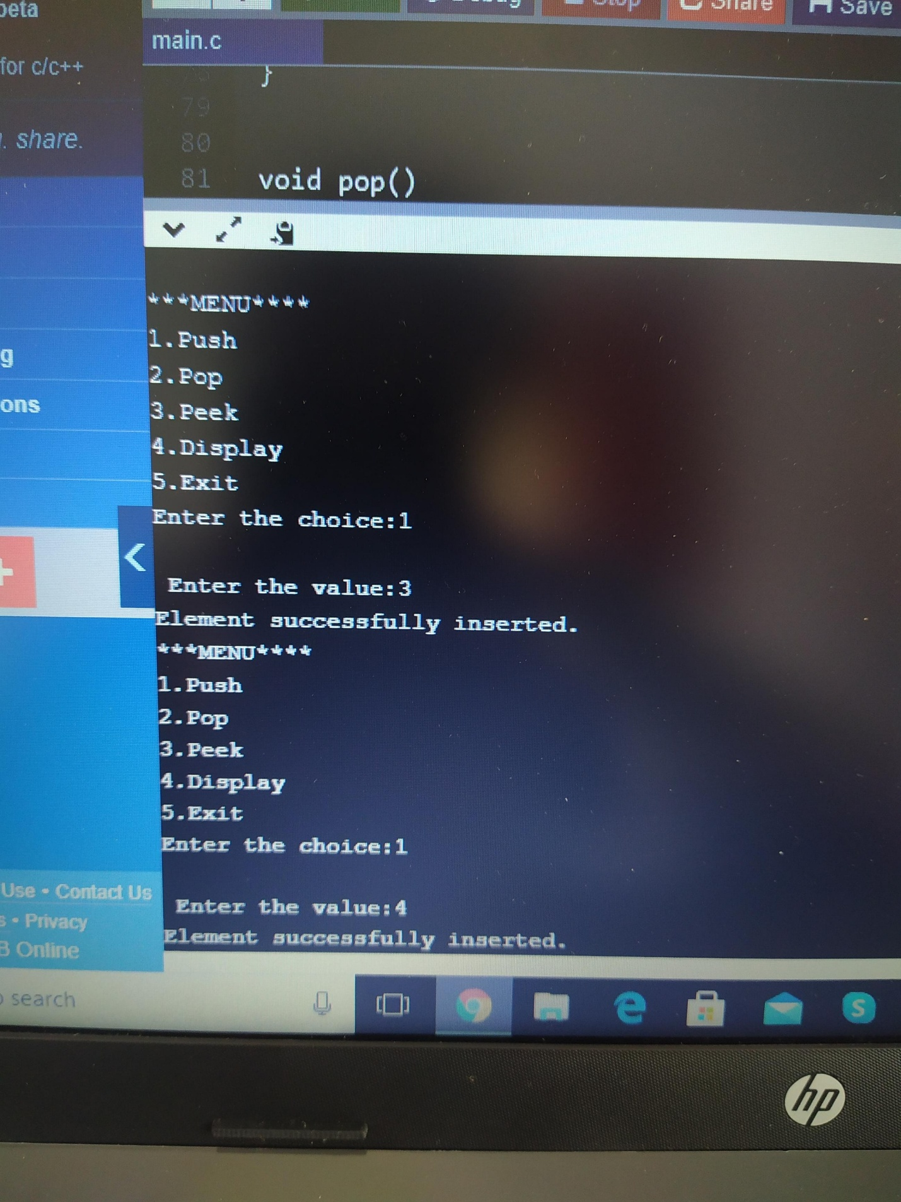**Output**

