


Mobile PROJECT REPORT
Poster Filter — Snap Poster AI Platform
An AI-Powered Image Quantization & Artistic Poster Generation System

Presented By | Shimaa Samir Ahmed Ebrahim  Shorouk Mostafa Mohamed Hassan  Manar Ahmed Ahmed Hashad  Maryam Ahmed Ahmed Hashad  Nada Mohamed Rashid Saad
Department | [Faculty of Engineering — Computer & Systems Engineering]
Supervisor | [Dr. Rania ]
Academic Year | 2025 / 2026

Table of Contents
Chapter 1: Introduction 3
1.1 Project Overview 3
Chapter 2: Proposed Idea & Technologies Used 3
2.1 The Proposed Idea 3
Core Concept 3
The Technology 3
Target Solution 3
2.2 Technologies Used 4
Chapter 3: UX Phase — Research 4
3.1 UX Research Overview 4
3.2 Survey Insights 4
Survey Links 4
Executive Summary 4
Survey Charts 4
Gains and Pain Points 6
Pain Points (Challenges) 6
Gains (Desired Benefits) 6
Final Conclusions 6
Chapter 4: Empathy Map 7
Chapter 5: User Persona 8
Chapter 6: Define a Problem 9
6.1 Pain Points 9
6.2 5Ws and H Analysis 10
6.3 Problem Statements 11
11
Chapter 7: Goal Statement 12
8.1 Proposed Solutions 14
Solution A — Mobile Quick-Filter App 14
Solution B — AI-Powered Web Platform 14
Solution C — Manual Editing Plugin 14
8.2 Selected Solution 14
8.3 Project Brief & Features 14
Problem Statement 14
Selected Solution 14
8.4 Proposed Features 14
8.5 Application Flow 15
Chapter 9: Design Identity 16
9.1 Color Palette 16
9.2 Typography 17
9.3 Buttons & Interactive Elements 18
9.4 Shadows & Elevation 19
Chapter 10: Wireframes 20
10.1 Low-Fidelity Wireframes 20
10.2 High-Fidelity Wireframe(Whimsical) 21
Chapter 11: UI Design 22
11.1 Sign In & Registration Screens 22
11.2 Main Dashboard Screen 23
11.3 Additional UI Screens 24
Chapter 13: Conclusion 25

Chapter 1: Introduction

1.1 Project Overview
Poster Filter, branded as the Snap Poster AI Platform, is a graduation project developed by a team of five software engineering and UI/UX design students. The project addresses a critical gap in the digital creative tools market: the space between simple social media filters and complex professional software like Adobe Photoshop.
The platform leverages advanced Image Quantization algorithms powered by Computer Vision techniques to automatically transform standard photographs into high-quality, minimalist artistic posters. The application is built using a modern full-stack architecture comprising React Native for the frontend, Flask (Python) for the backend API, SQLite for data persistence, and Computer Vision libraries for image processing.

Chapter 2: Proposed Idea & Technologies Used

2.1 The Proposed Idea
The core concept of the project is an AI-powered platform that automatically transforms standard photos into high-quality artistic posters. The three pillars of the proposed idea are:

Core Concept
An AI-powered platform that automatically transforms standard photos into high-quality artistic posters.

The Technology
Utilizes advanced Image Quantization algorithms to simplify visual structures into minimalist art forms. Image quantization reduces the number of distinct colors in an image, producing a poster-like, painterly aesthetic that is both visually striking and computationally deterministic.

Target Solution
Bridges the gap between "boring" traditional filters and complex design software like Photoshop. The platform is targeted at beginners and casual creators who desire high-art results without the high-effort learning curve typically associated with professional tools.

2.2 Technologies Used
The Snap Poster platform is built on a modern, full-stack technology architecture:
- React Native — Cross-platform mobile and web frontend framework
- Flask (Python) — Lightweight backend API and server-side image processing
- SQLite Database — Embedded relational database for user data and session storage
- Computer Vision — Core image quantization and processing engine

Chapter 3: UX Phase — Research

The UX Phase encompasses three primary stages: Research, Define a Problem, and Ideate a Solution. This chapter covers the Research stage in detail, including the survey methodology, insights derived, the empathy map, and the user persona developed from field research.

3.1 UX Research Overview
The UX Research phase for Snap Poster involved three primary research activities:
- Survey Insights — A structured questionnaire distributed to target users
- Empathy Map — A qualitative synthesis of user thoughts, feelings, behaviors, and motivations
- Persona — A representative user archetype constructed from research data
- Design Identity — Derived from user preferences and branding strategy

3.2 Survey Insights

Survey Links
Survey Form: https://docs.google.com/forms/d/e/1FAIpQLScy4TtKlf5hWDMWi-jWj3JbVJ1Jy6pFJ5LrMS3Lwia8Vd30pA/viewform?usp=publish-editor
Results Spreadsheet: https://docs.google.com/spreadsheets/d/1jgsgnjbn5mucELC4P68r8EZc2PmmVfS7212LyHeadOk/edit?resourcekey=&gid=712504842#gid=712504842

Executive Summary
The survey was conducted among 23 participants to evaluate the market need and feature preferences for an AI-driven poster creation tool. The results indicate a strong demand for a solution that simplifies complex design processes, with a particular preference for a web-based platform.

Survey Charts
The following charts present the quantitative results of the user survey across key questions:
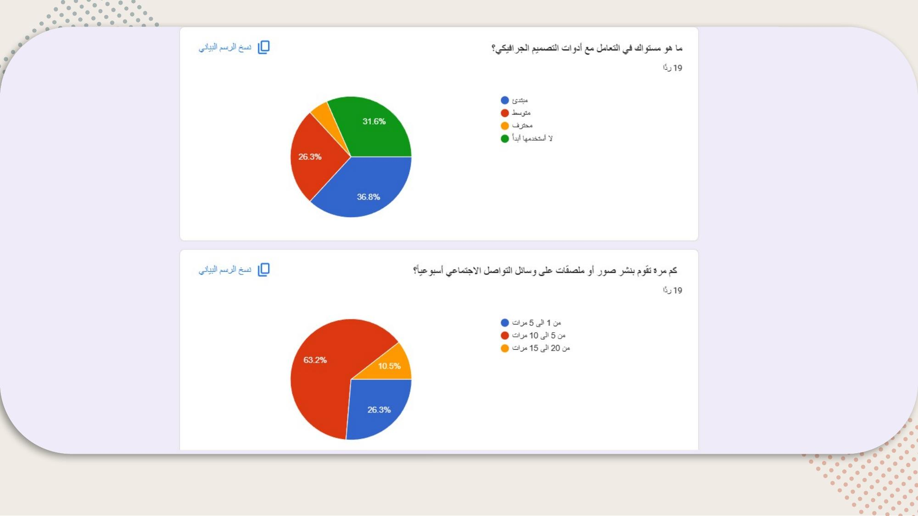
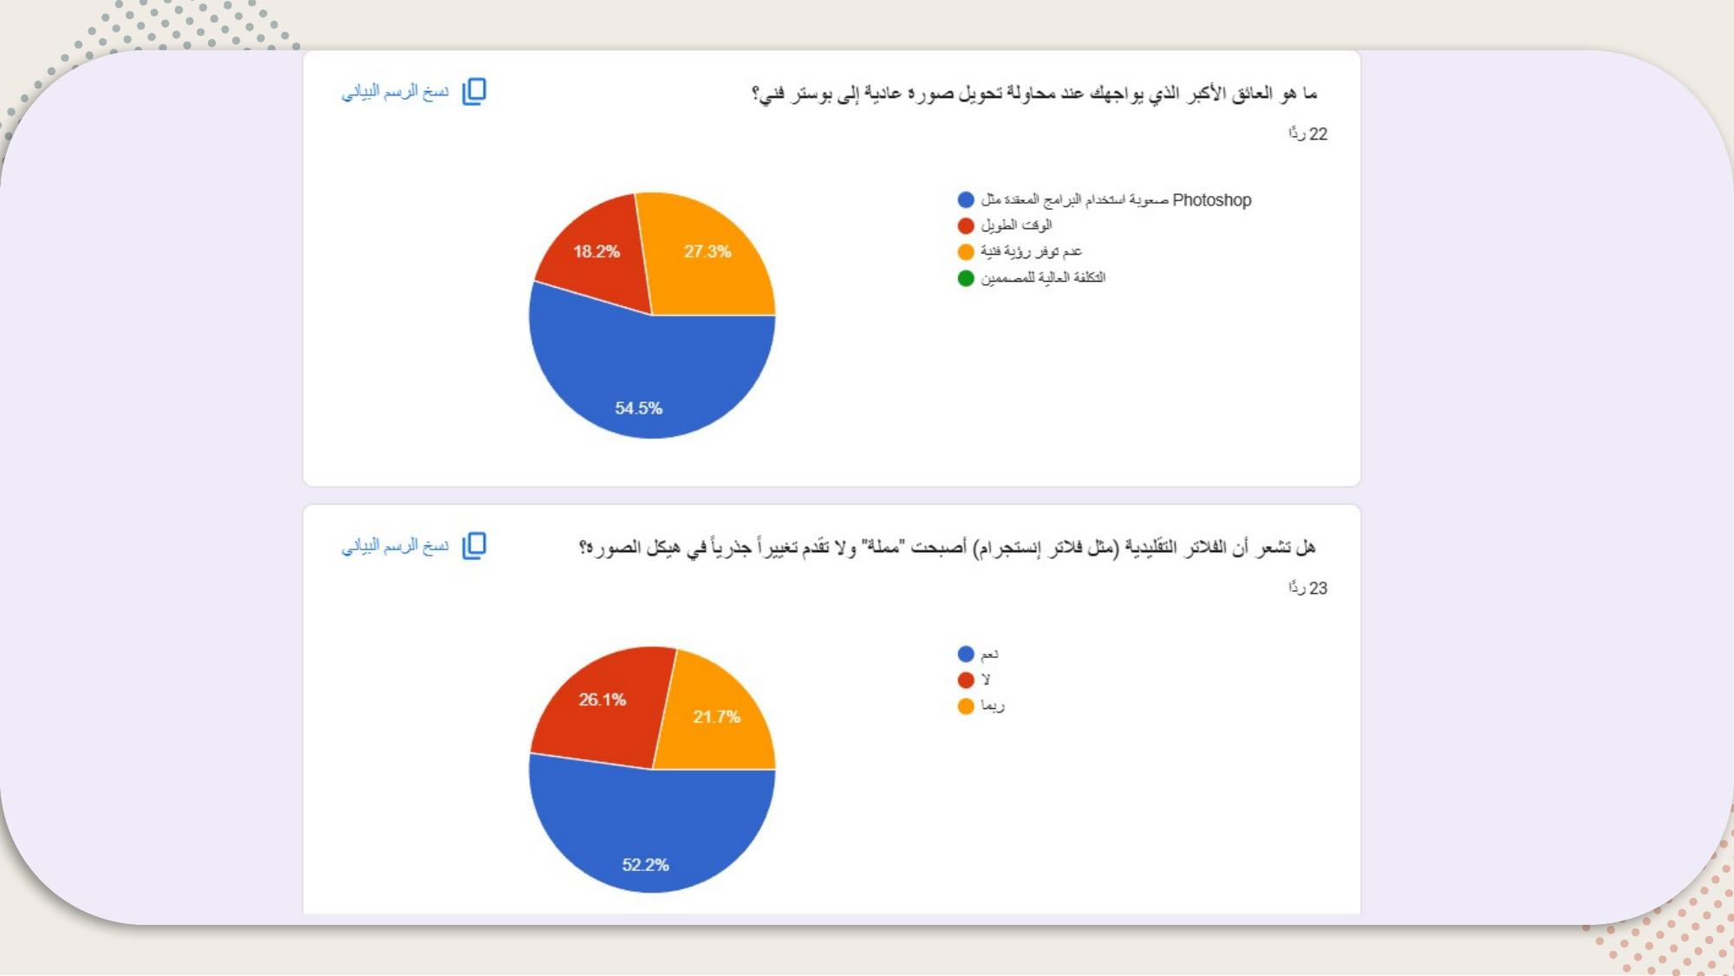
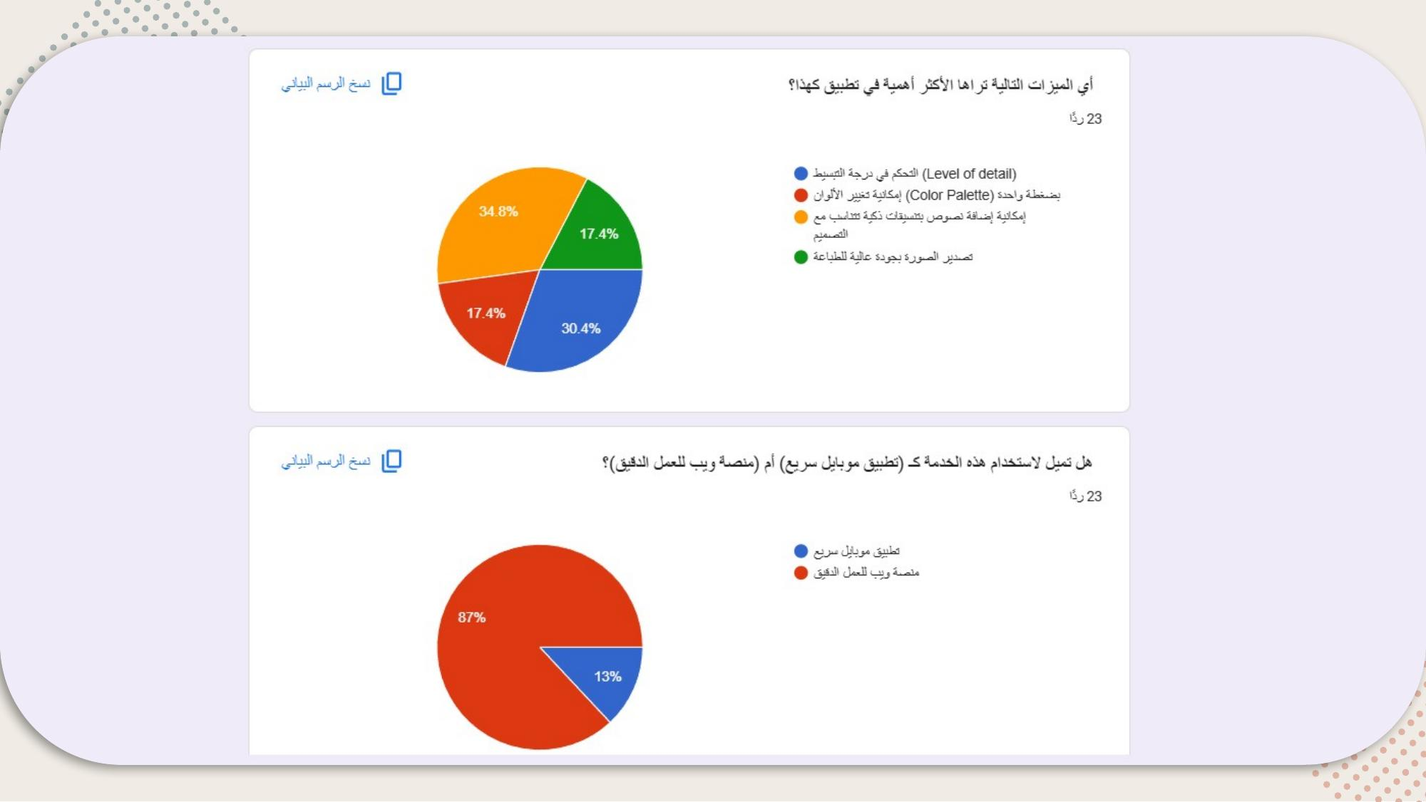

Gains and Pain Points

Pain Points (Challenges)
- Complexity: Users struggle with professional tools like Photoshop.
- Lack of Vision: Users don't always know how to make a photo "look artistic".
- Boredom: Traditional filters no longer satisfy the need for unique content.

Gains (Desired Benefits)
- Simplicity: Automated AI transformation to bypass technical learning curves.
- Artistic Guidance: Smart text formatting and quantized styles provide an instant "pro" look.
- Structural Change: Advanced AI quantization offers a fresh, minimalist aesthetic.

Final Conclusions
- Product Market Fit: There is a clear gap between basic social media filters and complex design software. Snap Poster fits perfectly in the middle.
- Primary Target: Beginners and casual creators who need "high-art" results without the "high-effort."
- Key Strategy: Focus development on a Web-based tool first, emphasizing smart text integration and adjustable AI quantization levels.
- Monetization Hint: Since high-quality printing is a valued feature, a "Pro" tier for high-resolution exports would be viable.

Chapter 4: Empathy Map

The empathy map synthesizes qualitative research about the target user — "The Modern AI Photo Editor" (Snap Poster User) — across six dimensions: See, Think & Feel, Hear, Do, Say, and Feel.
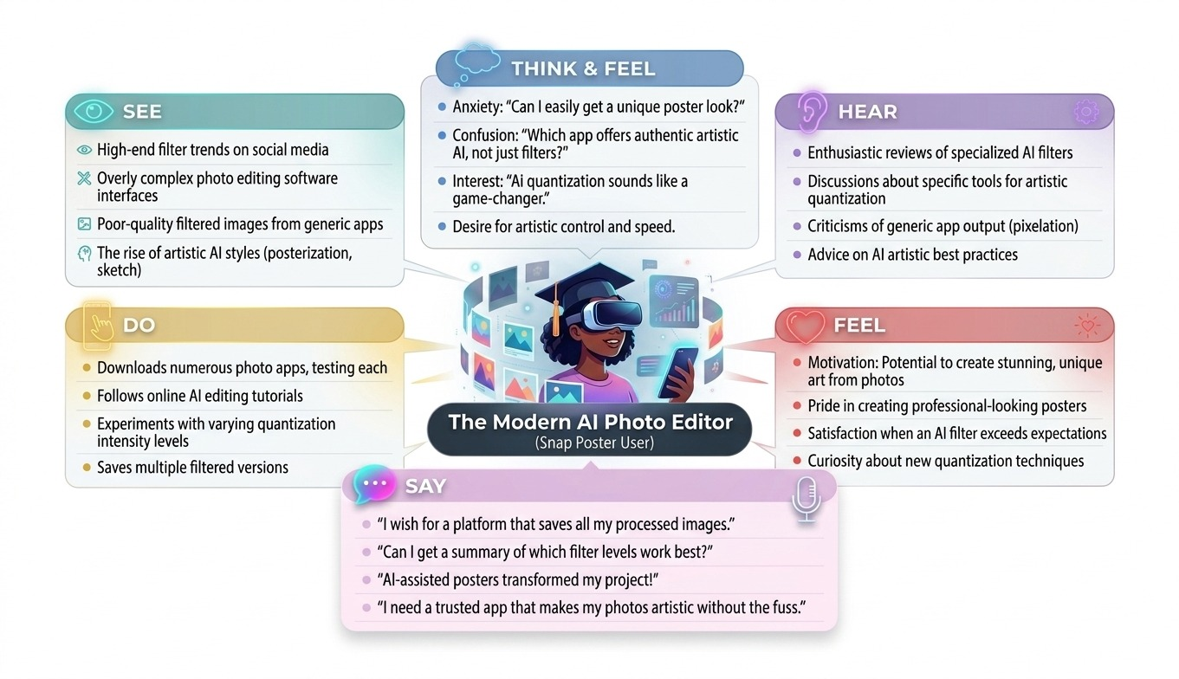

Chapter 5: User Persona

Based on the survey data and empathy mapping exercise, the team developed a representative user persona to guide all subsequent design and development decisions.
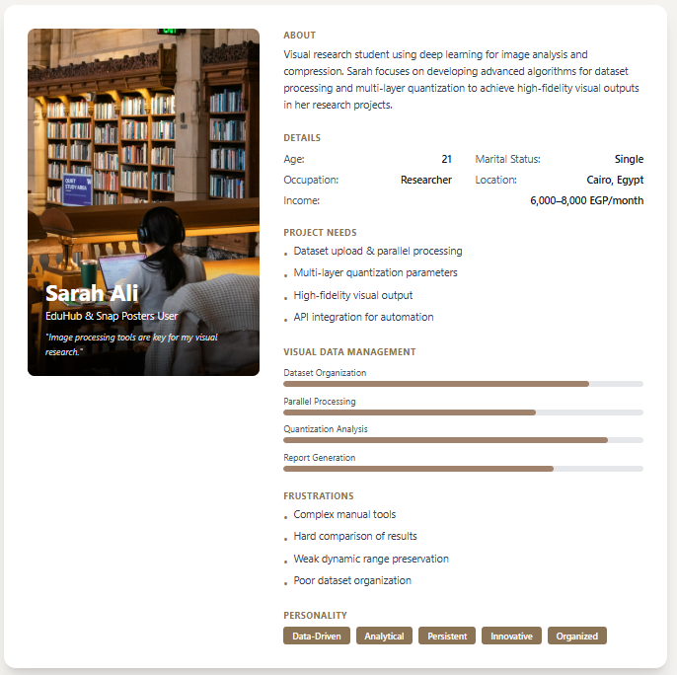

Chapter 6: Define a Problem

6.1 Pain Points
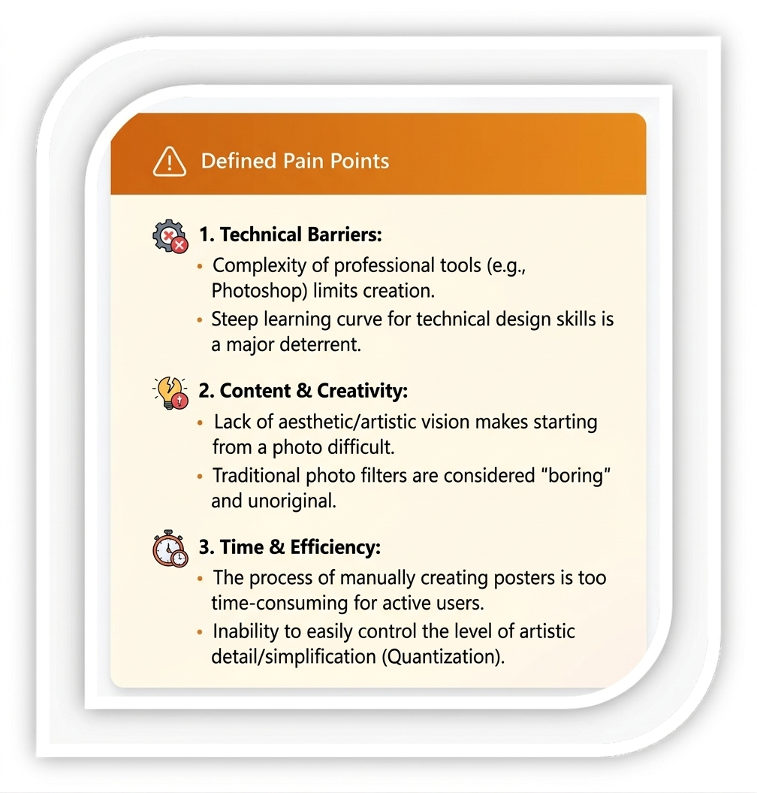

6.2 5Ws and H Analysis
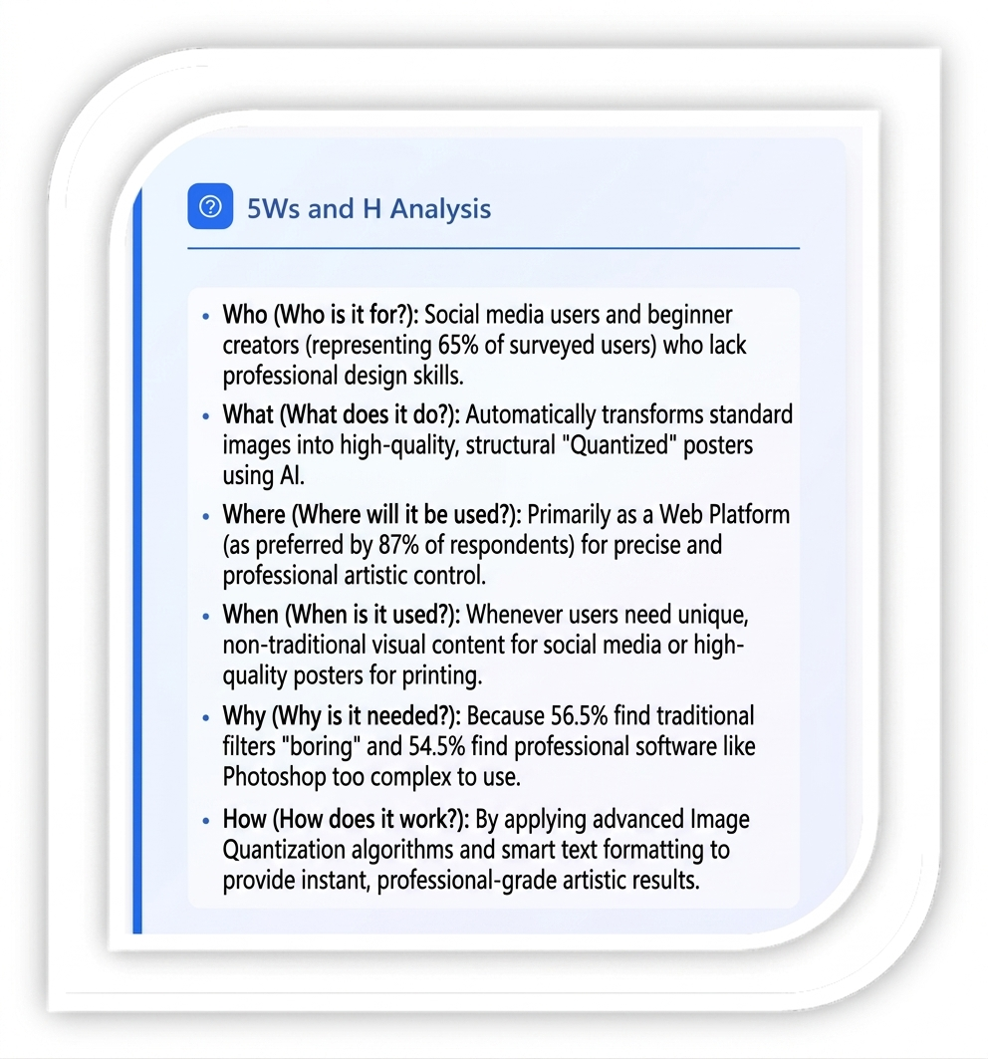

6.3 Problem Statements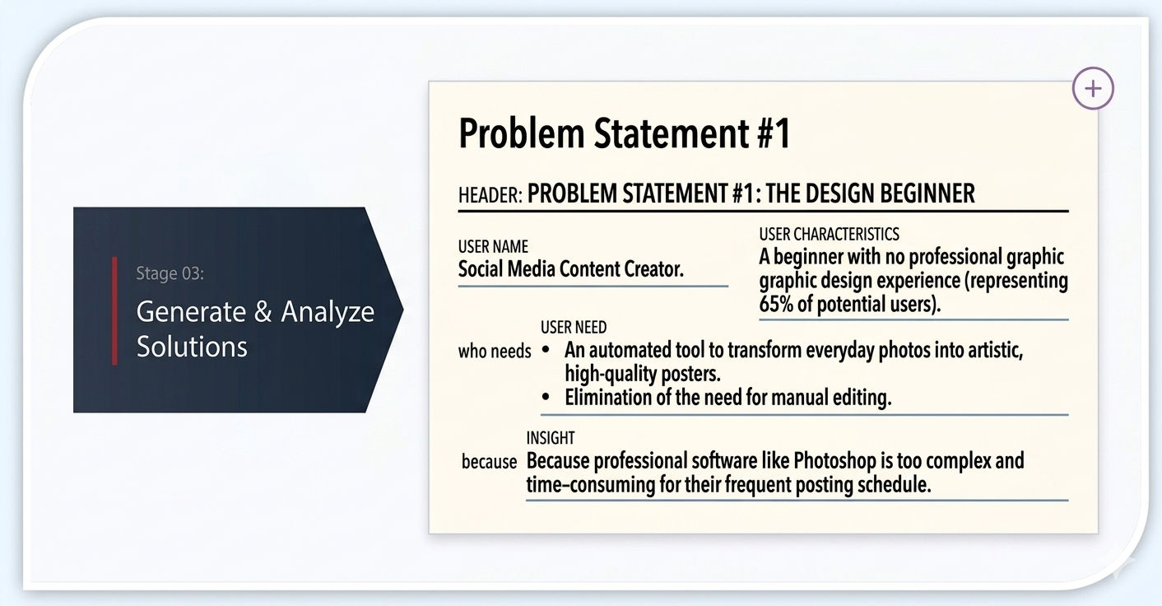

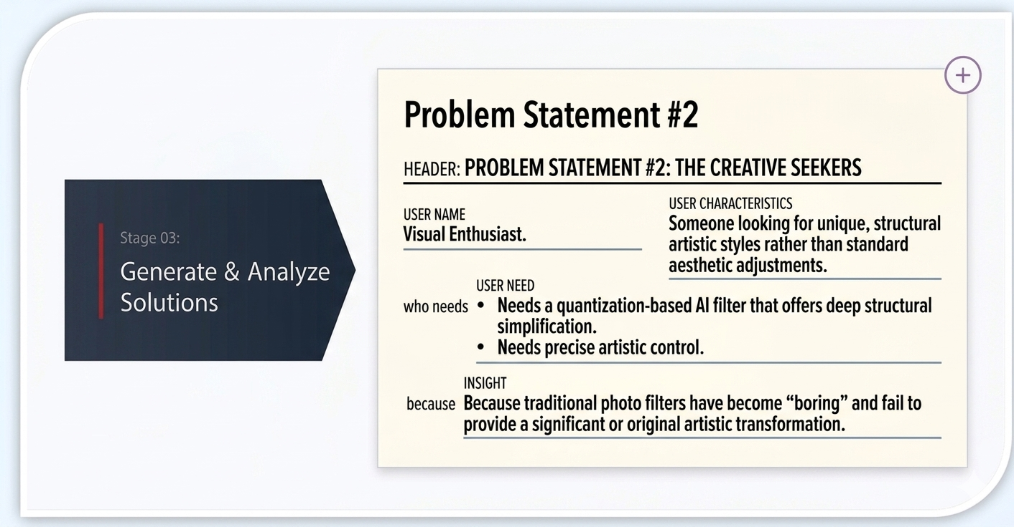
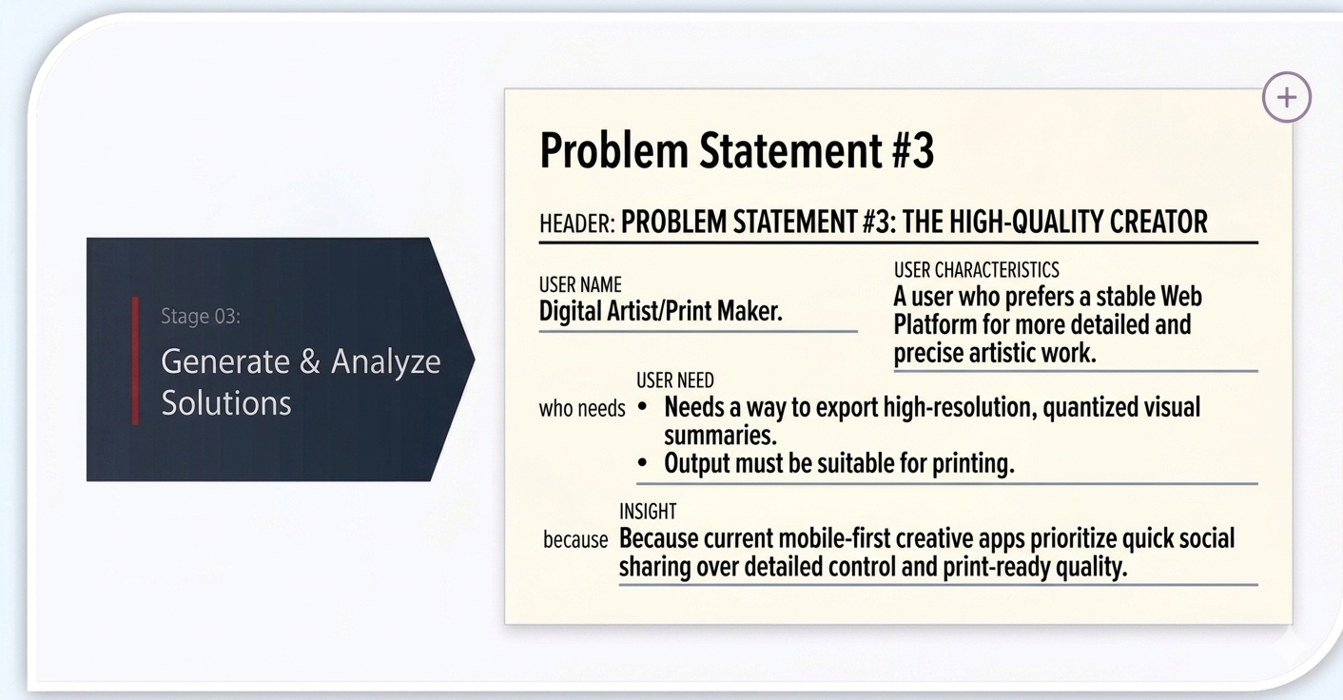

Chapter 7: Goal Statement
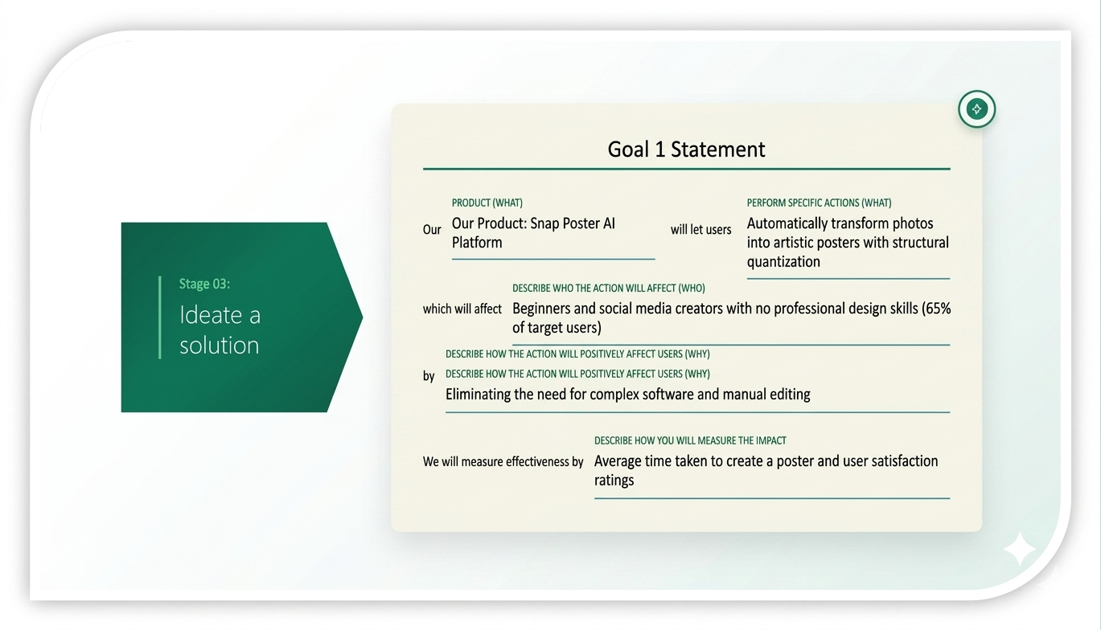
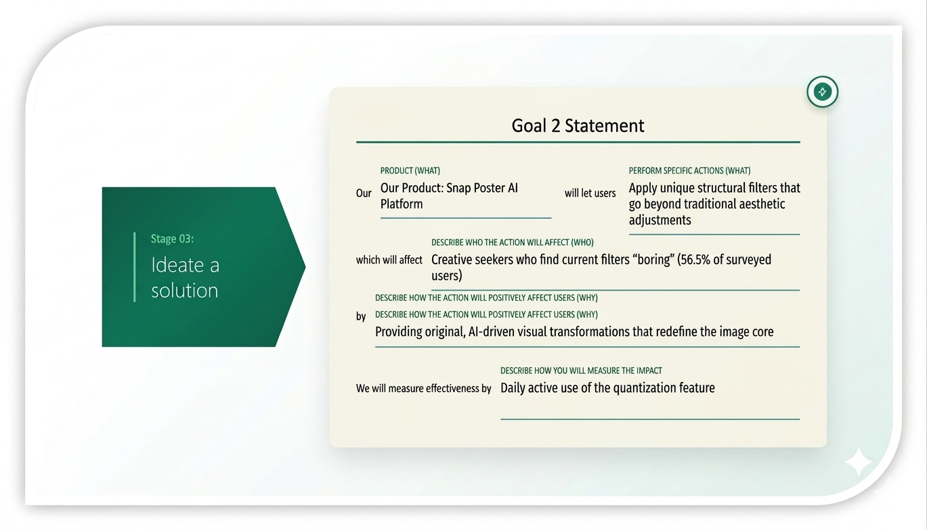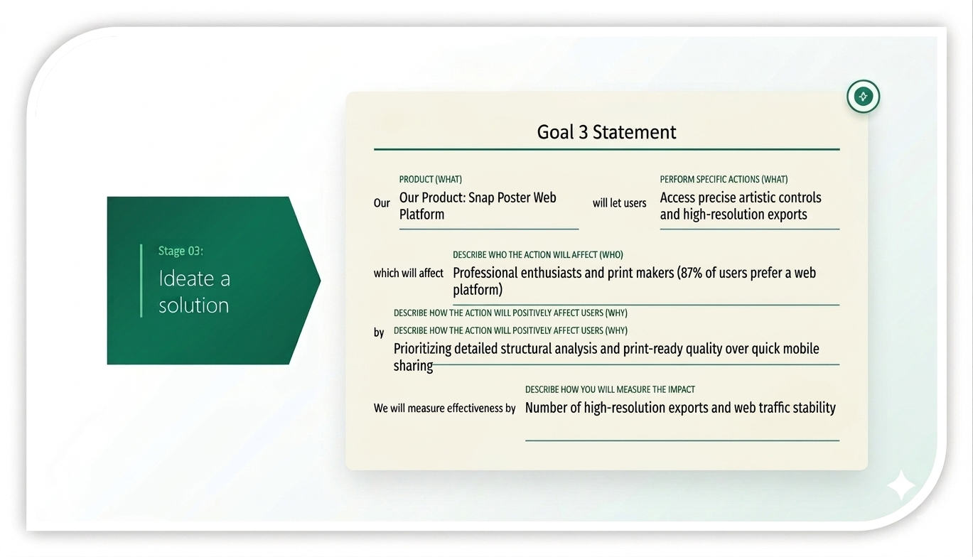
Chapter 8: Proposed Solutions & Project Features

8.1 Proposed Solutions
Three candidate solutions were evaluated during the ideation phase:

Solution A — Mobile Quick-Filter App
Focuses on speed and social media integration but offers limited control. Suitable for casual users who prioritize convenience over artistic depth.

Solution B — AI-Powered Web Platform
Focuses on high-precision structural quantization, smart text integration, and high-quality outputs. This solution provides a browser-based experience accessible across devices without installation.

Solution C — Manual Editing Plugin
Provides tools for professionals but requires high technical skills. Not suitable as a primary solution given the target audience of beginners.

8.2 Selected Solution
Selected Solution: Solution B — AI-Powered Web Platform.
Reason for Selection: This solution directly addresses the primary pain points found in the survey: it caters to the 87% preference for web-based tools and solves the complexity issue for beginners while providing the unique structural change users desire.

8.3 Project Brief & Features

Problem Statement
Design beginners and creative seekers struggle with complex professional software and find traditional photo filters uninspiring, leading to a gap in high-quality, artistic poster creation.

Selected Solution
An AI-driven web application that uses quantization algorithms to simplify image structures into minimalist art automatically.

8.4 Proposed Features
- AI Structural Quantization: Adjustable levels of visual simplification.
- Smart Text Layouts: Automatic artistic typography that complements the design.
- One-Click Color Palettes: Instant color scheme transformations.
- High-Resolution Export: Print-ready formats for physical posters.
- Style Templates: Suggested artistic directions based on AI analysis.

8.5 Application Flow
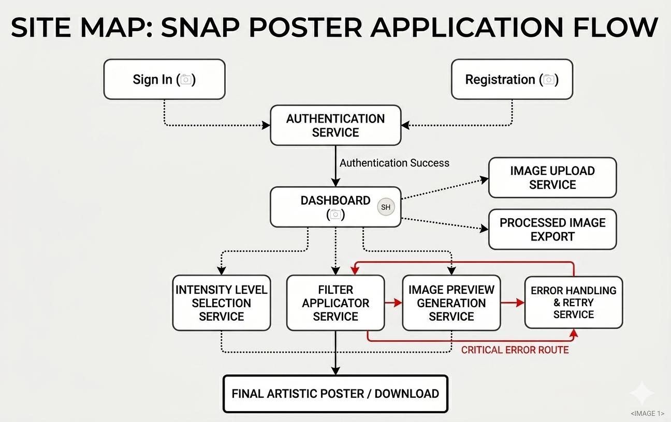
The site map above illustrates the complete Snap Poster application flow, covering Authentication, Dashboard, Image Upload, Filter Application, Preview Generation, and Final Download services.

Chapter 9: Design Identity

9.1 Color Palette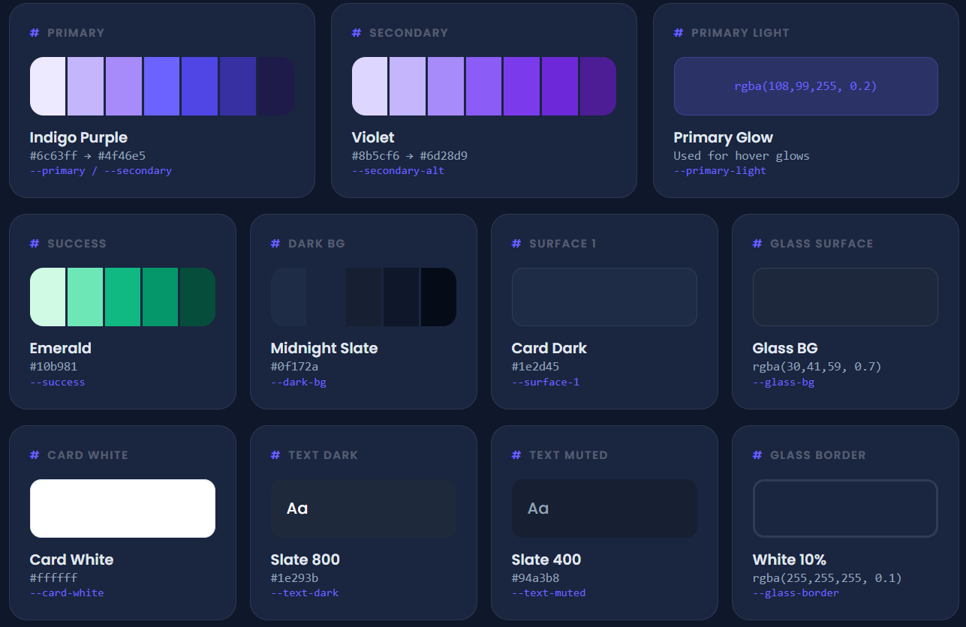

9.2 Typography
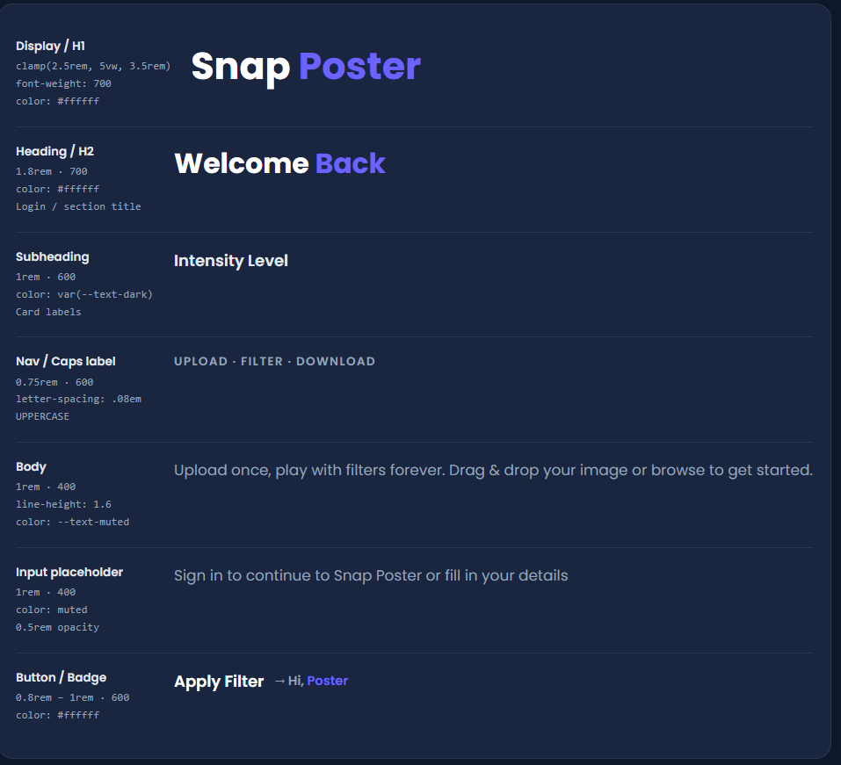

9.3 Buttons & Interactive Elements
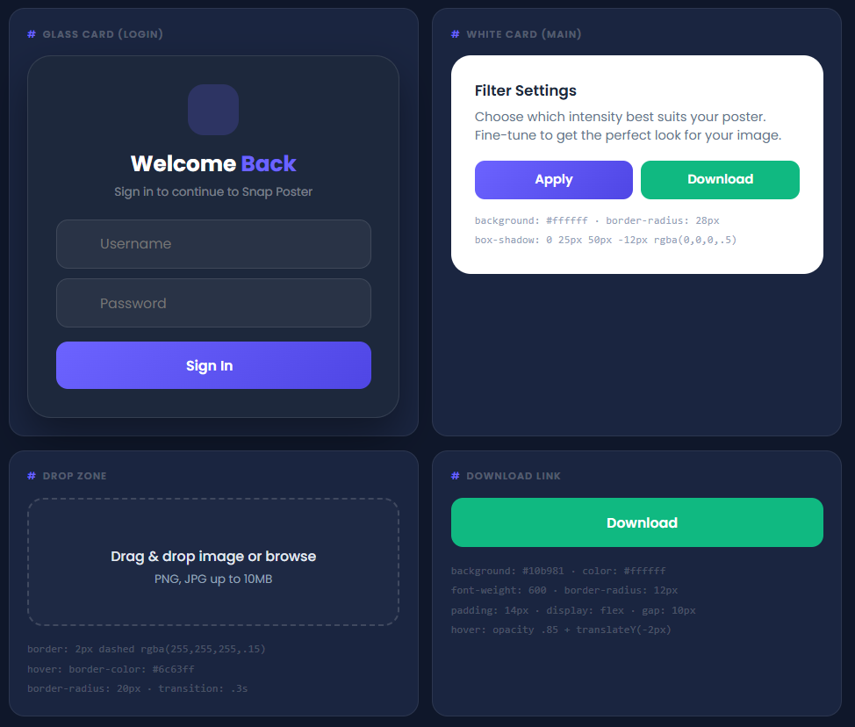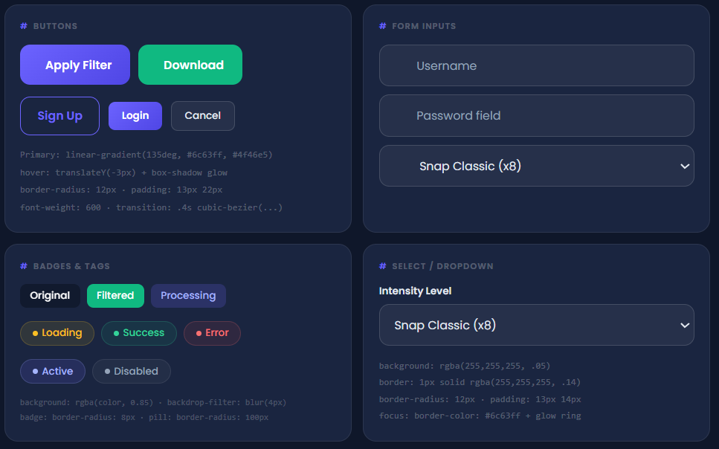

9.4 Shadows & Elevation
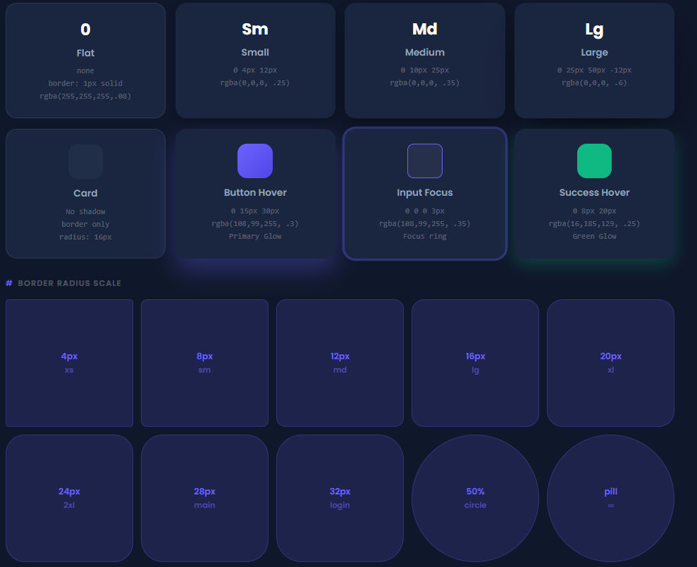

Chapter 10: Wireframes

10.1 Low-Fidelity Wireframes 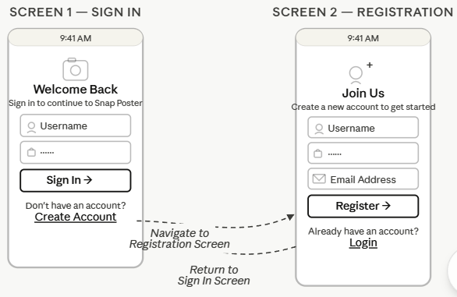
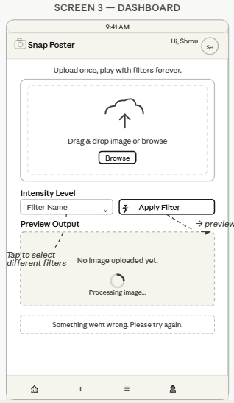

10.2 High-Fidelity Wireframe(Whimsical)
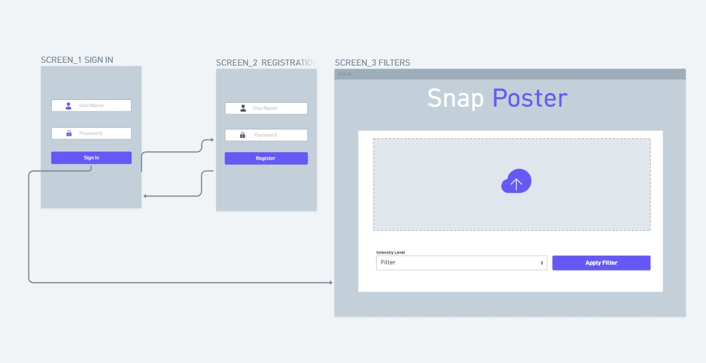
High-Fidelity Wireframe & UI Design (Whimsical): https://whimsical.com/shimaa-samer/VKDkXzXJSxVbzG6jsyjJz4

Chapter 11: UI Design

The User Interface was designed in Whimsical and implements the full Design Identity system defined in Chapter 9. The following screens represent the final high-fidelity UI screens of the Snap Poster application.

11.1 Sign In & Registration Screens
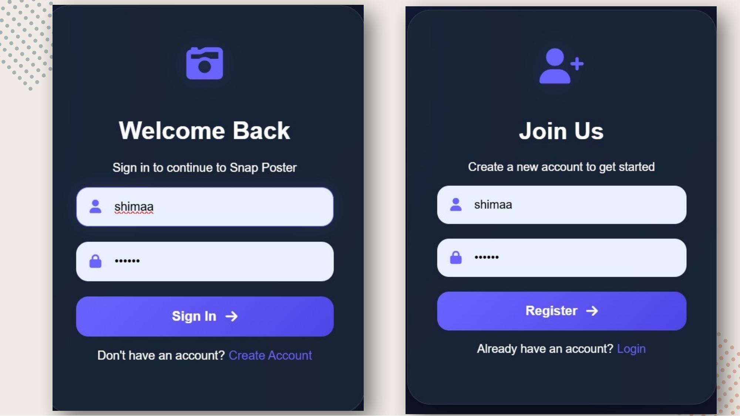
The authentication screens feature the dark Midnight Slate background with the Indigo Purple gradient button system. The Sign In screen presents the "Welcome Back" heading with username and password fields, and a "Create Account" link. The Registration screen mirrors this layout with an additional email field.

11.2 Main Dashboard Screen
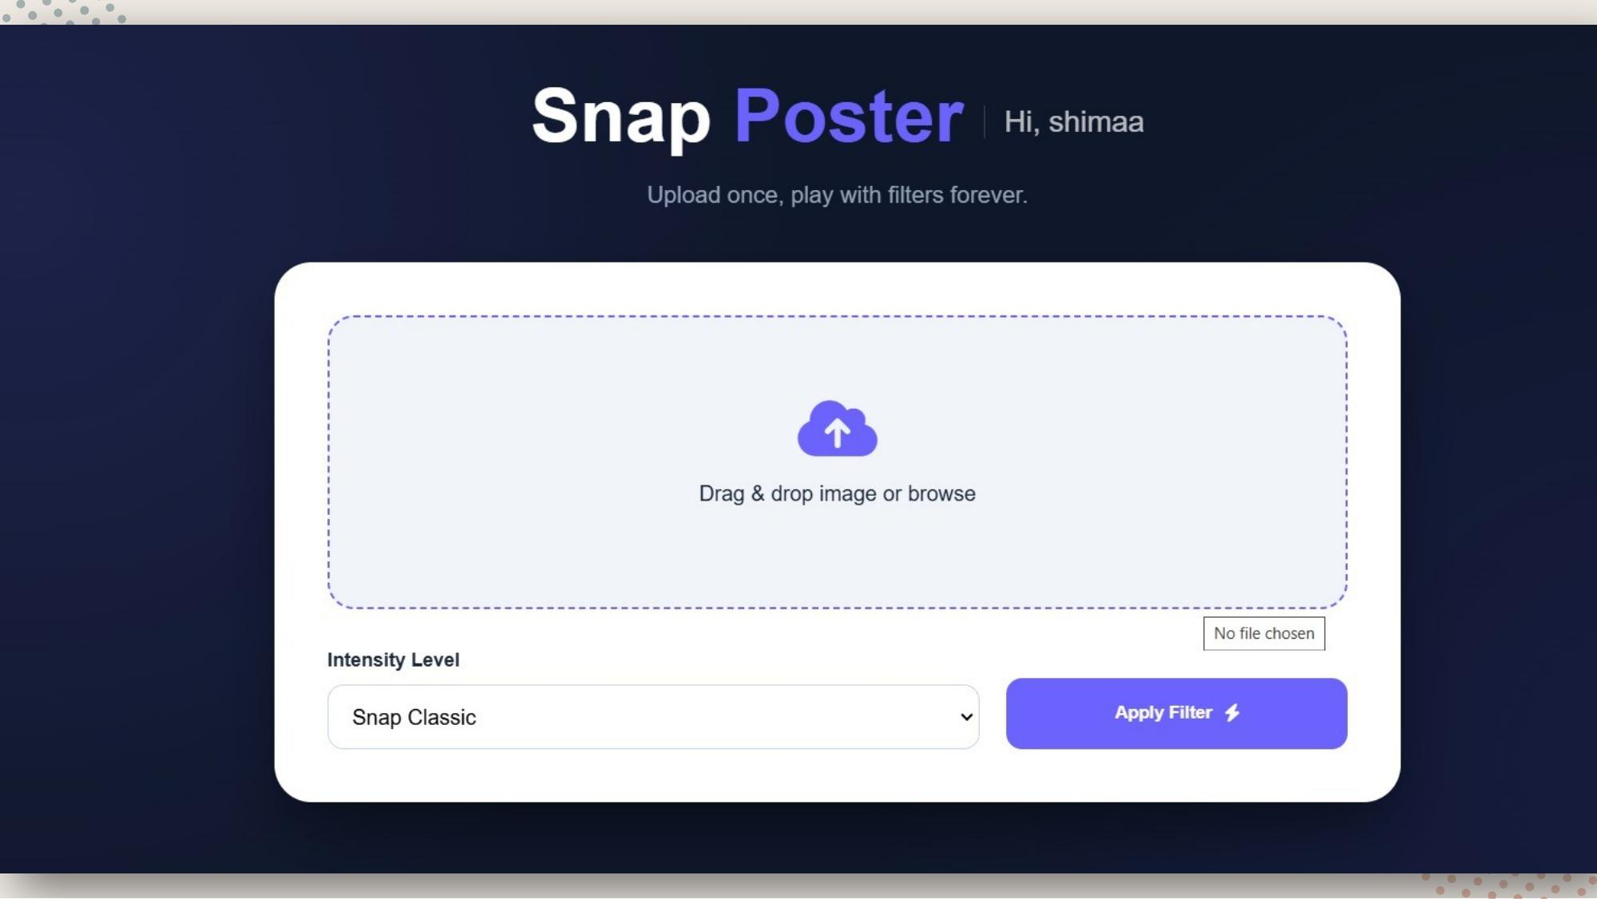
The dashboard is the core interaction screen. Users are greeted by name ("Hi, shimaa") alongside the Snap Poster brand logo. The main upload area features a drag-and-drop zone with a cloud upload icon and a "Browse" fallback. Below the upload area, users can select the Intensity Level (filter type) from a dropdown and initiate processing by clicking the "Apply Filter" button.

11.3 Additional UI Screens
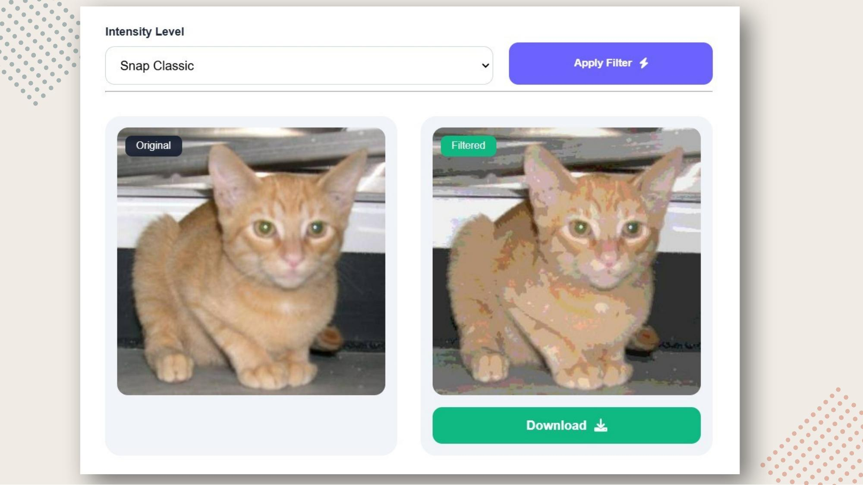
The results screen displays the original and filtered images side by side, labeled "Original" and "Filtered" respectively. Once a filter is applied, the "Download" button becomes available, allowing users to save their artistic poster.

Chapter 13: Conclusion

The Poster Filter — Snap Poster AI Platform project successfully demonstrates the feasibility and market viability of an AI-driven poster creation tool that bridges the gap between simplistic social media filters and complex professional design software.
Through a rigorous UX research process — including a 23-participant survey, empathy mapping, and persona development — the team validated a clear user need: creative seekers and design beginners who desire high-quality, structurally distinct artistic outputs without the steep learning curve of tools like Adobe Photoshop.
The selected solution — Solution B, the AI-Powered Web Platform — directly addresses the identified pain points. With an 87% survey preference for web-based platforms, the platform architecture (React Native + Flask + SQLite + Computer Vision) is well-aligned with user expectations.
The design identity, wireframes, and UI design phases produced a cohesive, dark-themed aesthetic with a clear visual hierarchy, intuitive interaction patterns, and a professional brand identity centered on the Indigo Purple gradient palette.
The working demo validates the core technical hypothesis: that image quantization algorithms can produce aesthetically compelling, minimalist poster art automatically from standard photographs.

Future work may include: expanding the filter library with additional quantization levels and styles; implementing the "Pro" tier for high-resolution exports as suggested by survey monetization insights; integrating social sharing functionality; and applying machine learning to recommend optimal filter settings based on image content analysis.

