Touchstone 3.1: Implementing Dynamic Features with JavaScript
Client: FitLife Fitness Center
Student Name: Biniyam Yohannes
Date: June 4, 2026
IDE Share Link: https://shimebet.github.io/FitLife-Fitness-Center/

Introduction
The primary objective of the website is to promote fitness services, highlight membership opportunities, and create meaningful interactions between the business and potential customers. In addition, the website provides convenient ways for visitors to submit feedback, inquire about services, and purchase fitness-related products.
When planning the website, I focused on creating a design that reflects the energy and professionalism typically associated with a modern fitness center. The color palette combines navy blue, orange, white, and light gray. Navy blue was chosen because it conveys trust, stability, and professionalism, while orange creates visual emphasis and encourages user engagement.

Wireframes
The desktop wireframe organizes each page with a consistent header, main content sections, and footer. This structure creates a predictable layout for visitors and keeps the design aligned with the client goals. The mobile wireframe stacks content vertically and uses a collapsible navigation menu so users can navigate more comfortably on smaller screens.
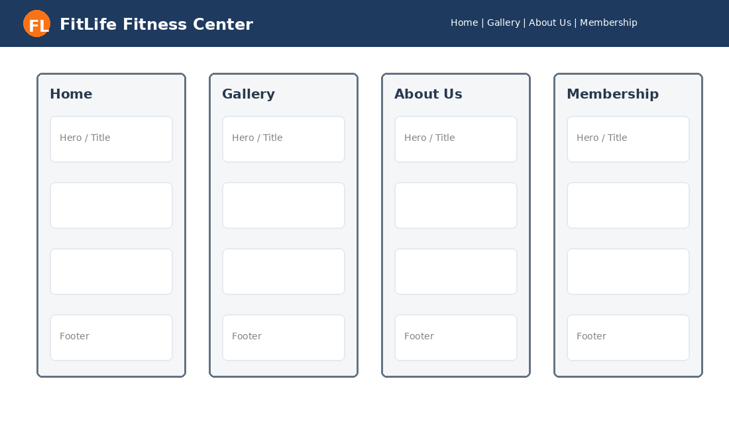
Desktop wireframe for the four webpages.
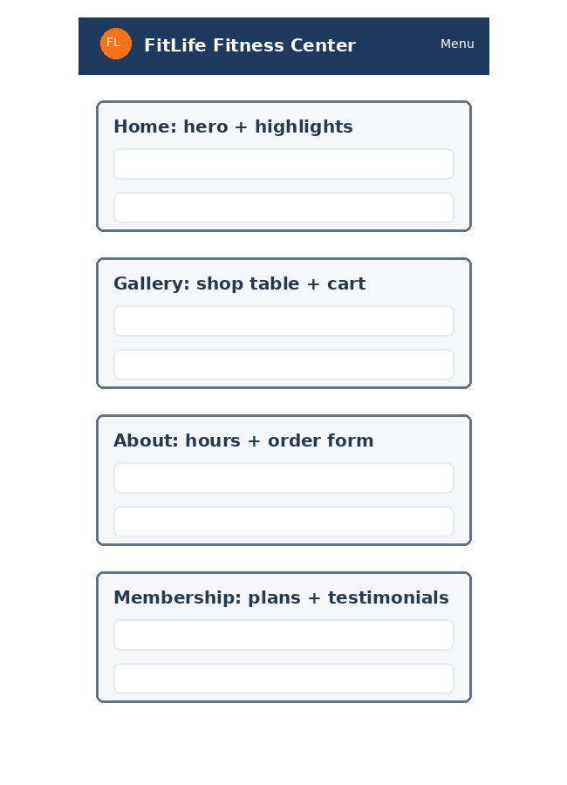
Mobile wireframe for the four webpages.

Website Structure and Content
The website contains four webpages: Home, Gallery, About Us, and Membership. Each page includes a consistent header, navigation menu, and footer. The Homepage highlights services, promotions, and membership benefits. The Gallery page presents products and services with Add to Cart functionality. The About Us page includes business information, operating hours, and a customer feedback/custom order form. The Membership page serves as the custom page and includes membership plans, testimonials, a comparison table, and an interest form.
Component | Description
Navigation bar | The navigation bar links to Home, Gallery, About Us, and Membership. It is functional on all pages and collapses for mobile display.
Header and footer | The header contains the FL logo, website title, and navigation. The footer contains the newsletter subscribe form, social media links, page links, and the corrected contact information.
Homepage | The Homepage presents client highlights, shopping promotions, product categories, and member statistics to encourage engagement.
Gallery page | The Gallery page includes a product/service table with images, descriptions, prices, Add to Cart buttons, and a View Shopping Cart button.
About Us page | The About Us page includes the business description, trainer cards, hours table, and feedback/custom order form.
Custom page | The Membership page acts as the custom fourth page. It includes membership plans, testimonials, community messaging, a plan comparison table, and a membership interest form.

Website Design and Styling
CSS was used to create a consistent visual identity across all webpages. Flexbox and Grid layouts were implemented to improve organization and readability. I tried to keep the layout clean because a fitness website can easily become visually crowded if too many images or colors compete for attention. The navy and orange color palette gives the site an energetic appearance while still maintaining a professional tone.
Accessibility considerations include semantic HTML, descriptive alt text, keyboard accessibility, strong color contrast, visible focus states, and properly labeled forms. These practices support users who rely on assistive technology and also make the site easier for all visitors to use. Responsive design principles were applied through media queries that adapt the navigation, cards, tables, and product sections for mobile devices.
The final review also corrected the color mismatch between the report screenshots and the actual project files. The report images now show the same navy header, orange FL logo, orange action buttons, and updated footer that appear in the project code.

Website Functionality
JavaScript is stored in script.js and adds dynamic functionality required for the project. The navigation bar uses a Menu button on small screens. The Subscribe feature stores the visitor email in localStorage and displays a confirmation message. The Gallery page uses Add to Cart buttons to store cart items in localStorage. The View Cart button opens a modal window that displays cart items and the total. Clear Cart removes stored cart items, and Process Order displays a thank-you message. The About Us feedback/custom order form stores the submitted request in sessionStorage.
One feature I found especially useful was the cart modal because it makes the shopping process feel more realistic without sending the user to another page. The form confirmation messages also improve the user experience by showing visitors that their action was received.

Web Data Storage
The website uses both localStorage and sessionStorage. localStorage is used for newsletter subscriptions and the shopping cart because those items can remain available after the browser is closed. sessionStorage is used for feedback, custom order requests, and membership interest forms because those submissions only need to remain during the active browsing session. Basic input validation is provided through required fields and email input types.
Using web storage in this project demonstrates how front-end websites can preserve user interactions without a server-side database. This is appropriate for the scope of the assignment and still shows practical understanding of client-side data handling.

Customization
The Membership page is the custom fourth page. It supports the business goals by helping visitors compare membership options after viewing services in the Gallery and learning about the business on the About Us page. The page includes testimonials and community language to build trust, while the plan comparison table and interest form encourage customers to take action.
This page fits naturally with the rest of the website because many visitors who explore a fitness center online are likely deciding whether a membership is worth the cost. Presenting the plans clearly helps reduce confusion and supports a more informed decision.

Screenshots
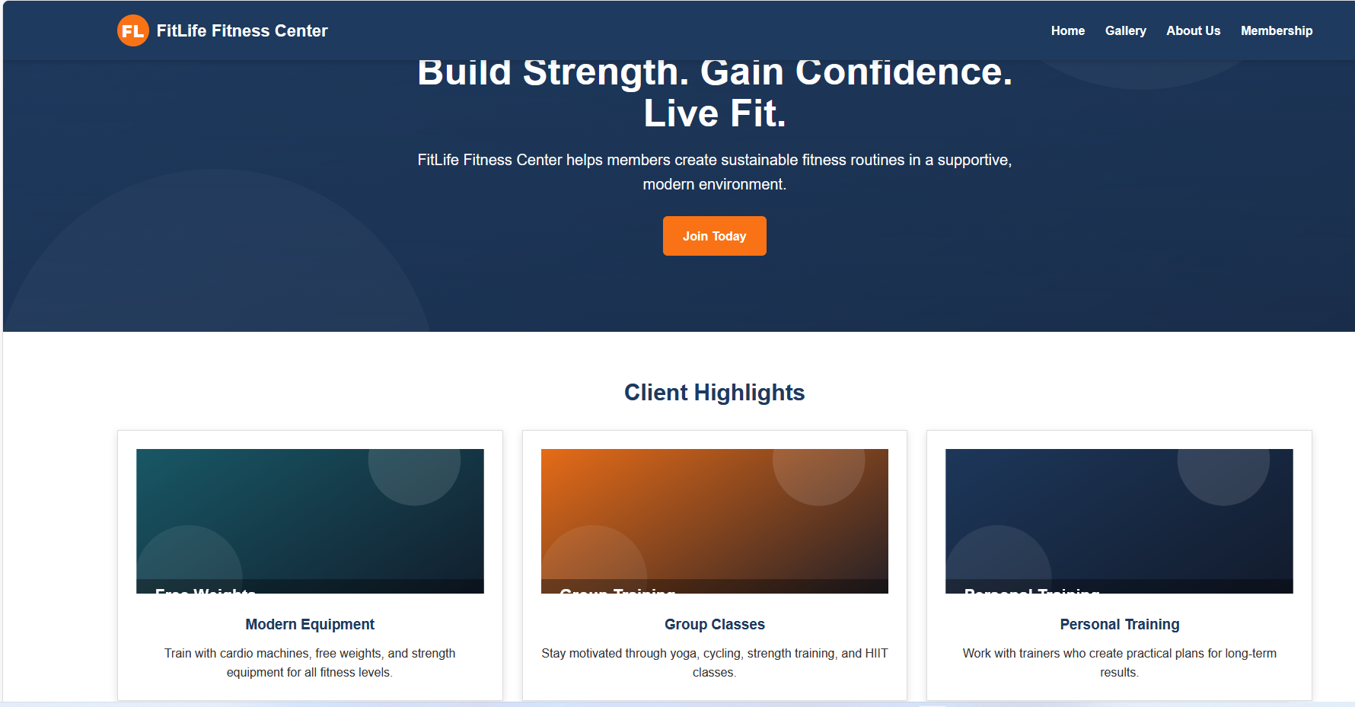
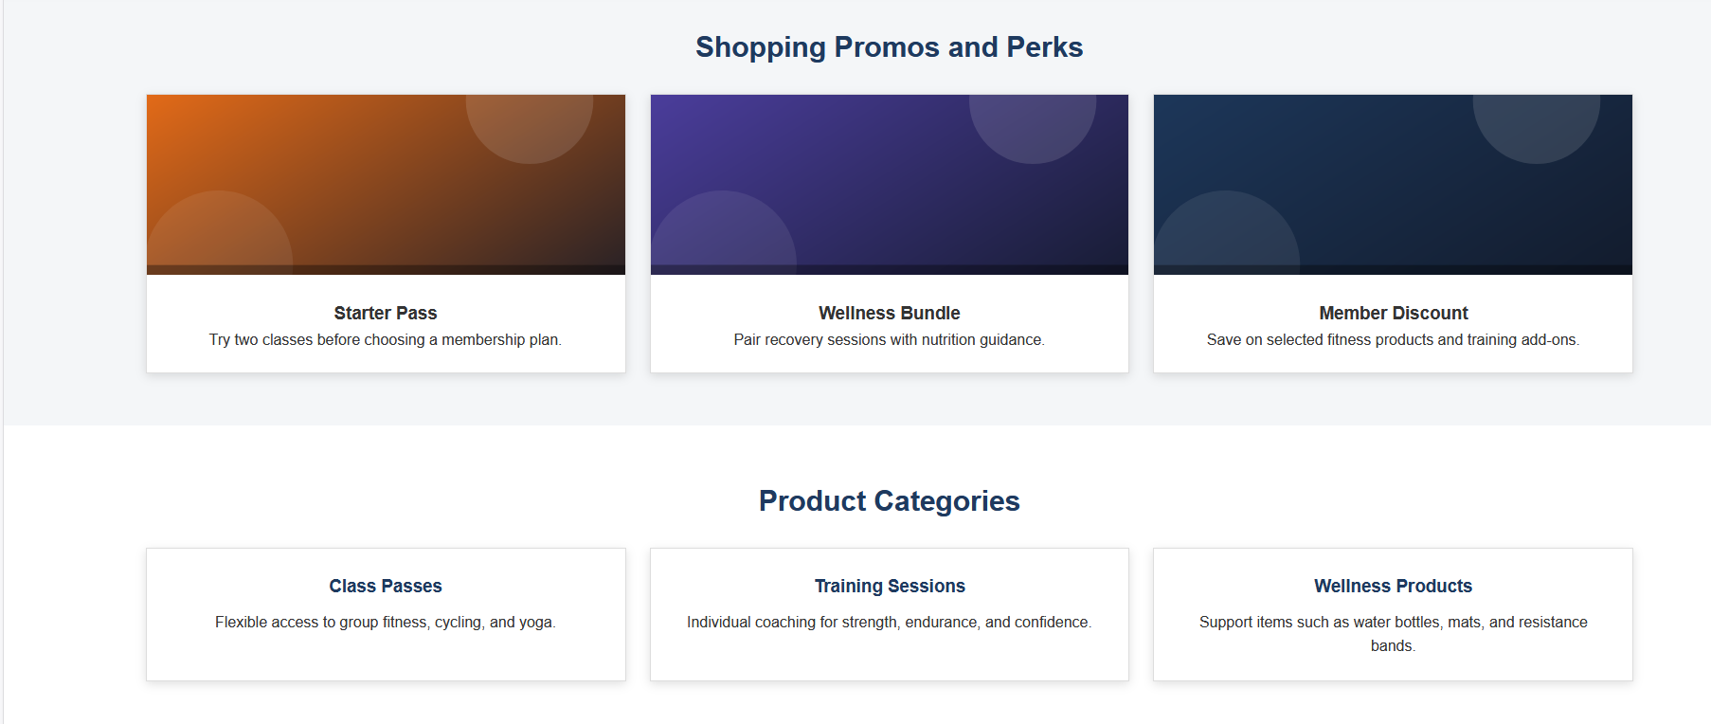

Homepage rendered webpage screenshot.
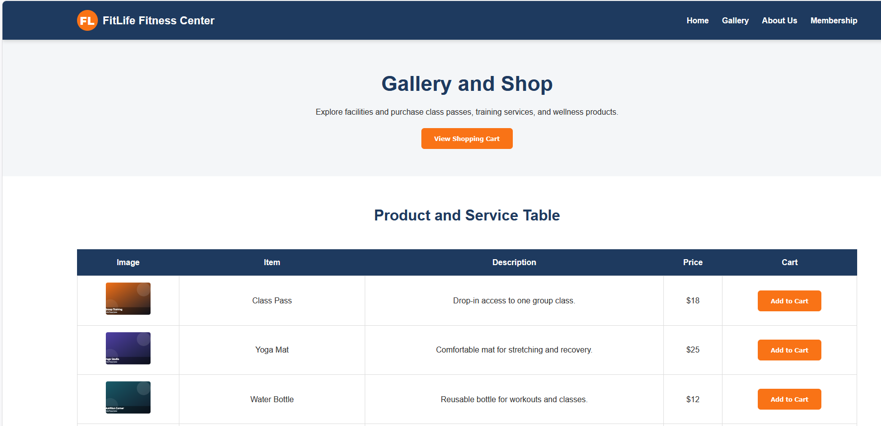
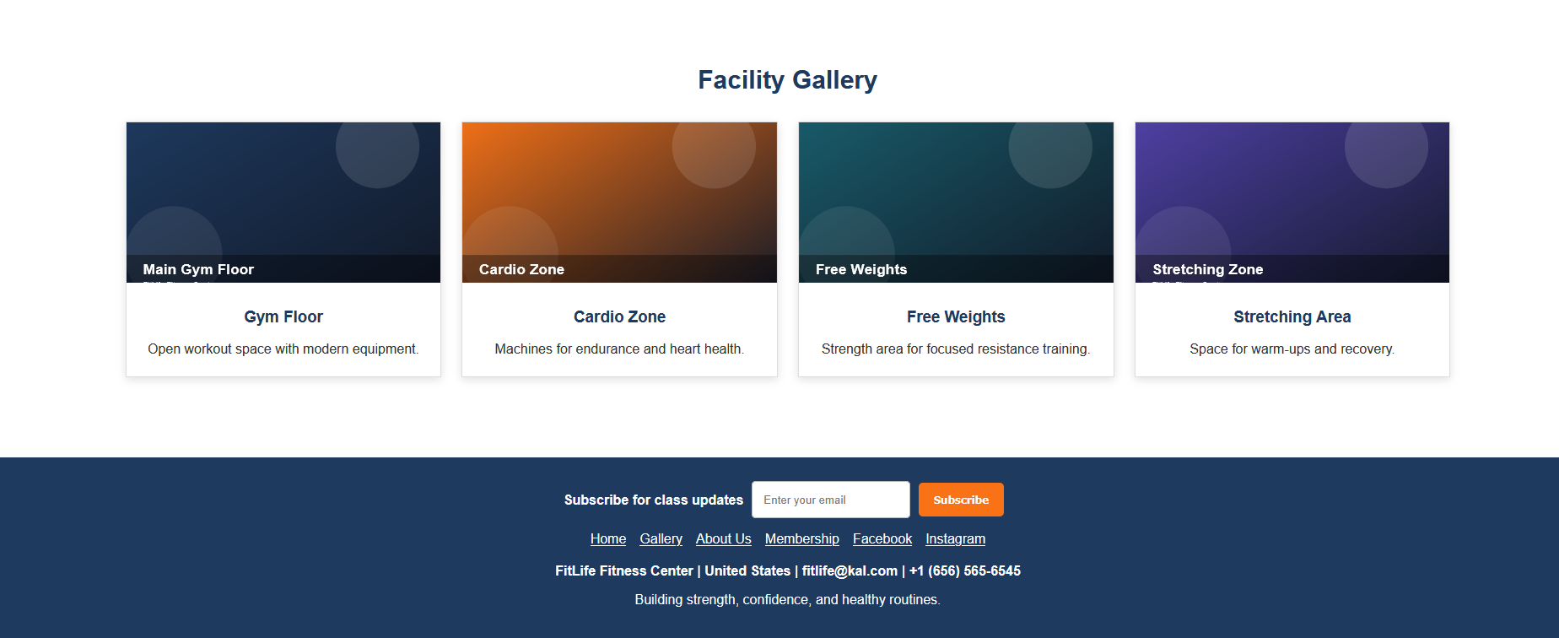
Gallery rendered webpage screenshot.
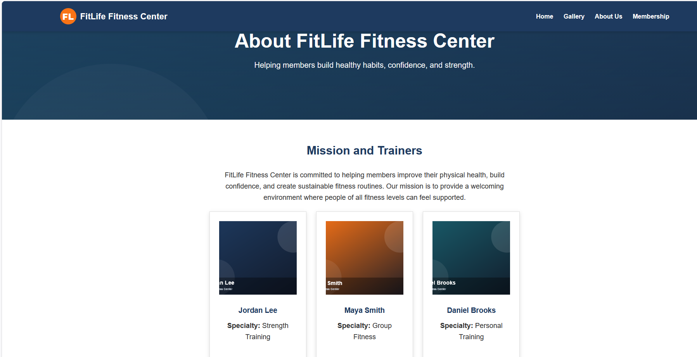



About Us rendered webpage screenshot.
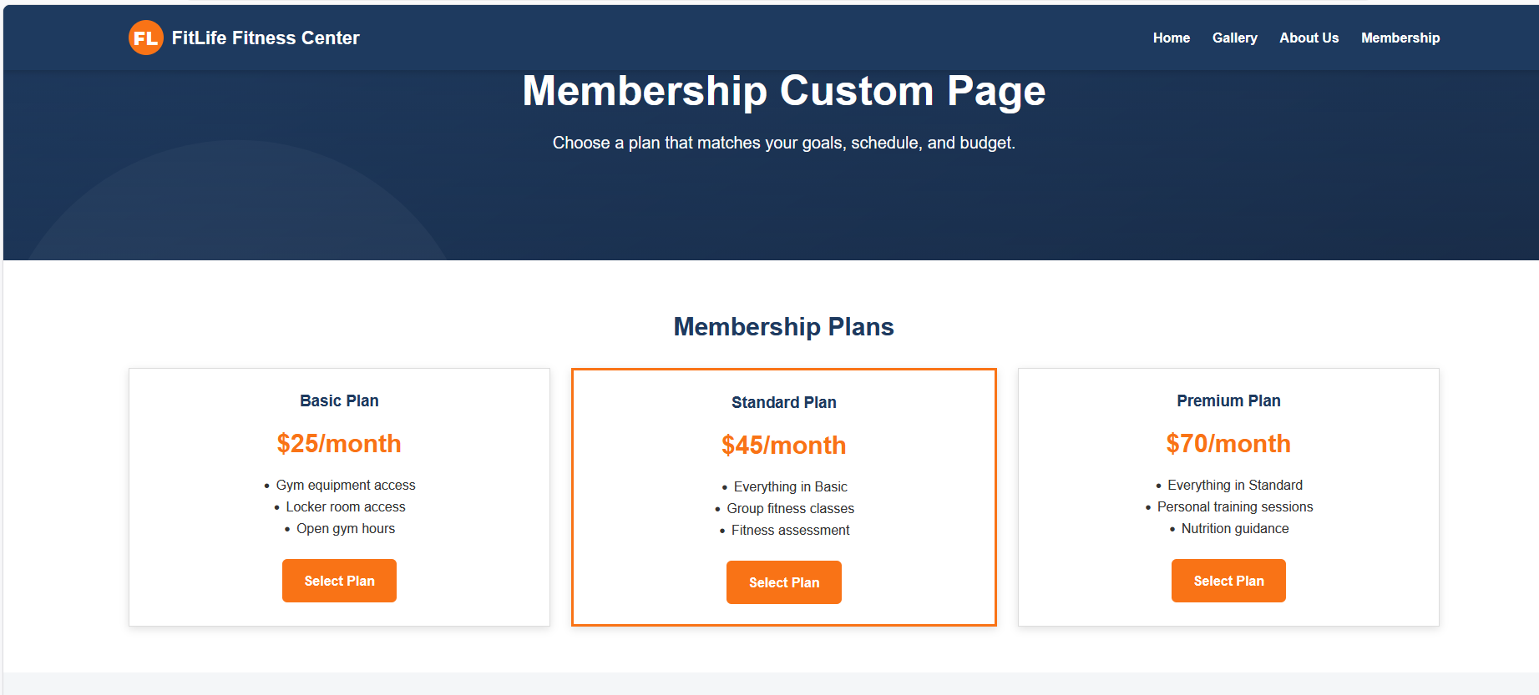
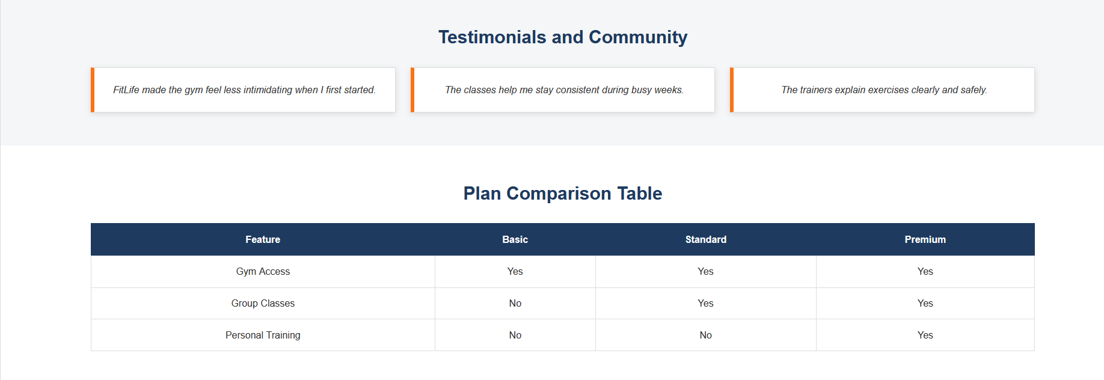


Membership custom page rendered webpage screenshot.
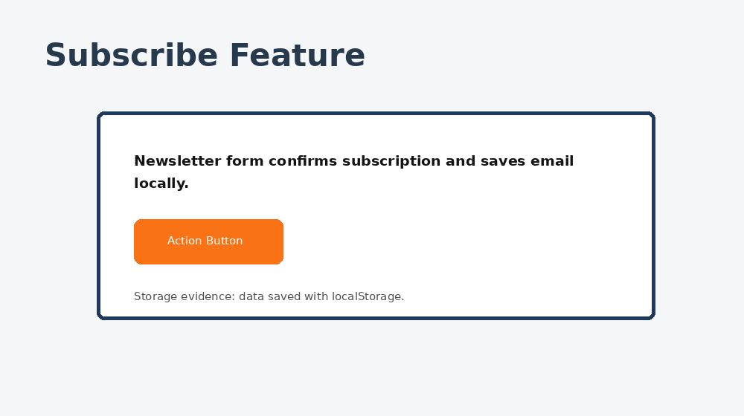
JavaScript screenshot: Subscribe feature.
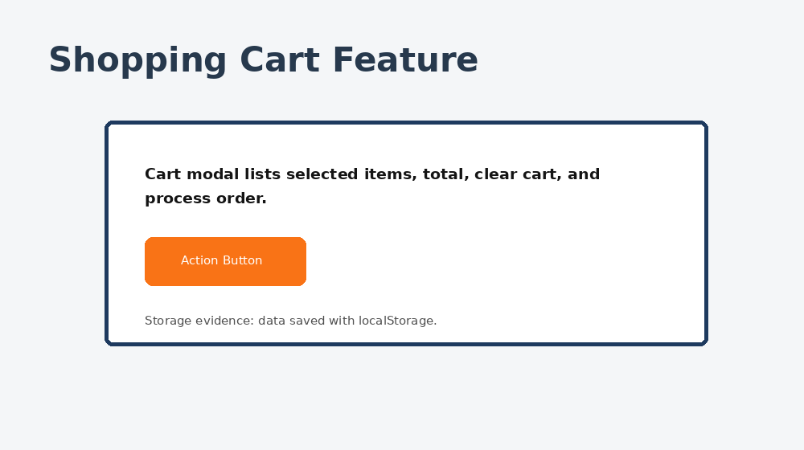
JavaScript screenshot: Shopping cart modal feature.
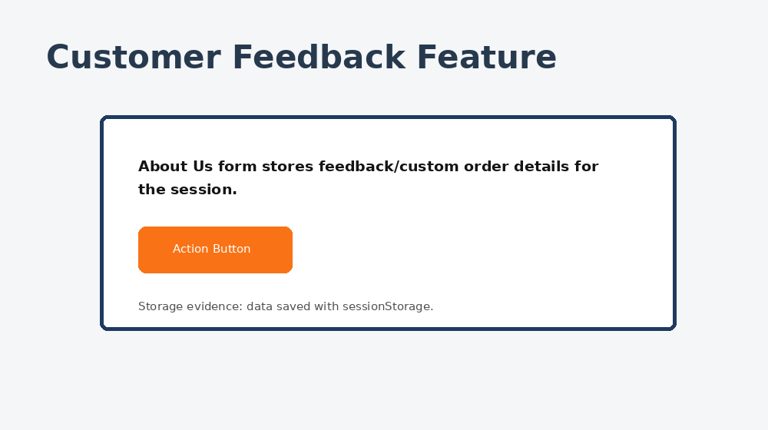
JavaScript screenshot: Customer feedback/custom order feature.

Conclusion
This project demonstrates the practical application of HTML, CSS, JavaScript, responsive design, accessibility principles, and web storage technologies. The final website supports the client’s objectives by promoting services, encouraging engagement, and providing user-friendly functionality.
Looking back at the final revision, the most important improvement was making the website and report match each other. The corrected header/logo colors, consistent footer, updated screenshots, and aligned functionality descriptions make the submission stronger and easier to evaluate. Overall, the project shows how design choices and technical features can work together to meet a client’s goals.

