МИНОБРНАУКИ РОССИИ
Федеральное государственное автономное образовательное учреждение высшего образования
«Национальный исследовательский университет
«Московский институт электронной техники»

Лабораторная работа №4
по дисциплине Системы управления базами данных»

Подготовил:
Студент группы ПИН-34
Семёнова В.Д.

Лабораторная работа 4. Подготовить 10 осмысленных запросов, демонстрирующих изменения структуры БД (из лабораторной работы 2). Запросы должны включать не менее 3-х таблиц. Обязательны запросы с подзапросами, группировкой и оконными функциями.
Изменения в структуре БД (вариант 15):
2. Возможность блокировки части мест из продажи на рейс.
6.«Бонусная программа» для пассажиров – накопление миль, использование их при оплате билетов.
9. Билеты с багажом и без багажа. Доплата за багаж.

1. Заблокированные места на рейс с указанием процента блокировки от всех мест самолёта

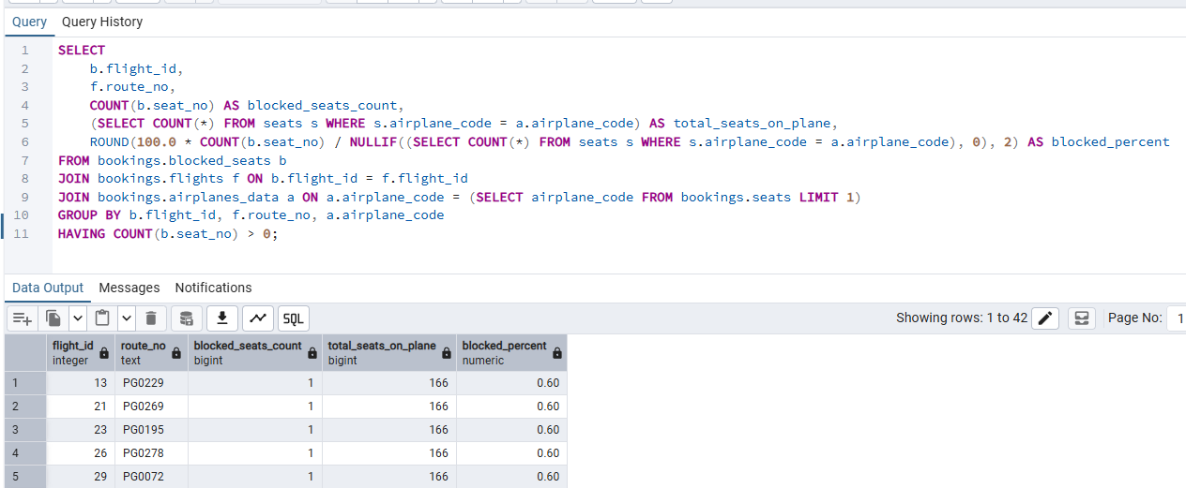

SELECT
b.flight_id,
f.route_no,
COUNT(b.seat_no) AS blocked_seats_count,
(SELECT COUNT(*) FROM seats s WHERE s.airplane_code = a.airplane_code) AS total_seats_on_plane,
ROUND(100.0 * COUNT(b.seat_no) / NULLIF((SELECT COUNT(*) FROM seats s WHERE s.airplane_code = a.airplane_code), 0), 2) AS blocked_percent
FROM bookings.blocked_seats b
JOIN bookings.flights f ON b.flight_id = f.flight_id
JOIN bookings.airplanes_data a ON a.airplane_code = (SELECT airplane_code FROM bookings.seats LIMIT 1)
GROUP BY b.flight_id, f.route_no, a.airplane_code
HAVING COUNT(b.seat_no) > 0;

2. Накопление миль за перелёты

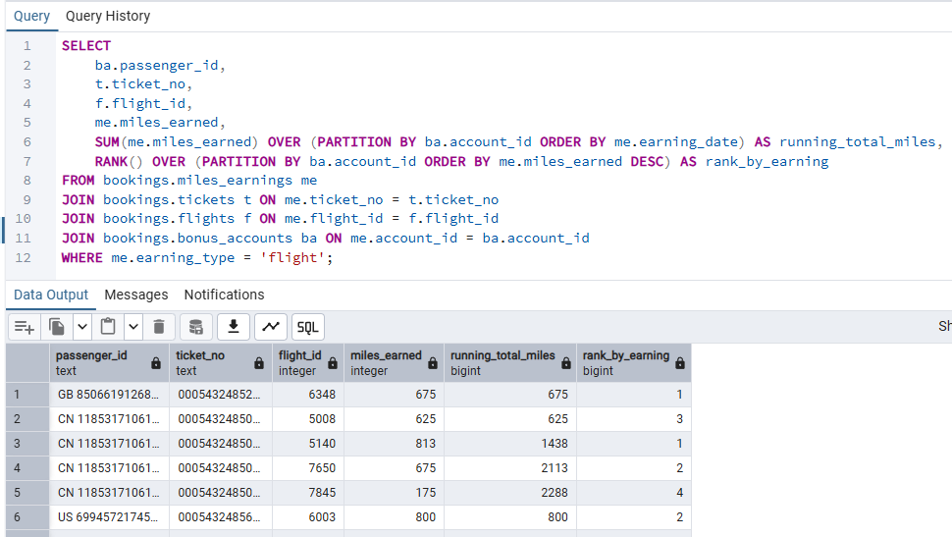

SELECT
ba.passenger_id,
t.ticket_no,
f.flight_id,
me.miles_earned,
SUM(me.miles_earned) OVER (PARTITION BY ba.account_id ORDER BY me.earning_date) AS running_total_miles,
RANK() OVER (PARTITION BY ba.account_id ORDER BY me.miles_earned DESC) AS rank_by_earning
FROM bookings.miles_earnings me
JOIN bookings.tickets t ON me.ticket_no = t.ticket_no
JOIN bookings.flights f ON me.flight_id = f.flight_id
JOIN bookings.bonus_accounts ba ON me.account_id = ba.account_id
WHERE me.earning_type = 'flight';

3. Использование миль при оплате билетов

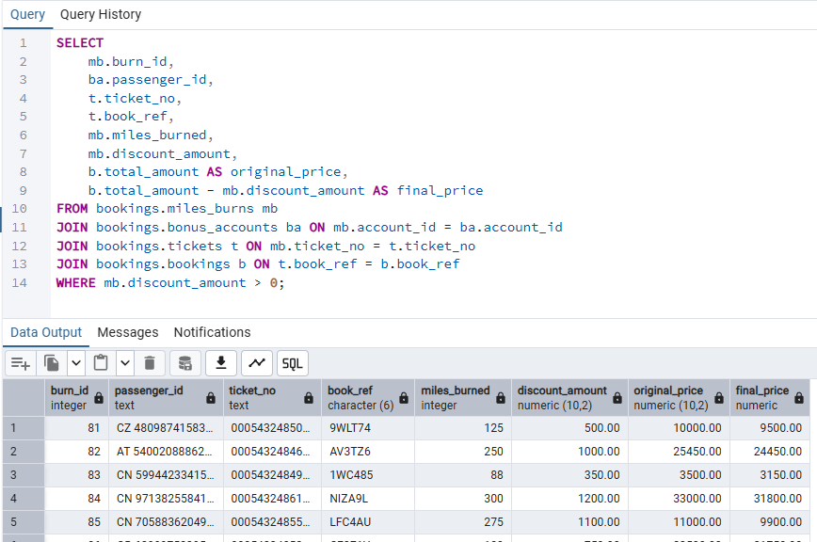

SELECT
mb.burn_id,
ba.passenger_id,
t.ticket_no,
t.book_ref,
mb.miles_burned,
mb.discount_amount,
b.total_amount AS original_price,
b.total_amount - mb.discount_amount AS final_price
FROM bookings.miles_burns mb
JOIN bookings.bonus_accounts ba ON mb.account_id = ba.account_id
JOIN bookings.tickets t ON mb.ticket_no = t.ticket_no
JOIN bookings.bookings b ON t.book_ref = b.book_ref
WHERE mb.discount_amount > 0;

4. Билеты с багажом и без багажа

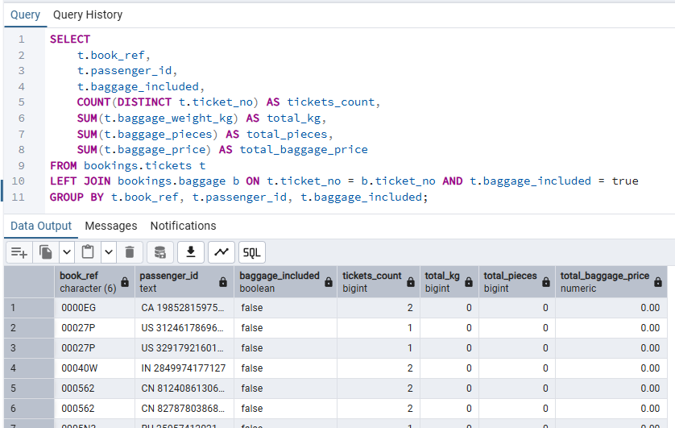

SELECT
t.book_ref,
t.passenger_id,
t.baggage_included,
COUNT(DISTINCT t.ticket_no) AS tickets_count,
SUM(t.baggage_weight_kg) AS total_kg,
SUM(t.baggage_pieces) AS total_pieces,
SUM(t.baggage_price) AS total_baggage_price
FROM bookings.tickets t
LEFT JOIN bookings.baggage b ON t.ticket_no = b.ticket_no AND t.baggage_included = true
GROUP BY t.book_ref, t.passenger_id, t.baggage_included;

5. Доплата за багаж

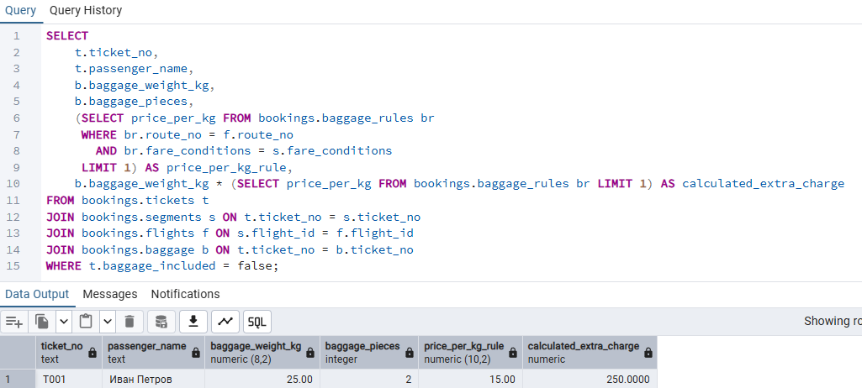

SELECT
t.ticket_no,
t.passenger_name,
b.baggage_weight_kg,
b.baggage_pieces,
(SELECT price_per_kg FROM bookings.baggage_rules br
WHERE br.route_no = f.route_no
AND br.fare_conditions = s.fare_conditions
LIMIT 1) AS price_per_kg_rule,
b.baggage_weight_kg * (SELECT price_per_kg FROM bookings.baggage_rules br LIMIT 1) AS calculated_extra_charge
FROM bookings.tickets t
JOIN bookings.segments s ON t.ticket_no = s.ticket_no
JOIN bookings.flights f ON s.flight_id = f.flight_id
JOIN bookings.baggage b ON t.ticket_no = b.ticket_no
WHERE t.baggage_included = false;

6. Сравнение накопленных и потраченных миль

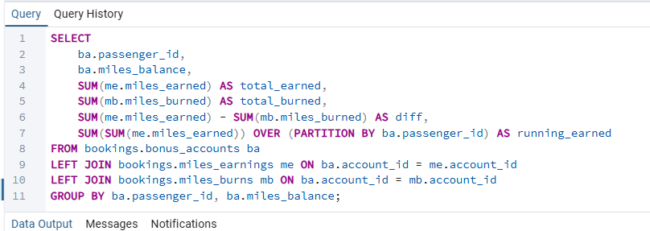

SELECT
ba.passenger_id,
ba.miles_balance,
SUM(me.miles_earned) AS total_earned,
SUM(mb.miles_burned) AS total_burned,
SUM(me.miles_earned) - SUM(mb.miles_burned) AS diff,
SUM(SUM(me.miles_earned)) OVER (PARTITION BY ba.passenger_id) AS running_earned
FROM bookings.bonus_accounts ba
LEFT JOIN bookings.miles_earnings me ON ba.account_id = me.account_id
LEFT JOIN bookings.miles_burns mb ON ba.account_id = mb.account_id
GROUP BY ba.passenger_id, ba.miles_balance;

7. Заблокированные места

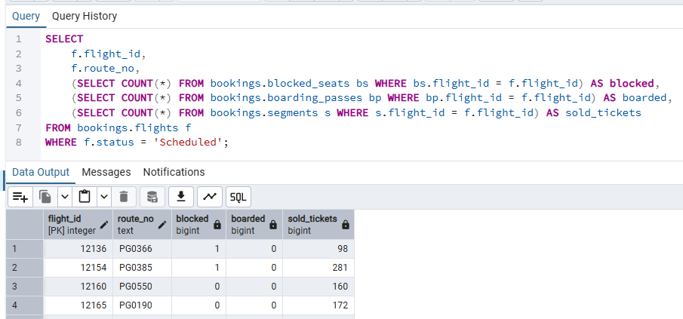

SELECT
f.flight_id,
f.route_no,
(SELECT COUNT(*) FROM bookings.blocked_seats bs WHERE bs.flight_id = f.flight_id) AS blocked,
(SELECT COUNT(*) FROM bookings.boarding_passes bp WHERE bp.flight_id = f.flight_id) AS boarded,
(SELECT COUNT(*) FROM bookings.segments s WHERE s.flight_id = f.flight_id) AS sold_tickets
FROM bookings.flights f
WHERE f.status = 'Scheduled';

8. Пассажиры с самым большим количеством миль

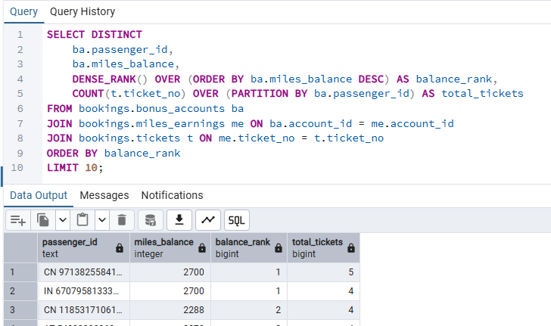

SELECT DISTINCT
ba.passenger_id,
ba.miles_balance,
DENSE_RANK() OVER (ORDER BY ba.miles_balance DESC) AS balance_rank,
COUNT(t.ticket_no) OVER (PARTITION BY ba.passenger_id) AS total_tickets
FROM bookings.bonus_accounts ba
JOIN bookings.miles_earnings me ON ba.account_id = me.account_id
JOIN bookings.tickets t ON me.ticket_no = t.ticket_no
ORDER BY balance_rank
LIMIT 10;

9. Багаж, оплаченный отдельно (без багажа в тарифе)

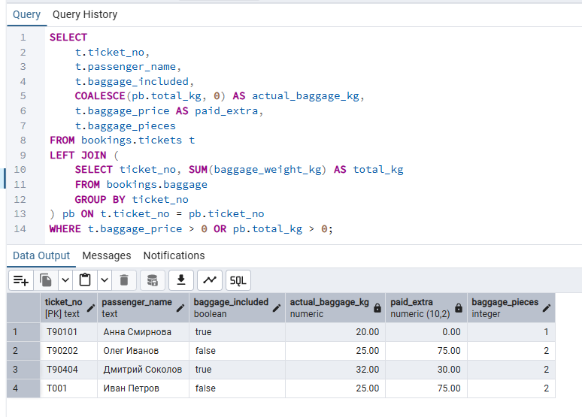

SELECT
t.ticket_no,
t.passenger_name,
t.baggage_included,
COALESCE(pb.total_kg, 0) AS actual_baggage_kg,
t.baggage_price AS paid_extra,
t.baggage_pieces
FROM bookings.tickets t
LEFT JOIN (
SELECT ticket_no, SUM(baggage_weight_kg) AS total_kg
FROM bookings.baggage
GROUP BY ticket_no
) pb ON t.ticket_no = pb.ticket_no
WHERE t.baggage_price > 0 OR pb.total_kg > 0;

10. Пассажиры, которые могли бы оплатить билет милями

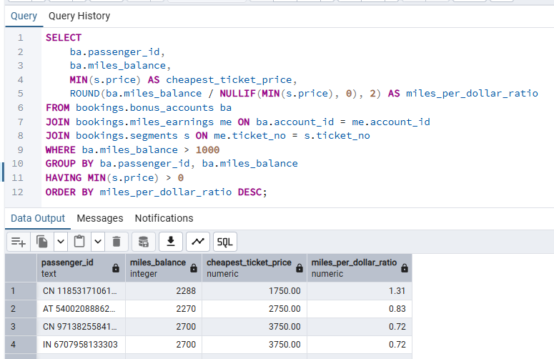

SELECT
ba.passenger_id,
ba.miles_balance,
MIN(s.price) AS cheapest_ticket_price,
ROUND(ba.miles_balance / NULLIF(MIN(s.price), 0), 2) AS miles_per_dollar_ratio
FROM bookings.bonus_accounts ba
JOIN bookings.miles_earnings me ON ba.account_id = me.account_id
JOIN bookings.segments s ON me.ticket_no = s.ticket_no
WHERE ba.miles_balance > 1000
GROUP BY ba.passenger_id, ba.miles_balance
HAVING MIN(s.price) > 0
ORDER BY miles_per_dollar_ratio DESC;

