МИНОБРНАУКИ РОССИИ
Федеральное государственное автономное образовательное учреждение высшего образования
«Национальный исследовательский университет
«Московский институт электронной техники»

Лабораторная работа №5
по дисциплине Системы управления базами данных»

Подготовил:
Студент группы ПИН-34
Семёнова В.Д.

Лабораторная работа 5. Реализовать в БД процедуры (триггеры, если нужно)
1) реализующие работу с изменениями в структуре (из лабораторной работы 2)
2) по заданию для лабораторной работы 5
Задание ЛР5 (вариант 15):
5. Отображения динамики пассажиропотока по разным направлениям.

1. Триггер для автоматического начисления миль при посадке пассажира

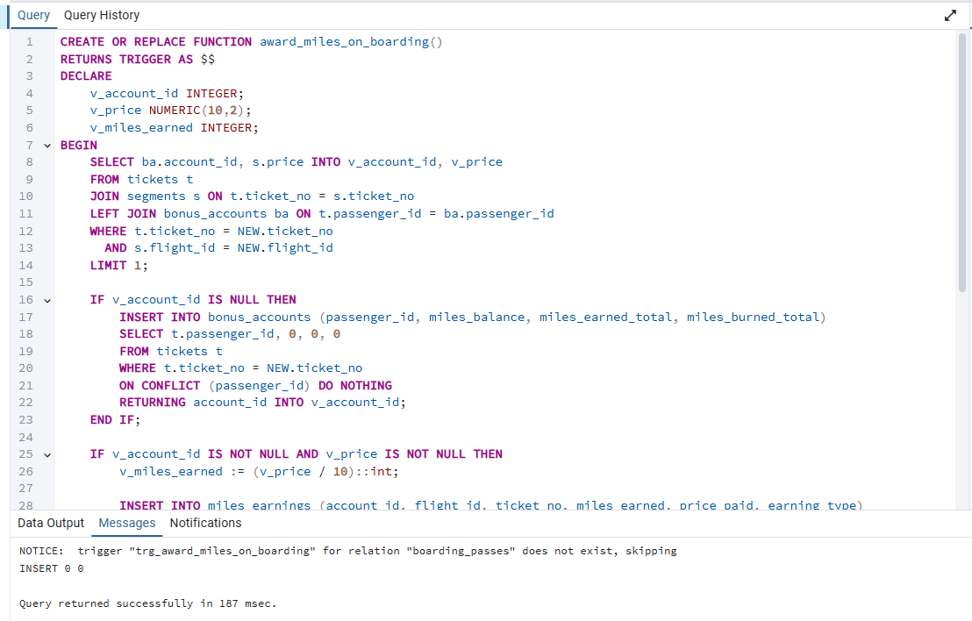

CREATE OR REPLACE FUNCTION award_miles_on_boarding()
RETURNS TRIGGER AS $$
DECLARE
v_account_id INTEGER;
v_price NUMERIC(10,2);
v_miles_earned INTEGER;
BEGIN
SELECT ba.account_id, s.price INTO v_account_id, v_price
FROM tickets t
JOIN segments s ON t.ticket_no = s.ticket_no
LEFT JOIN bonus_accounts ba ON t.passenger_id = ba.passenger_id
WHERE t.ticket_no = NEW.ticket_no
AND s.flight_id = NEW.flight_id
LIMIT 1;

IF v_account_id IS NULL THEN
INSERT INTO bonus_accounts (passenger_id, miles_balance, miles_earned_total, miles_burned_total)
SELECT t.passenger_id, 0, 0, 0
FROM tickets t
WHERE t.ticket_no = NEW.ticket_no
ON CONFLICT (passenger_id) DO NOTHING
RETURNING account_id INTO v_account_id;
END IF;

IF v_account_id IS NOT NULL AND v_price IS NOT NULL THEN
v_miles_earned := (v_price / 10)::int;

INSERT INTO miles_earnings (account_id, flight_id, ticket_no, miles_earned, price_paid, earning_type)
VALUES (v_account_id, NEW.flight_id, NEW.ticket_no, v_miles_earned, v_price, 'flight');

UPDATE bonus_accounts
SET miles_balance = miles_balance + v_miles_earned,
miles_earned_total = miles_earned_total + v_miles_earned,
updated_at = CURRENT_TIMESTAMP
WHERE account_id = v_account_id;
END IF;

RETURN NEW;
END;
$$ LANGUAGE plpgsql;

DROP TRIGGER IF EXISTS trg_award_miles_on_boarding ON boarding_passes;
CREATE TRIGGER trg_award_miles_on_boarding
AFTER INSERT ON boarding_passes
FOR EACH ROW
EXECUTE FUNCTION award_miles_on_boarding();

INSERT INTO boarding_passes (ticket_no, flight_id, seat_no, boarding_no, boarding_time)
VALUES ('0005432000000', 108, '12A', 999, CURRENT_TIMESTAMP)
ON CONFLICT DO NOTHING;

2. Триггер для проверки доступности мест при продаже билета
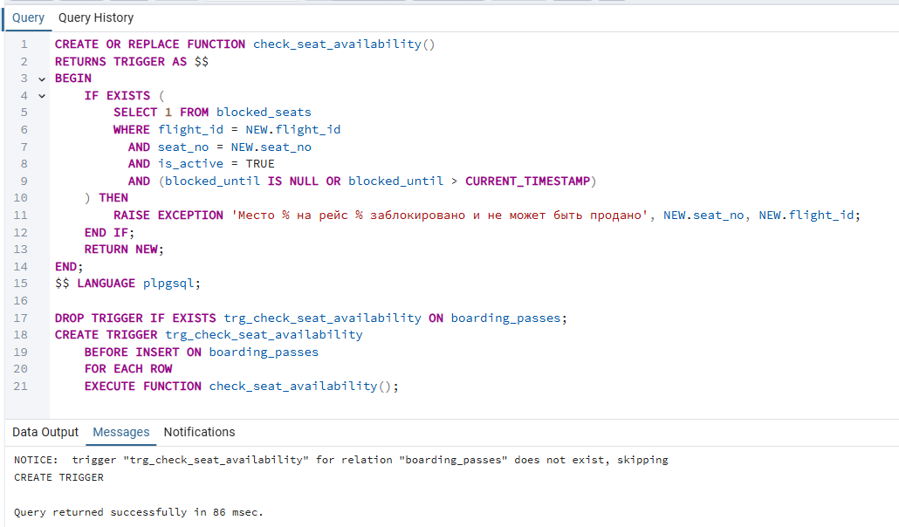

CREATE OR REPLACE FUNCTION check_seat_availability()
RETURNS TRIGGER AS $$
BEGIN
IF EXISTS (
SELECT 1 FROM blocked_seats
WHERE flight_id = NEW.flight_id
AND seat_no = NEW.seat_no
AND is_active = TRUE
AND (blocked_until IS NULL OR blocked_until > CURRENT_TIMESTAMP)
) THEN
RAISE EXCEPTION 'Место % на рейс % заблокировано и не может быть продано', NEW.seat_no, NEW.flight_id;
END IF;
RETURN NEW;
END;
$$ LANGUAGE plpgsql;

DROP TRIGGER IF EXISTS trg_check_seat_availability ON boarding_passes;
CREATE TRIGGER trg_check_seat_availability
BEFORE INSERT ON boarding_passes
FOR EACH ROW
EXECUTE FUNCTION check_seat_availability();

3. Процедура блокировки места

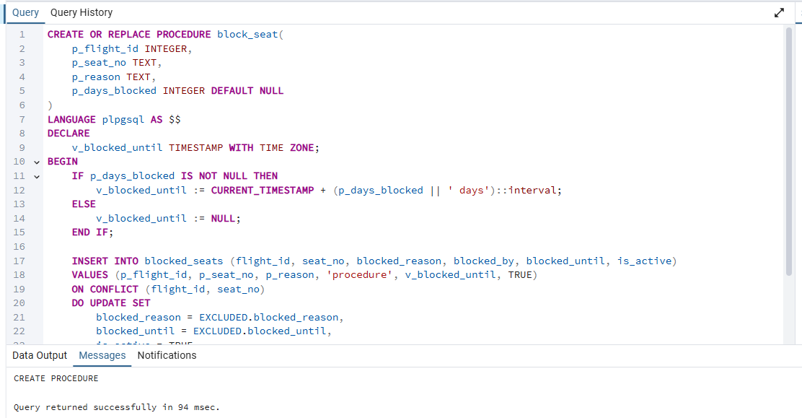

CREATE OR REPLACE PROCEDURE block_seat(
p_flight_id INTEGER,
p_seat_no TEXT,
p_reason TEXT,
p_days_blocked INTEGER DEFAULT NULL
)
LANGUAGE plpgsql AS $$
DECLARE
v_blocked_until TIMESTAMP WITH TIME ZONE;
BEGIN
IF p_days_blocked IS NOT NULL THEN
v_blocked_until := CURRENT_TIMESTAMP + (p_days_blocked || ' days')::interval;
ELSE
v_blocked_until := NULL;
END IF;

INSERT INTO blocked_seats (flight_id, seat_no, blocked_reason, blocked_by, blocked_until, is_active)
VALUES (p_flight_id, p_seat_no, p_reason, 'procedure', v_blocked_until, TRUE)
ON CONFLICT (flight_id, seat_no)
DO UPDATE SET
blocked_reason = EXCLUDED.blocked_reason,
blocked_until = EXCLUDED.blocked_until,
is_active = TRUE,
blocked_by = 'procedure';

RAISE NOTICE 'Место % на рейс % заблокировано', p_seat_no, p_flight_id;
END;
$$;
4. Процедура для отображения динамики пассажиропотока

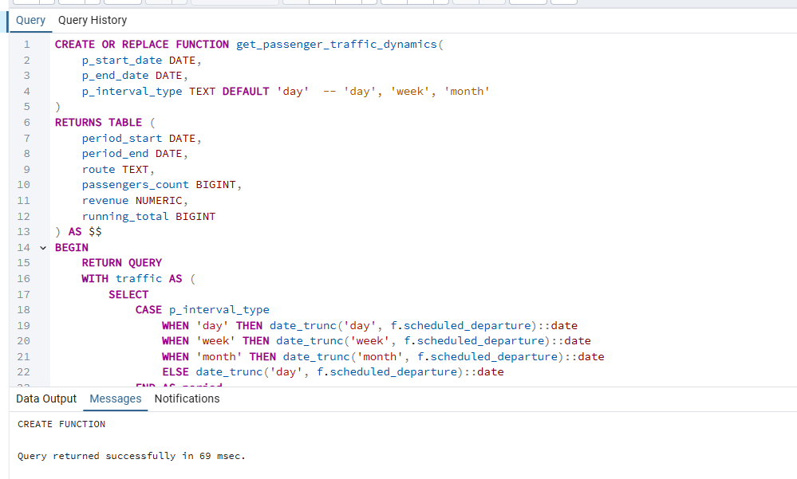

CREATE OR REPLACE FUNCTION get_passenger_traffic_dynamics(
p_start_date DATE,
p_end_date DATE,
p_interval_type TEXT DEFAULT 'day' -- 'day', 'week', 'month'
)
RETURNS TABLE (
period_start DATE,
period_end DATE,
route TEXT,
passengers_count BIGINT,
revenue NUMERIC,
running_total BIGINT
) AS $$
BEGIN
RETURN QUERY
WITH traffic AS (
SELECT
CASE p_interval_type
WHEN 'day' THEN date_trunc('day', f.scheduled_departure)::date
WHEN 'week' THEN date_trunc('week', f.scheduled_departure)::date
WHEN 'month' THEN date_trunc('month', f.scheduled_departure)::date
ELSE date_trunc('day', f.scheduled_departure)::date
END AS period,
r.departure_airport || ' → ' || r.arrival_airport AS route_name,
COUNT(DISTINCT t.ticket_no) AS passenger_count,
SUM(s.price) AS total_revenue
FROM flights f
JOIN routes r ON f.route_no = r.route_no
JOIN segments s ON f.flight_id = s.flight_id
JOIN tickets t ON s.ticket_no = t.ticket_no
WHERE f.scheduled_departure::date BETWEEN p_start_date AND p_end_date
GROUP BY period, route_name
)
SELECT
period AS period_start,
period + (CASE p_interval_type
WHEN 'day' THEN interval '1 day'
WHEN 'week' THEN interval '7 days'
WHEN 'month' THEN interval '1 month'
END)::date - 1 AS period_end,
route_name AS route,
passenger_count,
total_revenue,
SUM(passenger_count) OVER (PARTITION BY route_name ORDER BY period) AS running_total
FROM traffic
ORDER BY route_name, period;
END;
$$ LANGUAGE plpgsql;

