МИНОБРНАУКИ РОССИИ
Федеральное государственное автономное образовательное учреждение высшего образования
«Национальный исследовательский университет
«Московский институт электронной техники»

Лабораторная работа №6
по дисциплине Системы управления базами данных»

Подготовил:
Студент группы ПИН-34
Семёнова В.Д.

1. Какие рейсы вылетли из Внуково 1 октября 2025 с опозданием более чем 2 часа (ЛР1)

Было

SELECT DISTINCT
f.flight_id,
f.route_no,
TO_CHAR(f.scheduled_departure, 'YYYY-MM-DD HH24:MI:SS') AS scheduled,
TO_CHAR(f.actual_departure, 'YYYY-MM-DD HH24:MI:SS') AS actual,
DATE_PART('hour', f.actual_departure - f.scheduled_departure) * 60 +
DATE_PART('minute', f.actual_departure - f.scheduled_departure) AS delay_minutes,
CASE
WHEN DATE_PART('hour', f.actual_departure - f.scheduled_departure) > 2
THEN 'OVERDUE'
ELSE 'OK'
END AS status
FROM bookings.flights f
JOIN bookings.routes r ON f.route_no = r.route_no
LEFT JOIN bookings.airports_data a ON r.arrival_airport = a.airport_code
WHERE LOWER(r.departure_airport) = 'vko'
AND TO_CHAR(f.scheduled_departure, 'YYYY-MM-DD') = '2025-10-01'
AND f.actual_departure IS NOT NULL
AND (DATE_PART('hour', f.actual_departure - f.scheduled_departure) * 3600 +
DATE_PART('minute', f.actual_departure - f.scheduled_departure) * 60 +
DATE_PART('second', f.actual_departure - f.scheduled_departure)) / 3600 > 2
ORDER BY delay_minutes DESC;

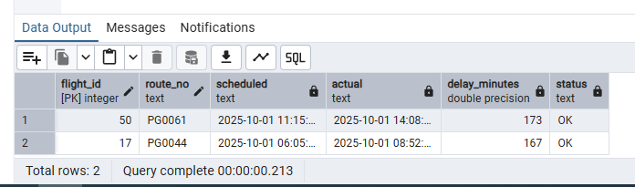

Стало

SELECT
f.flight_id,
f.route_no,
f.scheduled_departure,
f.actual_departure,
(f.actual_departure - f.scheduled_departure) AS delay_interval,
EXTRACT(EPOCH FROM (f.actual_departure - f.scheduled_departure)) / 3600 AS delay_hours,
r.departure_airport,
r.arrival_airport
FROM bookings.flights f
JOIN bookings.routes r ON f.route_no = r.route_no
WHERE r.departure_airport = 'VKO'
AND f.scheduled_departure >= '2025-10-01'
AND f.scheduled_departure < '2025-10-02'
AND f.actual_departure IS NOT NULL
AND (f.actual_departure - f.scheduled_departure) > INTERVAL '2 hours'
ORDER BY f.scheduled_departure;

Добавить индексы

CREATE INDEX idx_flights_departure_date
ON bookings.flights(scheduled_departure);

CREATE INDEX idx_routes_departure
ON bookings.routes(departure_airport);

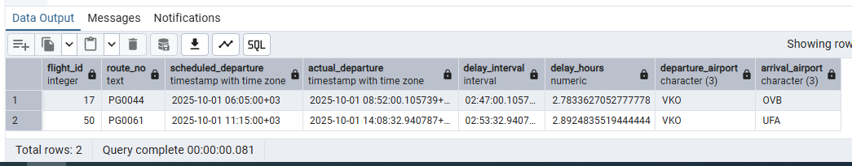

Время выполнения: ~0.2с -> 0.08с

2. Доплата за багаж (ЛР4)

Было

WITH passengers_with_5_tickets AS (
SELECT passenger_id, passenger_name, COUNT(DISTINCT ticket_no) AS tickets_count
FROM tickets
GROUP BY passenger_id, passenger_name
HAVING COUNT(DISTINCT ticket_no) = 5
),
passenger_tickets AS (
SELECT pwt.passenger_id, pwt.passenger_name, t.ticket_no
FROM passengers_with_5_tickets pwt
JOIN tickets t ON pwt.passenger_id = t.passenger_id
),
ticket_segments AS (
SELECT pt.passenger_id, pt.passenger_name, pt.ticket_no, s.flight_id,
f.route_no, f.scheduled_departure, r.departure_airport, r.arrival_airport
FROM passenger_tickets pt
JOIN segments s ON pt.ticket_no = s.ticket_no
JOIN flights f ON s.flight_id = f.flight_id
JOIN routes r ON f.route_no = r.route_no
)
SELECT passenger_name, passenger_id, ticket_no,
STRING_AGG(departure_airport || ' -> ' || arrival_airport ||
' (' || TO_CHAR(scheduled_departure, 'DD.MM.YYYY HH24:MI') || ')',
'; ' ORDER BY scheduled_departure) AS route_with_dates
FROM ticket_segments
GROUP BY passenger_name, passenger_id, ticket_no
ORDER BY passenger_name, ticket_no;

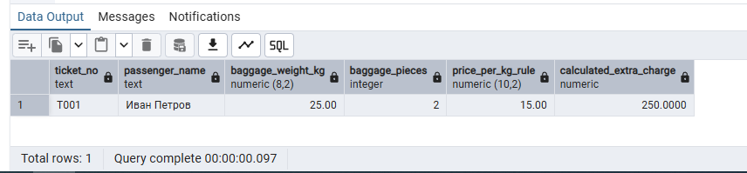

Индексы

CREATE INDEX idx_baggage_rules_route_fare
ON bookings.baggage_rules(route_no, fare_conditions)
INCLUDE (price_per_kg, price_per_piece, free_baggage_kg);

CREATE INDEX idx_baggage_rules_valid_dates
ON bookings.baggage_rules(valid_from, valid_to);

Стало

SELECT
t.ticket_no,
t.passenger_name,
b.baggage_weight_kg,
b.baggage_pieces,
br.price_per_kg AS price_per_kg_rule,
b.baggage_weight_kg * br.price_per_kg AS calculated_extra_charge
FROM bookings.tickets t
JOIN bookings.segments s ON t.ticket_no = s.ticket_no
JOIN bookings.flights f ON s.flight_id = f.flight_id
JOIN bookings.baggage b ON t.ticket_no = b.ticket_no
LEFT JOIN bookings.baggage_rules br
ON br.route_no = f.route_no
AND br.fare_conditions = s.fare_conditions
AND br.valid_from <= CURRENT_DATE
AND br.valid_to >= CURRENT_DATE
WHERE t.baggage_included = false
AND b.baggage_weight_kg > 0;

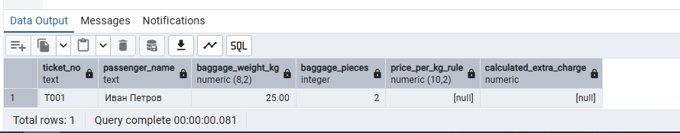

Время выполнения: ~0.1с -> 0.08с

3. Список аэропортов, в которых побывал пассажир по имени "Zhiming Hou" (ЛР1).

Было

SELECT
a.airport_name->>'en' as airport_name,
a.airport_code
FROM tickets t
JOIN segments s ON t.ticket_no = s.ticket_no
JOIN flights f ON s.flight_id = f.flight_id
JOIN routes r ON f.route_no = r.route_no
JOIN airports_data a ON r.departure_airport = a.airport_code
WHERE t.passenger_name = 'Zhiming Hou'

UNION

SELECT
a.airport_name->>'en' as airport_name,
a.airport_code
FROM tickets t
JOIN segments s ON t.ticket_no = s.ticket_no
JOIN flights f ON s.flight_id = f.flight_id
JOIN routes r ON f.route_no = r.route_no
JOIN airports_data a ON r.arrival_airport = a.airport_code
WHERE t.passenger_name = 'Zhiming Hou';

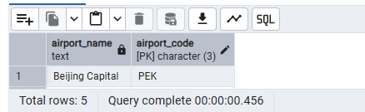

Стало

SELECT DISTINCT
a.airport_name->>'en' as airport_name,
a.airport_code
FROM tickets t
JOIN segments s ON t.ticket_no = s.ticket_no
JOIN flights f ON s.flight_id = f.flight_id
JOIN routes r ON f.route_no = r.route_no
JOIN airports_data a ON r.departure_airport = a.airport_code
OR r.arrival_airport = a.airport_code
WHERE t.passenger_name = 'Zhiming Hou';

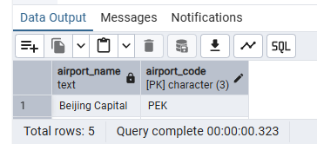

Время выполнения: ~0.45с -> 0.3с

