**The weather around the globe**

**Weather for cast in Capital cities?**

Use the [OpenWeather JSON API](http://openweathermap.org/current) (create a free account) and create a page that shows the weather of the next 6 days in a selected city.  (use [5 days/3 hour forecast API](https://openweathermap.org/forecast5))

A user will select a Capital city out of the following cities and will get the result of its weather in the next 5 days.  (Select 5 cities….  And yes you can select Tel Aviv if you want to :) )

The app page should look like the following: (only for inspiration)

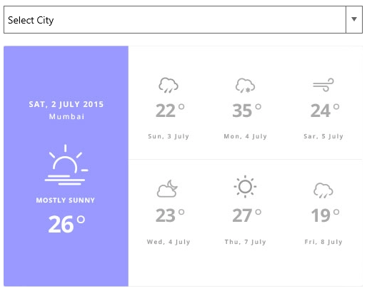

You are free to look for your own design.

**Goals**:

* Understanding the Angular framework.
* Use RxJs and understand the basics.
* Use Service with Dependency Injection.
* Html & CSS practice

**Requirements**

* The page will work on client-side only, will be tested only in Google Chrome
* Use an angular framework.
* Don't worry about performance but let the user know what's happening

**Hint**

* **Create user service and use HttpClient to communicate with the open weather API. (** [**https://openweathermap.org/api**](https://openweathermap.org/api) **)**

**Good luck!**