

**Project: Resolving Overbooked flight**

***Course Code: CSE207***

***Course Title: Data Structure***

***Section: 02***

***Submitted By:***

***Biplob Sutra Dhar***

***2017-1-60-121***

***Shimanto Chakroborty***

***2017-2-68-001***

***Abu Saem Nazmul***

***2017-3-60-054***

***Submitted To:***

**Dr.Maheen Islam**

**Department of Computer Science and Engineering**

***Submission Date: 12 December 2019***

**Introduction:**

The project called **Resolving Overbooked flight**. It is an application in Object oriented programming. The application reads the customer’s data from file. Then calculates the priority number by using the formula P.N.=A/1000+B-C. Where A is customer’s total mileage of past, B is number of years of their frequent flier program and C is the sequence number.   
This project is compiled in Code Blocks.

**Description:**

Based on priority number the application creates a heap and the customer’s information is stored in a stack who will get ticket later. After all the tickets has given the stack will be empty. On this we can print the customer’s list and also give ticket to them based on their priority number. We can also print the data of the customer who are waiting or been served.

Sample outputs are given below

1.Displaying the customer based on their priority

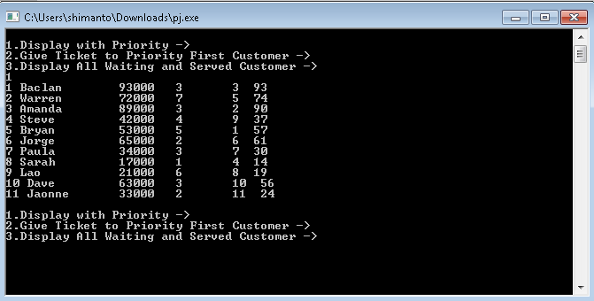

2.Giving ticket to the customer based on their priority number:

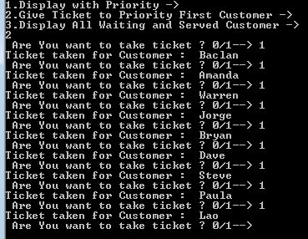

3.List of data of customer who are waiting:

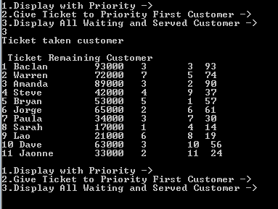

*Source:*

[https://www.geeksforgeeks.org › priority-queue-set-1-introduction](https://www.geeksforgeeks.org/priority-queue-set-1-introduction/)

[https://www.tutorialspoint.com › data_structures_algorithms › priority_que...](https://www.tutorialspoint.com/data_structures_algorithms/priority_queue.htm)

[https://www.tutorialspoint.com › stack_algorithm](https://www.tutorialspoint.com/data_structures_algorithms/stack_algorithm.htm)

[www.cplusplus.com › Reference › <queue>](http://www.cplusplus.com/reference/queue/priority_queue/)

[https://www.programiz.com › dsa › priority-queue](https://www.programiz.com/dsa/priority-queue)