Development of a “Restaurant Management System for EmpowerBD"

Jannatun Ferdous Jerin
ID# 21303178

A Practicum in the Partial Fulfillment of the Requirements
for the Award of Bachelor of Computer Science and Engineering (BCSE)

Department of Computer Science and Engineering
College of Engineering and Technology
IUBAT—International University of Business Agriculture and Technology
Summer 2026

Development of a “Restaurant Management System"
Jannatun Ferdous Jerin

A Practicum in the Partial Fulfillment of the Requirements for the Award of Bachelor of Computer Science and Engineering (BCSE)
The practicum has been examined and approved,

_____________________________
Prof. Dr. Utpal Kanti Das
Chairman

_____________________________
Shahinur Alam
Co-supervisor, Coordinator and Assistant Professor

_____________________________
M. M Rakibul Hasan
Supervisor and Assistant Professor

Department of Computer Science and Engineering
College of Engineering and Technology
IUBAT—International University of Business Agriculture and Technology
Summer 2026

Letter of Transmittal

Organization’s Certificate

Student’s Declaration

I, Jannatun Ferdous Jerin (ID: 21303178), a student of the Bachelor of Computer Science and Engineering (BCSE) program under the College of Engineering and Technology (CEAT) at the International University of Business Agriculture and Technology (IUBAT), hereby declare that this report on the topic “Development of a Restaurant Management System for EmpowerBD” has been prepared to fulfill the requirements of the Internship Course CSC 490, which is a partial requirement for the Bachelor of Computer Science and Engineering degree.
I confirm that I have developed this report and the associated project independently. All modules and processes have been thoroughly tested and meet the requirements of the project client. This report has not been prepared for any other purpose, reward, or presentation.

_____________
Jannatun Ferdous Jerin
21303178

Supervisor’s Certification

This is to certify that the practicum report titled “Development of Restaurant Management System for EmpowerBD” has been conducted by Jannatun Ferdous Jerin (ID: 21303178), an undergraduate student of the Bachelor of Computer Science and Engineering (BCSE) program in the Department of Computer Science and Engineering at IUBAT—International University of Business Agriculture and Technology, as part of the requirements for the practicum defense course.This report was prepared under my supervision and represents a comprehensive record of the work completed. To the best of my knowledge and based on the student’s declaration, no portion of this report has been previously submitted for any degree, diploma, or certification. Jannatun Ferdous Jerin is hereby authorized to submit this report, and I extend my best wishes for her continued success in all future endeavors.

_______________________________
M. M Rakibul Hasan
Supervisor and Assistant Professor
Department of Computer Science and Engineering
IUBAT—International University of Business Agriculture and Technology

Abstract

The "Development of a Restaurant Management System for EmpowerBD" is a comprehensive web-based platform designed to simplify and optimize restaurant operations. Built using Laravel, Bootstrap, and MySQL (with XAMPP for local development), the system automates essential daily tasks such as order management, inventory tracking, payment processing, and business reporting. It is engineered to handle all aspects of restaurant workflow—from managing customer orders and payments to generating sales reports and monitoring inventory levels—minimizing manual intervention and reducing operational errors.

The primary objective of this system is to eliminate the inefficiencies and mistakes associated with manual processes. Restaurant staff can efficiently track customer orders, process payments, and monitor inventory in real time, resulting in smoother operations and fewer errors. The system also empowers managers with detailed, data-driven reports, including daily sales summaries, inventory status, and operational insights, enabling informed decision-making and continuous performance improvement.

Laravel ensures a secure, scalable, and efficient backend, while Bootstrap provides a responsive and user-friendly interface. MySQL serves as the reliable database for storing orders, payments, and inventory records. Together, these technologies deliver a seamless experience for both employees and management.

The current system significantly enhances accuracy, transparency, and speed in restaurant operations. Future enhancements may include mobile access, advanced analytics, and integration with third-party services. Overall, this Restaurant Management System improves customer satisfaction and operational efficiency, giving restaurant owners the confidence to manage their business effectively.

-

Acknowledgments

In the name of ALLAH, the Most Merciful and Gracious, I present this report on the project titled “Point of Sale System for Restaurant.” This work would not have been possible without the support and guidance of many people.
First, I sincerely thank our respected Chairman, Prof. Dr. Utpal Kanti Das, whose inspiration and encouragement motivated me to complete this project with dedication.
I am also deeply grateful to my Coordinators, Md. Rashedul Islam, Associate Professor, and Shahinur Alam, Assistant Professor, Department of Computer Science and Engineering, IUBAT. Their guidance and feedback were essential in shaping this report.
Special thanks go to my Supervisor, M. M Rakibul Hasan, Assistant Professor, Department of Computer Science and Engineering, IUBAT, for his valuable suggestions and continuous support. His mentorship was a great source of learning and motivation.
I also appreciate my friends and classmates for their helpful feedback and encouragement throughout different stages of the project.
Above all, I am forever thankful to my parents for their unconditional love, prayers, and constant support. Their blessings have been the true driving force behind my journey.

Chapter 1. Introduction

The modern food service industry demands rapid service delivery, impeccable accuracy, and transparent data tracking. Relying on pen-and-paper methods or disjointed legacy software often results in miscommunications between the waitstaff and the kitchen, inventory mismatches, and inaccurate billing. To systematically eliminate these operational bottlenecks, the "Restaurant Management System" was conceptualized and developed. Built utilizing a modern technology stack—React.js, Laravel, and MySQL—this system centralizes all restaurant activities into a single, cohesive digital environment.

1.1 Background of the Study
Operating a restaurant involves managing a complex web of simultaneous activities. Staff members must handle customer seating, record specific dietary preferences, communicate orders to culinary teams, finalize bills, and track the depletion of raw materials. Traditionally, these processes operate in silos. A waiter’s notepad does not automatically update the kitchen’s queue or the manager’s inventory ledger. As business scales, these manual gaps translate into significant revenue loss and decreased customer satisfaction. The development of this unified management system bridges these gaps, allowing data to flow instantaneously from the customer’s table to the kitchen display and the management’s reporting dashboard.
The "Development of a Restaurant Point of Sale System” was built to meet these needs. It automates everything—from order taking and inventory management to payment processing and report generation. By replacing manual processes with automation, restaurants can streamline their operations, reduce errors, increase customer satisfaction, and provide better service [4].

1.2 Methodology
This project's methodology integrated knowledge derived from research with real-world application. Iterative steps were used to carry out the development process, where every feature, including order management, payment processing, inventory control, and user roles, was put into use, examined, and refined .
Both primary and secondary sources of information were used in the research portion.

1.2.1 Primary Sources.
The following are the steps for using primary sources:
- Simulated Operations: Running mock restaurant environments to test order flows and identify UI friction.
- Expert Consultations: Regular syncs with academic supervisors and senior developers to refine system architecture.
- Workflow Observation: Analyzing how staff and cashiers naturally interact with point-of-sale interfaces.
- User Feedback: Informal feedback from restaurant staff and management about system usability.
- Trial Runs: Running simulated restaurant operations (order taking, payment processing, inventory tracking) to identify gaps and fix errors [4].

1.2.2 Secondary Sources.
The steps of secondary sources are given below:
- Technical Documentation: Reference to official guides for Laravel, and MySQL.
- Academic Materials: Lecture notes and course handouts from the Department of Computer Science and Engineering.
- Online Resources: Articles, tutorials, and forums related to POS systems, database optimization, and inventory management tools.
- Case Studies: Previous project reports and research papers on similar restaurant management systems .
Together, these sources provided both practical insights and theoretical understanding for building the project.

1.3 Objectives
The main aim of the project is to develop a robust and automated system that ensures smooth trading operations while minimizing manual errors. These objectives are given below:

1.3.1 Broad Objective.
To design and implement the "Development of a Restaurant Management System” that enhances efficiency, transparency, and reliability in restaurant operations by automating day-to-day workflows such as order management, inventory tracking, and billing.

1.3.2 Specific Objectives.
- To implement user and role management for secure access control.
- To automate the ordering process, including menu management and payment processing.
- To enable real-time inventory tracking and automatic low-stock alerts.
- To provide tools for generating daily, weekly, and monthly sales reports.
- To ensure secure payment processing and data encryption for customer transactions .
- To streamline customer feedback collection for better service quality.
- To reduce manual effort, speed up billing, and improve decision-making for both staff and restaurant management.
.

1.4 Process Model
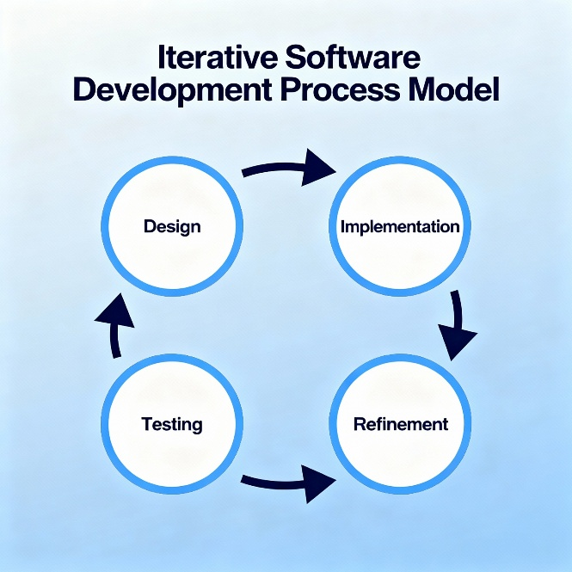
The development followed an Iterative Process Model. Instead of building the entire system at once, the project was broken into small modules (e.g., order management, payment processing, inventory management). Each module was:
Figure 1.4: Iterative Process Model
- Designed based on requirements.
- Implemented using Bootstrap for the frontend, Laravel for backend services, and MySQL for database management.
- Tested through trial runs, including real-world order simulations.
- Improved based on feedback from restaurant staff and managers.
This approach allowed flexibility. If an issue was found during testing, only that part of the system needed revision without affecting the rest. The iterative model was chosen because it fits well with projects that require gradual improvement and frequent testing, such as order systems where accuracy is critical .

1.5 Feasibility Study
Before starting development, a feasibility study was conducted to ensure the project was technically possible, economically viable, and operationally practical. The proposed system is feasible in all these three phases as discussed below:

1.5.1 Technical Feasibility.
The technologies used— Laravel, and MySQL—are all stable, widely used, and well-supported. They provide:
- Strong database handling for restaurant order records.
- Customizable workflows suitable for order management and inventory tracking.
- Secure and real-time payment processing capabilities.
- The hardware and software requirements were minimal and easily available, confirming that the project was technically feasible.

1.5.2 Economic Feasibility.
The project used cost-effective tools. Bootstrap and Laravel are open-source frameworks, and MySQL is a widely used database system that minimizes licensing costs. By automating manual tasks, the system reduces operational costs in the long term, making it economically sustainable.

1.5.3 Operational Feasibility.
The system was designed to be user-friendly. With a simple menu structure (Login, Orders, Payments, Reports, Inventory), staff and managers can easily operate it with minimal training. Customers also benefit from fast, accurate billing and seamless payment processing. Thus, the system is operationally feasible for real-world adoption .

Chapter 2. Organizational Overview

EMPOWERBD is a forward-thinking IT firm and software solutions provider with a dual presence in Dhaka, Bangladesh, and Ontario, Canada. The organization is dedicated to bridging the gap between complex business challenges and intuitive digital solutions. EMPOWERBD specializes in custom software engineering, responsive web platforms, mobile application development, and targeted digital marketing campaigns. Furthermore, the company has developed a strong portfolio of proprietary enterprise solutions, including academic management platforms, donor management systems, and advanced inventory tracking software.

Figure 2: Organization Logo

2.1 Organization Vision
Vision: “We code better life.”
This concise, aspirational statement reflects CODETREE’s commitment to enhancing everyday experiences through smart, efficient, and life-enriching digital solutions.

2.2 Organization Mission
EMPOWERBD operates with the mission of consolidating top-tier digital talent—ranging from UI/UX designers to full-stack engineers—into a unified ecosystem capable of delivering high-performance, scalable, and tailored software products to a global clientele.

2.3 Organization Services
Empowerbd offers a comprehensive suite of services, catering to a wide range of digital and technological needs. Key services include:
- Web Development & Design – creating dynamic, responsive websites
- App Development – building custom mobile applications
- Graphic Design – crafting visual identities and marketing materials
- Digital Marketing – implementing online advertising and promotion strategies
- Bulk SMS Services – mass messaging for customer outreach
- Cloud Hosting – reliable infrastructure for hosting client solutions
Additionally, they provide specialized software solutions such as:
- Point-of-Sale (POS) & Inventory Management
- School & College Management Systems
- Donation Management Platforms.

2.4 Organizational Structure

Chapter 3. Requirement Engineering

Requirement engineering is the backbone of any successful software project, as it ensures that the system meets the true needs of its users while adhering to operational and regulatory standards. For complex systems like the Restaurant Management System, requirement engineering is crucial because it defines the workflows for order management, payment processing, inventory tracking, and reporting. A well-executed requirement engineering phase minimizes errors, reduces development costs, and ensures operational efficiency.
This chapter details the requirement elicitation, analysis, specification, and use case modeling of the Restaurant System. Each section has been expanded to provide practical insights and real-world scenarios to illustrate the system's functionality.

3.1 Requirement Elicitation "Development of a Restaurant Management System for EMPOWERBD

3.1.1 Stakeholder Identification
Stakeholder Identification
Primary Stakeholders:
- System Administrators/Owners: Require macro-level control, financial summaries, and system configuration access.
- Restaurant Managers: Oversee daily operations, manage orders, and monitor inventory.
- Waiter-staff: Input customer orders, process payments, and communicate with the kitchen.
- Customers: End users who interact with the system via the point-of-sale interface to place orders and make payments.
- Kitchen Staff: Depend on clear, immediate visual cues regarding incoming, pending, and completed food orders.

3.1.2 Techniques Used for Elicitation
A combination of elicitation techniques was applied to ensure completeness:
- Interviews: Conducted with restaurant staff and managers to uncover operational workflows. One manager emphasized, "We need a fast and reliable order management system."
- Observation: Analysts observed the order-taking process, identifying tasks like manual billing and inventory tracking that could be automated.
- Workshops: Collaborative workshops with staff helped define roles, order flows, and reporting needs.
- Document Analysis: Reviewed industry standards for POS systems and compliance requirements to ensure the system meets legal and operational guidelines.
- Prototyping: Early UI mock-ups were shared with staff to validate system usability and design.
This multi-technique approach ensured that requirements were comprehensive, validated, and realistic.

3.1.3 Key Findings
The elicitation process revealed critical requirements:
- Secure login and role-based access for users.
- Easy menu setup and item management.
- Real-time order tracking and payment processing.
- Reporting tools for daily sales, inventory levels, and customer orders.
- Integration with payment gateways for secure transaction handling.
- Ability to generate end-of-day reports, including sales summaries and inventory updates.
- Automatic backup and recovery of transaction data.

3.2 Requirement Analysis of "Development of a Restaurant Management System for Empowerbd"
Requirement analysis refines elicited data to identify conflicts, assess feasibility, and prioritize needs. For the Restaurant System, analysis was particularly important due to the complexity of workflows and the need for real-time data processing .

3.2.1 Completeness and Consistency
Completeness ensures all critical features are included, while consistency ensures no contradictions exist [10].
- Completeness: Analysts cross-checked elicited requirements against existing restaurant workflows to ensure that all critical features like order processing, inventory management, and reporting were included.
- Consistency: Conflicts arose, such as waitstaff requesting more detailed customer order information, while managers insisted on limiting access. This was resolved through role-based access control, allowing waitstaff to only see customer orders and not sensitive payment data.

3.2.2 Feasibility Study
Feasibility analysis assessed multiple dimensions:
- Technical Feasibility: The system will be developed on a web-based architecture using React.js for the frontend, Laravel for backend services, and MySQL for database management.
- Operational Feasibility: Staff are familiar with basic digital tools, and minimal training will ensure smooth adoption of the POS system.
- Economic Feasibility: The cost of implementation will be justified by the time saved through automation, reduced human error, and improved reporting accuracy.
- Schedule Feasibility: A phased implementation within 3 months is achievable, with pilot runs and feedback cycles to ensure system quality.

Requirement specifications formalize user and system needs, providing developers with a concrete reference

3.3 Requirement Specifications

3.3.1 User Requirements
Primary Actor: Administrator
- The Administrator must securely authenticate into the system using valid login credentials.
- The Admin is tasked with overseeing and controlling all aspects of the restaurant's digital operations, encompassing order fulfillment, financial transactions, and stock control.
- Full privileges are granted to the Admin to set up and modify the digital menu, adjusting prices, categories, and general restaurant configurations.
- The user must be equipped to seamlessly handle the lifecycle of a customer's order, including final payment settlement.
- The Admin is authorized to extract detailed analytical reports spanning daily, weekly, or monthly timeframes.
- The user carries the responsibility of cross-checking and validating the integrity of all operational data entered into the platform.
- Routine operational triggers, specifically the initialization (Day-Start) and closure (Day-End) of business days, are exclusively executed by the Admin.
- The user is responsible for monitoring real-time stock levels, adjusting inventory parameters, and maintaining supplier databases.
- The Admin maintains overarching visibility over all system interactions to guarantee operational precision.
- Absolute administrative rights are assigned to this user, allowing unrestricted creation, modification, or deletion of system records and settings.
- The user manages all customer-related data, including historical order logs and feedback records.
- The Admin initiates system backups and governs data restoration procedures.

3.3.2 System Requirements
Authentication Workflow:
- The system must provide a secure login interface where the administrator inputs their assigned username and password before submitting the request.
- Upon successful verification of the credentials, the system automatically redirects the user to the central management dashboard, granting full operational access.
- In the event of mismatched or incorrect credentials, the system must deny access and display a clear "invalid user info" alert to the user.

3.3.3 Functional Requirements
These specifications define the core behaviors and capabilities of the Restaurant Management System:
- The software shall serve as a unified platform empowering the administrator to orchestrate and oversee all restaurant-related activities.
- The system shall feature a secure repository for storing customer profiles, capturing details such as contact information, historical orders, and payment records.
- The platform must host a comprehensive and easily modifiable menu database. This includes tracking individual dish pricing, categorization, ingredient lists, and real-time availability.
- The application must facilitate end-to-end order management, capturing the workflow from initial order placement through status updates, financial settlement, and receipt printing.
- The system shall execute dynamic inventory tracking, featuring automated low-stock notifications and supplier management tools, strictly accessible by the administrative role.
- The software must include an analytics engine capable of producing detailed business intelligence, including sales trends, stock consumption, and overall performance indicators.

3.3.4 Non-Functional Requirements
Performance Metrics:
- Latency: All standard operations and interface interactions must execute and respond within a 5-second window.
- Throughput: The architecture must seamlessly process up to 10,000 discrete transactions per day without experiencing bottlenecks.
- Concurrency: The platform must smoothly support multiple administrators operating simultaneously without session conflicts.
- Database Efficiency: Complex data queries, especially those driving analytics and reporting, must resolve and render in under 3 seconds.
Security Standards:
- Data Cryptography: Sensitive details, particularly customer transaction data and passwords, must be protected using robust, industry-standard encryption algorithms.
- Access Control: The system must strictly enforce Role-Based Access Control (RBAC), ensuring only verified administrative identities can reach sensitive modules.
- System Logging: An immutable audit trail must be maintained, meticulously recording all user activities, database modifications, and transactional events for future security audits.
- Data Preservation: Automated, encrypted data backups must be generated securely during the day-end closure sequence.
System Reliability:
- High Availability: The application infrastructure must guarantee 99.9% uptime, incorporating failover protocols to prevent service interruptions during peak dining hours.
- Exception Handling: The software must gracefully catch and manage unexpected errors, presenting users with understandable alerts and clear paths for recovery.
- Information Integrity: The system must guarantee that order placements, inventory deductions, and payment records are processed synchronously and accurately, preventing any data corruption.
- Disaster Recovery: Alongside routine backups, the system must support rapid data restoration frameworks to recover quickly from any theoretical hardware or server failures.
Usability and UX:
- Interface Design: The visual interface must be highly intuitive, tailored specifically to the fast-paced nature of restaurant operations.
- Information Architecture: Navigation must remain straightforward (e.g., dedicated tabs for Orders, Payments, Inventory, Reports) to drastically reduce the learning curve for new staff.
- Dashboard Accessibility: Core management tools must be centrally located on the dashboard for immediate access upon login.
- Mistake Prevention: The UI must incorporate safeguard prompts (e.g., confirmation dialogs) to prevent users from executing accidental or destructive actions.
Scalability Potential:
- Volume Growth: The backend architecture should be capable of accommodating a 200% surge in transaction frequency and user records without requiring an immediate infrastructure overhaul.
- Elastic Storage: The database design must permit seamless expansion as the restaurant’s menu, customer base, and historical data archives grow.
- Modular Architecture: The codebase must be structured modularly, allowing developers to easily append new features in future iterations.
Software Maintainability:
- Codebase Quality: The source code must adhere to best practices—utilizing React.js, Laravel, and MySQL—ensuring it is well-commented and easily comprehensible for future development teams.
- Deployment: Applying system patches and bug fixes must be streamlined to ensure they do not disrupt active restaurant operations.
- Health Monitoring: The application should include built-in diagnostic tools to observe system health and flag potential backend issues preemptively.
Platform Portability:
- Device Agnosticism: Being a web-based solution, the system must be fully accessible and responsive across desktops, laptops, tablets, and mobile devices.
- Browser Support: The frontend must render correctly and function flawlessly across all major web browsers (Google Chrome, Mozilla Firefox, Apple Safari, Microsoft Edge).
- OS Independence: The system must operate seamlessly regardless of the underlying operating system (Windows, macOS, Linux, iOS, Android).

3.4.2 Use Case Diagram
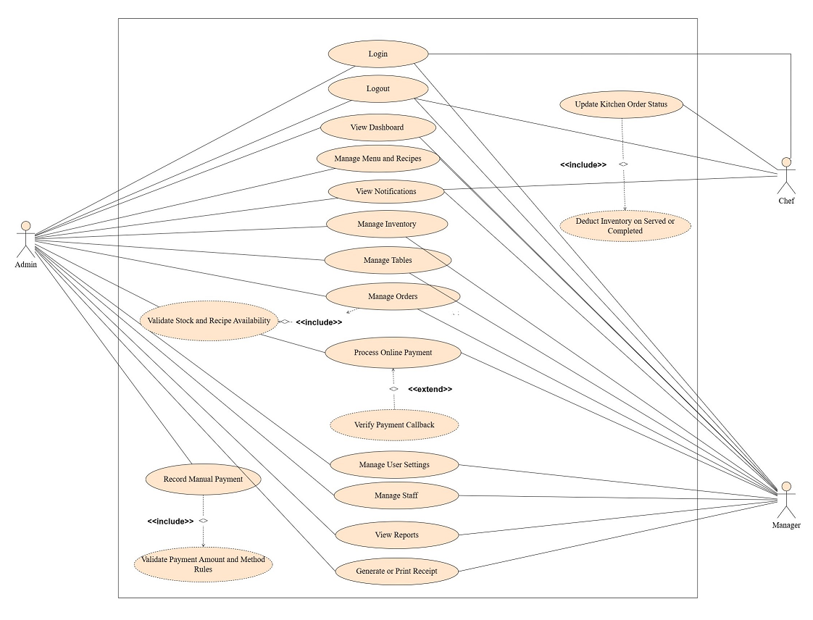

Figure 3.4.2 Use case Diagram

Chapter 4. Analysis Modelling

4.1 Activity Diagrams

4.1.1 Admin Activity Diagram
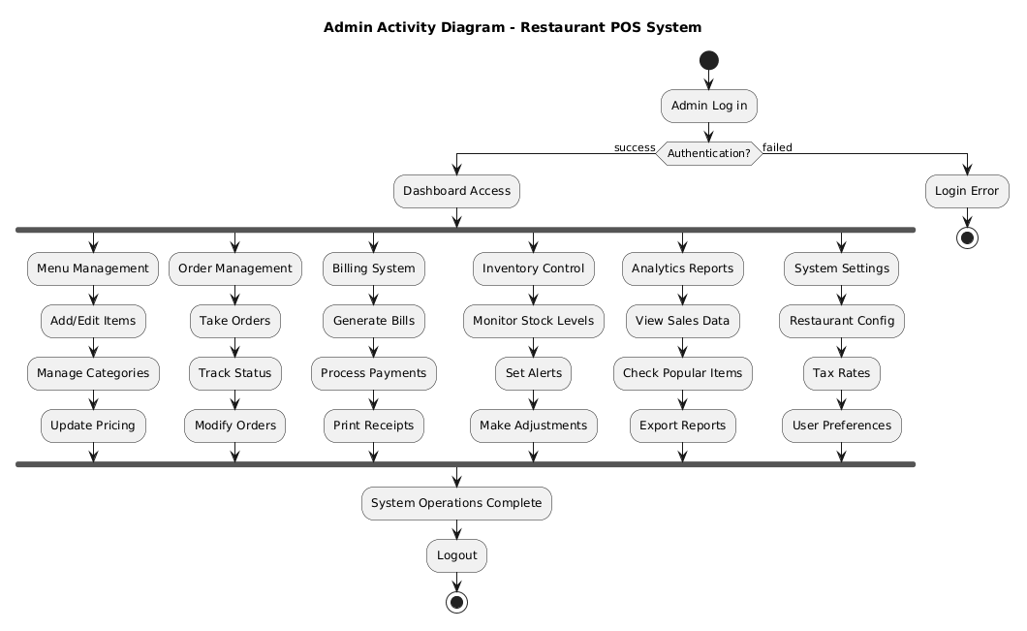
Figure 4.1.1: Restaurant Setup & System Configuration

4.2 Swim Lane Diagram

4.2.1 Swim-lane Diagram for Authentication & Login Process

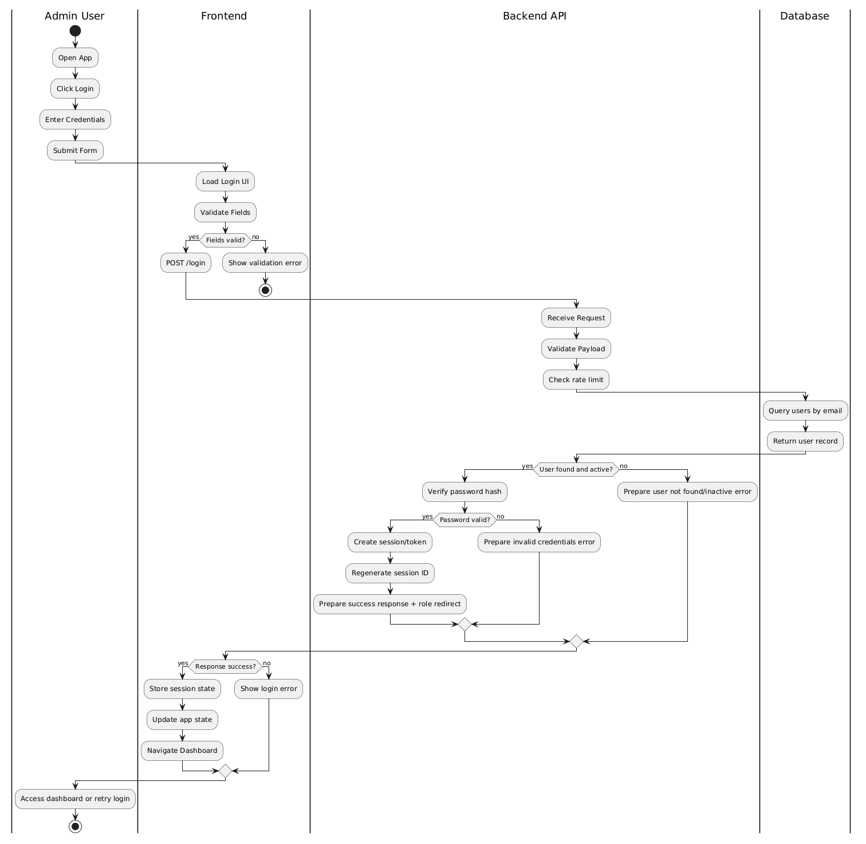

Figure 4.2.1 Swim-lane Diagram for Authentication & Login Process

4.2.2 Swim-lane Diagram for Menu Management
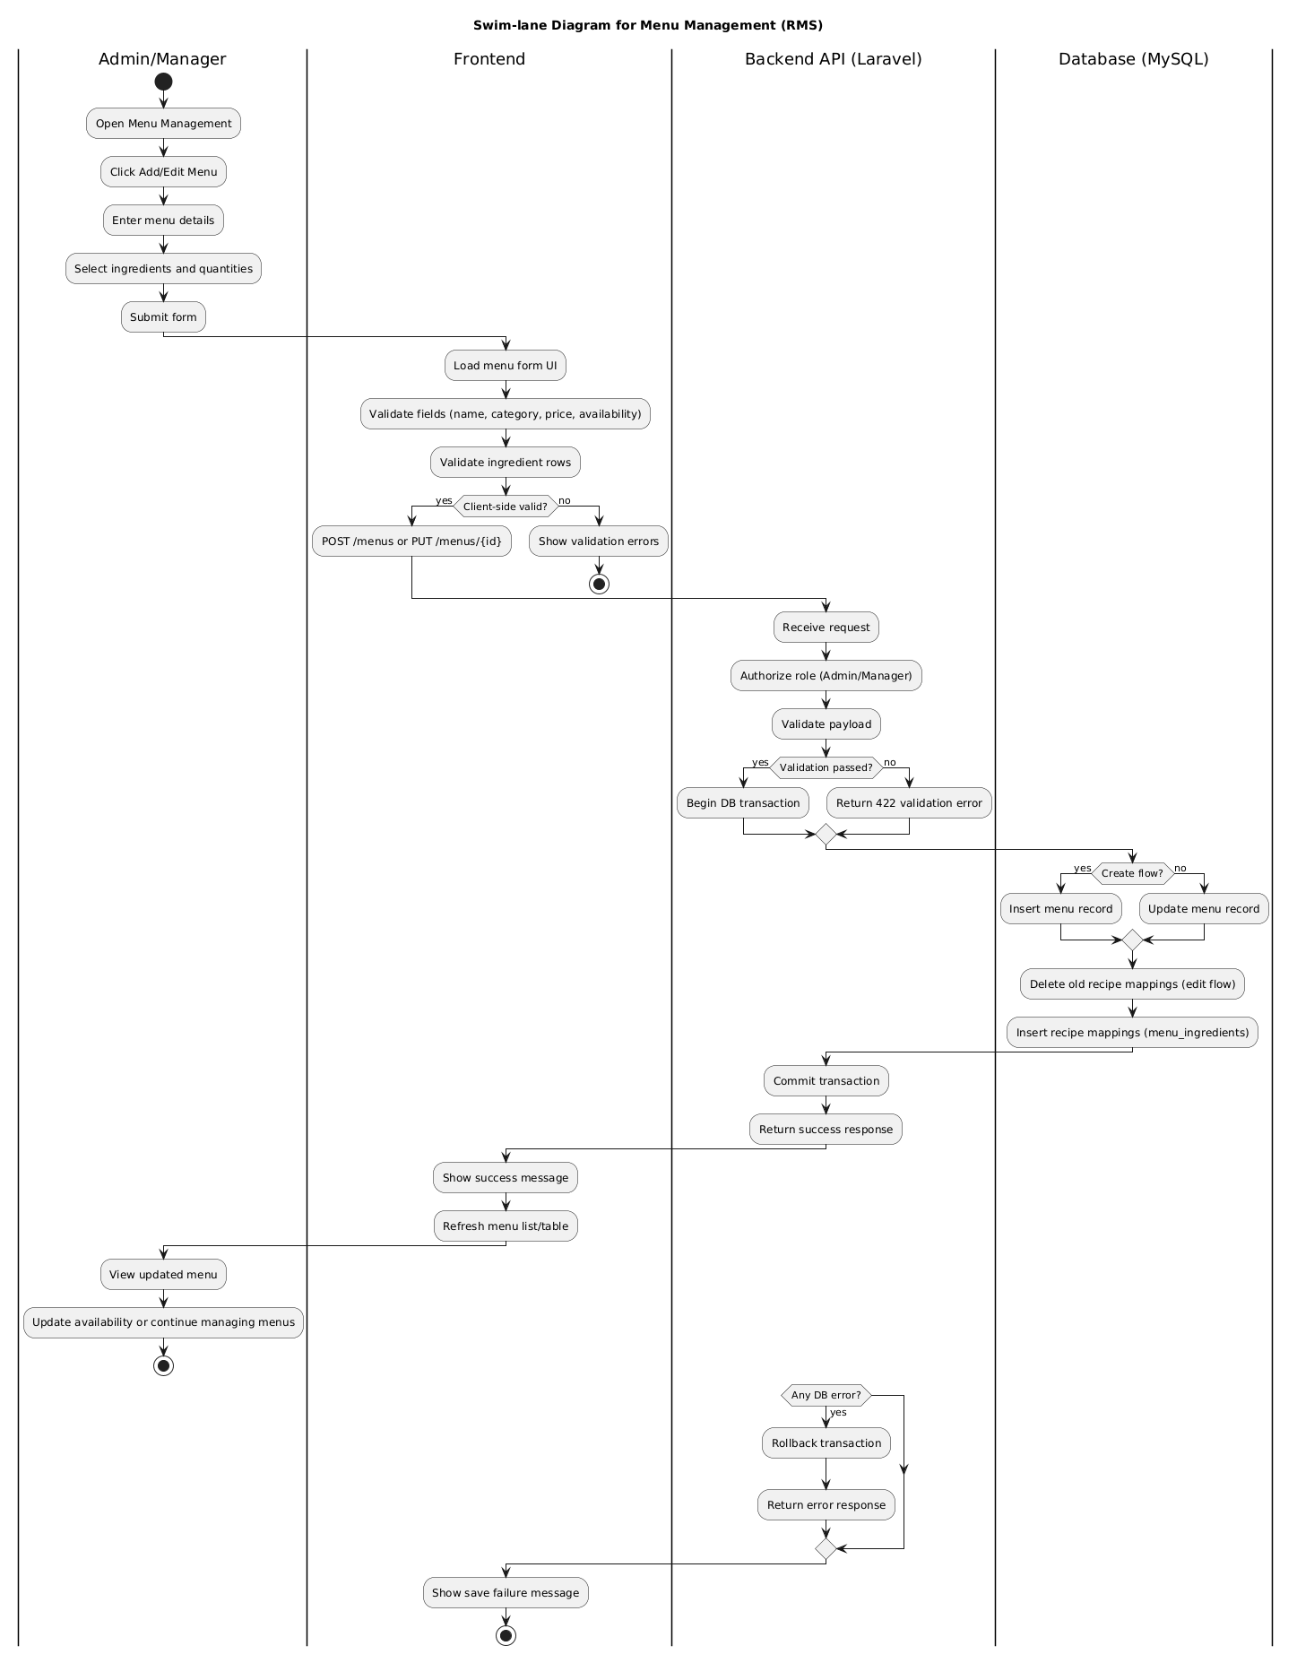
Figure 4.2.2 Swim-lane Diagram for Menu Management.

4.2.3 Swim-lane Diagram for Order Processing Workflow
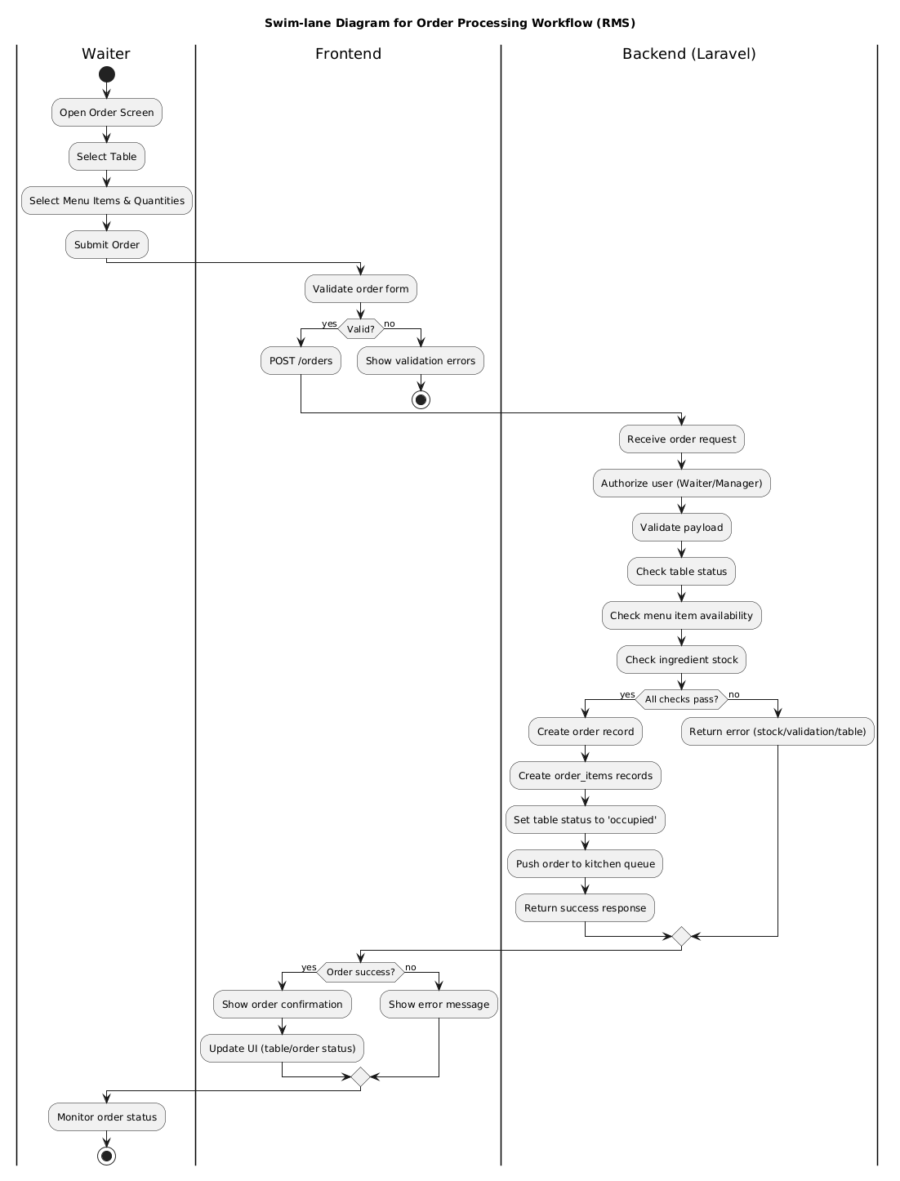
Figure 4.2.3 Swim-lane Diagram for Order Processing Workflow

4.2.4 Swim-lane Diagram for Inventory Management
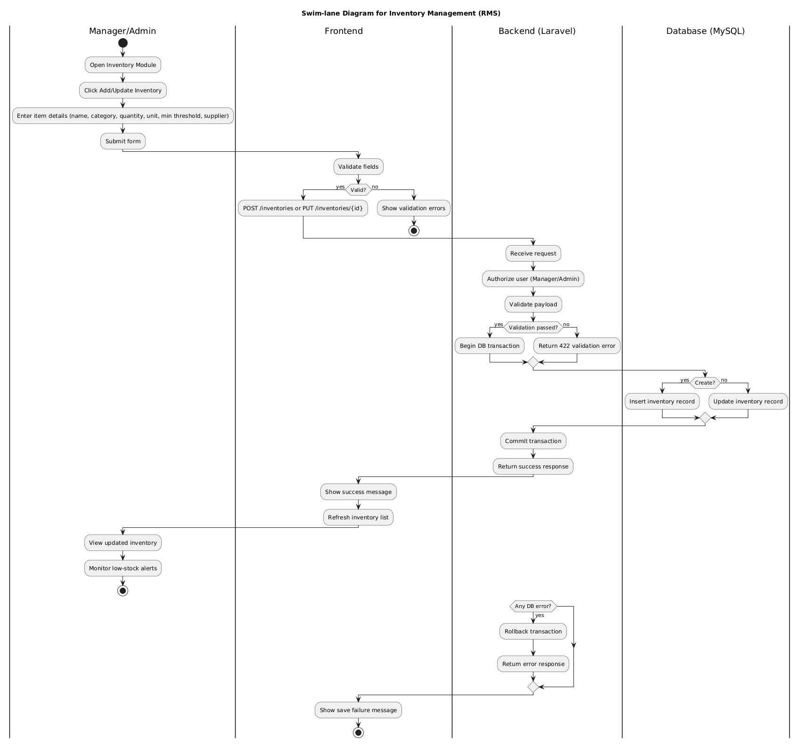
Figure 4.2.4 Swim-lane Diagram for Inventory Management

4.2.5 Swim-lane Diagram for Report & Analytics
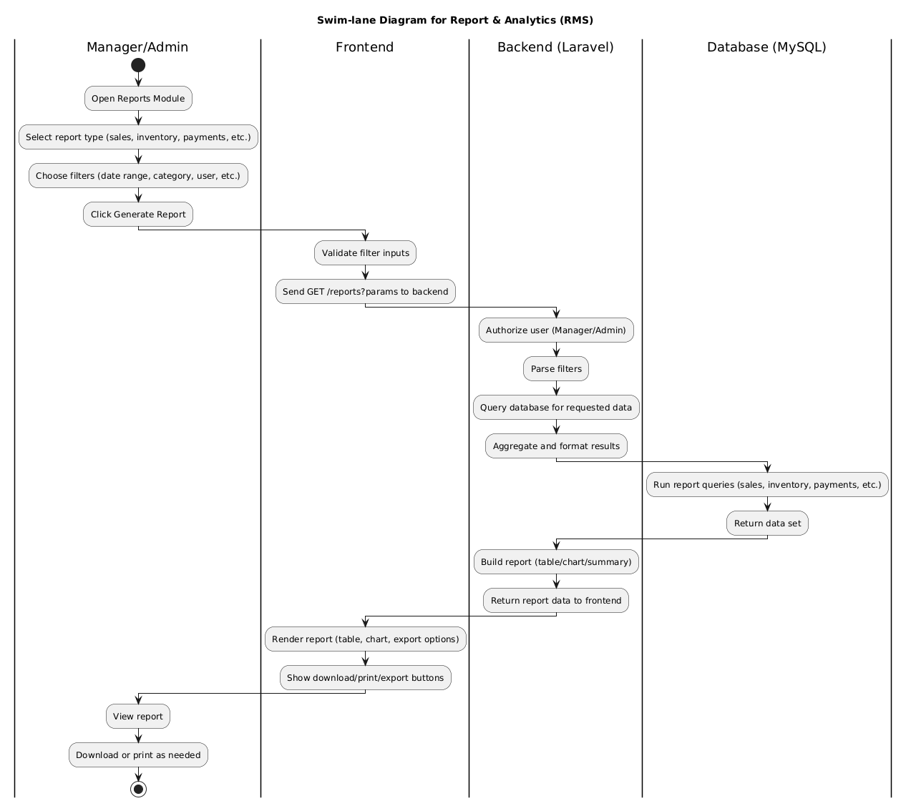
Figure 4.2.5 Swim-lane Diagram for Payment Report & Analytics

4.2.6 Swim-lane Diagram for Billing Module
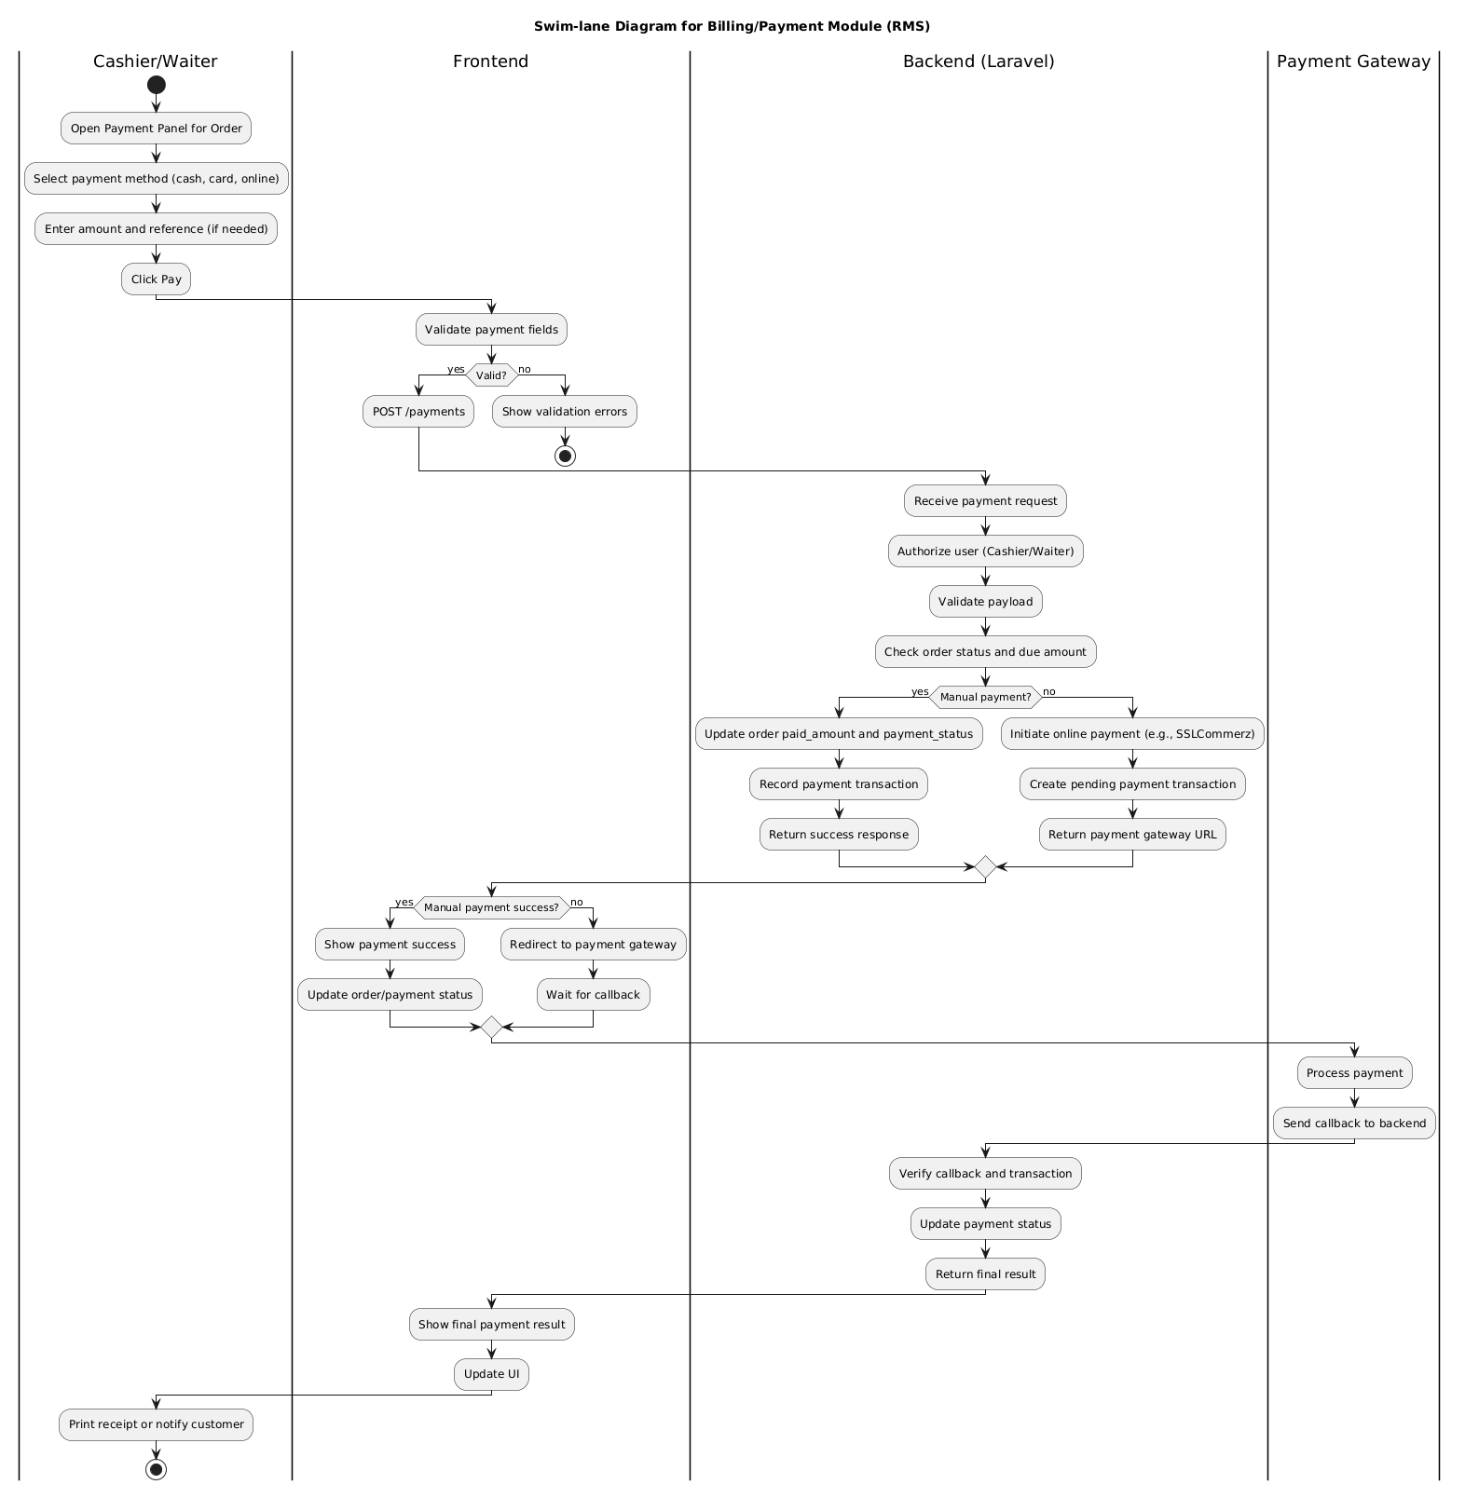
Figure 4.2.6 Swim-lane Diagram for Billing Module

4.3 Class Diagram
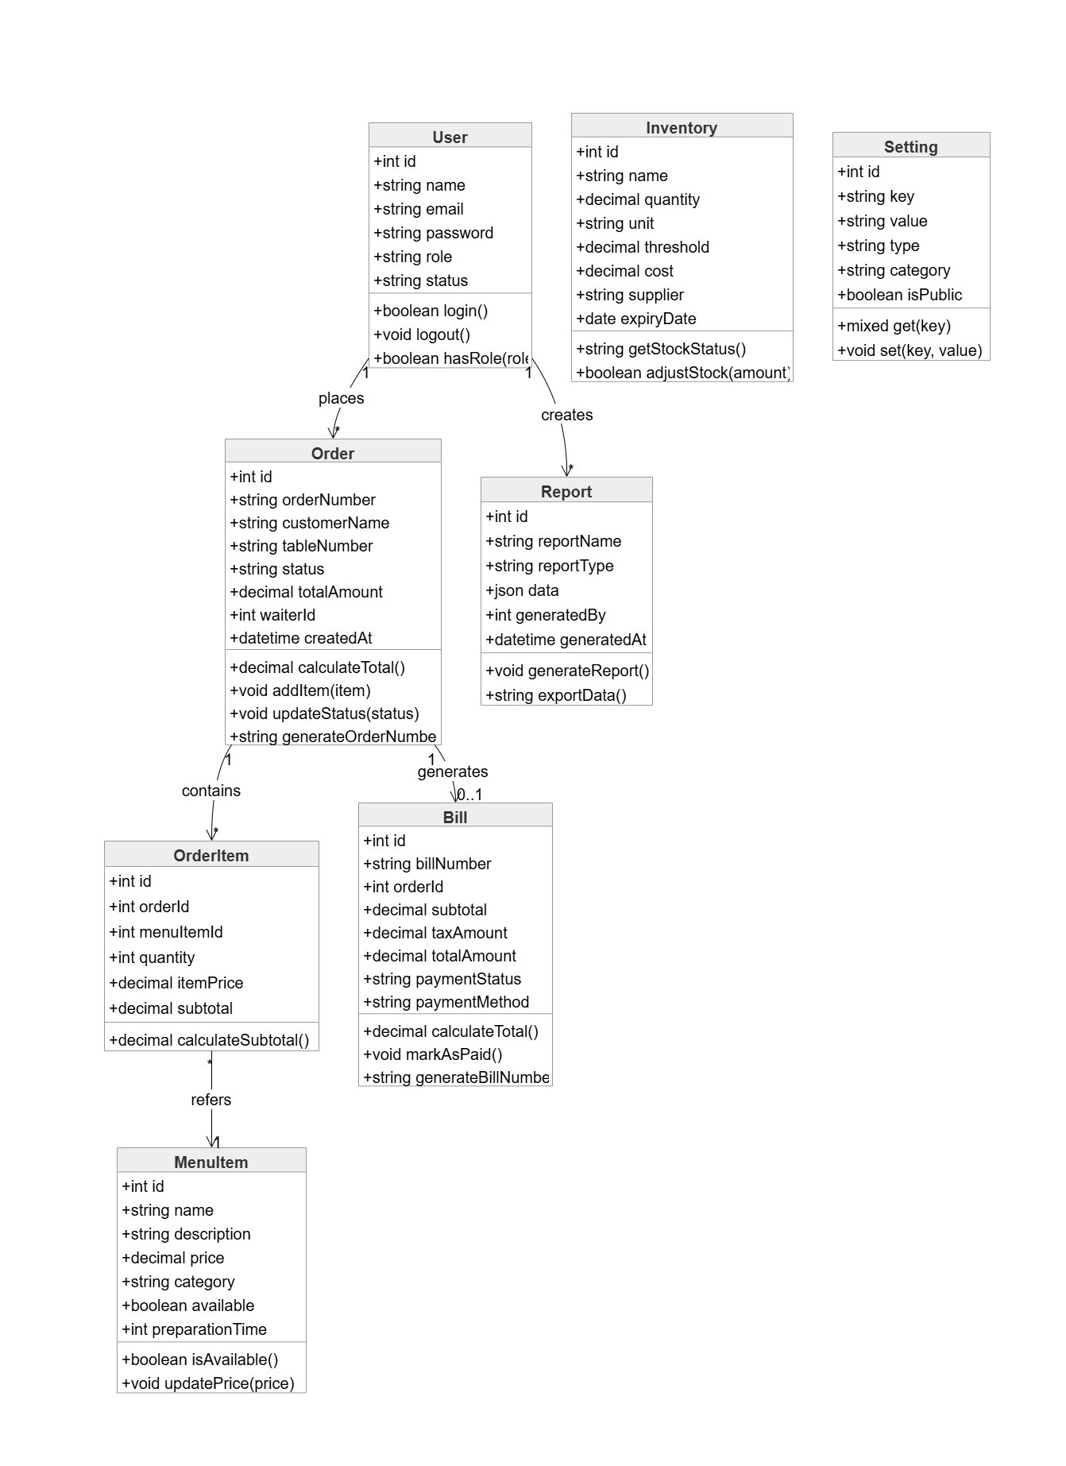

Figure 4.3 Class Diagram

Chapter 5. Project Management

