Instructions: Please read carefully
- Please rename this file as only your ID number (e.g. 18-*****-1 Homework.doc or 18-*****-1 Homework.pdf).
- Submit the file before 14-08-2021 in the MS TEAMS Assignment section labeled Final Assignment.
Do Not Copy!!!
- Represent the following graph with adjacency matrix or adjacency list.
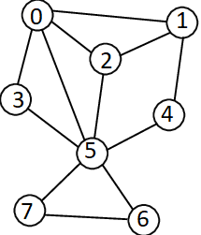
Insert a picture of the adjacency matrix and adjacency list for the graph: Hand Written answer

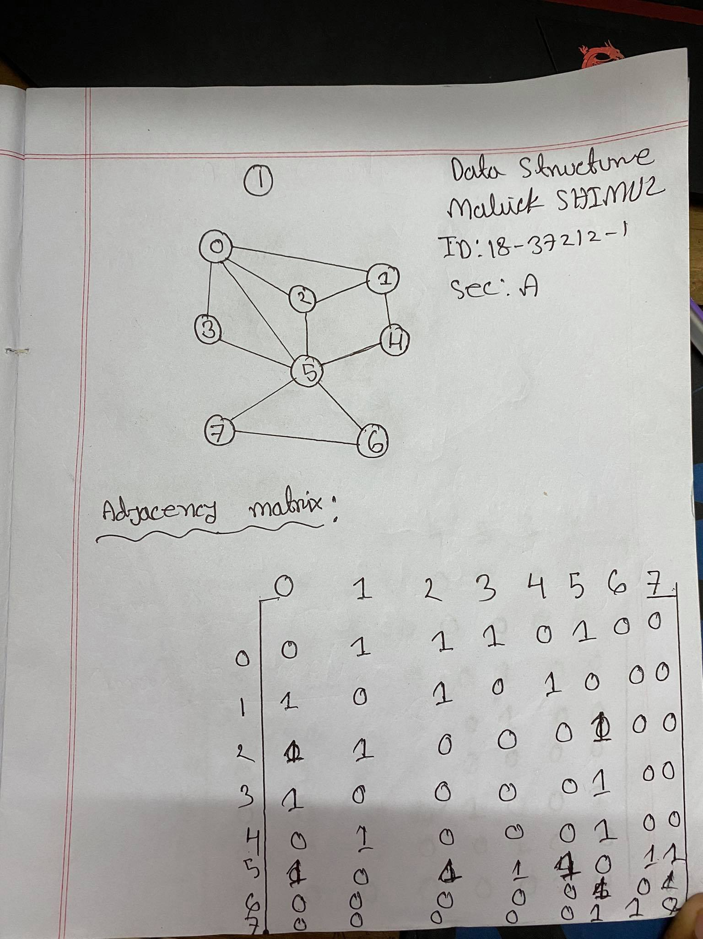
Your code here:
#include<iostream>
using namespace std;
int vertArr[20][20];
int count = 0;
void displayMatrix(int v) {
int i, j;
for(i = 0; i < v; i++) {
for(j = 0; j < v; j++) {
cout << vertArr[i][j] << " ";
}
cout << endl;
}
}
void add_edge(int u, int v) {
vertArr[u][v] = 1;
vertArr[v][u] = 1;
}
main(int argc, char* argv[]) {
int v = 8;
add_edge(0, 1);
add_edge(0, 2);
add_edge(0, 3);
add_edge(0, 5);
add_edge(1, 2);
add_edge(1, 4);
add_edge(2, 5);
add_edge(3, 5);
add_edge(4, 5);
add_edge(5, 6);
add_edge(5, 7);
add_edge(6, 7);
displayMatrix(v);
}

Your whole Screenshot here: (Console Output):

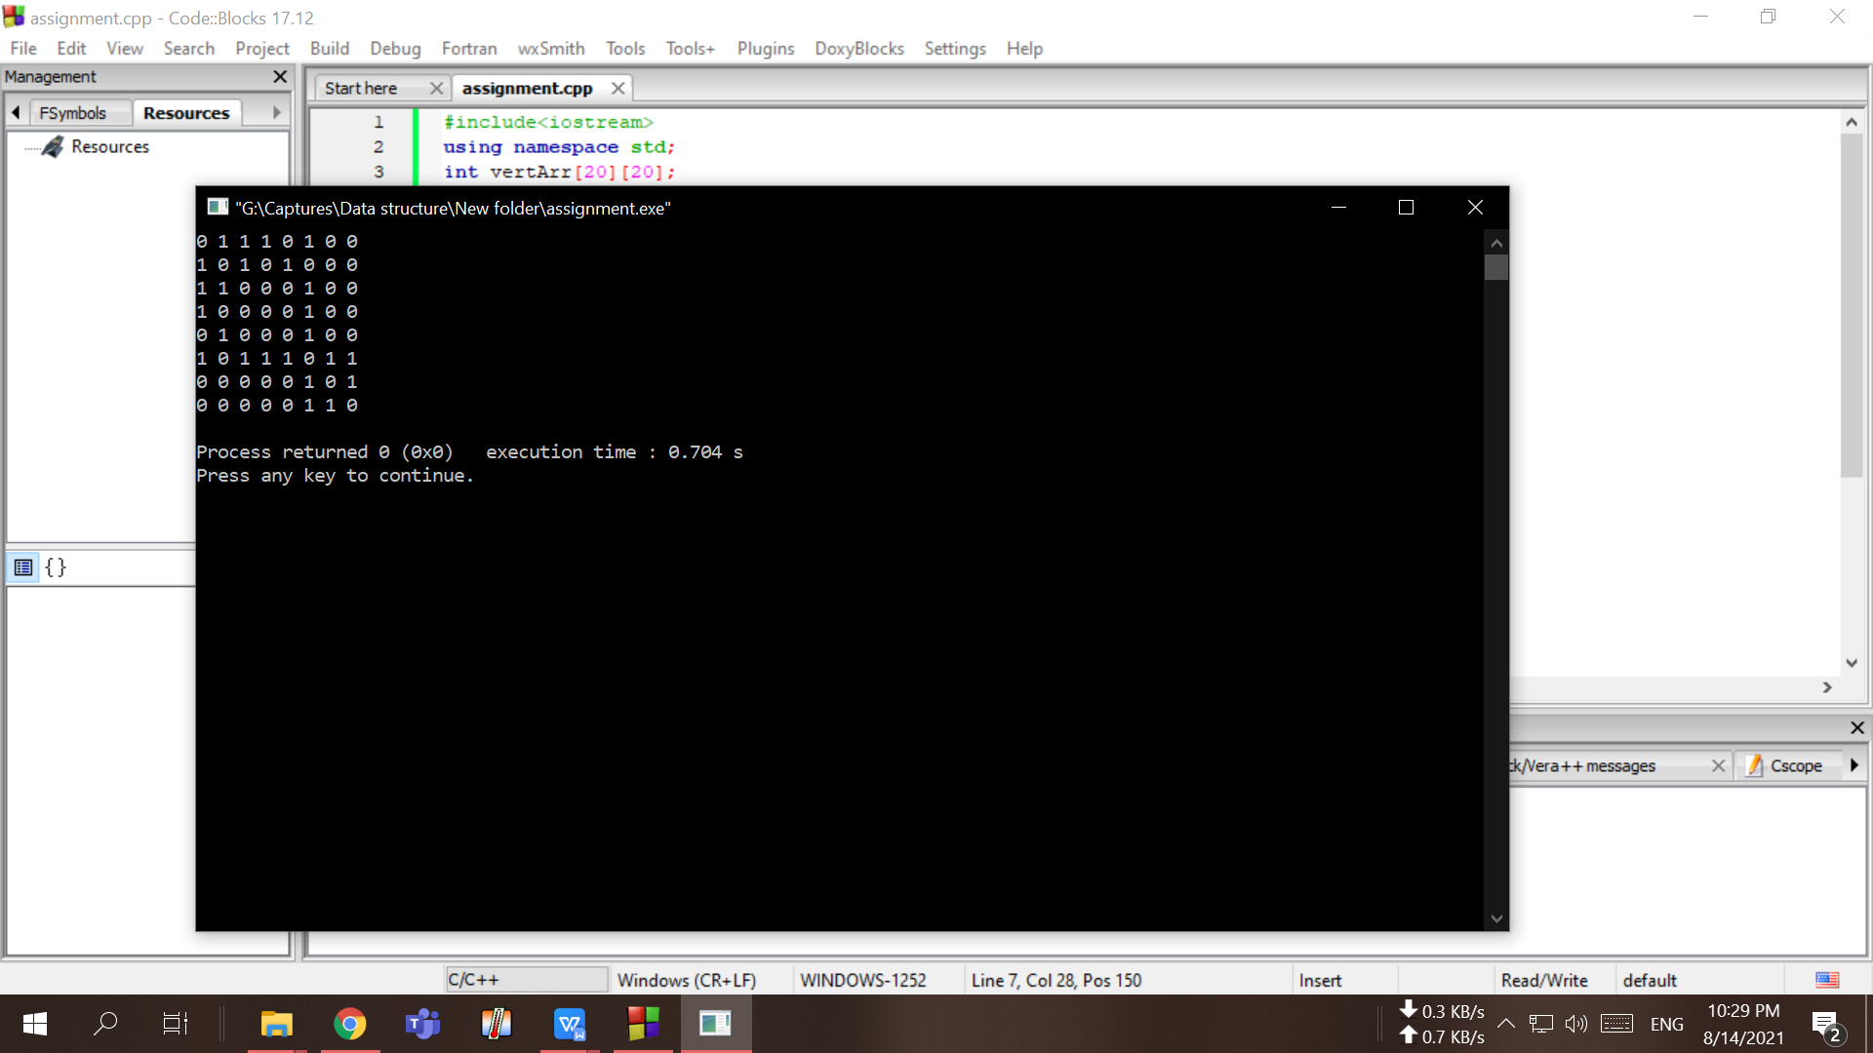

- Represent the following graph with adjacency matrix or adjacency list.

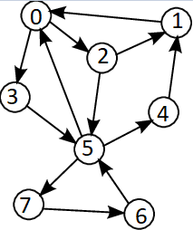
Insert a picture of the adjacency matrix and adjacency list for the graph: Hand Written answer

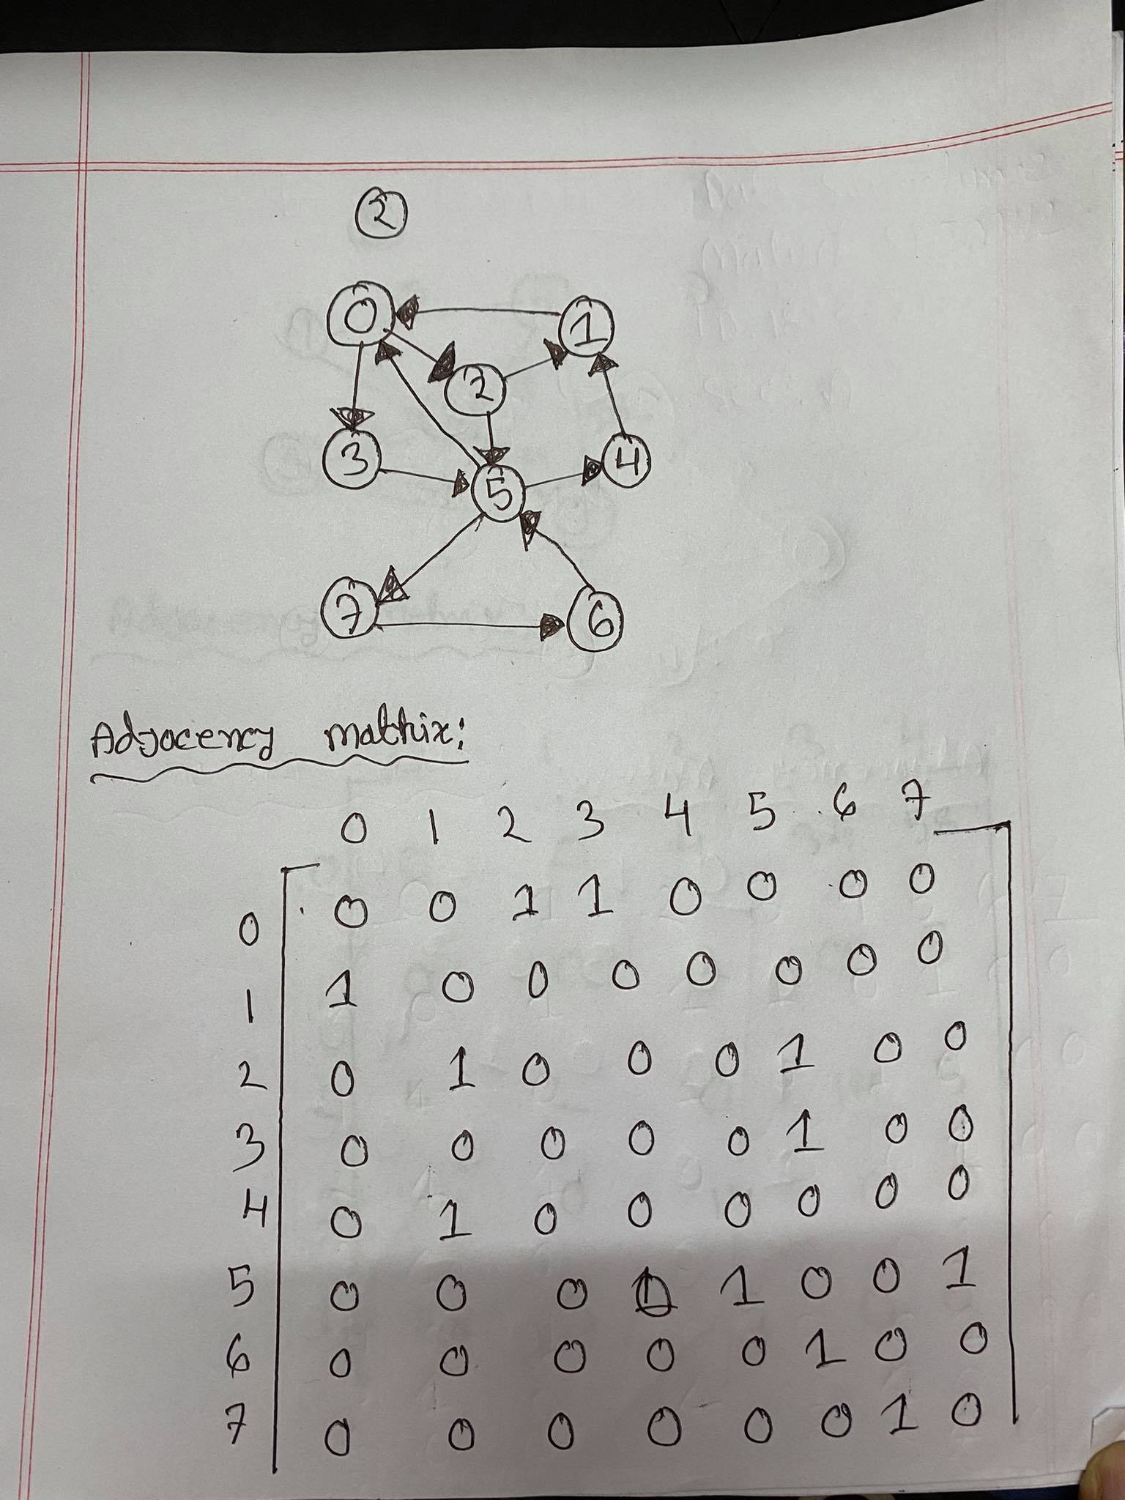
Your code here:

#include <iostream>

using namespace std;
#define v 8
void inti(int mat[][v])
{
for(int i=0;i<v;i++)
{
for(int j=0;j<v;j++)
{
mat[i][j]=0;
}
}
}
void addedge(int mat[][v],int start,int endvertix)
{
mat[start][endvertix]=1;
}
void printmat(int mat[][v])
{
for(int i=0;i<v;i++)
{
for(int j=0;j<v;j++)
{
cout<<mat[i][j]<<" ";
}
cout<<endl;

}
}

int main()
{
int array_in_graph[v][v];
inti(array_in_graph);
addedge(array_in_graph,0,2);
addedge(array_in_graph,0,3);
addedge(array_in_graph,1,0);
addedge(array_in_graph,2,1);
addedge(array_in_graph,2,5);
addedge(array_in_graph,3,5);
addedge(array_in_graph,4,1);
addedge(array_in_graph,5,4);
addedge(array_in_graph,5,7);
addedge(array_in_graph,6,5);
addedge(array_in_graph,7,6);
printmat(array_in_graph);
return 0;
}

Your whole Screenshot here: (Console Output):

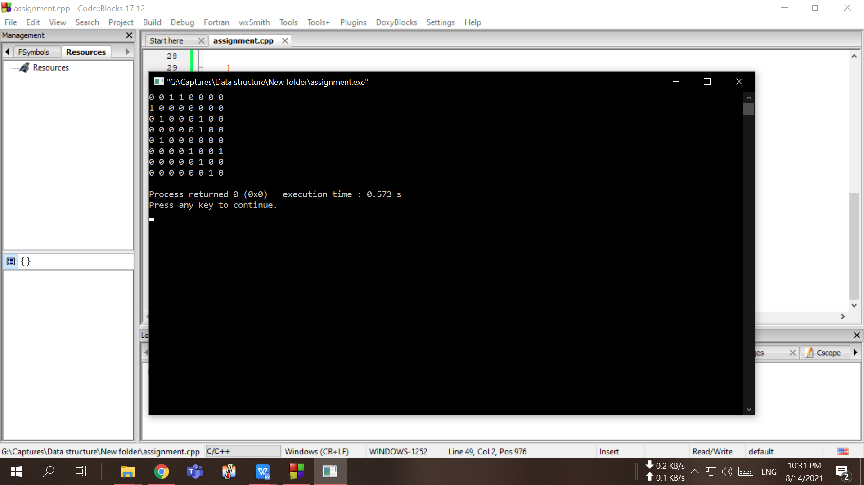

- Represent the following graph with adjacency matrix or adjacency list.
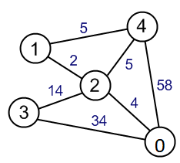
Insert a picture of the adjacency matrix and adjacency list for the graph: Hand Written answer

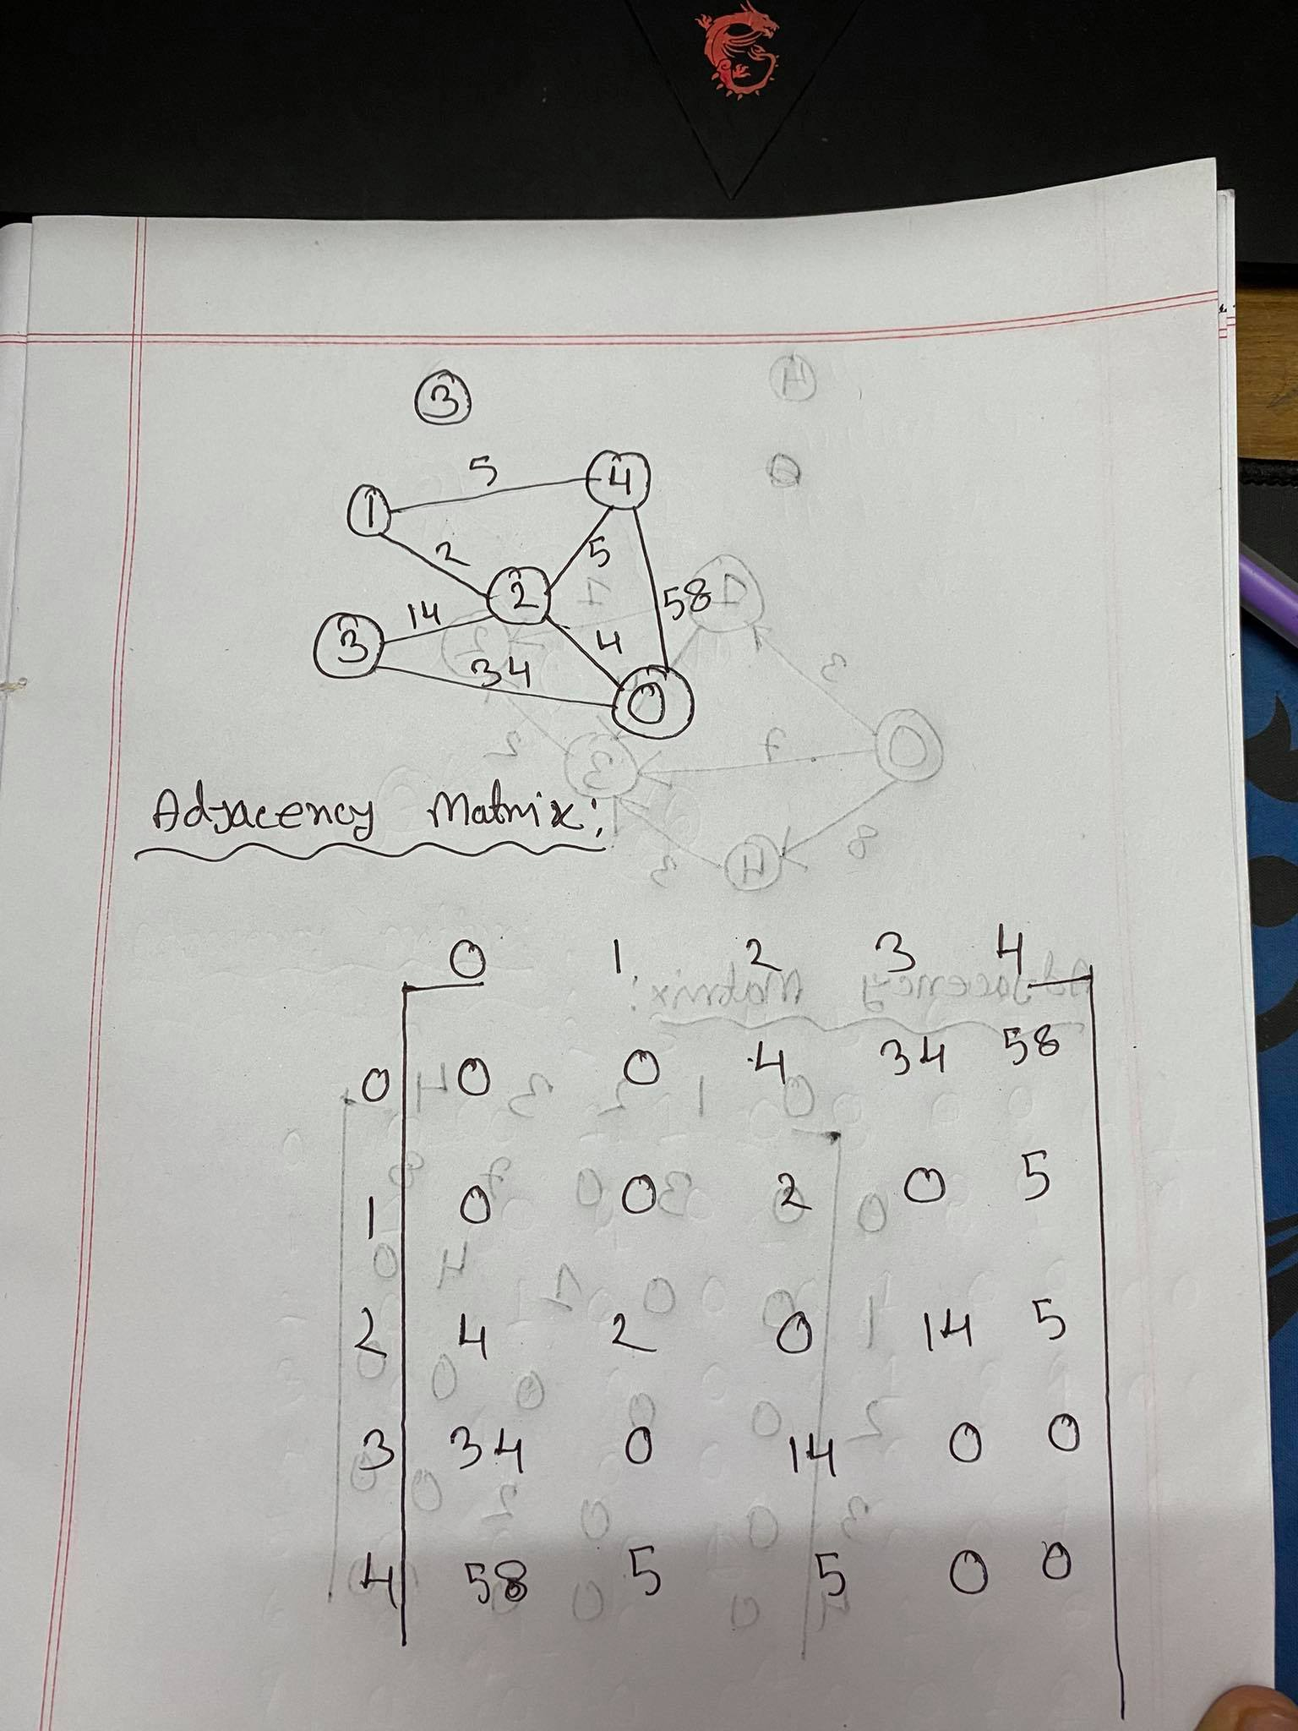
Your code here:
#include <bits/stdc++.h>
using namespace std;
void addEdge(vector <pair<int, int> > adj[], int u,
int v, int wt)
{
adj[u].push_back(make_pair(v, wt));
adj[v].push_back(make_pair(u, wt));
}
void printGraph(vector<pair<int,int> >adj[], int V)
{
int v, w;
for (int u = 0; u < V; u++)
{
cout << "Node " << u << " makes an edge with \n";
for (auto it=adj[u].begin(); it!=adj[u].end(); it++)
{
v = it->first;
w = it->second;
cout << "\tNode " << v << " with edge weight ="
<< w << "\n";
}
cout << "\n";
}
}
int main()
{
int V = 5;
vector<pair<int, int> > adj[V];
addEdge(adj, 0, 2, 4);
addEdge(adj, 0, 3, 34);
addEdge(adj, 0, 4, 58);
addEdge(adj, 1, 2, 2);
addEdge(adj, 1, 4, 5);
addEdge(adj, 2, 0, 4);
addEdge(adj, 2, 1, 2);
addEdge(adj, 2, 3, 14);
addEdge(adj, 2, 4, 5);
addEdge(adj, 3, 0, 34);
addEdge(adj, 3, 2, 14);
addEdge(adj, 4, 0, 58);
addEdge(adj, 4, 1, 5);
addEdge(adj, 4, 2, 5);
printGraph(adj, V);
return 0;
}

Your whole Screenshot here: (Console Output):
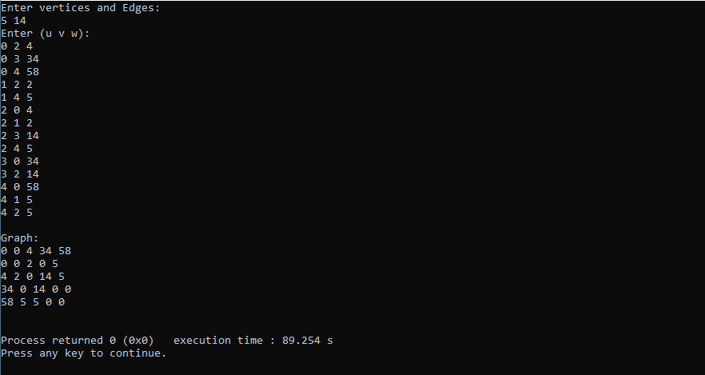

- Represent the following graph with adjacency matrix or adjacency list.

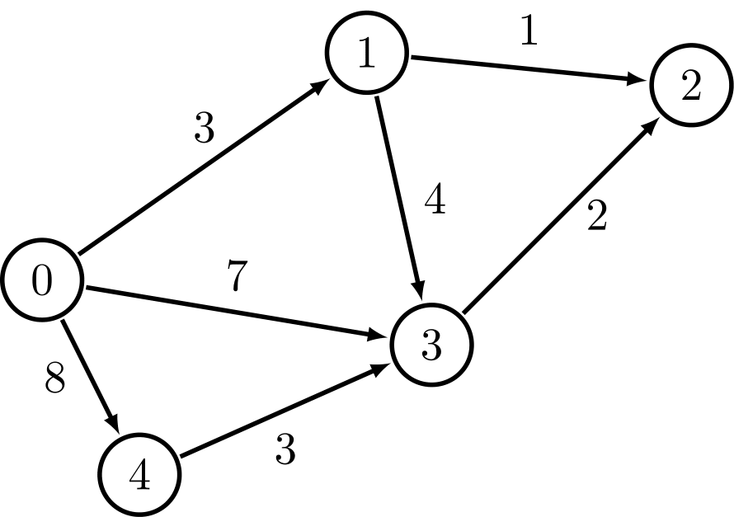
Insert a picture of the adjacency matrix and adjacency list for the graph: Hand Written answer

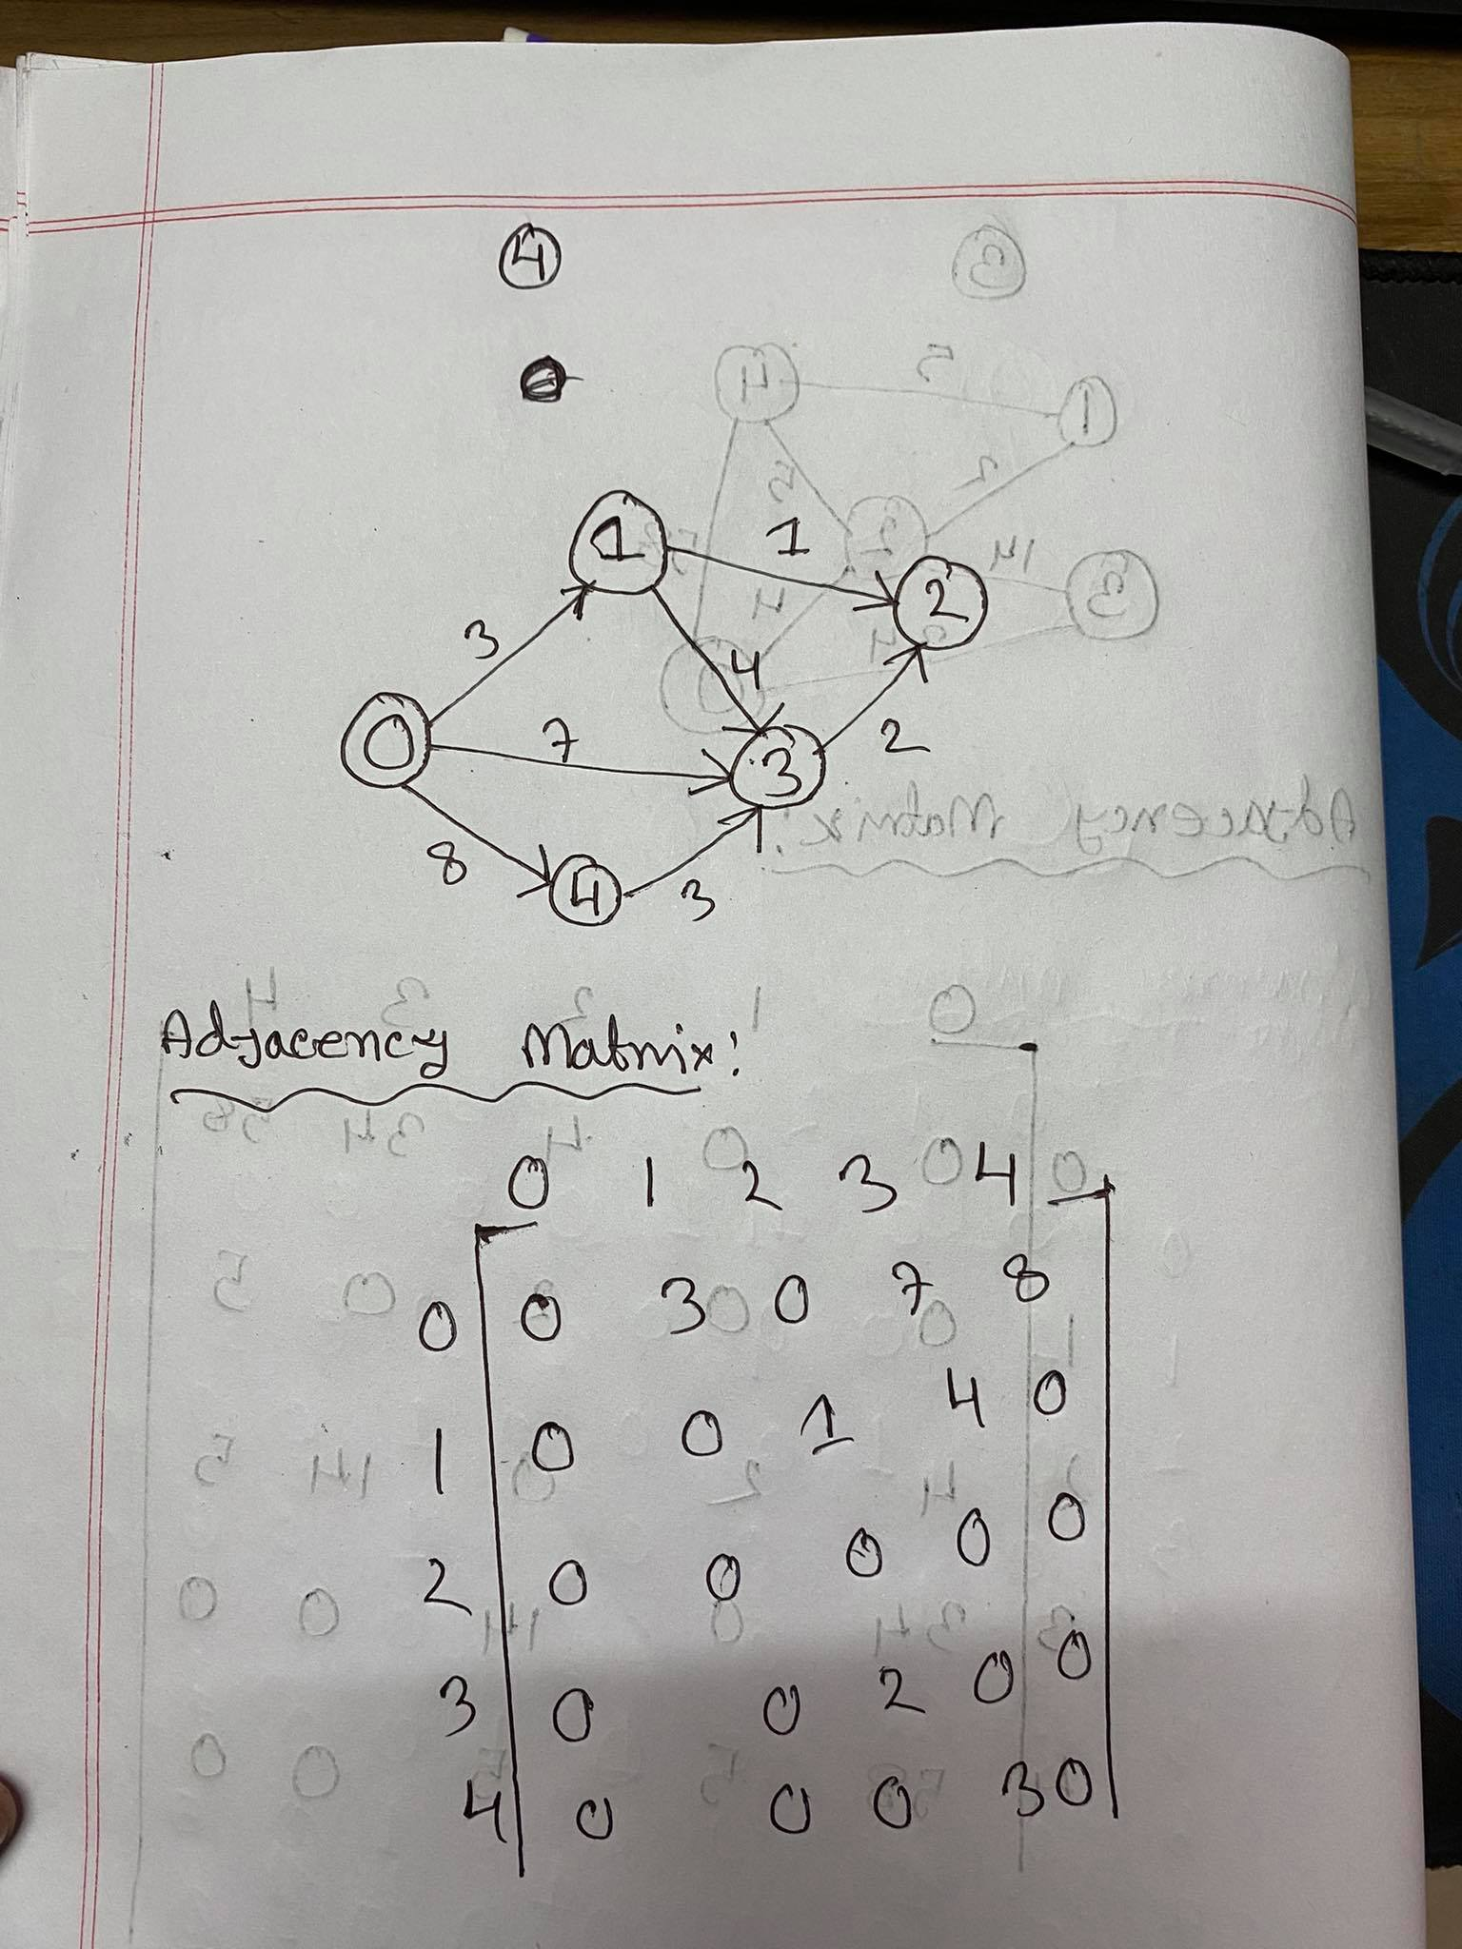
Your code here:

#include<stdio.h>

#define N 100

int Graph[N][N];

int vertices, edges;
int u, v, w;
int i, j;

void InputGraph(){
printf("Enter vertices and Edges:\n");
scanf("%d%d", &vertices, &edges);

for(i = 0; i < vertices; ++i)
for(j = 0; j < vertices; ++j)
Graph[i][j] = 0;

printf("Enter (u v w):\n");
for(i = 0; i < edges; ++i){
scanf("%d%d%d", &u, &v, &w);
Graph[u][v] = w;
}
}

void PrintGraph(){

printf("\n");
printf("Graph:\n");
for(i = 0; i < vertices; ++i){
for(j = 0; j < vertices; ++j)
printf("%d ", Graph[i][j]);
printf("\n");
}
printf("\n");
}

int main(){

InputGraph();
PrintGraph();

return 0;
}

Your whole Screenshot here: (Console Output):
