Instructions: Please read carefully
- Please rename this file as only your ID number (e.g. 18-*****-1.doc or 18-*****-1.pdf).
- Submit the file before 11:00am on 09/06/2021 in the Portal Performance section labeled Lab task 2. If you cannot complete the full task, do not worry. Just upload what you have completed.
Do not copy!!!
- Initialize TWO integer arrays of different sizes. Merge the input arrays and create a new array. Then print the new array in reverse order.
For example,
Array_1 = {10,20,30,40,50}
Array_2 = {1,2,3,4,5,6,7,8}
Output: 8 7 6 5 4 3 2 1 50 40 30 20 10

Your code here:
/*1.Initialize TWO integer arrays of different sizes. Merge the input arrays and
create a new array. Then print the new array in reverse order.*/
#include<iostream>
using namespace std;

void mergearr(int arr1[], int arr2[], int n1,int n2, int arr3[])
{
int i = 0, j = 0, k = 0;
while (i<n1 && j <n2)
{
if (arr1[i] < arr2[j])
arr3[k++] = arr1[i++];
else
arr3[k++] = arr2[j++];
}
while (i < n1)
arr3[k++] = arr1[i++];
while (j < n2)
arr3[k++] = arr2[j++];
}
int main()
{
int arr1[5];
cout<<"enter value of arr1"<<endl;
for(int i=0;i<=4;i++)
{
cin>>arr1[i];
}
int n1 = sizeof(arr1)/sizeof(arr1[0]);

int arr2[7];

cout<<"enter value of arr2"<<endl;
for(int j=0;j<=6;j++)
{
cin>>arr2[j];
}
int n2 = sizeof(arr2)/sizeof(arr2[0]);

int arr3[n1+n2];
mergearr(arr1, arr2, n1, n2, arr3);

cout << "merge array" <<endl;
for (int k=0; k < n1+n2; k++)
cout << arr3[k] << " ";
cout<<'\n'<<"reverse array of arr1"<<endl;
for(int i=4;i>=0;i--)
{
cout<<arr1[i]<<" ";
}
cout<<'\n'<<"reverse array of arr2"<<endl;
for(int j=6;j>=0;j--)
{
cout<<arr2[j]<<" ";
}
cout<<'\n'<<" Merge reserve array"<<endl;
for(int k=11;k>=0;k--)
{
cout<<arr3[k]<<" ";
}
cout<<'\n'<<"Merge reserve array"<<endl;
for(int i=11;i>=0;i--)
{
cout<<arr3[i]<<" ";
}

return 0;
}

Your whole Screenshot here: (Console Output):
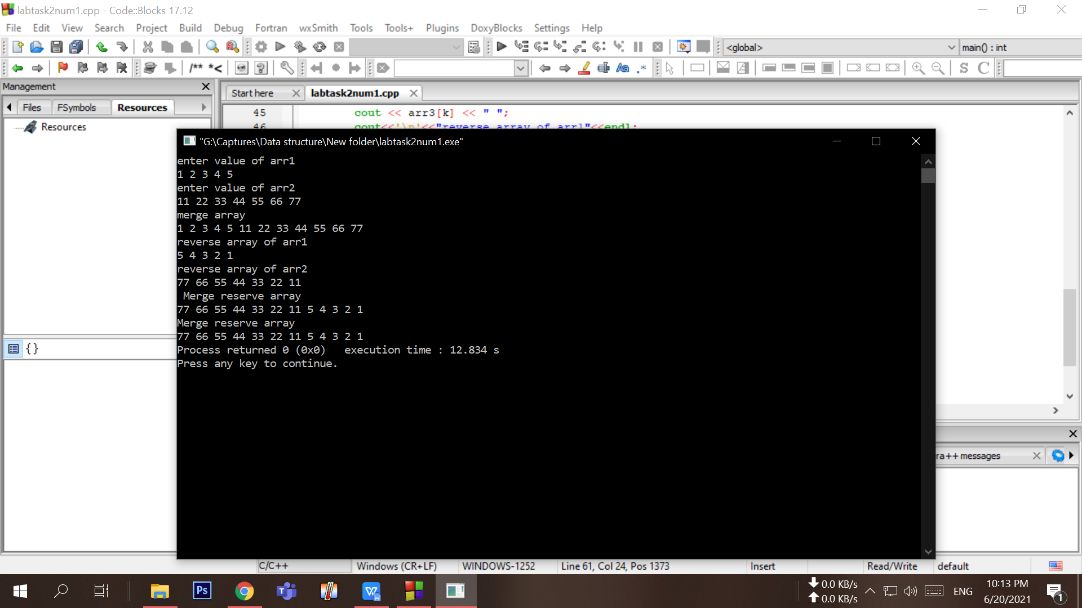

- Initialize TWO integer arrays A and B of different sizes. Make a new array with the common elements between A and B. Print the new array element(s). If there is no common element, output “No common element!”.
For example,
Scenario 1:
Array_1 = {1,4,6,3,6,9}
Array_2 = {5,3,7,1,2,6}
Output: 1 6 3
Scenario 2:
Array_1 = {1,4,6,3,6,9}
Array_2 = {5,8,7,12,21,63}
Output: No common element!

Your code here:
/*Initialize TWO integer arrays A and B of different sizes. Make a new array with the common
elements between A and B. Print the new array element(s).If there is no common element,
output “No common element!”.
*/
#include <bits/stdc++.h>
using namespace std;
void printcommonelement(int arr1[], int arr2[], int m,int n)
{
int i = 0, j = 0;
while (i < m && j < n) {
if (arr1[i] < arr2[j])
i++;
else if (arr2[j] < arr1[i])
j++;
else /* if arr1[i] == arr2[j] */
{
cout << arr2[j] << " ";
i++;
j++;
}
if(arr1[i]!=arr2[j]){
cout<<"\n There is no common element";
}
}

}
int main()
{
int arr1[6];
cout<<"enter value of arr1"<<endl;
for(int i=0;i<=5;i++)
{
cin>>arr1[i];
}
int arr2[6];
cout<<"enter value of arr2"<<endl;
for(int j=0;j<=5;j++)
{

cin>>arr2[j];
}
cout<<"common element array is: "<<endl;
int m = sizeof(arr1) / sizeof(arr1[0]);
int n = sizeof(arr2) / sizeof(arr2[0]);

printcommonelement(arr1, arr2, m, n);

return 0;
}

Your whole Screenshot here: (Console Output):

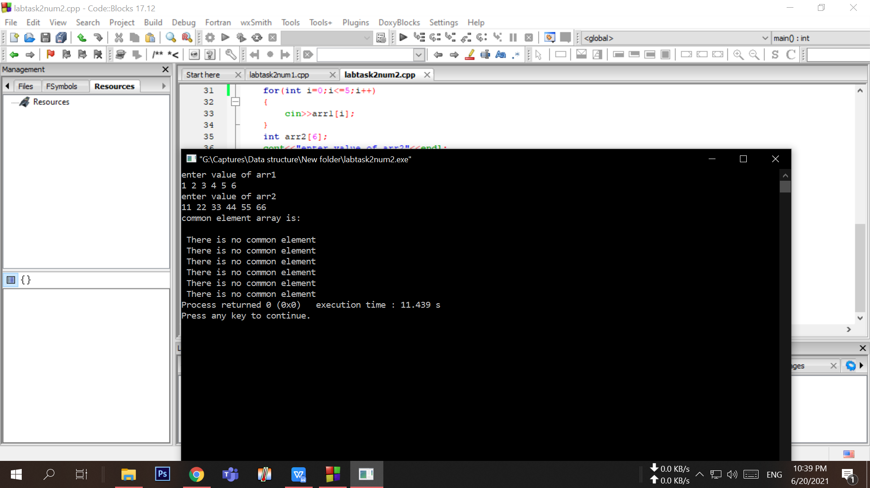

- Initialize an array. Size should be more than FIVE. Write your program to change the array in such a way so that there cannot be any duplicate element in the array anymore. Print the changed array. If the initialized array already had no duplicate elements from the beginning, output a message saying “Array already unique!”;
For example,
Scenario 1:
Array_1 = {1,4,6,3,6,9,1}
Output: 1 4 6 3 9
Scenario 2:
Array_1 = {1,4,5,3,6,9}
Output: Array already unique!

Your code here:
/*3.Initialize an array. Size should be more than FIVE.
Write your program to change the array in such a way so that there
cannot be any duplicate element in the array anymore. Print the changed array. If the initialized
array already had no duplicate elements from the beginning, output a message saying “Array already unique!”;
*/
#include <iostream>
using namespace std;

int main()
{
int arr1[6];
cout<<"enter value of arr1"<<endl;
for(int i=0;i<=5;i++)
{
cin>>arr1[i];
}
cout << "array is: ";

for (int i=0; i < 6; i++)
cout << arr1[i] <<" ";

cout <<"\nUnique changed array: ";
for (int i=0; i<6; i++)
{
int j;
for (j=0; j<i; j++)
if (arr1[i] == arr1[j])
break;
if (i == j)
cout << arr1[i] << " ";
}
cout <<"\nthe array is already unique: ";
for (int i=0; i<6; i++)
{
int j;
for (j=0; j<i; j++)
if (arr1[i] == arr1[j])
cout << arr1[j] << " ";
}

return 0;
}

Your whole Screenshot here: (Console Output):
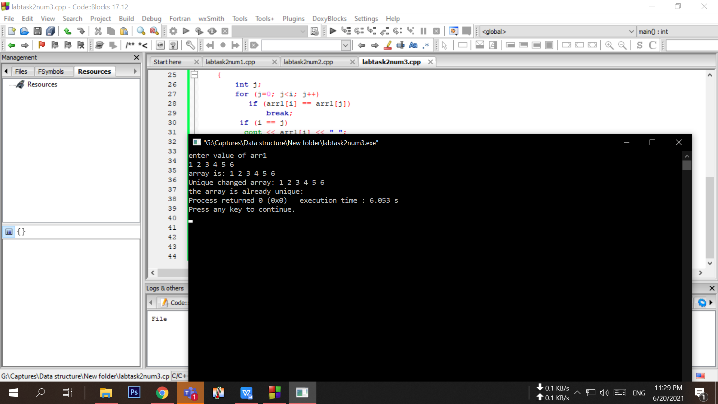

- Initialize an integer array A of size 10. Take an integer as input and print how many times that integer occurs in A.
For example,
Array_1 = {8,4,6,1,6,9,6,1,9,8}
Output:
Input a number to search: 6
The number occurs 3 times in the array

Your code here:
/*4.Initialize an integer array A of size 10.
Take an integer as input and print how many times that integer occurs in A.
*/
#include<bits/stdc++.h>
using namespace std;
int countOccurrences(int arrayA[], int x)
{
int res = 0;
for (int i=0; i<10; i++)
if (x == arrayA[i])
res++;
return res;
}

int main()
{
int i;
int arrayA[10];
cout<<"enter value of array; "<<endl;
for(int i=0;i<10;i++)
{
cin>>arrayA[i];
}

cout<<" input a number to search ";
int x;
cin>>x;
cout << "The number occurs "<<countOccurrences(arrayA, x)<<" times in the array";
return 0;
}

Your whole Screenshot here: (Console Output):
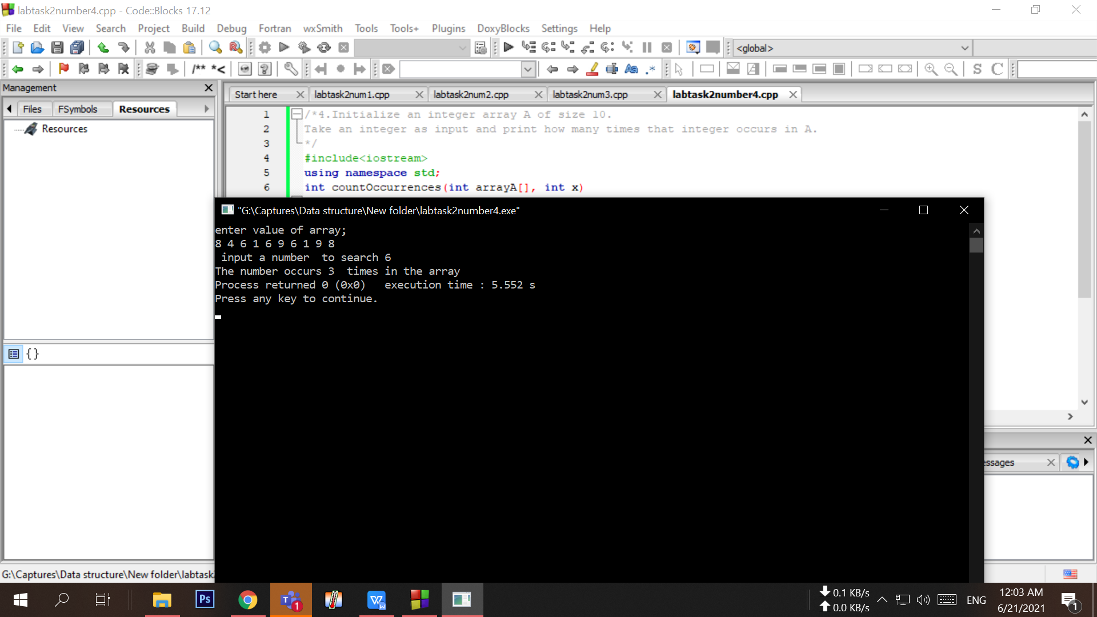

- Initialize an integer array of size 10. Print the number of time each element occurs in the array.
For example,
Array_1 = {8,4,6,1,6,9,6,1,9,8}
Output:
8 occurs = 2 times
4 occurs = 1 time
6 occurs = 3 times
1 occurs = 2 times
9 occurs = 2 times

Your code here:
/*5.Initialize an integer array of size 10.
Print the number of time each element occurs in the array.
*/
#include<iostream>
using namespace std;
int countOccurrences(int arrayA[], int x)
{
int res = 0;
for (int i=0; i<10; i++)
if (x == arrayA[i])
res++;
return res;
}

int main()
{
int i;
int arrayA[10];
cout<<"enter value of array; "<<endl;
for(int i=0;i<10;i++)
{
cin>>arrayA[i];
}

cout<<" input a number to search ";
int x;
cin>>x;
cout <<x<< " occurs="<<countOccurrences(arrayA, x)<<" times "<<endl;
cout<<" input a number to search ";
cin>>x;
cout <<x<< " occurs="<<countOccurrences(arrayA, x)<<" times "<<endl;
cout<<" input a number to search ";
cin>>x;
cout <<x<< " occurs="<<countOccurrences(arrayA, x)<<" times "<<endl;
cout<<" input a number to search ";
cin>>x;
cout <<x<< " occurs="<<countOccurrences(arrayA, x)<<" times "<<endl;
cout<<" input a number to search ";
cin>>x;
cout <<x<< " occurs="<<countOccurrences(arrayA, x)<<" times "<<endl;
return 0;
}

Your whole Screenshot here: (Console Output):

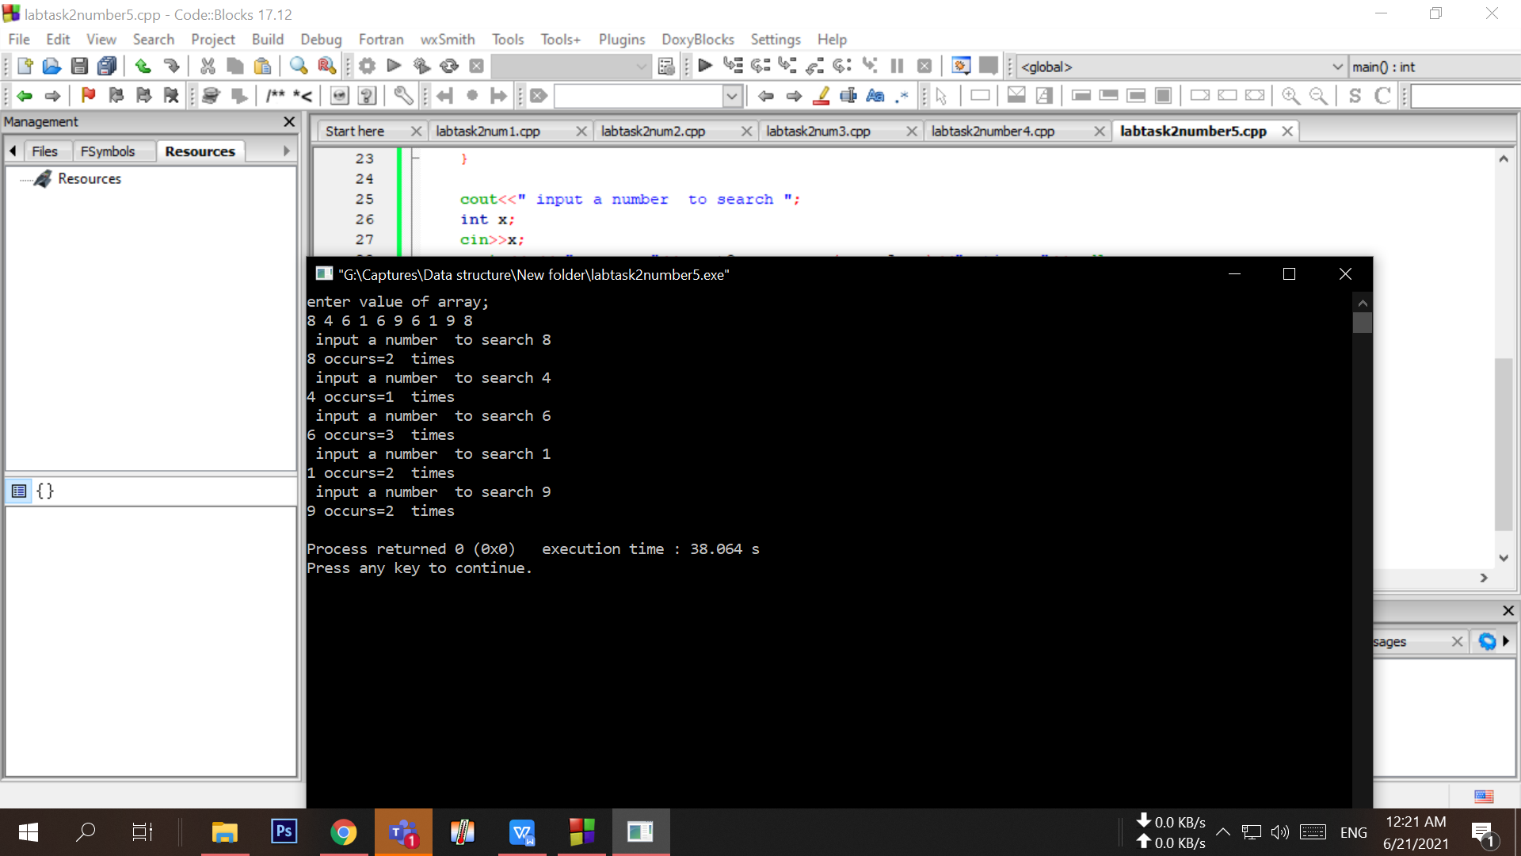

- Initialize a matrix of 3x3 (row x column) size multiply with another matrix of 3x3. Output its multiplied matrix.
For example,
Matrix_1:
1 6 7
2 4 8
3 1 9
Matrix_2:
1 6 7
2 4 8
3 1 9

Output:
34 37 118
34 36 118
32 31 110
Your code here:
/*6.Initialize a matrix of 3x3 (row x column) size
multiply with another matrix of 3x3. Output its multiplied matrix.
*/

#include <iostream>
using namespace std;
int main()
{
int a[3][3],b[3][3],multiply[3][3],i,j,k;
cout<<"enter the first matrix =\n";
for(i=0; i<3; i++)
{
for(j=0; j<3; j++)
{
cin>>a[i][j];
}
}
cout<<"enter the second matrix =\n";
for(i=0; i<3; i++)
{
for(j=0; j<3; j++)
{
cin>>b[i][j];
}
}
cout<<"Multiplied matrix=\n";
for(i=0; i<3; i++)
{
for(j=0; j<3; j++)
{
multiply[i][j]=0;
for(k=0; k<3; k++)
{
multiply[i][j]+=a[i][k]*b[k][j];
}
}
}
for(i=0; i<3; i++)
{
for(j=0; j<3; j++)
{
cout<<multiply[i][j]<<" ";
}
cout<<"\n";
}
return 0;
}

Your whole Screenshot here: (Console Output):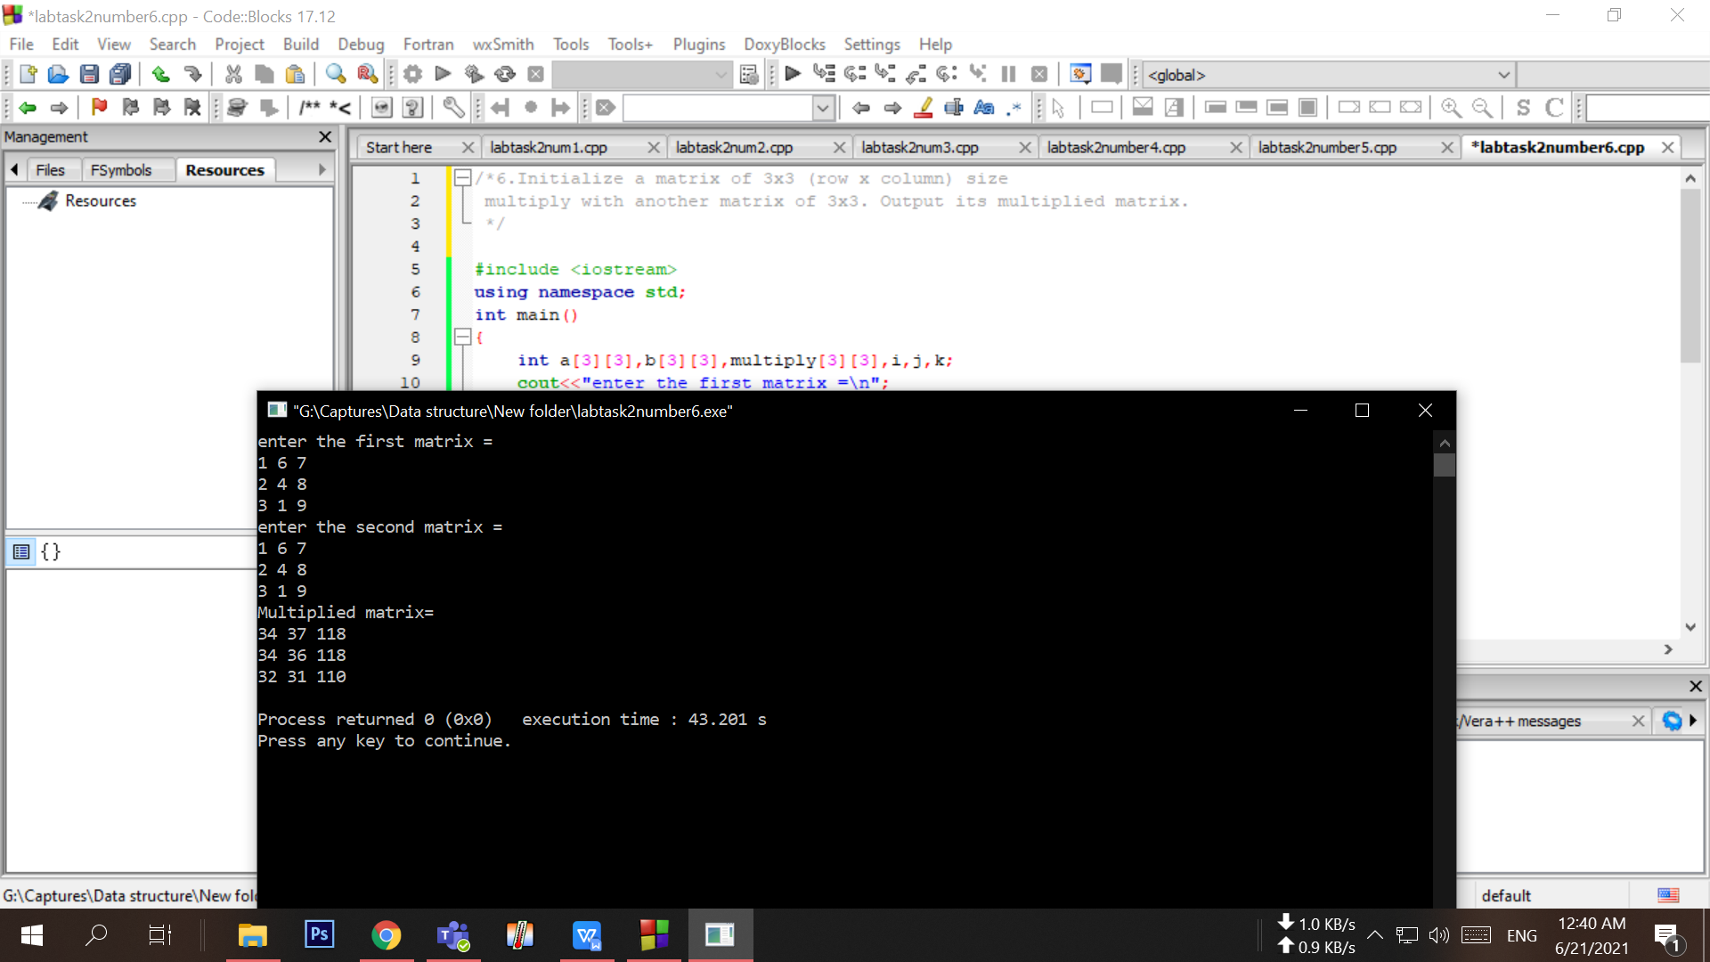

- Initialize a matrix of minimum 3x4 (row x column) size. Output its transpose matrix.
For example,
Matrix_1:
1 6 7 9
2 4 8 5
3 1 9 4
Output:
1 2 3
6 4 1
7 8 9
9 5 4

Your code here:
#include <iostream>
using namespace std;

int main()
{
int a[3][4], transpose[4][3], i, j;

cout << "\nEnter elements of matrix: " << endl;

for (int i = 0; i < 3; ++i)
{
for (int j = 0; j < 4; ++j)
{
cin >> a[i][j];
}
}
for (int i = 0; i < 3; ++i)
for (int j = 0; j < 4; ++j)
{
transpose[j][i] = a[i][j];
}

cout << "\nTranspose of Matrix: " << endl;
for (int i = 0; i < 4; ++i){
for (int j = 0; j < 3; ++j)
{
cout << " " << transpose[i][j];
if (j == 3 - 1)
cout << endl << endl;
}
}

return 0;

}

Your whole Screenshot here: (Console Output):

