Instructions: Please read carefully
- Please rename this file as only your ID number (e.g. 18-*****-1.doc or 18-*****-1.pdf).
- Submit the file before 11:59pm on 16/06/2021 in the Portal Lab Performance section labeled Task 3. If you cannot complete the full task, do not worry. Just upload what you have completed.

- Find the summation of the boundary elements for the given array. Take input from user keyboard.

1 | 2 | 3 | 4 | 5
14 | 15 | 16 | 17 | 6
13 | 20 | 9 | 18 | 7
12 | 11 | 10 | 9 | 8
Hint: max row size = m = 4 and max column size = n = 5.
If(i==0||i==m-1||j==0||j==n-1){
sum= arr[i][j] + sum;
}
For example,
Matrix_1:
1 2 3 4 5
14 15 16 17 6
13 1 9 18 7
12 11 10 9 8
Output:
Summation is: 105

Your code here://1.Find the summation of the boundary elements for the given array. Take input from user keyboard.
#include<iostream>
using namespace std;

int main()
{
int i,j,m, n, sum = 0;

m=4;
n=5;
int arr[m][n];
cout << "\nInput the matrix elements\n";
for(i = 0; i < m; i++)
{
for(j = 0; j < n; j++)
cin >> arr[i][j];
}

//cout << "Boundary Matrix"<<endl;
for(i = 0; i < m; i++)
{
for(j = 0; j < n; j++)
{
if(i==0||i==m-1||j==0||j==n-1)
{
//cout << arr[i][j] << " ";
sum = sum + arr[i][j];
}
else
cout <<" ";
}
cout << endl;
}
cout << " Sum of boundary is " << sum << endl;
return 0;
}

Your whole Screenshot here: (Console Output):
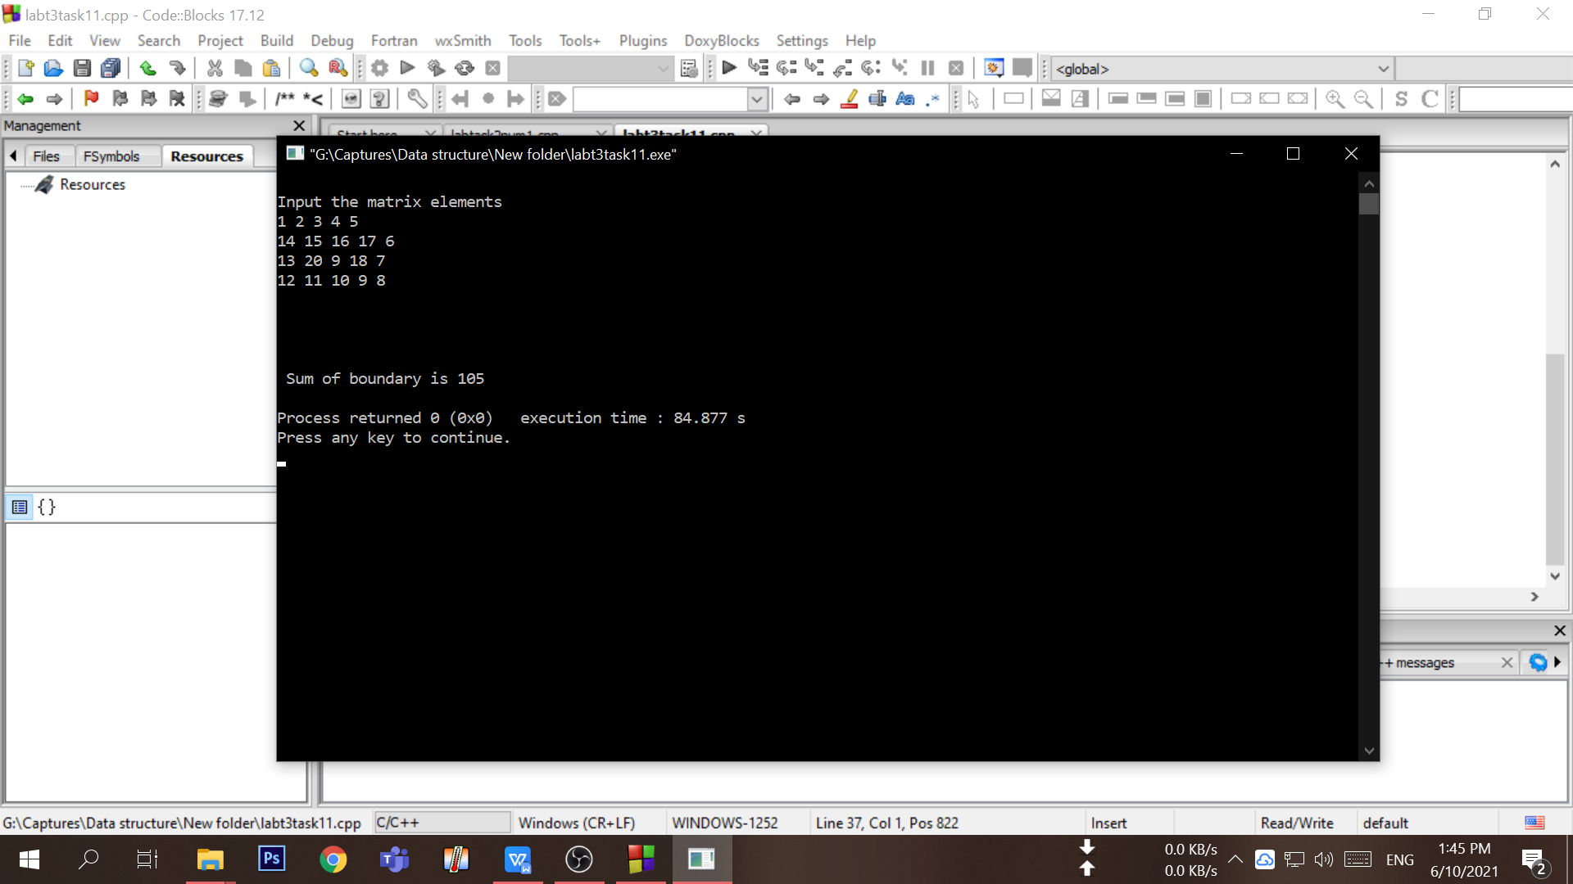

- Find the summation of the diagonal and anti-diagonal elements for the given array. Take input from user keyboard.

1 | 2 | 3 | 4 | 5
14 | 15 | 16 | 17 | 6
13 | 20 | 19 | 18 | 7
12 | 11 | 10 | 9 | 8
21 | 22 | 23 | 24 | 25
If( i==j || i+j == n+1 )
For example,
Matrix_1:
1 2 3 4 5
14 15 16 17 6
13 1 19 18 7
12 11 10 9 8
21 22 23 24 25
Output:
Summation is: 123

Your code here:

Your whole Screenshot here: (Console Output):

- Write a code that will create custom ciphers (encoded words) on strings. Follow this procedure:
  - Write a function named encode that takes TWO parameters, a string s and an integer j.
  - Increase the ASCII value of the next character by 2 (leave white spaces).
  - Perform step (2) throughout the string.
  - Return the converted string from encode function.
For example,
Sample String (s): I am a student
Sample Integer (j): 2
Converted String: K co c uvwfgpv
Your code here:

Your whole Screenshot here: (Console Output):

- Write a program with appropriate data structure to keep records of 10 students. Each student will have the following information:
  - Unique ID (you can use integer for this)
  - Number of Credits Completed
  - CGPA
Print all the student’s ID whose CGPA is more than 3.75.
Print all the student’s ID who has completed more than 50 credits.
Your code here:

Your whole Screenshot here: (Console Output):

