Instructions: Please read carefully
- Please rename this file as only your ID number (e.g. 18-*****-1.doc or 18-*****-1.pdf).
- Submit the file before 11:59pm on 23/06/2021 in the Portal Performance section labeled task 4. If you cannot complete the full task, do not worry. Just upload what you have completed.

- Write a code to implement an array (static) based stack and its operations (Push and Pop). Get options from the user to push, pop and display the stack. If the stack is full and you want to push another value show message “Stack overflowed!!!”. If empty show “Stack is empty”

Example:
What you want to do?
1. Push element in the stack
2. Pop element from the stack
3. Display the stack
Your code here:
#include <iostream>
using namespace std;
int stack[5], n=5, top=-1;
bool push(int value) {
if(top>=n-1)
cout<<"Stack overflowed!!!"<<endl;
else {
top++;
stack[top]=value;
}
}
bool pop() {
if(top<=-1)
cout<<"Stack Underflow"<<endl;
else {
cout<<"The popped element is "<< stack[top] <<endl;
top--;
}
}
void display() {
if(top>=0) {
cout<<"Stack elements are:";
for(int i=top; i>=0; i--)
cout<<stack[i]<<" ";
cout<<endl;
} else
cout<<"Stack is empty";
}
int main() {
int ch, value;
cout<<"What you want to do? "<<endl;
cout<<"1) Push element in the stack"<<endl;
cout<<"2) Pop element from the stack"<<endl;
cout<<"3) Display the stack"<<endl;
do {
cout<<"I want to "<<endl;
cin>>ch;
switch(ch) {
case 1: {
cout<<"Enter value to be pushed:"<<endl;
cin>>value;
push(value);
break;
}
case 2: {
pop();
break;
}
case 3: {
display();
break;
}
default: {
cout<<"Invalid Choice"<<endl;
}
}
}
while(ch!=3);
return 0;
}

Your whole Screenshot here: (Console Output):
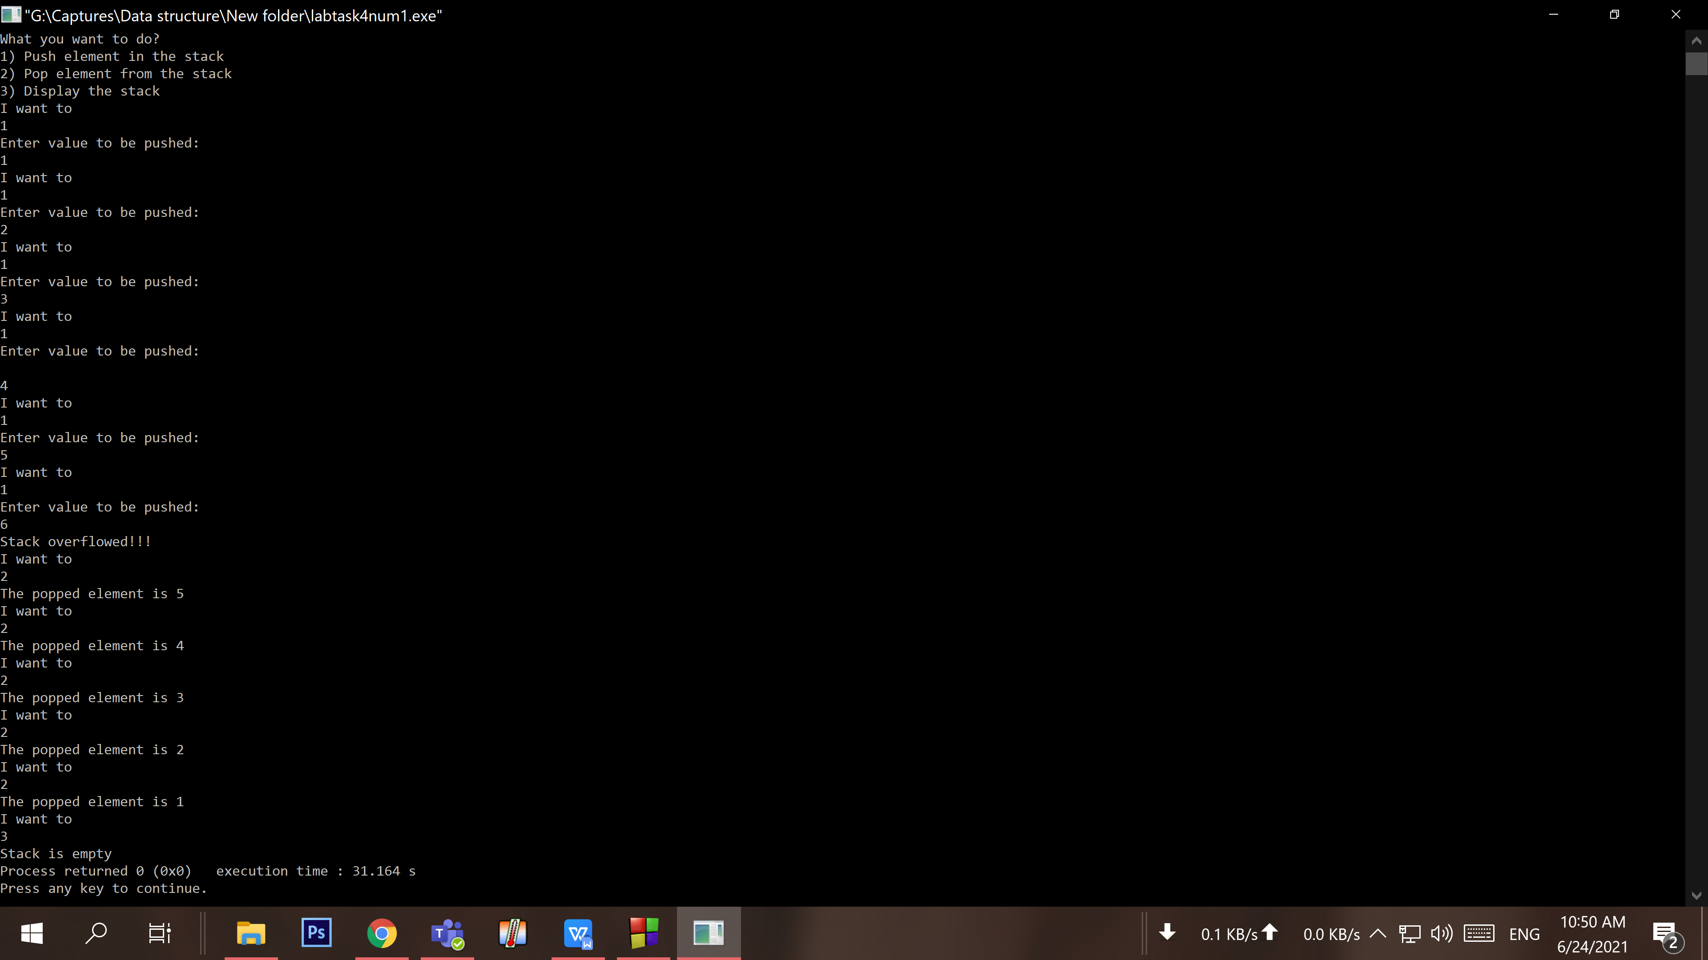

- Write a code to implement an array (static) based queue and its operations (Enqueue and Dequeue). Get options from the user to Enqueue, Dequeue and display the queue. If the Queue is full and you want to enqueue another value show message “Queue overflowed!!!”. If empty show “Queue is empty”

Example:
What you want to do?
1. Enqueue element in the queue
2. Dequeue element in the queue
3. Display the stack
Your code here:

#include <iostream>
using namespace std;
int queue[5], n = 5, front = - 1, rear = - 1;
void Enqueue() {
int value;
if (rear == n - 1){
cout<<"Queue Overflow"<<endl;
return;
}
else {
if (front == - 1)
front = 0;
cout<<"Insert the element in queue : "<<endl;
cin>>value;
rear++;
queue[rear] = value;
}
}
void Dequeue() {
if (front == - 1 || front > rear) {
cout<<"Queue Underflow ";
return ;
} else {
cout<<"Element deleted from queue is : "<< queue[front] <<endl;
front++;;
}
}
void displayQueue() {
if (front == -1) {
cout<<"Queue is empty"<<endl;
return;
}
cout<<"Queue elements are :\n";
if (front <= rear) {
for(int i=front; i<=rear; i++){
cout<<queue[i]<<" ";
}
}
cout<<endl;
}
int main() {
int ch,value;
cout<<"What you want to do? "<<endl;
cout<<"1. Enqueue element in the queue"<<endl;
cout<<"2. Dequeue element in the queue"<<endl;
cout<<"3. Display the Queue"<<endl;
do {
cout<<"I want to "<<endl;
cin>>ch;
switch (ch) {
case 1: Enqueue();
break;
case 2: Dequeue();
break;
case 3: displayQueue();
break;
}
}
while(ch!=3);
return 0;
}

Your whole Screenshot here: (Console Output):

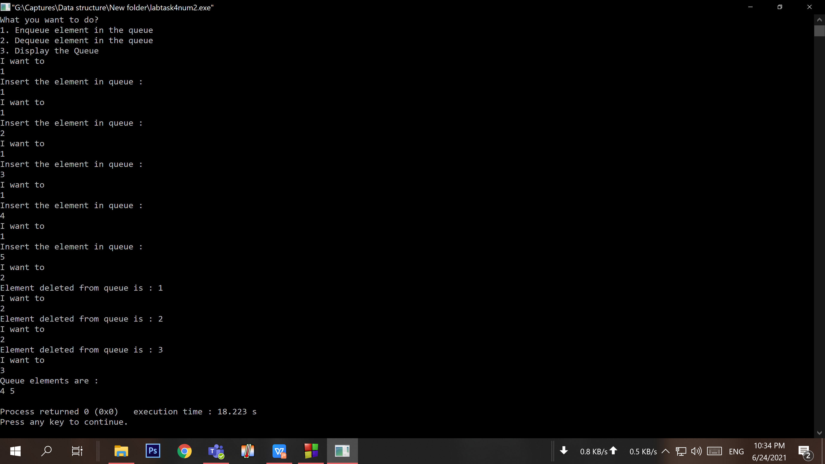

- Write a code to implement a dynamic (memory) array based stack and its operations (Push and Pop). Get options from the user to push, pop and display the stack. If the stack is full and you want to push another value, it will allow you to increase the size of stack and push the data. If empty show “Stack is empty”
Example:

What you want to do?
1. Push element in the stack
2. Pop element in the stack
3. Display the stack

Your code here:
#include<iostream>
using namespace std;

class MyStack{
int *Stack, Top, MaxSize=5;
public:
Stack(int);
Stack();
bool isEmpty();
bool isFull();
bool push(int Element);
bool pop();
bool topElement();
void show();
void resize( int size);
};
MyStack::Stack( int Size =5 ){
MaxSize = Size;
Stack = new int[MaxSize];
Top = 0;

MyStack::Stack(){
delete [] Stack;
}
void resize( int Size = 5 ){
int *tempStk = new int[ MaxSize + Size ];
for( int i=0; i<MaxSize; i++ ) tempStk[i] = Stack[i];
MaxSize += Size;
delete [] Stack;
Stack = tempStk;
}
void push( int Element ){
if( isFull( ) ) resize( );
Stack[ Top++ ] = Element;
}
nt main() {
int ch,value;
cout<<"What you want to do? "<<endl;
cout<<"1. Enqueue element in the queue"<<endl;
cout<<"2. Dequeue element in the queue"<<endl;
cout<<"3. Display the Queue"<<endl;

Your whole Screenshot here: (Console Output):

