Instructions: Please read carefully
- Please rename this file as only your ID number (e.g. 18-*****-1.doc or 18-*****-1.pdf).
- Submit the file before 26-06-2021 in the Portal Lab Performance section labeled Lab task 5. If you cannot complete the full task, do not worry. Just upload what you have completed.
- Write a code to implement an array (static) based Circular queue and its operations (Enqueue and Dequeue). Get options from the user to Enqueue, Dequeue and display the queue. If the Queue is full and you want to enqueue another value show message “Queue overflowed!!!”. If empty show “Queue is empty”

Example:
What you want to do?
1. Enqueue element in the queue
2. Dequeue element from the queue
3. Display the queue
Your code here:
/*1.Write a code to implement an array (static) based Circular queue
and its operations (Enqueue and Dequeue). Get options from the user to Enqueue,
Dequeue and display the queue. If the Queue is full and you want to enqueue another value
show message “Queue overflowed!!!”.
If empty show “Queue is empty”
*/
#include <iostream>
using namespace std;

int Queue[4],maxsize=4,value;
int front =-1, rear = -1;

void Enqueue(int value) {
if ((front == 0 && rear == maxsize-1) || (front == rear+1)) {
cout<<"Queue Overflow \n";
return;
}
if (front == -1 && rear ==-1) {
front = 0;
rear = 0;
}
else {
rear=(rear+1)%maxsize;
}
Queue[rear] = value ;
}
void Dequeue() {
if (front == -1) {
cout<<"Queue Underflow\n";
return ;
}
cout<<"Element deleted from queue is : "<<Queue[front]<<endl;

if (front == rear) {
front = -1;
rear = -1;
}
else {
front=(front+1)%maxsize;
}
}
void displayQueue() {
if (front == -1) {
cout<<"Queue is empty"<<endl;
return;
}
cout<<"Queue elements are :\n";
if (front <= rear) {
for(int i=front; i<=rear; i++){
cout<<Queue[i];
}
}
else {
for(int i=front; i<=(maxsize-1); i++){
cout<<Queue[i];
}
front = 0;
for(int i=0; i<=rear; i++){
cout<<Queue[i];
}
}
cout<<endl;
}
int main() {

int ch, value;
cout<<"What you want to do? "<<endl;
cout<<"1. Enqueue element in the queue"<<endl;
cout<<"2. Dequeue element in the queue"<<endl;
cout<<"3. Display the Queue"<<endl;
do {
cout<<"Enter choice : "<<endl;
cin>>ch;
switch(ch) {
case 1:
cout<<"Input for insertion: "<<endl;
cin>>value;
Enqueue(value);
break;

case 2:
Dequeue();
break;

case 3:
displayQueue();
break;
}
}
while(ch != 3);
return 0;
}

Your whole Screenshot here: (Console Output):
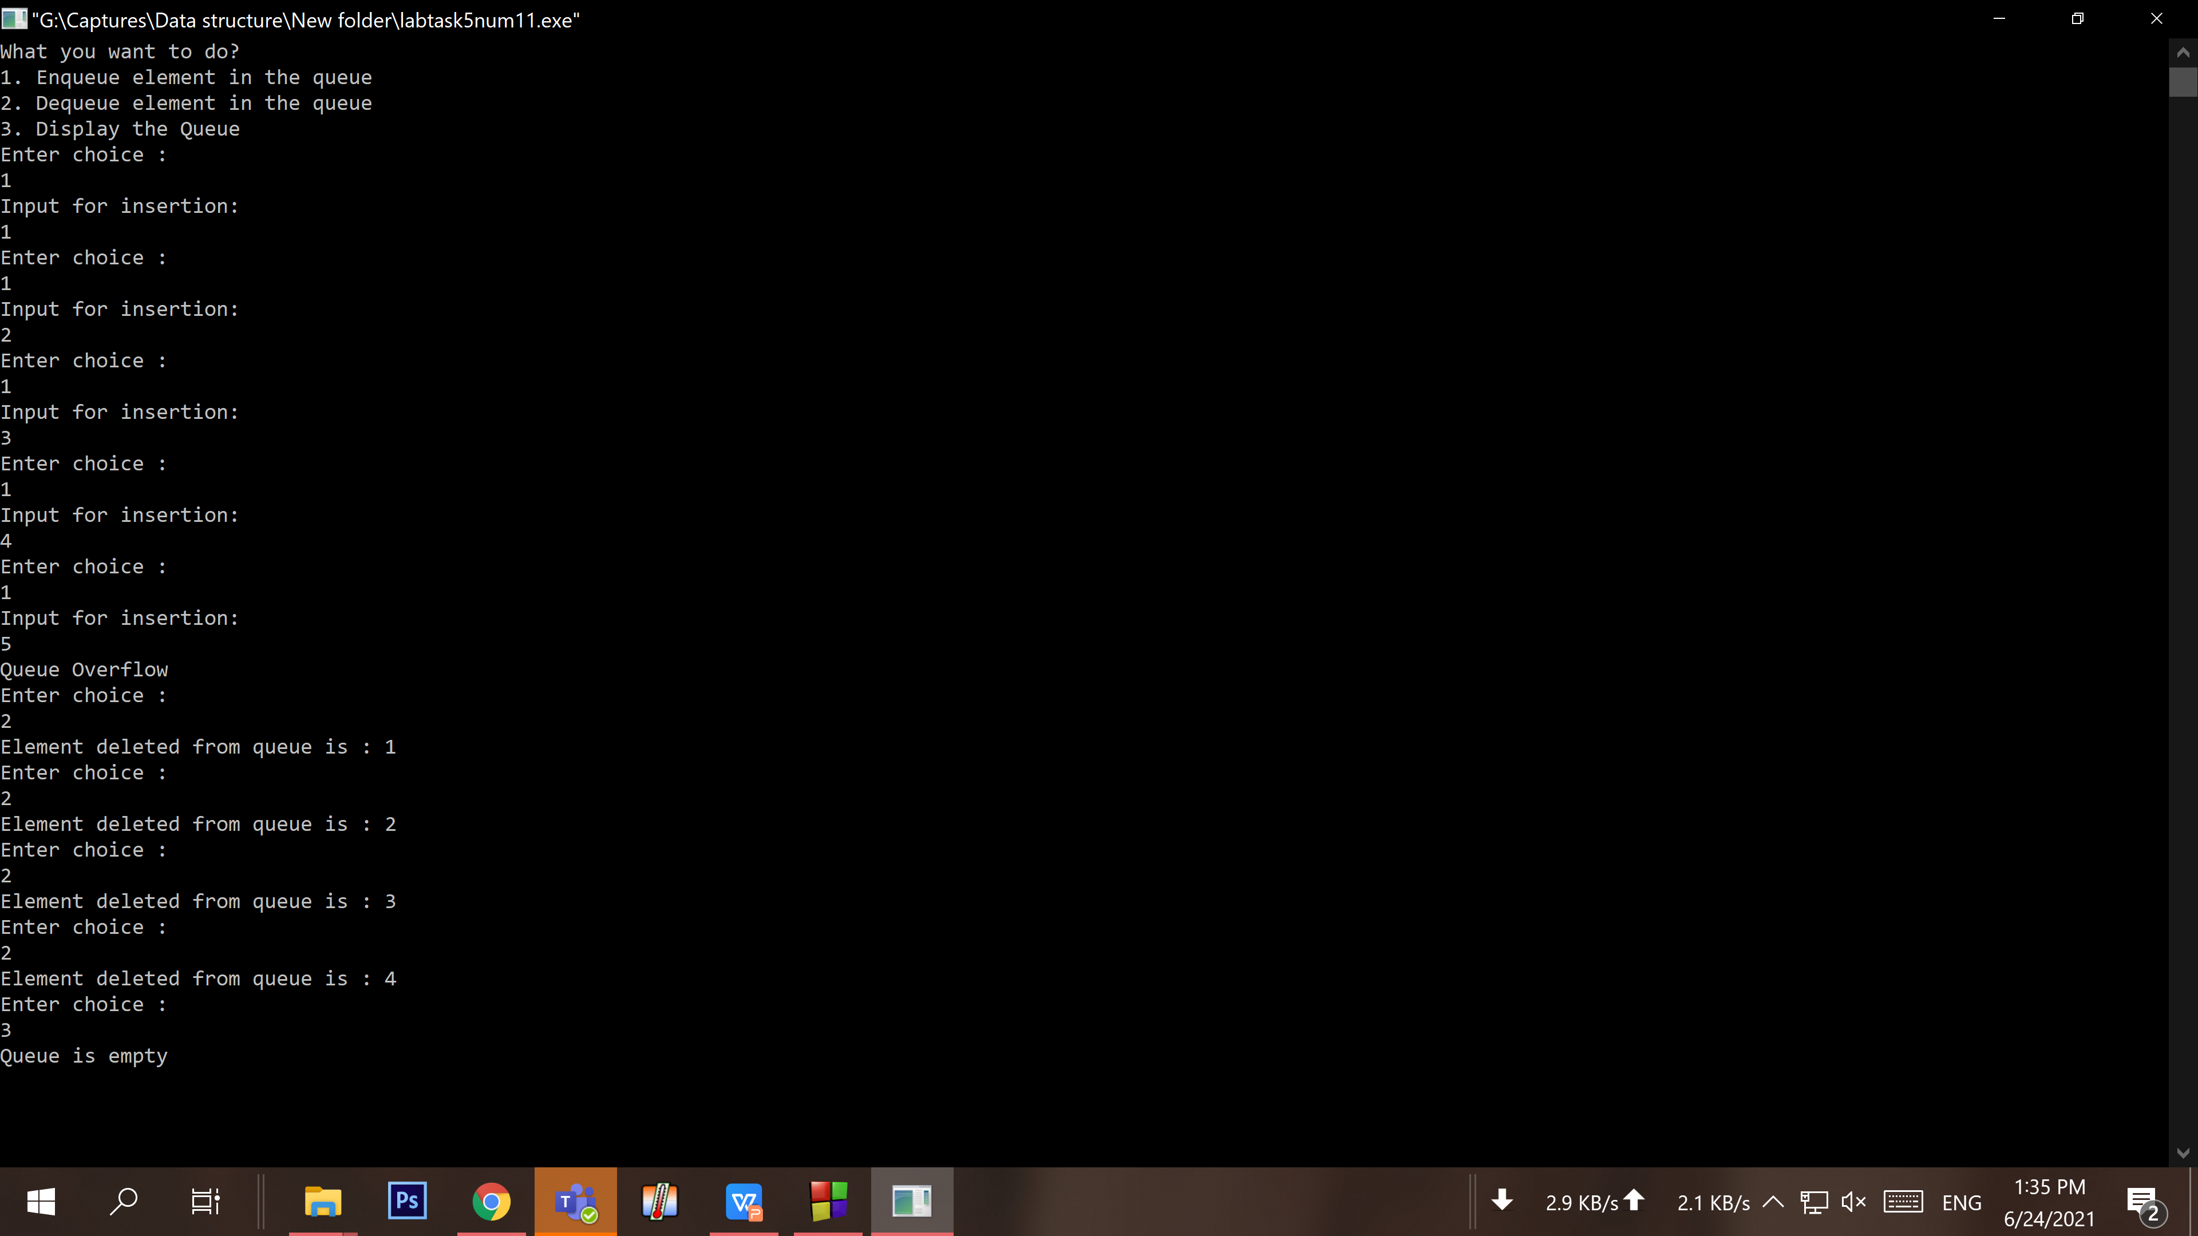

Code Instruction:
For both of the following problems, an operand is assumed to be a single digit. And an operator is limited to ‘+’, ‘-’, ‘*’, ‘/’ (these 4 types). Also, for usage of parentheses, use only ‘(‘ for opening and ‘)’ for closing.
In light of these remarks, an algebraic expression for example can be written like below:
2 * 4 + ( 6 – 3 ) / 3

- Write a code to convert an infix algebraic expression to both postfix and prefix using the help of Stack.

Your code here:
#include <bits/stdc++.h>
using namespace std;

bool isOperator(char c)
{
return (!isalpha(c) && !isdigit(c));
}

int getPriority(char C)
{
if (C == '-' || C == '+')
return 1;
else if (C == '*' || C == '/')
return 2;
else if (C == '^')
return 3;
return 0;
}

string infixToPostfix(string infix)
{
infix = '(' + infix + ')';
int l = infix.size();
stack<char> char_stack;
string output;

for (int i = 0; i < l; i++) {

if (isalpha(infix[i]) || isdigit(infix[i]))
output += infix[i];
else if (infix[i] == '(')
char_stack.push('(');
else if (infix[i] == ')') {

while (char_stack.top() != '(') {
output += char_stack.top();
char_stack.pop();
}

char_stack.pop();
}

else {

if (isOperator(char_stack.top())) {
while (getPriority(infix[i])
<= getPriority(char_stack.top())) {
output += char_stack.top();
char_stack.pop();
}
char_stack.push(infix[i]);
}
}
}
return output;
}

string infixToPrefix(string infix)
{
int l = infix.size();

reverse(infix.begin(), infix.end());

for (int i = 0; i < l; i++) {

if (infix[i] == '(') {
infix[i] = ')';
i++;
}
else if (infix[i] == ')') {
infix[i] = '(';
i++;
}
}

string prefix = infixToPostfix(infix);
reverse(prefix.begin(), prefix.end());

return prefix;
}
int main()
{
string infix = "2*4+(6-3)/3";
string postfix = ("2*4+(6-3)/3");
cout<<"Expression is :"<<infix<<endl;
cout << "Prefix Form is :"<<infixToPrefix(infix) << endl;
cout<<"Postfix Form is :"<<infixToPostfix(postfix)<<endl;
return 0;
}

Your whole Screenshot here: (Console Output):
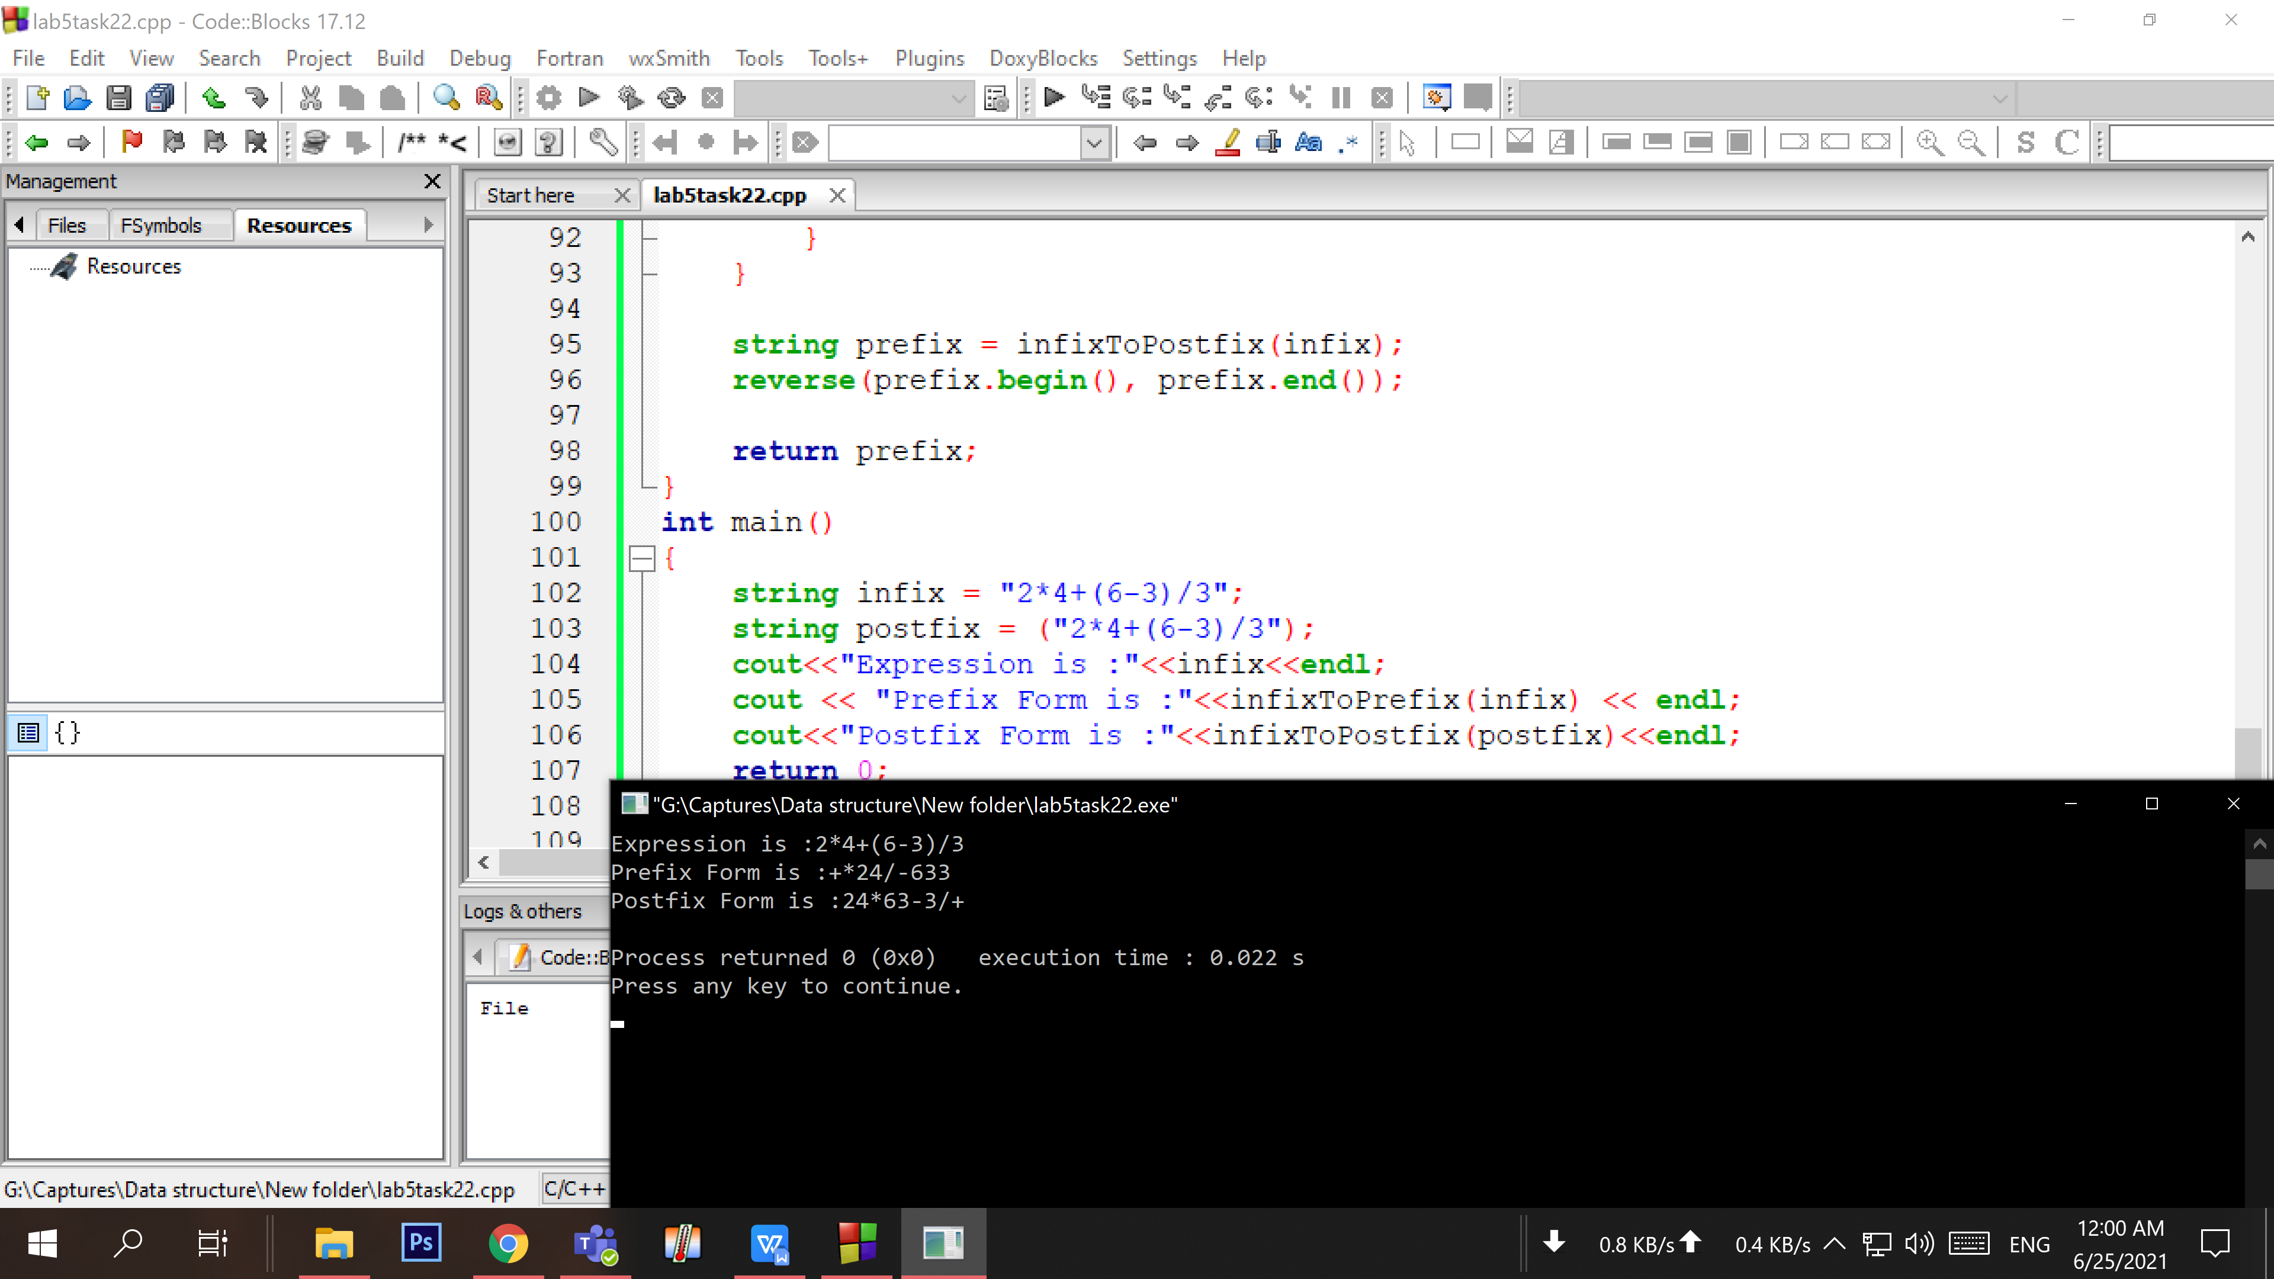

- Write a code to evaluate a given postfix algebraic expression using the help of Stack.

Your code here:

Your whole Screenshot here: (Console Output):

