Instructions: Please read carefully
- Please rename this file as only your ID number (e.g. 18-*****-1 Lab 8.doc or 18-*****-1 Lab 8.pdf).
- Submit the file before 24-07-2021 in the Portal Lab Performance section labeled Lab task 8. If you cannot complete the full task, do not worry. Just upload what you have completed.
- Write a code to implement Bubble Sort for the following list
50 | 60 | 44 | 222 | 15 | 24 | 63 | 57 | 59 | 88

Your code here:
#include<iostream>
using namespace std;

void swap(int *x, int *y)
{
int temp = *x;
*x = *y;
*y = temp;
}

void bubbleSort(int arr[], int n)
{
int i, j;
for (i = 0; i < n-1; i++)

for (j = 0; j < n-i-1; j++)
if (arr[j] > arr[j+1])
swap(&arr[j], &arr[j+1]);
}
void printArray(int arr[], int size)
{
int i;
for (i = 0; i < size; i++)
cout << arr[i] << " ";
cout << endl;
}

int main()
{
int arr[] = {50,60,44,222,15,24,63,57,59,88};
int n = sizeof(arr)/sizeof(arr[0]);
bubbleSort(arr, n);
cout<<"Bubble sort \n";
printArray(arr, n);
return 0;
}

Your whole Screenshot here: (Console Output):

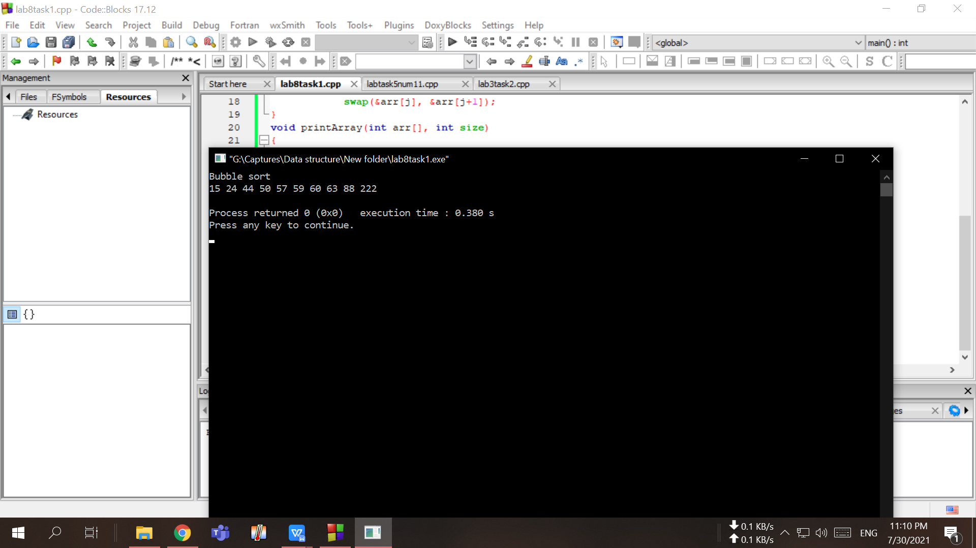

- Write a code to implement Selection Sort for the following list
50 | 60 | 44 | 222 | 15 | 24 | 63 | 57 | 59 | 88

Your code here:

#include<iostream>

using namespace std;

int main()
{
int i,j,n,l,t,m,a[30];
cout<<"Enter the number of elements:";
cin>>n;
cout<<"\nEnter Array values :\n";

for(i=0;i<n;i++)
{
cin>>a[i];
}

for(i=0;i<n-1;i++)
{
m=a[i];
l=i;
for(j=i+1;j<n;j++)
{
if(m>a[j])
{
m=a[j];
l=j;
}
}

t=a[i];
a[i]=a[l];
a[l]=t;
}

cout<<"\n Selection Sorted list :\n";
for(i=0;i<n;i++)
{
cout<<a[i]<<" ";
}

return 0;
}

Your whole Screenshot here: (Console Output):

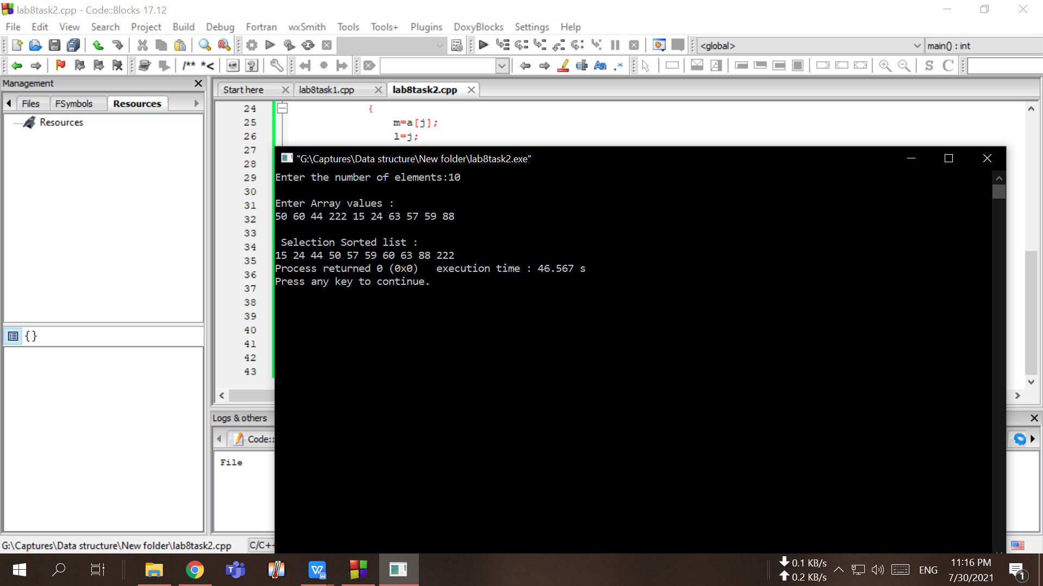

- Write a code to implement Insertion Sort for the following list
50 | 60 | 44 | 222 | 15 | 24 | 63 | 57 | 59 | 88

Your code here:
#include<iostream>

using namespace std;

int main()
{
int i,j,n,temp,a[30];
cout<<"Enter the number of elements:";
cin>>n;
cout<<"\nEnter Array elements :\n";

for(i=0;i<n;i++)
{
cin>>a[i];
}

for(i=1;i<=n-1;i++)
{
temp=a[i];
j=i-1;

while((temp<a[j])&&(j>=0))
{
a[j+1]=a[j];
j=j-1;
}

a[j+1]=temp;
}

cout<<"\n Insertion sort list : \n";
for(i=0;i<n;i++)
{
cout<<a[i]<<" ";
}

return 0;
}

Your whole Screenshot here: (Console Output):

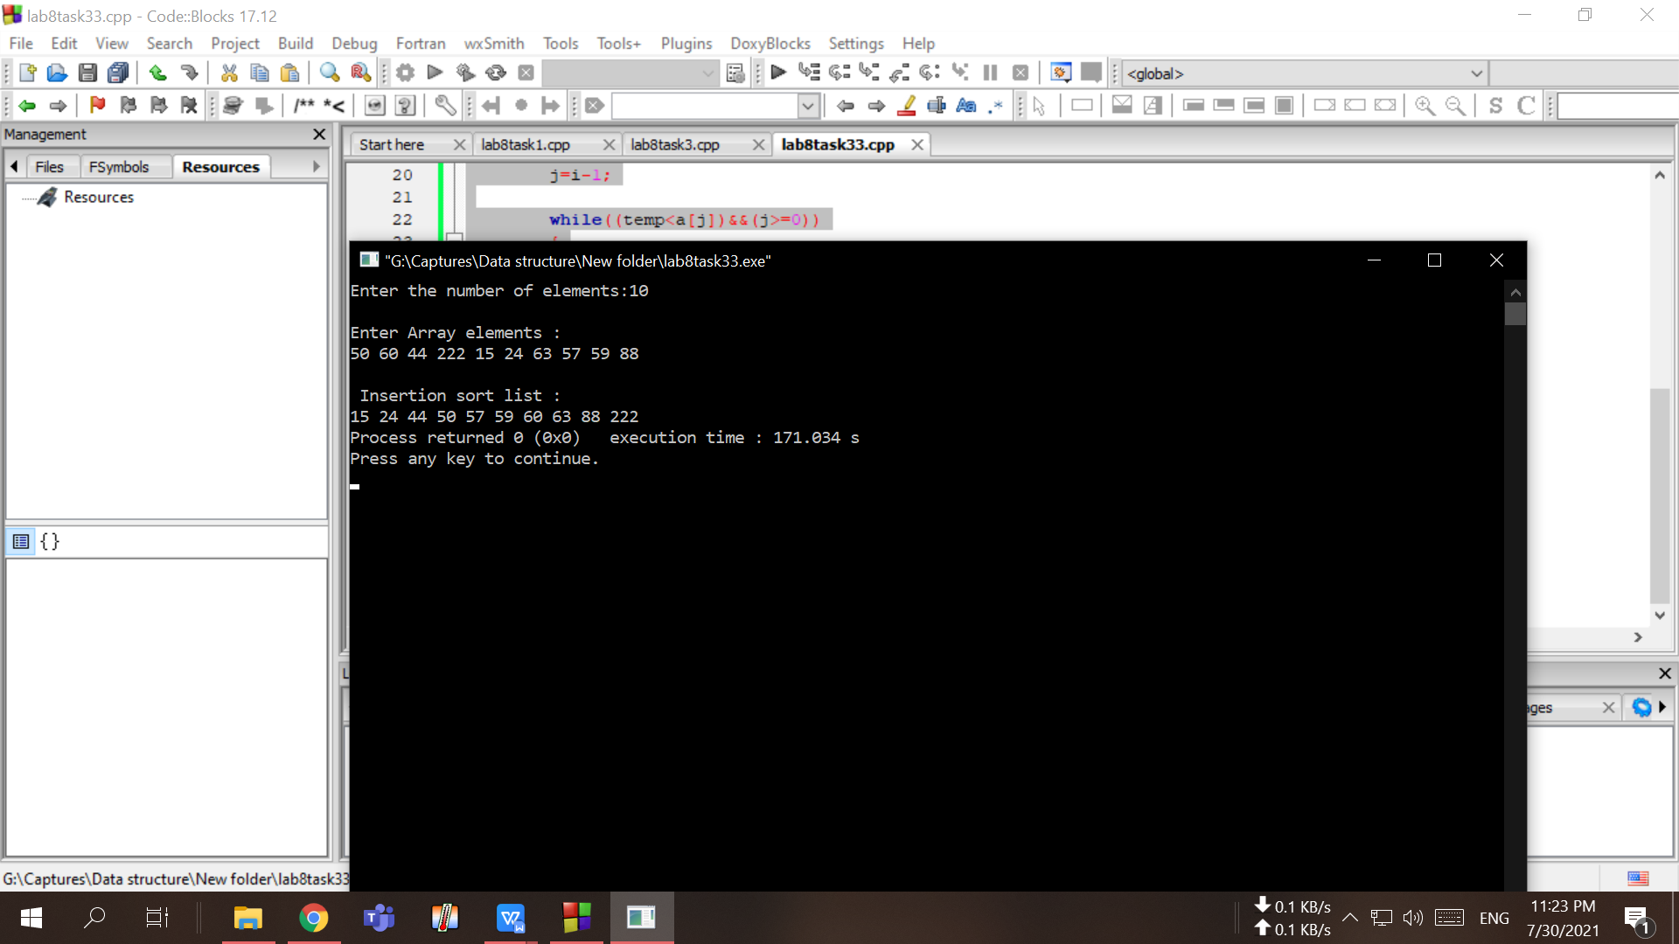

- Write a Program for Binary Search Implementation to find 63 in the following list: If needed first apply any of (1-3 sorting algorithm)
50 | 60 | 44 | 222 | 15 | 24 | 63 | 57 | 59 | 88

Your code here:

#include<iostream>
using namespace std;

int binarySearch(int arr[], int left, int right, int x) {
while (left <= right) {
int mid = left + (right - left) / 2;

if (arr[mid] == x) {
return mid;
} else if (arr[mid] < x) {
left = mid + 1;
} else {
right = mid - 1;
}
}

return -1;
}

int main() {
int arr[10];
int num;
int output;

cout << "enter 10 elements" << endl;
for (int i = 0; i < 10; i++) {
cin >> arr[i];
}
cout << "element to search" << endl;
cin >> num;

output = binarySearch(arr, 0, 9, num);

if (output == -1) {
cout << "No Match Found" << endl;
} else {
cout << "Match found at position: " << output << endl;
}

return 0;
}

Your whole Screenshot here: (Console Output):

