PHASE II: Business Process Modelin

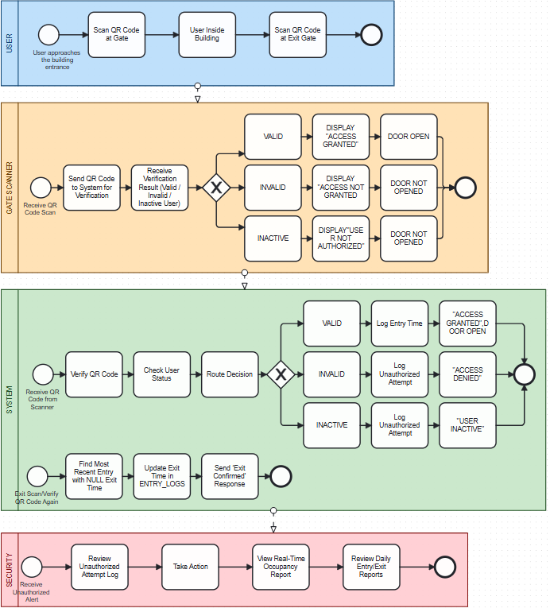

The BPMN shows four pools and how the whole project moves. From when a person the building scans the qr_code ,see if he/she are allowed to enter, if he/she is not allowed the system alerts the people incharge get and make a report about it and also record the time the user exits.
The first pool USERS show what happens for an allowed user that has an valid qr_code. The second pool GATE SCANNER show what happens when a person scans the qr_code it shows if he/she is valid,invalid or inactive and if he/she enters or doesn’t. The third pool SYSTEM is the one that receives and logs the results from gate scanner. The four pool is SECURITY and review unauthorized attemps, take actions, view real time occupancy and review daily entry and exit report.

