This is the discipler user interface.

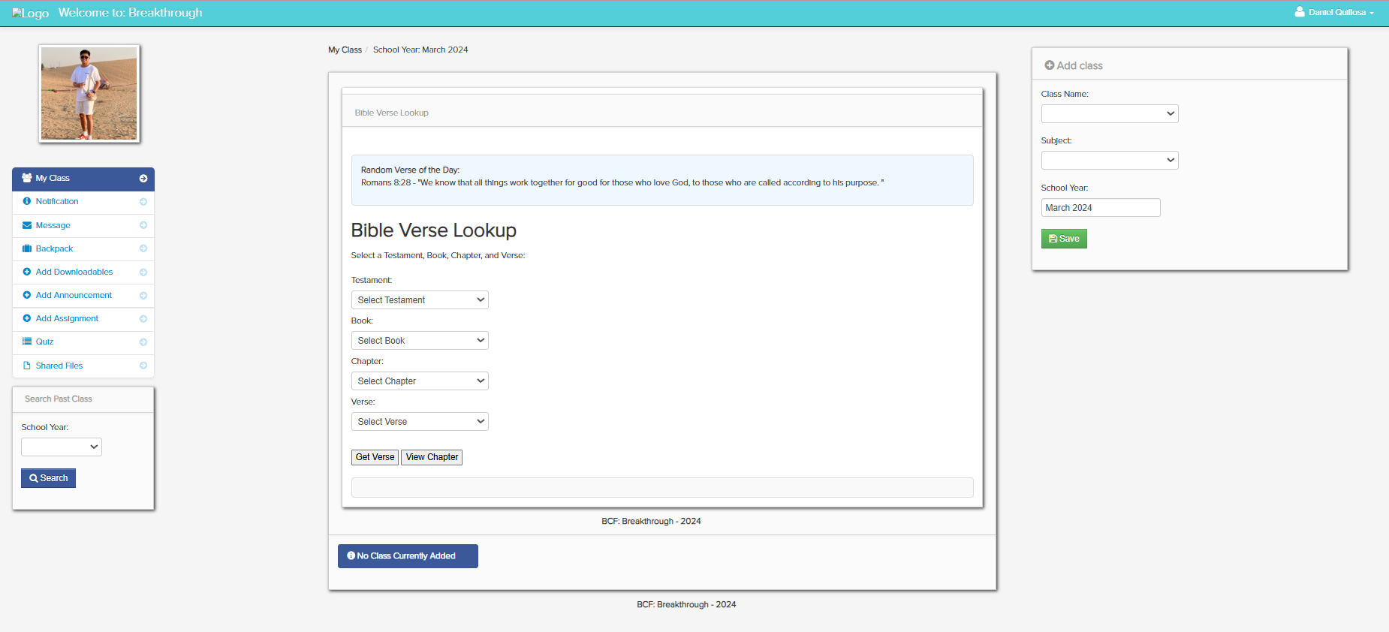

1. Class – In this window, you create a class.

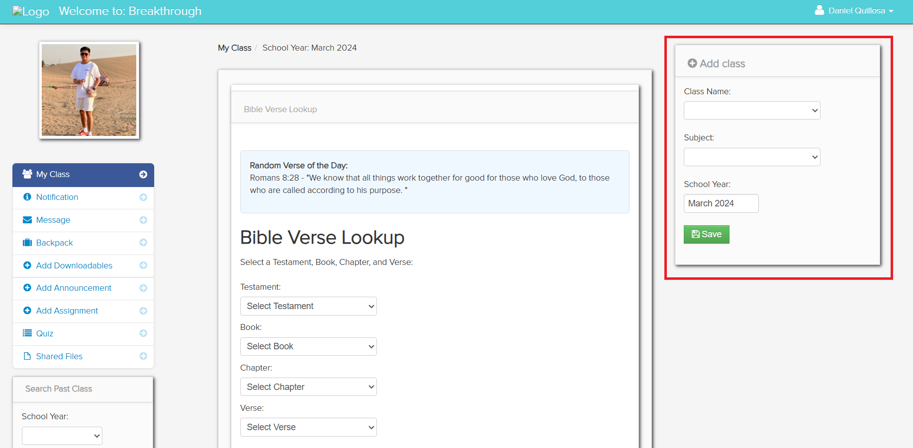

To create a class.

1. Click the dropdown and select a class name if discipleship or explanatory.

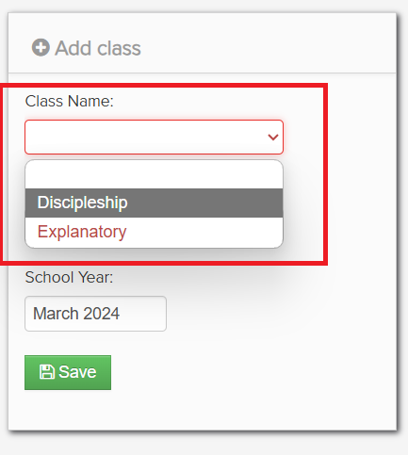

1. Click the dropdown then select the subject of your class.

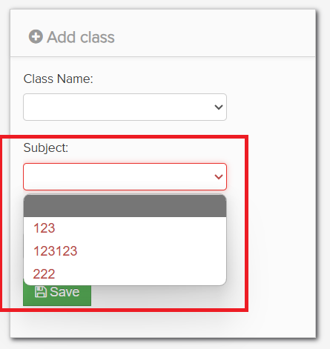

1. Type the current month and year of when you added the class.

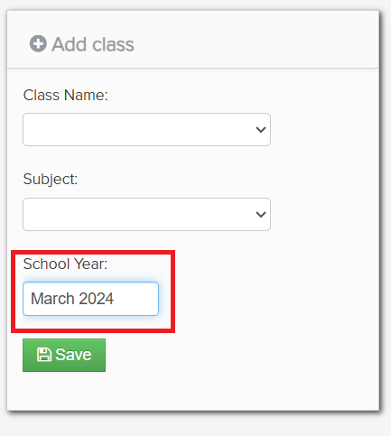

1. Then click save to add the created class.

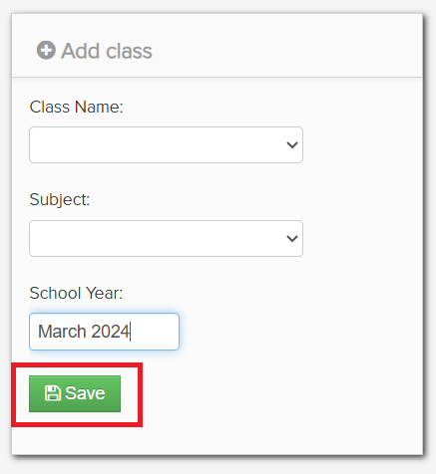

1. Notification – In this module, you receive notifications about student submissions etc.

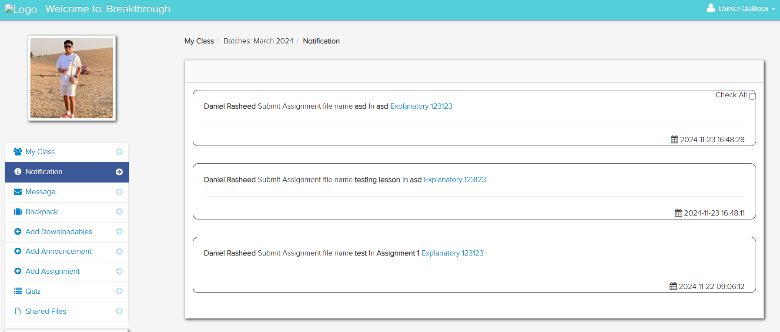

1. Message – In this module, messages received and sent are displayed.

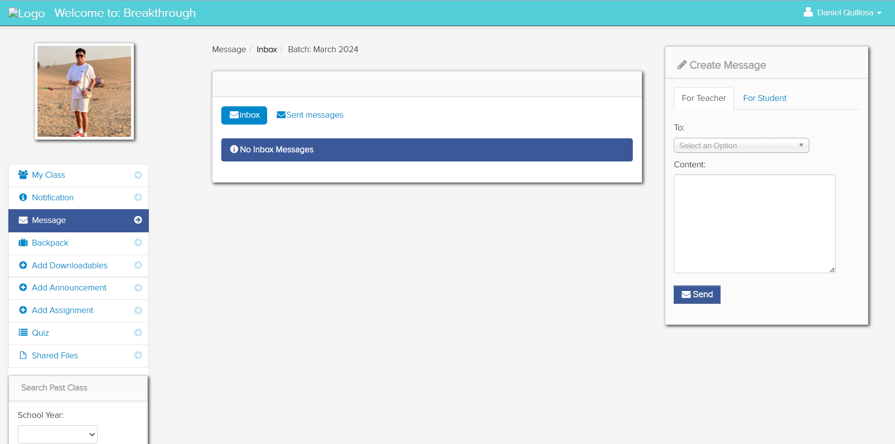

1. Inbox – this is where messages received are displayed.

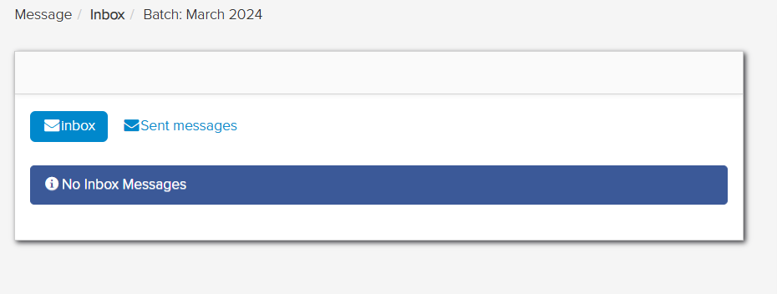

1. Sent messages – this is where messages sent are displayed.

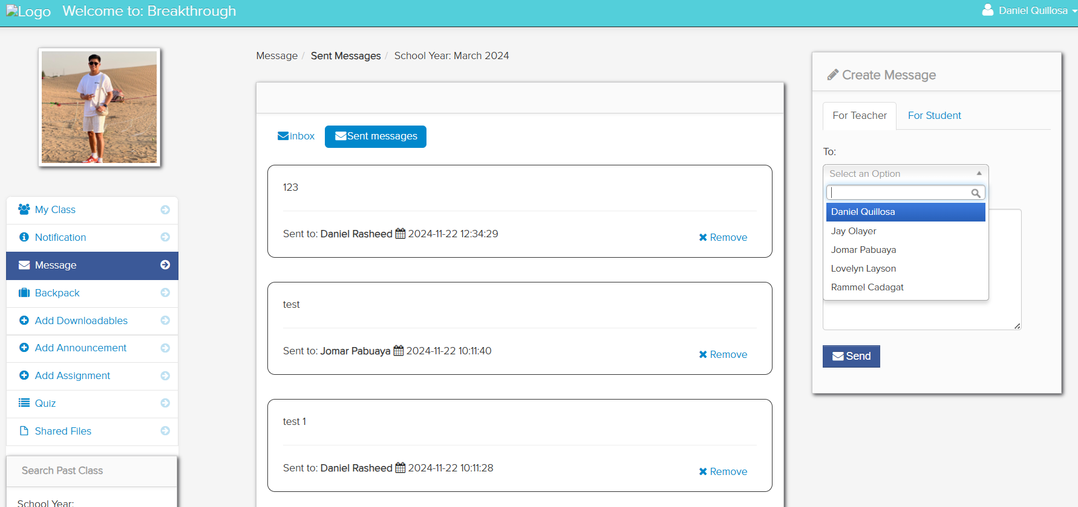

To create a message:

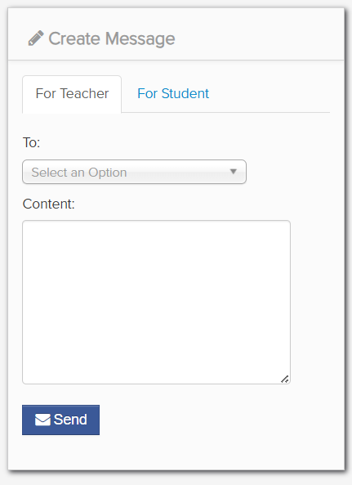

1. Select the type of person you want to message.

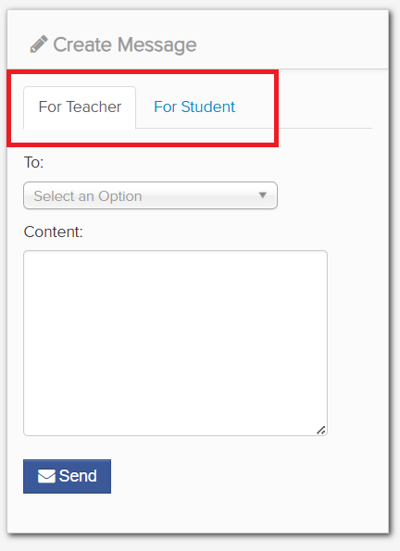

1. Select the person you want to send a message to.

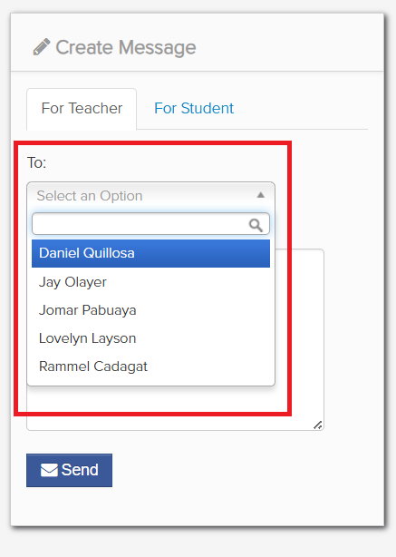

1. Add the message you want to send inside the content, then press the send button to send.

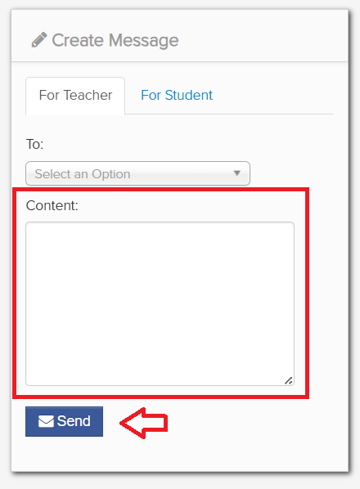

1. Add Downloadable – In this module, you can create downloadable material that will also be added and displayed on downloadable material module.

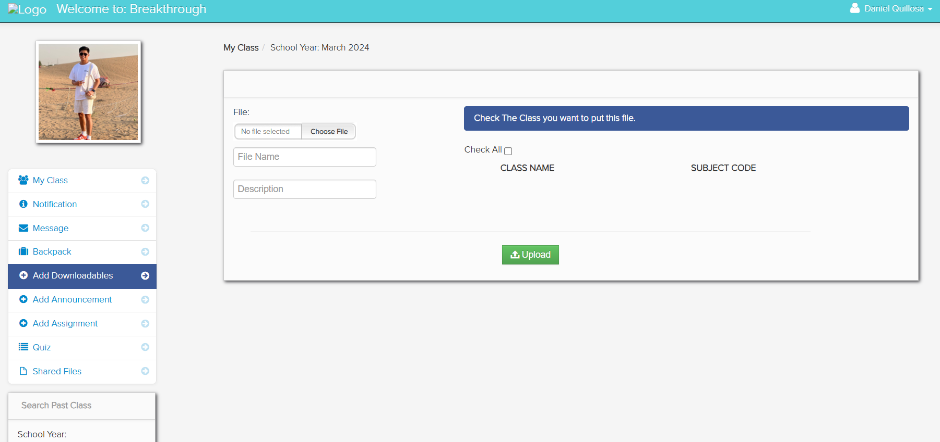

To upload downloadable file:

1. Choose a file from your computer you want to upload.

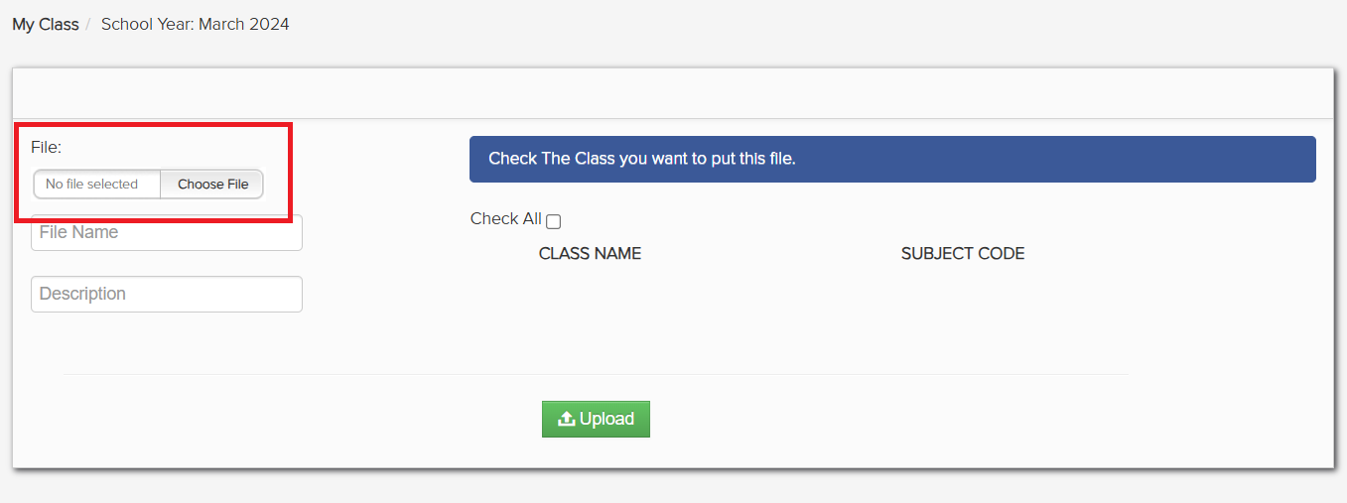

1. Type the file name and description.

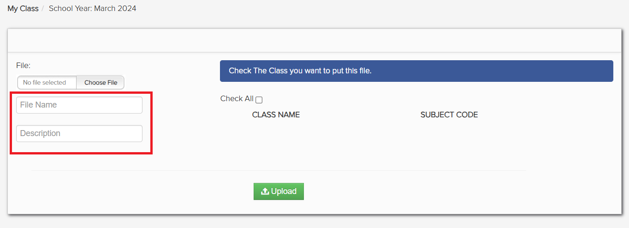

1. Then select a class you want to upload the file to or simply click the box to send to all.

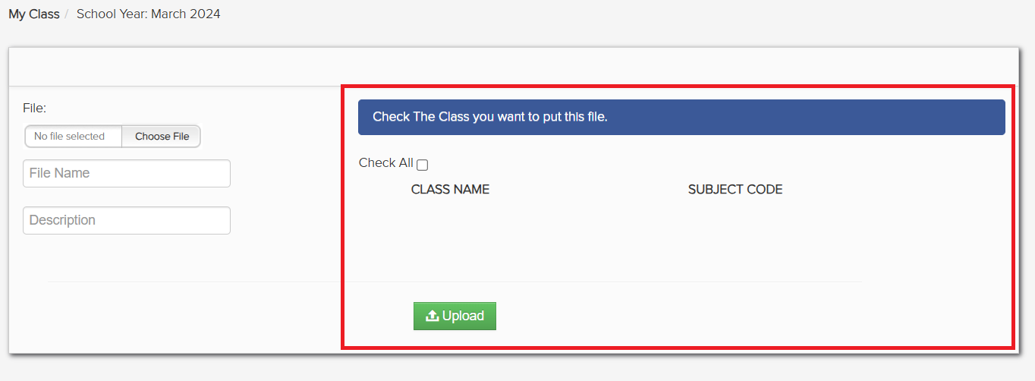

1. If finished, then click upload.

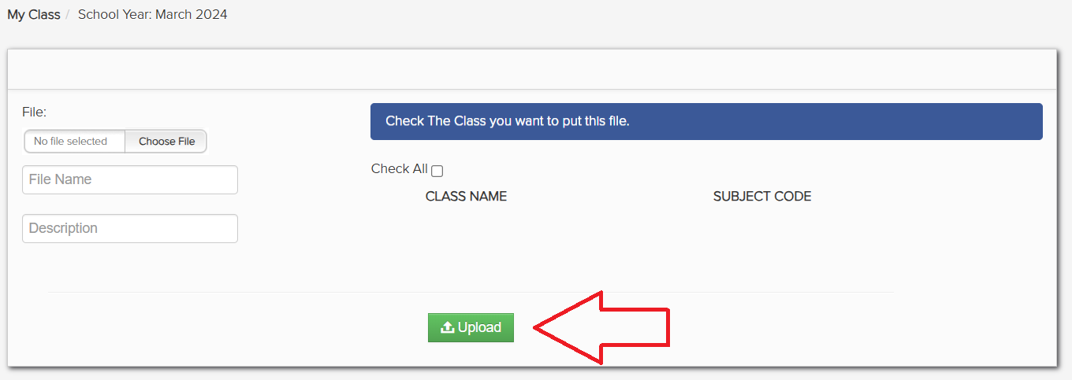

1. Add Announcements – In this module, you can create announcements.

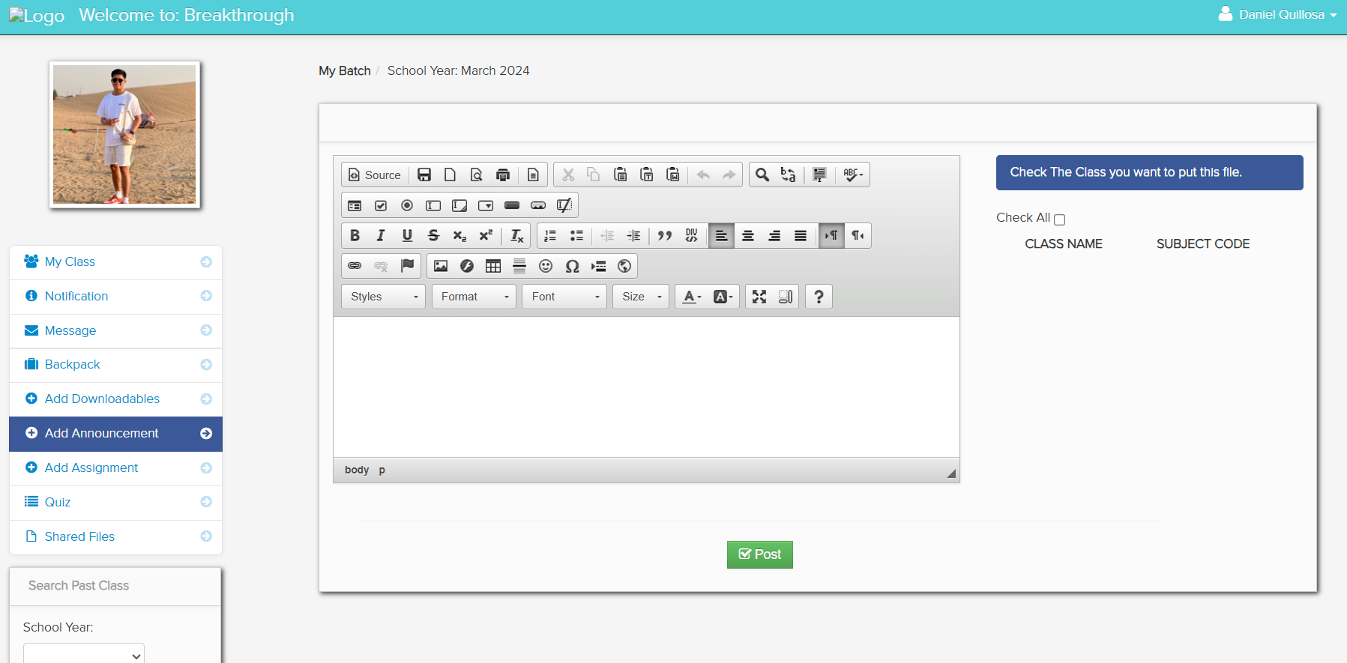

To create a post:

1. Type something you want to post.

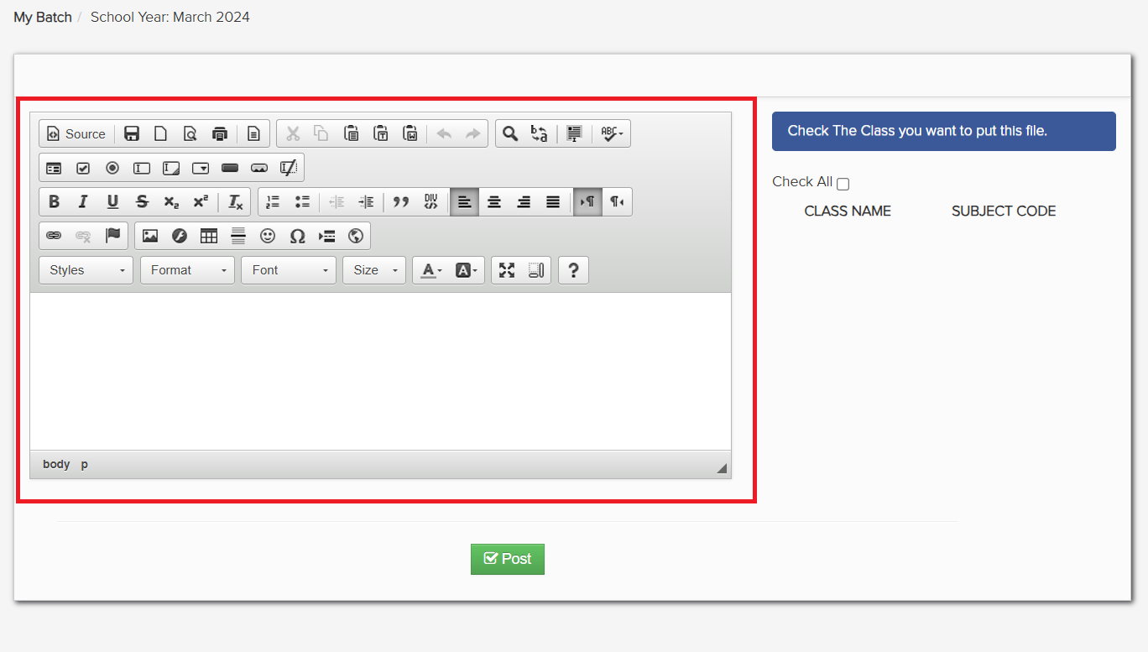

1. Select a class you want to upload the file to or simply click the box to send to all. Then click upload if done to post.

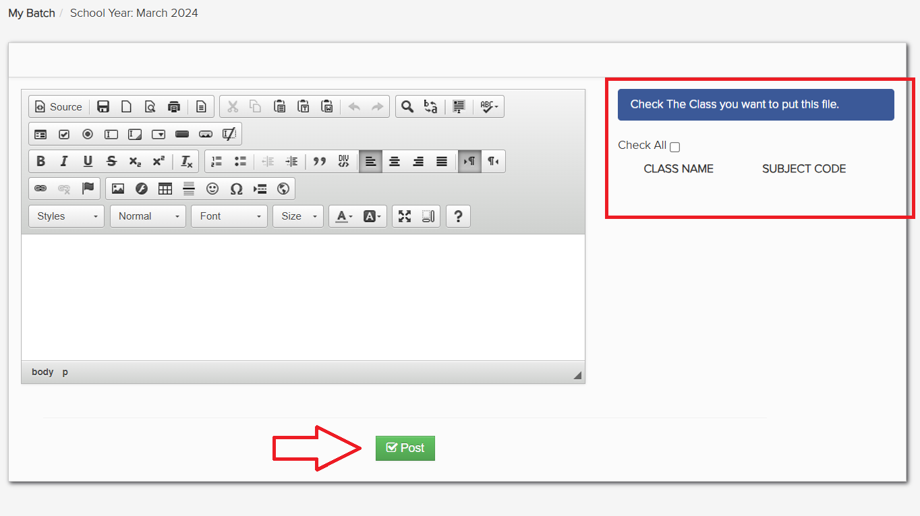

1. Add Assignment – In this module, you can create assignments.

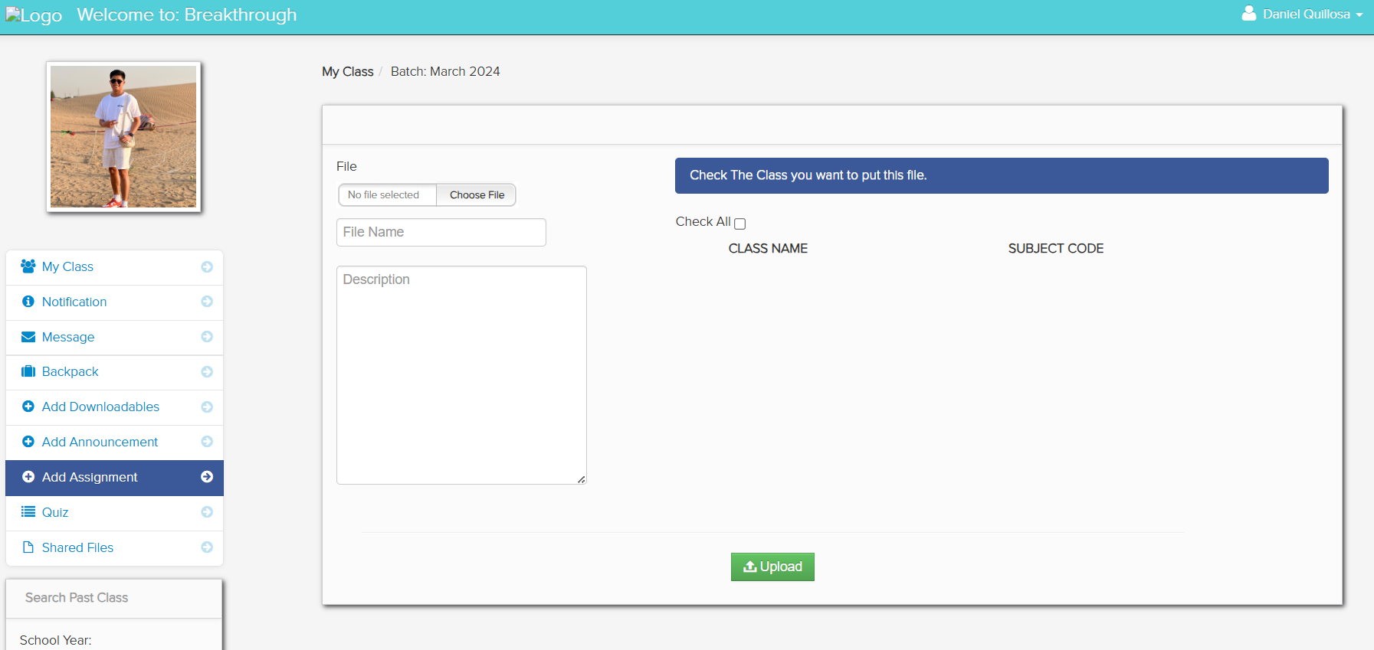

To add an assignment:

1. Choose a file you want to upload.

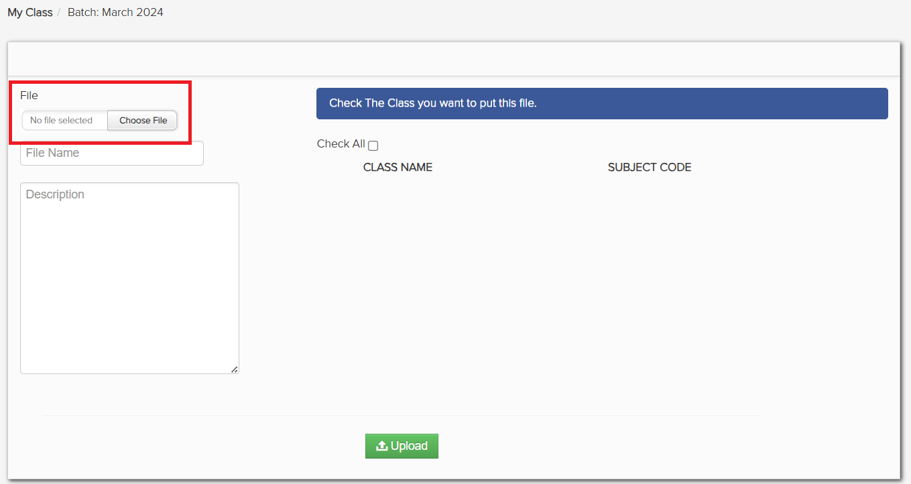

1. Type the file name and description.

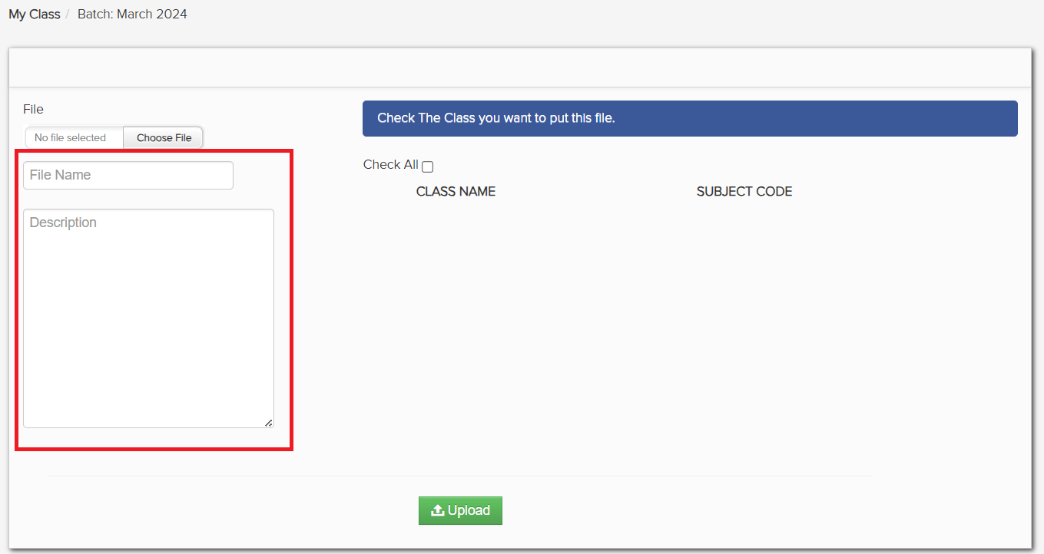

1. Choose a class name and subject code or click check all to send to all. Then click upload if done.

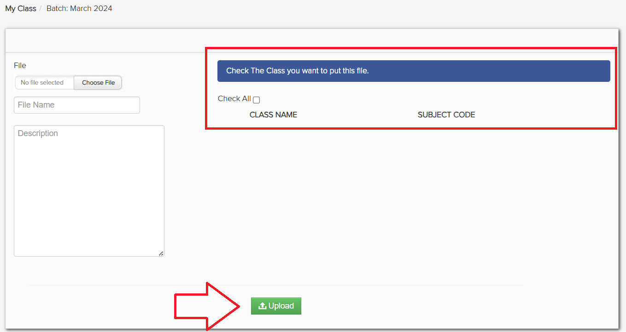

1. Quiz – In this module, you can create quizzes for disciples.

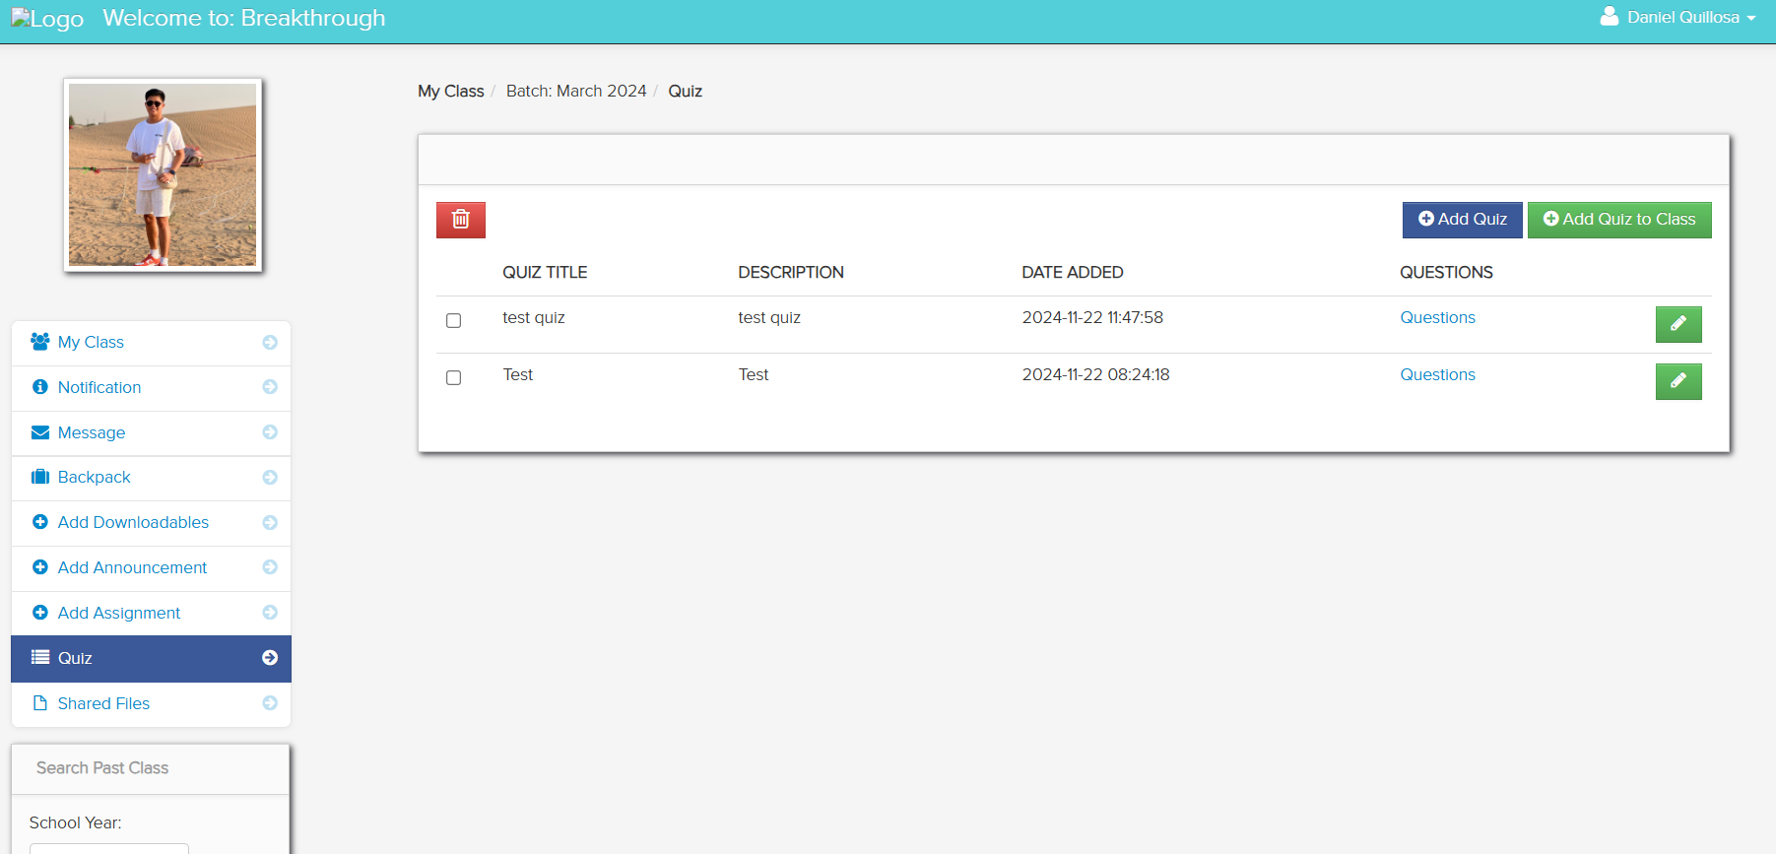

To add quiz:

1. Click add quiz.

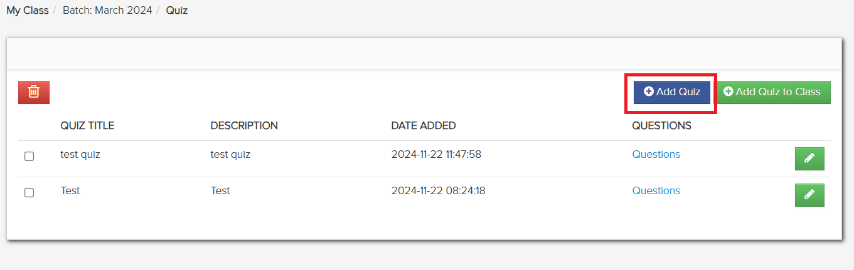

1. Type the quiz title and description, then save if done.

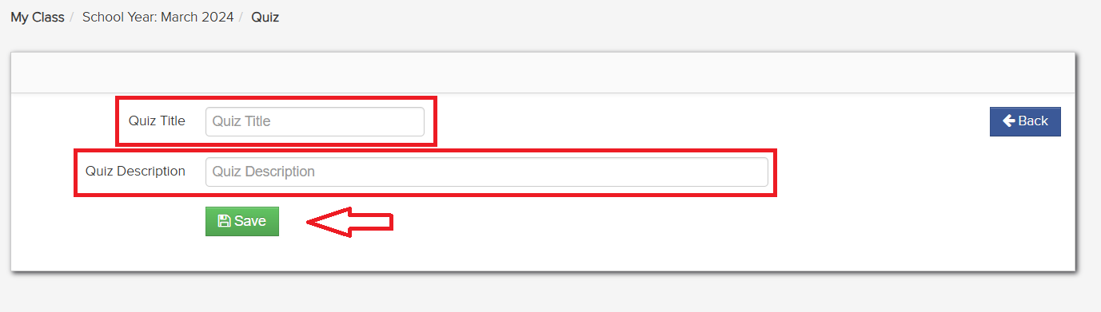

1. The created quiz will be displayed here.

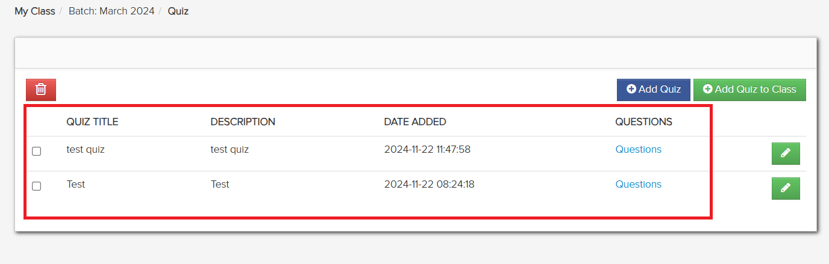

To send created quiz to a class:

1. Click add quiz to class.

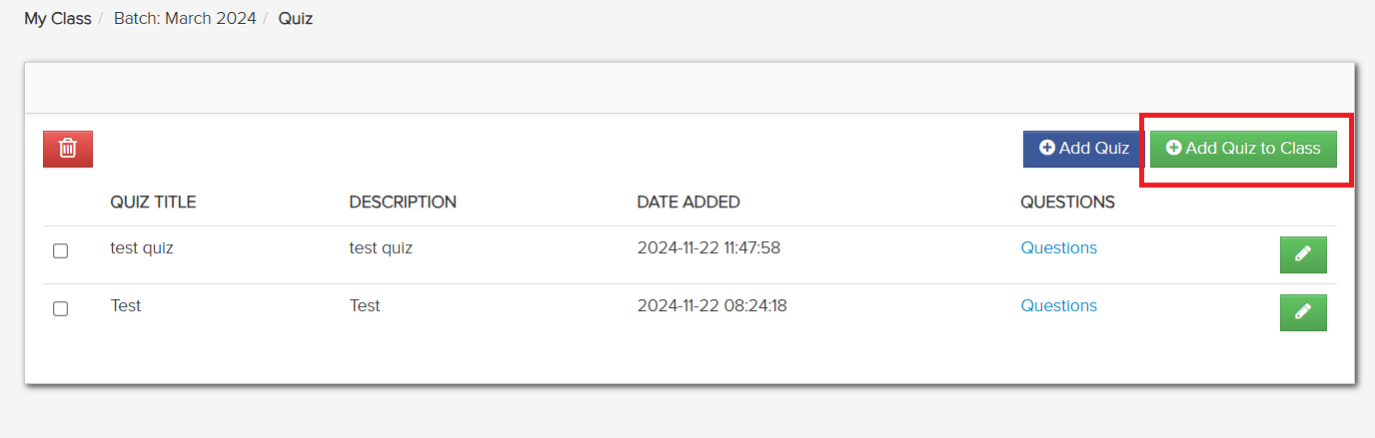

1. Click the dropdown to show quizzes then select one.

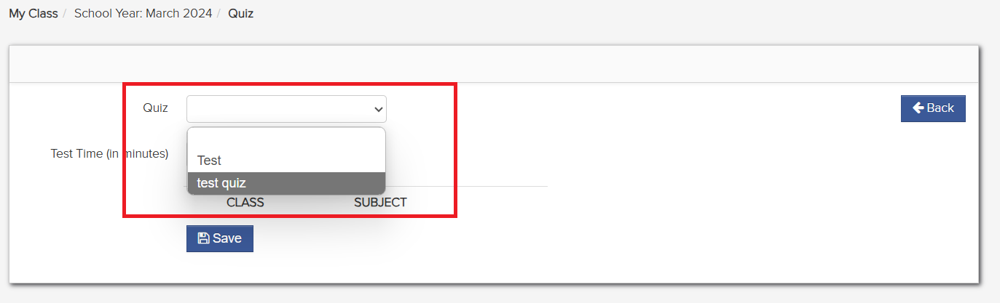

1. Input the duration of the quiz.

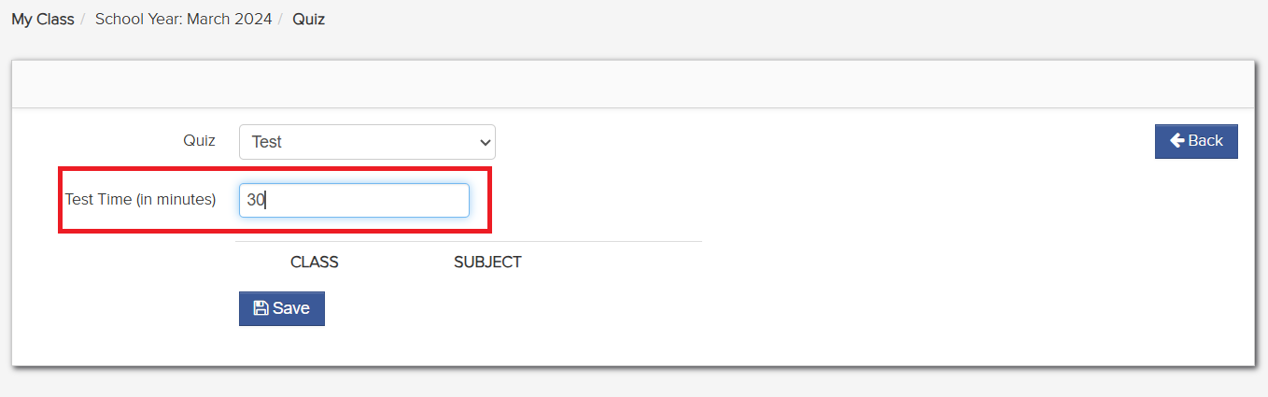

1. Choose where to send the quiz by selecting the class and subject, then click save if done.

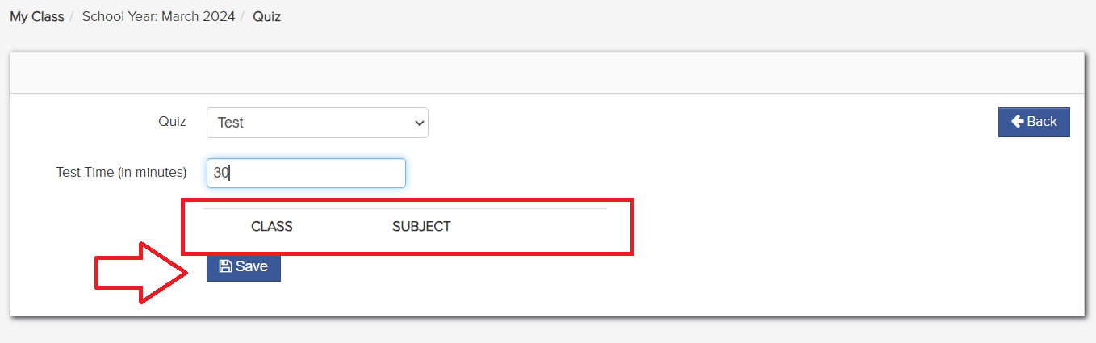

To edit quiz:

1. Click the pencil icon.

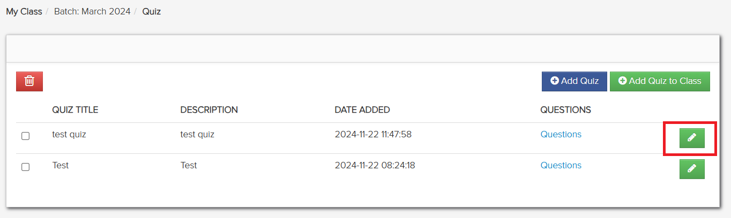

1. Edit the details, then click save.

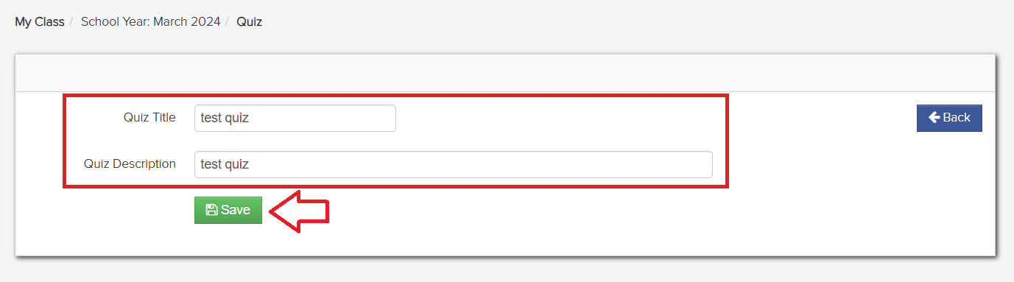

To remove quiz:

1. Click the checkbox of the quiz, then select the trashcan icon.

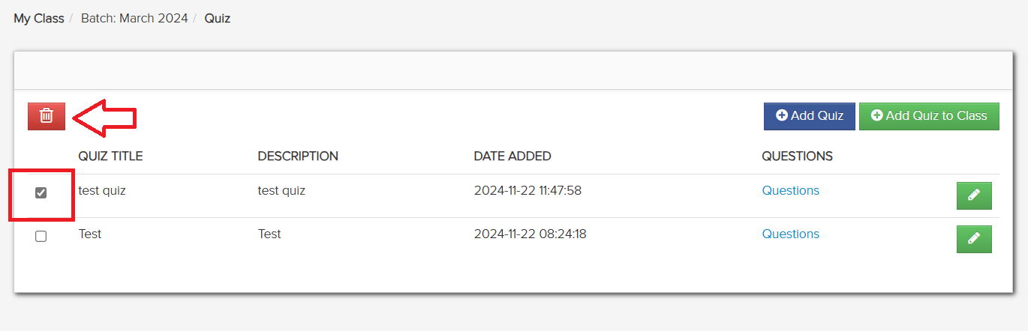

1. A confirmation window will appear, click yes to remove or close.

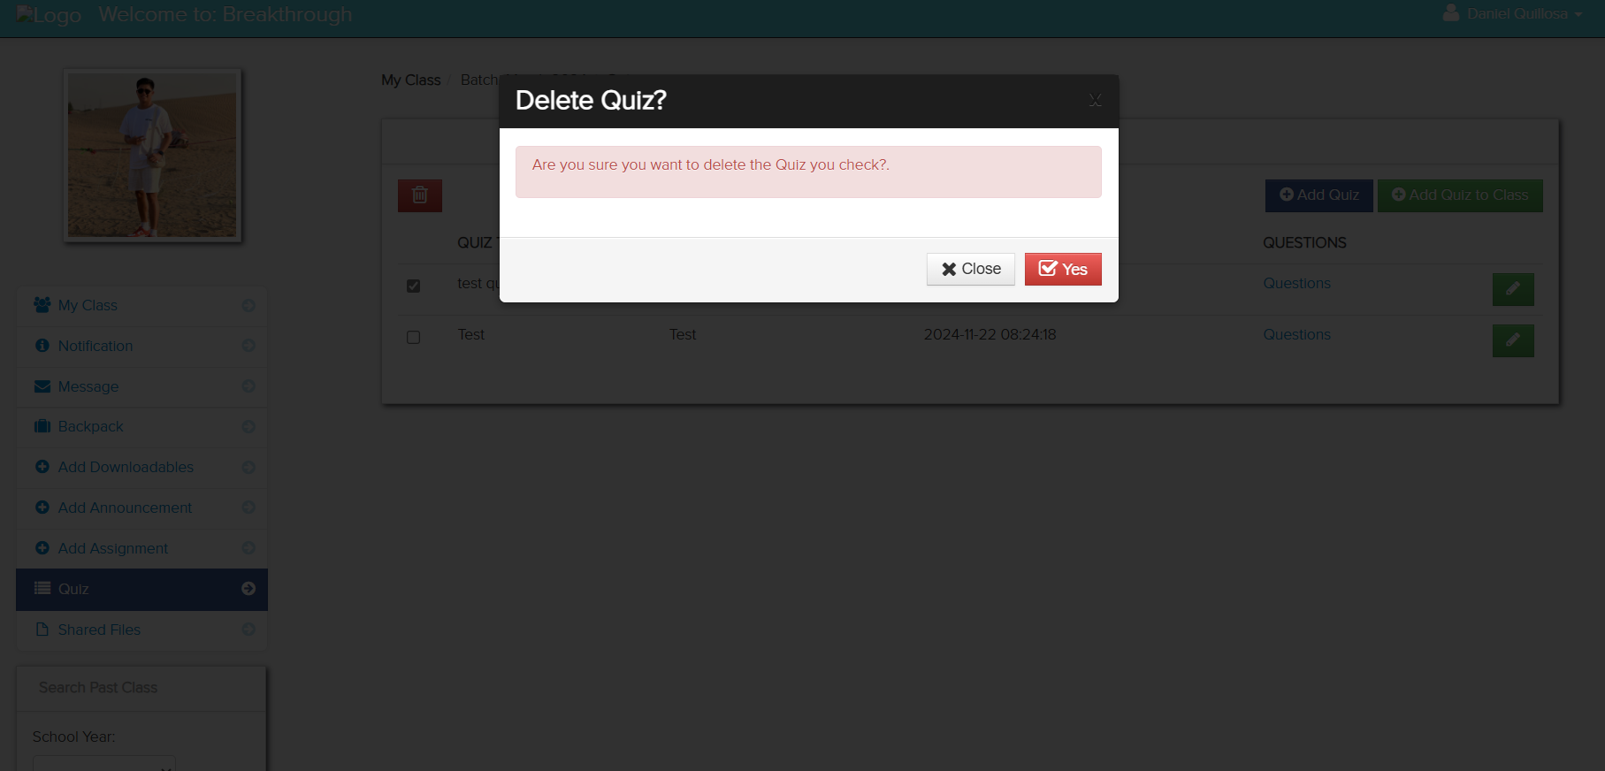

1. This window is where you search for existing classes. Located at the bottom left of descipler user interface.

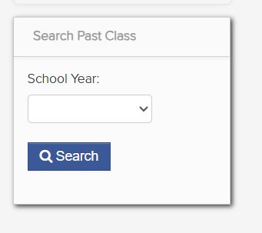

To look for existing classes:

1. Click the dropdown to see existing classes.

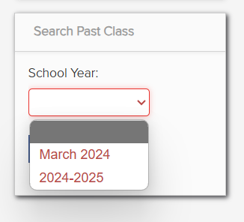

1. After clicking existing classes from the dropdown, click search.

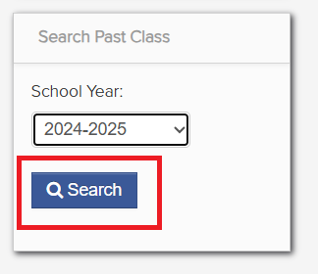

1. The existing classes will appear here.

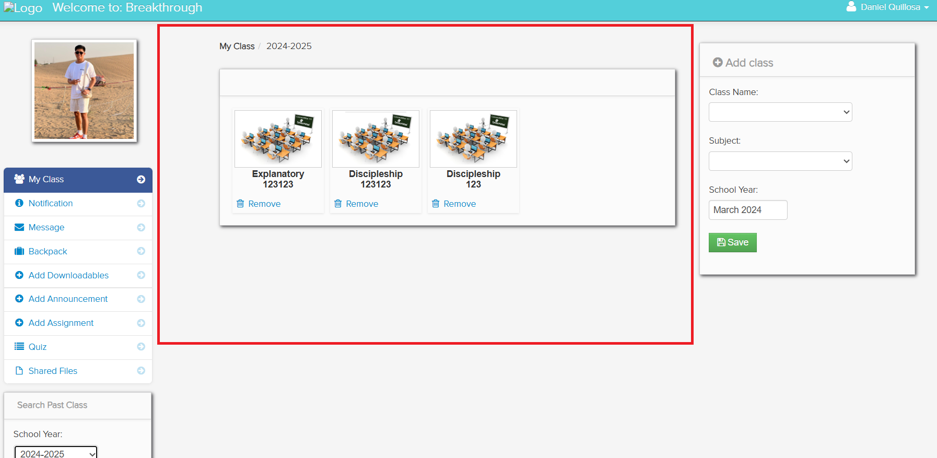

1. By selecting one of these classes, you will be able to see the students enrolled in that class.

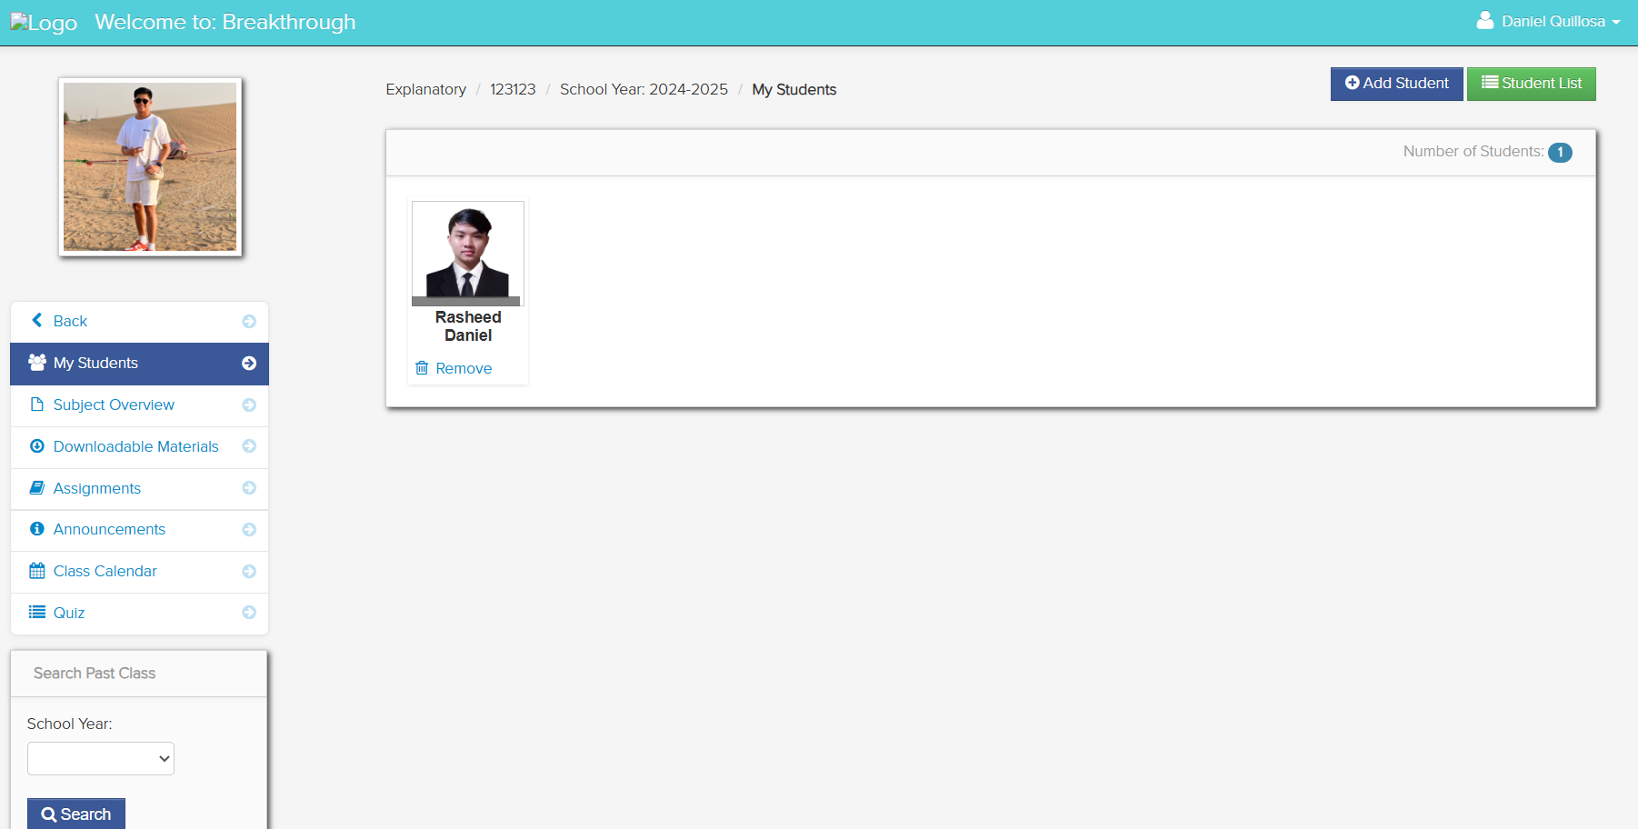

1. You can also add students to your class by clicking add student on the upper right.

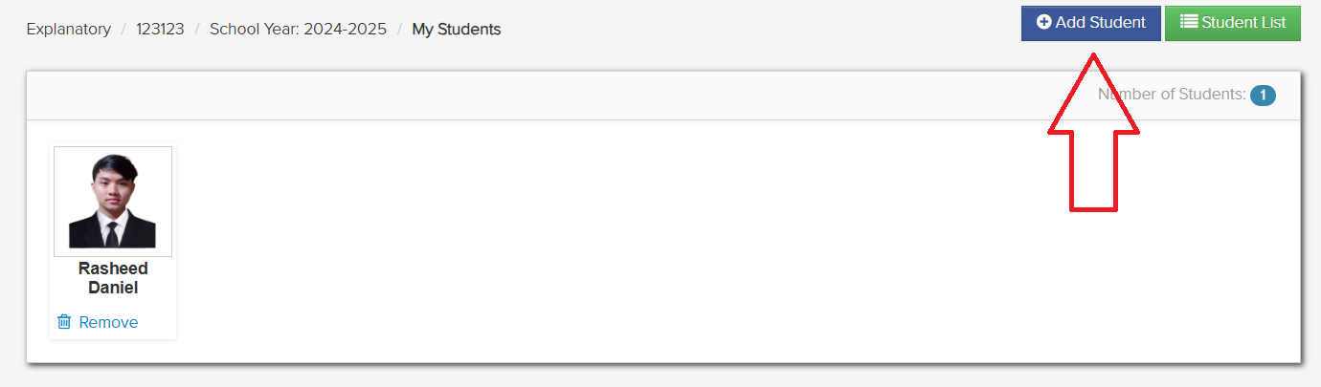

1. To add student, click the dropdown on the right side of disciple then click add.

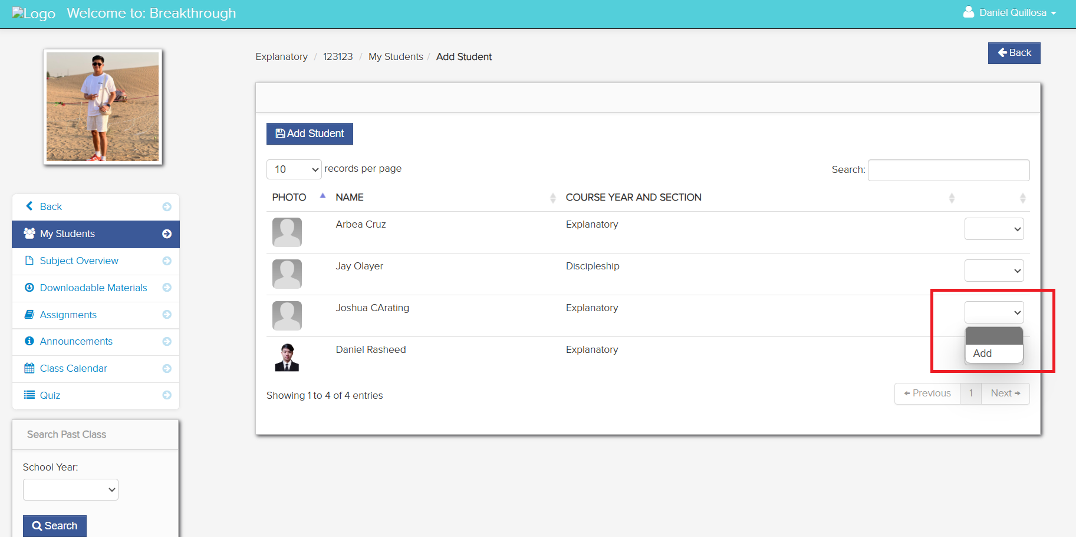

1. You can also remove students by clicking remove.

