BREAKTHROUGH: CHURCH WEB-BASED LEARNING SYSTEM FOR BREAKTHROUGH CHRISTIAN FELLOWSHIP

A Capstone Project

Presented to the Faculty of the

Information and Communications Technology Program

STI College Sta. Maria

In Partial Fulfillment

of the Requirements for the Degree

Bachelor of Science in Information Technology

Arbea O. Cruz

Aldrie B. Bautista

Jay Olayer

Daniel Rasheed Quillosa

NOVEMBER 2024

ENDORSEMENT FORM FOR ORAL DEFENSE

TITLE OF RESEARCH: Breakthrough: Church Web-Based

Learning Management System for Breakthrough

Christian Fellowship

NAME OF PROPONENTS: Arbea O. Cruz

Aldrie B. Bautista

Jay Olayer

Daniel Rasheed Quillosa

In Partial Fulfillment of the Requirements

for the degree Bachelor of Science in Information Technology

has been examined and is recommended for Oral Defense.

ENDORSED BY:

Mr. John Rej I. Santiago

Capstone Project Adviser

APPROVED FOR ORAL DEFENSE:

Mr. Erwin H. Hufancia

Capstone Project Coordinator

NOTED BY:

Asst. Prof. Alfie B. Benito, MIT

Program Head

# NOVEMBER 2024

# APPROVAL SHEET

This capstone project titled Breakthrough: Church Web-Based Learning Management System for Breakthrough Christian Fellowship, prepared and submitted by Arbea O. Cruz, Aldrie B. Bautista, Jay Olayer, and Daniel Rasheed Quillosa, in partial fulfillment of the requirements for the degree of Bachelor of Science in Information Technology, has been examined and is recommended for acceptance and approval.

Mr. John Rej I. Santiago

Capstone Project Adviser

Accepted and approved by the Capstone Project Review Panel

in partial fulfillment of the requirements for the degree of

Bachelor of Science in Information Technology

|  |  |
| --- | --- |
|  | Mr. Ceejay Fajardo |
| Panel Member | Panel Member |

Ms. Lara Camille V. Vergara

Lead Panelist

Noted:

|  |  |
| --- | --- |
| Mr. Erwin H. Hufancia | Asst. Prof. Alfie B. Benito, MIT |
| Capstone Project Coordinator | Program Head |

November 30, 2024

# Acknowledgments

First and foremost, the developers give glory to God. It is through his guidance and wisdom that the developers were able to get through hardships and setbacks.

They also extend their gratitude towards the people who supported them along the way.

To their Capstone Advisor, Sir Erwin Hufancia, his supervision of the project is acknowledged.

To their Program Head, Asst. Prof. Alfie B. Benito, they recognize his efforts to guide them and make sure that they are on the right track.

To their Adviser, Sir John Rej I. Santiago, they are grateful for him sharing knowledge and advice from the beginning until the end of the project.

They also show their appreciation towards the panelists, Sir Ceejay Fajardo, Maam Lara Camille Vergara and (name), for giving constructive feedback on improving the quality of the document.

To their beneficiary, Ms. Tricia Cruz, the secretary of Breakthrough Christian Fellowship, they are thankful for the opportunity given to to them.

Immense gratitude is also given to the parents. Their love, support, and understanding gave them motivation.

To their classmates and friends, they are thankful for looking out for them and making sure that they are in a good state.

Last but not the least, they want to thank Ma'am Sheena Rañon, their subject professor, for also offering feedback on the document, and Mr. Kimbriel Oraya, the mentor of one of the developers, for providing relevant information for the project.

# Abstract

Title of research**: Breakthrough: Church Web-Based Learning Management System for Breakthrough Christian Fellowship**

Researchers: Arbea O. Cruz

Aldrie Bautista

Jay Olayer

Rasheed Quillosa

Degree: Bachelor of Science in Information Technology

Date of Completion: June 2025

Keywords: church learning management system, Breakthrough Christian

Fellowship, bible content, modules, calendar, notifications,

messaging.

A church learning management system is a platform that allows the creation and management of educational bible content, as well as the tracking of disciple's progress. Features such as modules, calendar, notifications and messaging are usually included. The objective is to simplify the discipleship program for both the disciples and disciplers.

Breakthrough Christian Fellowship is the beneficiary for the created system. The developers aim to help the beneficiary streamline the church's discipleship process by developing a centralized storage for learning materials and quizzes. Moreover, they want to add progress tracking and monitoring, messaging, and security and privacy features such as email verification.

The Breakthrough learning management system allows disciples to access content and answer quizzes in one place. Besides that, it allows the disciplers to add content, send reminders and track progress.

# Table of Contents

|  |  |  |
| --- | --- | --- |
|  | | Page |
| Title Page | | i |
| Endorsement form for Oral Defense | | ii |
| Abstract | | iii |
| Approval Sheet | | iv |
| Acknowledgments | | v |
| Table of Contents | | vi |
| List of Figures | | vii |
| List of Tables | | viii |
| List of Notations | | ix |
| Introduction | | 1 |
|  | Project Context |  |
|  | Purpose and Description |  |
|  | Objectives |  |
|  | Scope and Limitations  Review of Related Literature/Studies/Systems |  |
| Methodology | |  |
|  | Requirements Analysis |  |
|  | Requirements Documentation |  |
|  | Design of Software, System, Product, and/or Processes |  |
|  | Development |  |
| Results and Discussion | |  |
|  | Testing |  |
|  | Description of Prototype |  |
|  | Implementation Plan |  |
|  | Implementation Results |  |
| Conclusion | |  |
| References | |  |
| Appendices | |  |
|  | Resource Persons |  |
|  | Relevant Source Code |  |
|  | Evaluation Tool/Test Documents |  |
|  | Sample Input/Output/Reports |  |
|  | User’s Guide |  |
|  | Personal Technical Vitae |  |
|  | |  |

# Introduction

## Project Context

Discipleship is central to Christian ministry. For those passionate about helping believers deepen their faith and create a lasting impact in the world, discipleship training is essential. This process strengthens the believer by enhancing their knowledge, skills, and spiritual foundation, enabling them to actively engage in the lifelong journey of becoming Christlike and making disciples (Reigh Ministries, 2024). In addition, individuals are prepared to guide others in their spiritual growth, fostering a community of faith that continues to expand and deepen its commitment to Christian principles and values.

The developers conducted an interview last April 2024 with Ms. Tricia Cruz, the secretary of Breakthrough Christian Fellowship Church (BCF). BCF is a place of worship established by Pastor Glenzer Fernandez and Pastora Eunice Fernandez. Its main location is in Paso, Sta. Maria Bulacan. Besides that, they have two other branches, one in San Jose Del Monte and one in North Caloocan. All of these branches have more than 450 members each. Out of these members, less than 150 are actively attending Sunday worship service.

The BCF Main Church in Paso conducts a discipleship program called Explanatory Training. The Facebook page will have a post containing a registration link. Interested parties can click on it, which directs them to a Google Form that they must fill up. After registration, members are sorted into Messenger groups. An orientation on Zoom is then conducted. Afterwards, the Explanatory Training Starts. Every Monday and Wednesday, from 8 to 9 in the evening, there is a short fellowship and a discussion about the video biblical lessons they have watched, which are sent by the leaders through a message group in the Messenger app. All disciples will take 5 lessons each batch in a month. After that there is a quiz (made by Pastor Glenzer) in Google Form that is sent via link in Messenger, which the disciplers must answer. If the members have finished all the quizzes, they graduate and have an option to either become disciplers or rejoin.

The Breakthrough Christian Fellowship faces problems in the discipleship meeting. The discipleship program uses multiple apps when conducting classes. Thus, disciples have to switch back-and-forth between the apps, making disciple lose focus and waste time in the process.

Disciplers also experience issues in the current discipleship process. They have to type up announcements on Facebook, then switch over to Messenger to send announcements, quiz links, and resources to both group chats and individual members. On top of that, they also have to access Google Forms to check which members answered the quizzes and manually record them on Google Sheet. The overall procedure is tedious and time-consuming.

The developers aim to resolve the above issues. By developing a discipleship learning management system, the learning process is optimized and simplified, eliminating access issues and the need to use multiple apps.

## Purpose and Description

The purpose of the BCF Web-Based System is to provide online Church learning and management system experience. It is also a system for introducing and spreading visibility to a wide audience.

The main feature of the system is the online discipleship training course. Its design is like an Electronic Learning Management System (ELMS), where ‘modules’ are loaded with different reading materials and activities. Completion of all of them nets users' certificate and lets them graduate to have an opportunity to become leaders and join ministries.

Besides that, there are other important sub-features. There is a calendar module for viewing upcoming events, notification module for activity reminders, messaging feature for communicating with disciples, and helpdesk module for asking questions and requesting assistance.

The System will be divided into three (3) user levels: Administrators, Disciplers, and Disciples.

The Administrator manages the entire website. They monitor the website security, check for bugs and upload necessary content such as announcements and events.

The Disciplers make the modules visible to disciples, check & grade their works and observe the disciples attendance.

The Disciples of various small groups access the modules, access church content and communicate with each other.

## Objectives

## General Objective: The study developed a Electronic Learning Management System that helps Breakthrough Christian Fellowship Church with their online classes.

## Specific Objectives:

* To develop a discipleship module.  
  The discipleship training course is the main feature of the system. Participants can view the learning materials, answer quizzes/activities, and view the leaderboard. When they complete all the tasks, they can either graduate and become disciplers, or continue being disciples.
* To develop a module for the calendar of events.  
  A calendar is also integrated in the system. It allows disciples to view upcoming church activities..
* To integrate notifications.  
  Another core feature is the notifications. It reminds disciples of new activities, as alert them if its almost due.
* To incorporate a communication channel.  
  The system integrates a communication channel. This is where disciple can chat with the discipler in vice versa and share their thoughts on the bible materials they read.
* To integrate a bible module.

This module allows users to read chapters and verses from the Bible.

* To evaluate the capability and acceptability of the prototype.

Using the ISO 25010 software quality model to test the functionality and reliability of the prototype and evaluate its acceptability.

##### Scope and Limitations

##### Scope

The study developed a church learning management system for Breakthrough Christian Fellowship. This system streamlines the discipleship process, enhance learning experience, and improve operational efficiency of Breakthrough Christian Fellowship.

The main features of the system are as follows:

Discipleship Module- This is the where the learning content are stored. When the disciple clicks on it, they will be sent to a page containing sections, which contain lessons and quizzes. They can also view the ranking based on their scores.

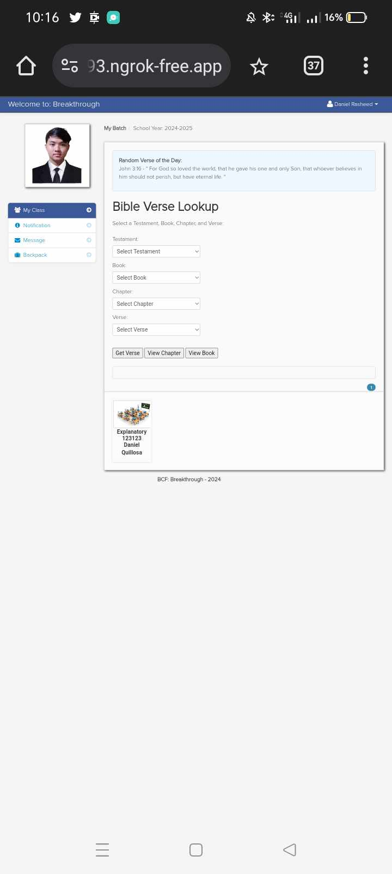

*Figure 1: Discipleship Module*

Notifications- This is where the reminders of activities are seen. Clicking on the reminders can send users to the activities page.

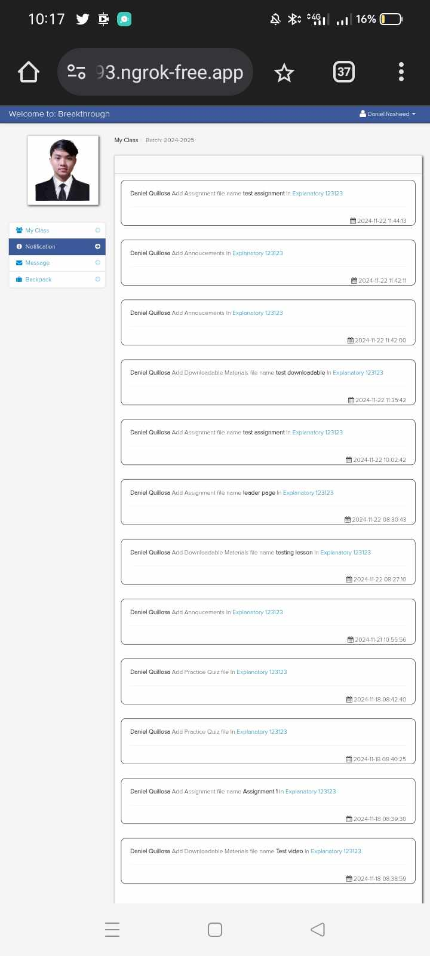

*Figure 2: Notifications*

Calendar- This is where the table containing weeks, days and months are found. Due dates of activities can also be seen here. Disciples can also add their own reminders in order to manage all their activities and finish them on time.

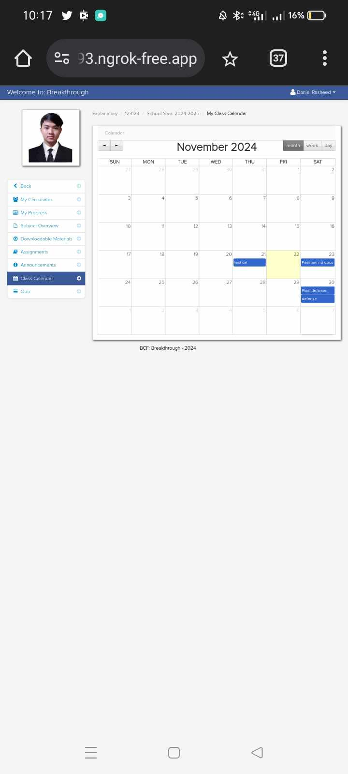

*Figure 3: Calendar*

Bible Module- This is where the disciples can view and read bible verses.



*Figure 4: Bible Module*

Communication channel-This is where the disciples communicate with each other.

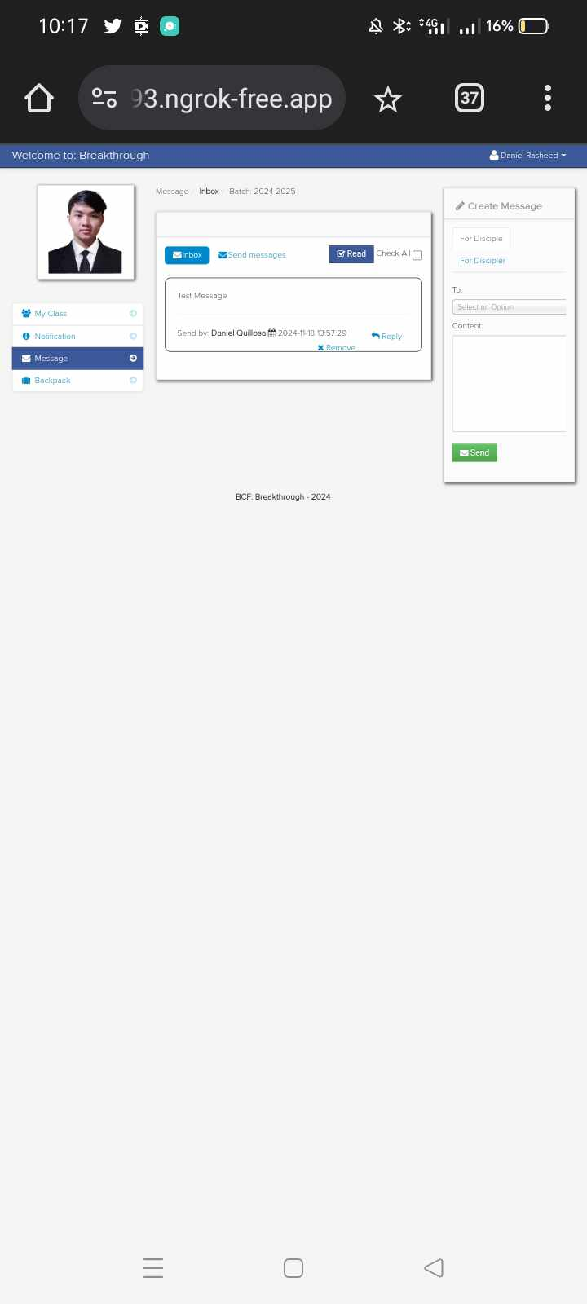

*Figure 5: Communication Channel*

**Limitations of the Study**

The limitations of the study are as follows:

Network Connection: The system needs internet connection in order to be accessed by disciples.

User Account: Disciples are required to register before they can access the website.

Discipleship: The system is solely focused on the discipleship program and not the other activities the church offers.

## Review of Related Literature/Studies/Systems

## Related Literature

## Learning Management System

## There is no doubt that technology has revolutionized how education is provided to individuals around the world. We now inhabit an interconnected global environment where the traditional idea of formal learning, conducted in one specific location, is becoming increasingly outdated. Today’s learners are growing frustrated with the conventional teaching methods that impose strict attendance schedules, designated learning spaces, and specific ways to engage. The rise of advanced communication technologies and portable devices has empowered a new generation of knowledge seekers to fulfill their educational needs without the requirement of being in a physical setting. Software providers, open-source creators, and educational organizations, aware of this trend, have adopted systems that enable the administration of courses and interaction with students from a distance. The technologies that support the delivery of courses over extended distances are commonly referred to as "learning management systems" or "LMSs" (Turnbull et al., 2020)

## Learning Management Systems (LMSs) are the leading software used for facilitating online education; this software enables us to develop, oversee, arrange, and provide digital learning resources for learners. For instance, Moodle, which stands for Modular Object-Oriented Dynamic Learning Environment, is an open-source course management system that was originally developed by Martin Dougiamas. This platform enables teachers to develop online courses, offering students round-the-clock access similar to that of a virtual classroom (Arifin et al., 2023).

## Discipleship Module

## Discipleship is a journey of intentional decisions leading to maturity in your relationship with Jesus so that you become more like Him in your attitudes, focus and ultimately behavior. It requires commitment from the potential disciple and the disciple-makers. It’s not something that happens by accident or overnight, and it can’t be completed in a six-week class. This is a lifelong commitment to follow God with your whole self and to both

## learn from and eventually teach others about how to follow Him (Bradley, n.d.). Before one can become a full-fledged disciple, they must undergo training which means teaching them the gospels and the methods to spread them to others (RADICAL, dlife). This is possible through joining discipleship groups, (Reel Life International) as “a small group which comes together for the purpose of growing into greater maturity in their faith.”

## Discipleship training is essential for the Breakthrough system because it forms the core of the church's mission to foster spiritual growth and maturity among its members. The training ensures that members understand the gospel deeply and are equipped to spread it, which is fundamental to the church's outreach and community-building efforts. Including a structured discipleship training program within the system allows for consistent, accessible, and effective training that can be managed and tracked online. This aligns with the church's goal of developing committed disciples who can mentor others, thus perpetuating a cycle of spiritual growth and leadership.

Calendar

With lots of events a church might have in a month, its difficult to remember each and every single one. Lucky for users, there is a feature that can help. The calendar is a centralized tool that serves as a centralized tool for religious communities to manage their worship services, events, and activities. It acts as a hub that houses all the essential dates and information related to the church’s schedule. By utilizing a church calendar, clergy members, staff, and congregation members can easily access and stay updated on upcoming services, special events, meetings, and other important aspects of the church’s

activities (GroupCal, n.d.).

A centralized calendar is essential for managing the numerous events and activities that occur within the church. It helps members stay informed about upcoming events, ensuring they can participate fully in church life. The calendar also aids administrators in planning and coordinating events efficiently, avoiding scheduling conflicts and ensuring smooth operation.

Communication Channel

Anyone who has attended a classroom in recent times, whether as an educator or a pupil, understands that technology has transformed the educational landscape. Today's learners anticipate being engaged both through technology and intellectually. The incorporation of technology allows students greater autonomy to critically analyze information, make informed choices, and apply skills in ways that surpass traditional teacher-led instruction. Furthermore, when technology is utilized to assist students in undertaking real-world tasks, they find themselves in the position to establish their objectives, make design choices, and assess their advancement. In a classroom driven by technology, the role of the teacher also evolves. The educator is no longer the primary source of information but instead leverages technological tools to foster community and facilitate discussions that extend beyond the confines of the classroom.

One of the technological advancements educators utilize for teaching is instant messaging. Instant messaging is generally configured in a peer-to-network configuration (this is also called client/server model). Peer-to-network configurations require a central server. This central server acts as the connector between users. When a user adds a connection, the central server alerts the user when that connection comes onto the network. This allows the two users to make a connection. The connection is through the central server which forwards the communications between the users. Examples include: AOL Instant Messenger, Yahoo!, ICQ, and Skype (GeeksforGeeks, n.d.)

Notifications

No more confusion about activities and events, for there are notifications. These are messages or alerts sent to the users. There are two types of notifications. In-app notifications are only visible within the application, while push notifications display as the app isn’t used. Both of these notifications offer benefits, such as enhanced user engagement and improved user experience (infobip, 2024).

Notifications are an essential feature for the Breakthrough system as they ensure that members stay informed about important updates, events, and activities. Notifications can be sent as push notifications, enhancing user engagement by keeping members connected and informed, even when they are not actively using the system. This feature is particularly useful for reminding members about upcoming discipleship training, sessions, church events, or any changes in schedules, thus ensuring better participation and involvement.

Bible Module

Learning the biblical texts is made easier by related software. Bible software refers to computer programs or applications that allow users to access and study the Bible electronically. This software is designed to provide easy access to various translations, commentaries, concordances, and other tools that assist in reading and analyzing biblical text (WordNet-Online, n.d.).

Bibles and readings of it are integral to the Breakthrough Christian Fellowship Church. That is why the bible module is integrated into the software. All of the scripts are combined into one section, making it easier to access and read.

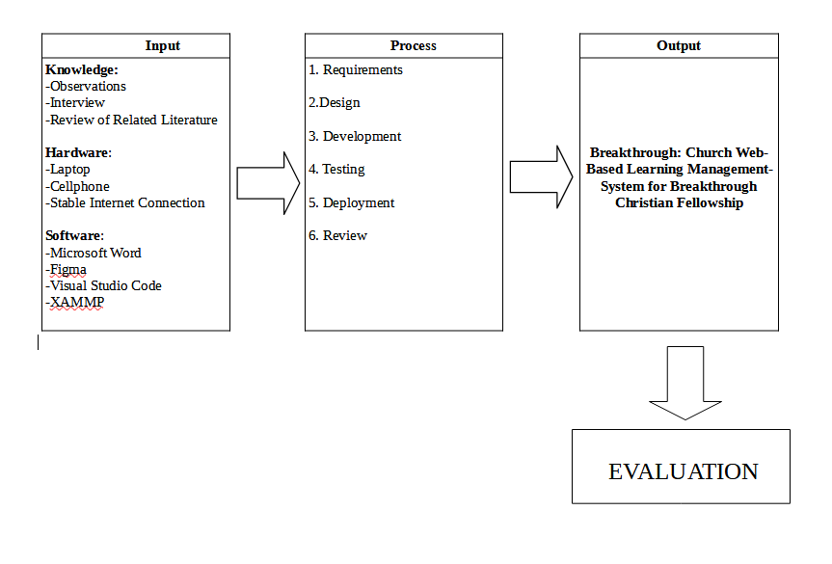Conceptual Model of The Study

*Figure 6: Input-Process-Output*

The figure that has been shown in the projects conceptual model is the input, process and output for the Breakthrough church learning management system which will aid in training disciples.

The diagram that has been shown is a representation of all components that will be utilized from begin until it accomplished its objectives, the graph covers where does the gathered information came from, materials that's required and the method to attain the study's objective. The developers aim to provide online Church learning and management system experience. For the input, they gathered data through interviews, and searched for related literature and systems. They also came up with the hardware and software requirements.

Next is the process, where the developers utilized the agile methodology to develop the church-based learning management system.

This culminates in the completion of the Breakthrough: Web-Based Church Learning Management System.

Benchmarking

|  |  |  |  |  |  |  |
| --- | --- | --- | --- | --- | --- | --- |
| System Features | LEAD™ LMS: An LMS built for the Church | Zion Christian Mission Learning  Portal | My Cathlolic Faith Delivered: Learning Management Platform | Churchtrac web-based system for administrator | ChurchCMS Management System – Mobile Application for Church Members | Breakthrough: Church Web-Based Learning Management System for Breakthrough Christian Fellowship  Task Management Application |
| Discipleship Module | ✓ | ✓ | ✓ |  |  | ✓ |
| Calendar |  |  |  | ✓ | ✓ | ✓ |
| Notifications | ✓ | ✓ |  | ✓ | ✓ | ✓ |
| Bible Module |  |  |  | ✓ |  | ✓ |
| Commu  -nication  Channels | ✓ | ✓ | ✓ |  | ✓ | ✓ |

*Table 1: Benchmarking Table*

Benchmarking involves comparing the current system's features with those of otherrelated systems. The table above presents all the features of the systems. The features of Breakthrough web-based learning management system have similarities with other related systems. However, the proposed system includes features that related systems do not have. Discipleship module, notifications and communication channels are common features, while the bible module and calendar is absent. The system’s comprehensive features give it an edge over other systems.

Related Studies and/or Systems

LEAD™ LMS: An LMS built for the Church

LEAD™ helps you consistently and effectively train, catechize, and engage your parishioners in mission. It automatically notifies a learner once they completed their formation and gives an always-up-to-date roster of everyone who’s trained for a given ministry. Besides that, it lets one email, text, or notify anyone (and everyone) who serves in a given ministry, has taken–or hasn’t quite remembered to finish–their training.

##### Zion Christian Mission Learning Portal

Zion Christian Mission Center (ZCMC) is a theological Institution in the Philippines. Like any modern institutions they have an online class. For online classes they use LMS– ZCMC Student Portal. This is where students can access the Zoom link for the class and view all lessons on their dashboard. The online classes we offer are also fun and convenient, allowing students to study at their own pace.

My Catholic Faith Delivered Learning Management Platform

My Catholic Faith Delivered is an online learning platform and delivery system. MCFD offers foundational courses in Scripture, Theology, and Catechesis for adults. In addition, MCFD offers several catechetical courses for high school and grade school students including the Didache series, Ignatius Press Faith and Life, and Theology of the Body. Catechetical leaders can use this platform to offer online formation for home study or in classroom experiences by subscribing to the service. MCFD offers assessments and tracking of student progress.

Churchtrac web-based system for administrator

##### Finally, a church software that all your people will love to use. ChurchTrac brings all the church apps and features you need together in one simplified ChMS so you can focus on your mission. (ChurchTrac Software, Inc., n.d.)

According to the website ChurchTrac, their comprehensive platform offers a range of features tailored to streamline church management and enhance member engagement. With tools for contributions and online giving, church calendar management, attendance tracking, and worship planning and scheduling, ChurchTrac provides a holistic solution for the diverse needs of religious organizations. The contributions and online giving feature enable members to contribute financially to the church securely and conveniently, whether in-person or remotely. The church calendar feature allows ad- ministrators to organize and manage church events effectively, ensuring seamless co- ordination of activities. Meanwhile, attendance tracking and worship planning tools empower church leaders and volunteers to optimize their operations and create worship best experiences for congregants.

ChurchCMS Management System – Mobile Application for Church Members.

Experience the ease of accessing your church from the comfort of your own home through our mobile application. In this era of technological advancement, your members can now stay updated on all spiritual matters with just a tap on their smartphones. With our app, you can effortlessly share all church-related information with your members, including daily notifications, event reminders, sermon videos and audios, bulletin updates, and memorable church moments captured in photos. This application serves as a vital link that closes the communication gap between members and their church, ensuring seamless connection and engagement at all times. (*Web Based Church Management Software With a Mobile App*, n.d.)

ChurchCMS is a online platform designed to streamline church management and enhance engagement within churches. It offers a comprehensive suite of features, including website event planning and scheduling capabilities, member directory management, and donation tracking functionalities. With its user-friendly interface and customizable templates, ChurchCMS enables churches to easily build and maintain professional looking websites tailored to their specific needs and preferences. The platform also facilitates seamless communication and collaboration among church members through features like event calendars, newsletters, and online forms.

Synthesis

The previous sections covered a wide range of content related to the development of the system. Based on the information, discipleship is a crucial element of church. Discipleship programs can serve as a foundation for spiritual growth, providing participants with a structured framework to explore their faith and scripture. With this in mind, the develops develop a system for BCF.

By developing a system that integrates traditional teaching methods with modern technology solutions, discipleship services can be improved in tremendous ways. First, there is a singular repository for teachings, lessons, and quizzes. Second, communication channels can facilitate meaningful conversations and connections among participants, as well as relay and resolve issues. Lastly, they can be reminded of events through the calendar and receive reminders though notifications.

The improvement of services can make learning easier and bring about unity to the entire church community.

## Technical Background

## Overview of Technologies to be Used in the System

## Web-based Technology

## During the development of Breakthrough, the developers utilized web-based technology. XAMPP, Bootstrap, MySQL and Visual Studio Code are used for the development of the system. XAMPP is used as the IDE, Visual Studio Code is for testing and debugging, Bootstrap is for the interactive elements, and MySQL is for the data storage. In addition the ones mentioned, developers used Word for documentation and Figma for system mockups.

## Local Area Network

## Local Area Network is also utilized by the developers for the development of the system. An internet connection is required to enter the website and access all the church-related content.

## Centralized Database

## Centralized database plays a huge role in the BCF church-based web learning management system. With a centralized database, there’s a singular storage for all the data inputted in the website that can be accessed through any device. This improves data governance and decreases maintenance burden.

## Calendar of Activities

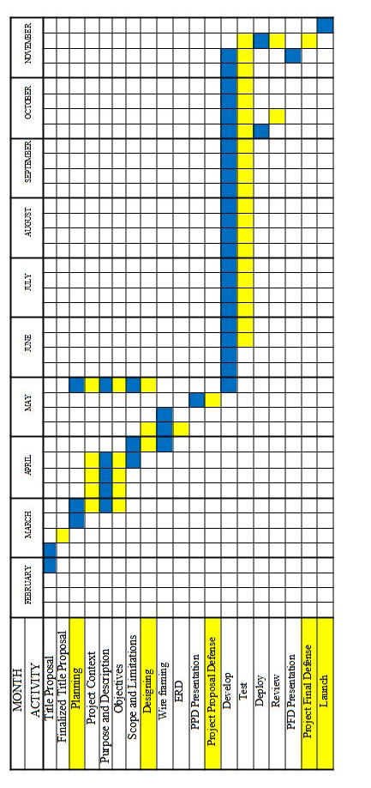

*Table 2: Gantt Chart of Activities*

* Resources

Hardware

|  |  |
| --- | --- |
| Hardware Components | Description |
| Operating System | Windows 11 |
| CPU | AMD Ryzen 5 5600G Radeon Vega 7  graphics |
| RAM | Ram T-Force Delta 16gb 3200Mhz |
| Monitor | Monitor Samsung 60Hz 1920x1080 |
| Peripherals | Mouse, Keyboard |

*Table 3: Hardware*

##### Software

##### The software resources are as follows:

|  |  |
| --- | --- |
| Software Categories | Specific Software |
| Integrated Development Environment | XAMPP |
| Communication Tool | Microsoft Teams and Messenger |
| Word Processing Software | Microsoft Word |
| Prototype Software | Figma |
| Framework Software | Bootstrap |
| Testing and Debugging Software | Visual Studio Code |

*Table 4: Software*

##### Microsoft Word -As programmers, we use Microsoft Word for creating all sorts of documents, especially for documenting project proposals. It serves as a guide to develop the system.

##### Figma -The developer use Figma to design user interfaces and user experiences. It allows us to create prototype and collaborate on the visual aspects of applications and websites efficiently.

##### MySQL -MySQL Workbench is chosen because of this capability to pass data online to cross platforms. It’s essential for the developer to query, design, and manage databases to insert all the data of the church members, lessons, and quizzes

##### Microsoft Visual Studio Code -Visual Studio Code software is used by the programmer as code editor to test and debug the web-based system. As for the features of the visual studio, we don’t need some other software for frameworks. The Microsoft Visual Studio Code has the ASP.NET framework.

##### AGILE METHODOLOGY

##### 

*Figure 7: Agile Methodology*

##### The development of the BCF Church Learning and Task Management System employed the Agile methodology, ensuring a smooth and systematic progression. This methodology served as the framework guiding the development team through the phases of planning, designing, developing, testing, deploying, reviewing, and launching the project.

##### The Agile method offers several benefits, such as increased motivation, enhanced quality, flexibility, improved service satisfaction, effective teamwork, transparency, and adaptability. It emphasizes flexible planning, frequent delivery of software updates, open communication, and a focus on quality through automated testing, continuous integration, and regular code reviews. By segmenting projects into smaller tasks, Agile allows teams to rapidly adjust to shifts in objectives, technological advances, or market dynamics. Additionally, it facilitates the early identification of errors.

##### The seven steps of Agile Method are as follows:

##### Planning: In this stage, developers gather data to understand the requirements and scope of the project. Based on the collected data, the proponents outline the system specifications and requirements, ensuring they align with the goals and needs of the Church.

##### Designing: Developers create wireframes and flowcharts to visualize the system's architecture and user interface. These design documents serve as blueprints for the development process, detailing the structure, layout, and flow of the application.

##### Development: This stage marks the beginning of the actual creation of the software. Developers use JavaScript and C# as the programming language and HTML, CSS for designing and writing the code. ASP.NET is employed as the framework, MySQL is used for the database management.

##### Testing: The complete functionality of the system is rigorously tested. Developers create and execute test-case scenarios to examine the code, identify bugs, and ensure the system performs as expected. This stage aims to verify the system’s reliability, security, and performance.

##### Deployment: In this phase, a pre-launch version of the system is deployed for test screening. The system is presented to the intended beneficiaries and selected users who provide feedback and suggest potential improvements. This user feedback is crucial for refining the system.

##### Review: Based on the feedback received during the deployment phase, developers make necessary adjustments and fine-tuning to enhance the system’s functionality and user experience. This iterative process ensures the system meets the users' needs and expectations.

##### Launch: The final phase involves the official launch of the application, making it available for the beneficiary. This marks the culmination of the entire development.

## Requirements Analysis

Prior to beginning the creation of Breakthrough: Church Web-Based Learning Management System for Breakthrough Christian Fellowship, the developers had to assess the project's potential obstacles and choose the most effective way to overcome them. Knowing who, what, where, when, and how it will be done was crucial. The developers made sure that Breakthrough is developed into a useful learning management system by answering the following queries.

Who: The Breakthrough learning management system will be beneficial for Breakthrough Christian Fellowship. The system aims to simplify the discipleship procedures for the disciplers and make learning fun for the disciples.

What: A learning management system that provides a centralized repository for lessons and quizzes. In addition, it integrates other features such as communication channel, calendar, notifications and bible module that enhance the learning experience.

Where: The SimuDrive is a car driving simulation that users can access on the desktop computers of ReyMalyn Driving School with the hardware components to be used in car simulation. SimuDrive applications are exclusive only to ReyMalyn Driving School because they are the only beneficiaries of this capstone project.

When: The learning management system is accessible through any devices, provided that the disciples and disciplers have a stable internet connection. Account registration is needed before they can access the website's contents.

How: Disciplers and disciples must enter a browser and enter Breakthrough on the search bar. Once the website is loaded, they must register or log-in. After the procedure is complete, they can access the website and do tasks such as accessing the modules, reading bible verses and communicating with others.

## Requirements Documentation

After conducting observations and interviews, developers decided to create Breakthrough, a web-based church management system. The developers' findings served as the basis for this concept, and any changes were made in response to panelists' suggestions for enhancing the system.

**Administrator Account Interface**:

* D**iscipleship module** In this module, the admin could upload, update, and manage all discipleship content across all age brackets.
* **Notifications** In this module, the admin could send notifications to all user levels.
* **Calendar of Event**s In this module, the admin could manage and update the calendar with all church events, photos and bible verses.
* **Bible App** In this module, the admin could add, edit or delete bible passages and scriptures.
* Lesson/ Subjects In this module, the admin could view the subjects.
* Admin Users In this module, the admin could view the admin users.
* **Department** In this module, the admin could view the admin users.
* Disciples and Disciplers In these modules, the admin could view the list of disciples and disciplers.
* **Disciples and Disciplers** In these modules, the admin could view the list of disciples and disciplers.
* Downloaded Materials and Uploaded Assignments In these modules, the admin could view the materials and assignments added by the disciplers and disciples.
* Content In this module, the admins can add, edit or delete content.
* Batches In this module, the admins can add, edit or delete batches.

**Discipler Account Interface**:

* **My Class** In this module, there is the **Bible Module** where disciplers can look for bible verses or passages. There’s also the **Discipleship Module** wherethe lessons are found**.** By clicking on it they will be directed to a page containing the sections **My Students**, **Subject Overview**, **Downloadable Materials**, **Assignments**, **Announcements**, **Class Calendar** and **Quiz** that they can edit. There is also a Back button that redirects to the **My Class** section.
* **Notifications** In this module, the discipler can send group-specific notifications and updates.
* **Calendar of Events** In this module, the discipler can view and add events pertinent to their group activities.
* **Message** In this module, the discipler can receive and compose messages.
* Backpack In this module, the discipler can view files.
* **Add Downloadables**, **Add Announcement**, and **Add** **Assignment** In these modules, the disciple can add documents, announcements and assignments
* Quiz In this module the discipler can create, edit or delete quizzes.
* Shared Files In this module the discipler can move files.

**Disciple Account Interface**:

* **My Class** In this module, the disciple can see the **Bible Verse** and the **Discipleship Module.** By clicking on it they will be directed to a page containing the sections **My Classmates**, **My Progress**, **Subject Overview**, **Downloadable Materials**, **Assignments**, **Class Calendar** and **Quiz**. There is also a Back button that redirects to the **My Class** section.
* **Notifications** In this module, the disciple can receive notifications about lessons, events, and other church activities.
* **Message** In this module, the disciple can send or receive messages.
* **Backpack** In this module, the disciple can view files.

## Design of Software, System, Product, and/or Processes

The developers designed the learning management system. Figma is used to create mockups of the system. Furthermore, prototyping and flowcharts are utilized, which ensures that the system is refined.

## Development

The developers utilized XAMPP as the platform for developing and designing the web-based church learning management system. Using XAMPP, the developers designed the website and implemented the features needed for a learning management system. Such features include the modules, calendar and notifications.

CSS and HTML are utilized for the appearance and interactivity of the system.

For testing and debugging, Visual Studio Code was chosen, offering a robust set of tools that significantly streamlined the coding and debugging processes. It has debugging tools perfect for spotting potential errors.

For the design, Bootrap is the CSS and HTML framework utilized for it. Numerous kinds of page design properties are included in Boostrap. By using it, the website's size can be adjusted to suit the user's needs, as well as add other interactive elements.

And Lastly, Figma is utilized for creating mockups of the system. Figma's wireframing feature enables the developers to create dynamic and precise designs.

# RESULTS AND DISCUSSION

## Testing

In this part, the proponents shall discuss and test the software development standards.

## Description of Prototype

This part includes the system requirements, the preliminary design, and how the system is being evaluated and tested.

## Implementation Plan

The Implementation Plan describes how the information system will be deployed, installed, and transitioned into an operational system. The plan contains an overview of the system, a brief description of the major tasks involved in the implementation, the overall resources needed to support the implementation effort (such as hardware, software, facilities, materials, and personnel), and any site-specific implementation requirements.

## Implementation Results

This part consists of the outputs during the implementation phase. These may include the generated outcomes as the ground for improving the project/system. This part is optional.

# Conclusion

The first part of this section is your summary, followed by the conclusion/s, and the last part is/are your recommendation/s.

This section summarizes the results based on the results and discussion chapter. There should be no presentation of tables or figures. A good summary should be comprehensive. A summary must be concise. Your summary should be considerably shorter than the source. Avoid repetitive details. A summary must be coherent and independent. You are expected to maintain your own voice throughout the summary. Don’t simply quote other researcher’s works; instead use your own words to express your understanding of what you have read. After all, your summary is based on your interpretation of the findings, points, or ideas. However, you should be careful not to create any misinterpretation or distortion by introducing comments or criticisms of your own.

Conclusions should unite with the findings and accomplishments of the study. If there are three summaries, there should also be three conclusions. Conclusions are arranged as they appear in the findings. Moreover, rejection and acceptance of the hypotheses, if applicable, are explained under conclusion. Only conclusions which are based definitely on the findings or results should be made. Mere opinions which have no basis in facts and findings have no place in the conclusions of the study.

Recommendations are based on the conclusions. It may include further research of the study and/ or enhancement of the developed system.

In the succeeding paragraphs, there should be no indentations, paragraphs are justified with left alignment. Delete this highlighted section and replace it with your content.

#### REFERENCES

*How the Latest Technology Trends Are Shaping Your Church*. (n.d.). CT Creative Studio. https://www.christianitytoday.com/partners/pushpay/how-latest-technology-trends- are-shaping-your-church.html

Barrett, D. (2023, May 22). *Technology and the Church: What You Need to Know*. Outreachmagazine.com. https://outreachmagazine.com/resources/76288-technology-and-the-church-what-you-need-to-know.html

Bradley, J. (n.d.). *What Is Discipleship and How Does It Happen? | Cru*. Cru.org. https://www.cru.org/us/en/train-and-grow/help-others-grow/discipleship/what-is- discipleship.html

*How should we be making disciples? - radical*. (2023, December 13). Radical. https://radical.net/article/making-disciples/

Arifin, M., Eryani, I., & Farahtika, G. (2023). *Students’ Perception of Using Moodle as a Learning Management System in Tertiary Education*. AL-ISHLAH: Jurnal Pendidikan, 15(4), 5140-5152. doi:https://doi.org/10.35445/alishlah.v15i4.3855

*DISCIPLESHIP GROUPS.* (n.d.) Real Life International. https://reel-life.org/discipleship-groups/

Turnbull, D., Chugh, R., & Luck, J. (2020). *Learning Management Systems, An Overview. In: Tatnall, A. (eds) Encyclopedia of Education and Information Technologies*. Springer, Cham. https://doi.org/10.1007/978-3-030-10576-1_248

Bullock A. N., Colvin A. D., & Sebrena Jackson M. (2022). *Using Social Media to Teach Advocacy to Students. Lecture Notes in Networks and Systems*. pp. 97-103. 10.1007/978-3-031-21569-8_9

What is instant messaging? GeeksforGeeks. https://www.geeksforgeeks.org/what-is-

instant-messaging/

*Church Calendar - Shared and published using GroupCal*. GroupCal. https://www.groupcal.app/guide/church-calendar

*Communication Software: Definitions, Types & Benefits*. CDW Expert (2021, October 26)CDW.com.https://www.cdw.com/content/cdw/en/articles/software/communicationsoftware-definitions-types-and-benefits.html

*bible software*. WordNet-Online. http://www.wordnet-online.com/bible_software.shtml

Yang, G., Ahmed, M. M., Gaweesh, S., & Adomah, E. (2020). Connected vehicle real-time traveler information messages for freeway speed harmonization under adverse weather conditions: Trajectory level analysis using driving simulator. *Accident Analysis and Prevention*, *146*, 105707. https://doi.org/10.1016/j.aap.2020.105707

*A learning Church is a growing Church*. lead (n.d.) https://leadlms.com/

*Courses & Programs*. Zion Christian Mission Center. https://zcmc.org.ph/courses-and-programs/

*Church management system as a service*. ChurchCMS. https://churchcms.app/

*Learning Management platform*. My Catholic Faith Delivered. https://mycatholicfaithdelivered.com/learning-management

Appendices

APPENDIX A: TECHNICAL VITAE

Curriculum Vitae of

ALDRIE I. BAUTISTA

Ericka St., San Vicente, Sta, Maria, Bulacan

aldriebautistagg@gmail.com

09058425312

EDUCATIONAL BACKGROUND

|  |  |  |
| --- | --- | --- |
| Level | Inclusive Dates | Name of school/ Institution |
| Tertiary | 2021-present | STI College Sta. Maria |
| Vocational/Technical | N/A | N/A |
| High School | 2015-2021 | Asian Institute of Science and  Technology Senior High  Cowry Abalone Institute of Cavite |
| Elementary | 2010-2015 | Cowry Abalone Institute of Cavite |

SKILLS

|  |  |  |
| --- | --- | --- |
| SKILLS | Level of Competency | Date Acquired |
| JavaScript  HTML  CSS  Java English Writing | Beginner  Beginner  Beginner  Beginner  Beginner | 2024  2024  2024  2022  2015 |
|  |  |  |
|  |  |  |

TRAININGS, SEMINARS, OR WORKSHOPS ATTENDED

|  |  |
| --- | --- |
| Inclusive Dates | Title of Training, Seminar, or Workshop |
| January 2024 | ENCRYPT IT : CYBERSECURITY SEMINAR |
|  |  |
|  |  |
|  |  |

Curriculum Vitae of

ARBEA O. CRUZ

12 Emerald St., TDSM, Pulong Buhangin, Sta, Maria, Bulacan [cruzarbeaolazo@gmail.com](mailto:cruzarbeaolazo@gmail.com)

09289902719

EDUCATIONAL BACKGROUND

|  |  |  |
| --- | --- | --- |
| Level | Inclusive Dates | Name of school/ Institution |
| Tertiary | 2021-present | STI College Sta. Maria |
| Vocational/Technical | N/A | N/A |
| High School | 2015-2021 | Mater Dei Academy |
| Elementary | 2010-2015 | Garden Village Elementary School |

SKILLS

|  |  |  |
| --- | --- | --- |
| SKILLS | Level of Competency | Date Acquired |
| JavaScript HTML  CSS  Java  C#  Graphic Design | Beginner  Beginner  Beginner  Beginner  Beginner  Beginner | 2024  2024  2024  2024  2023  2024 |
|  |  |  |

TRAININGS, SEMINARS, OR WORKSHOPS ATTENDED

|  |  |
| --- | --- |
| Inclusive Dates | Title of Training, Seminar, or Workshop |
| January 2024 | ENCRYPT IT : CYBERSECURITY SEMINAR |

Curriculum Vitae of

JAY OLAYER

#333 Hulo Manggahan, Sta. Maria,Bulacan

jayolayer@gmail.com

09491930918

EDUCATIONAL BACKGROUND

|  |  |  |
| --- | --- | --- |
| Level | Inclusive Dates | Name of school/ Institution |
| Tertiary | 2021-present | STI College Sta. Maria |
| Vocational/Technical | N/A | N/A |
| High School | 2015-2021 | Grace of Shekinah |
| Elementary | 2010-2015 | Manggahan Elementary School |

SKILLS

|  |  |  |
| --- | --- | --- |
| SKILLS | Level of Competency | Date Acquired |
| JavaScript  HTML  CSS  Java English Writing | Beginner  Beginner  Beginner  Beginner Beginner | 2024  2024  2024  2022  2015 |

TRAININGS, SEMINARS, OR WORKSHOPS ATTENDED

|  |  |
| --- | --- |
| Inclusive Dates | Title of Training, Seminar, or Workshop |
| January 2024 | ENCRYPT IT : CYBERSECURITY SEMINAR |

Curriculum Vitae of

DANIEL RASHEED QUILLOSA

Blk. 26 Lot 29, Cityland, Pulong Buhangin, Sta. Maria, Bulacan

[daniel171.quillosa@gmail.com](mailto:daniel171.quillosa@gmail.com)

09971623798

EDUCATIONAL BACKGROUND

|  |  |  |
| --- | --- | --- |
| Level | Inclusive Dates | Name of school/ Institution |
| Tertiary | 2021-present | STI College Sta. Maria |
| Vocational/Technical | N/A | N/A |
| High School | 2015-2021 | Immaculate Conception Polytechnic  Parada National Highschool |
| Elementary | 2010-2015 | Tumana Elementary School |

PROFESSIONAL OR VOLUNTEER EXPERIENCE

|  |  |  |
| --- | --- | --- |
| Inclusive Dates | Nature of Experience/  Job Title | Name and Address of Company or Organization |
| October 2023- March 2024 | Representative | Computer Society |

SKILLS

|  |  |  |
| --- | --- | --- |
| SKILLS | Level of Competency | Date Acquired |
| JavaScript  HTML  CSS  C#  Java  Git  Gomputer Design  Hardware | Beginner  Beginner  Beginner  Beginner Beginner  Beginner  Beginner  Beginner | 2024  2024  2024  2023  2021  2023  2024  2024 |

TRAININGS, SEMINARS, OR WORKSHOPS ATTENDED

|  |  |
| --- | --- |
| Inclusive Dates | Title of Training, Seminar, or Workshop |
| January 2024 | ENCRYPT IT : CYBERSECURITY SEMINAR |

Appendix B. reSOURCE PERSONS

RESOURCE PERSONS

|  |  |  |
| --- | --- | --- |
| NAME | POSITION | COMPANY/  ORGANIZATION |
| Mr. Jhon Rej I. Satiago | Capstone Advisor | STI College – Sta. Maria |
| Ms. Lara Camille Vergara | Professor | STI College – Sta. Maria |
| Mr. Sheena S. Rañon | Professor | STI College – Sta. Maria |
| Ms. Tricia Cruz | Secretary | Breakthrough Christian Fellowship |
| Mr. Kimbriel Oraya  *Table: Resource Persons* | Disciple | Breakthrough Christian Fellowhsip |

Appendix C. Interview

1. What is the Meaning of BCF?

Breakthrough Christian Fellowship.

2. Where is the Church located?

The Church has three branches: BCF Main is located in Paso, Sta. Maria, Bulacan; BCF North Caloocan; BCF San Jose Del Monte Bulacan.

3. What time does the Sunday Service start and finish?

The Sunday Service starts at 8:30 AM and finishes at 10:30 AM.

4. Who established the Church?

The Church was established by Pastor Glen and Pastora Eunice.

5. Do you accept Visitors?

Yes, visitors are counted as newcomers.

6. What activities does the Church have?

The Church offers various activities including Friday Prayer Night, Today’s Break- through (Morning Devotion), Sunday School every Sunday.

7. What is the process of Attendance in the Church?

Yes, the current method involves first timers filling out index cards with their personal data. Once their personal data is encoded in the google sheets, the ushering will tick the check box to mark their attendance,

8. How many ushers does the Church have?

The Church has 7 ushers

10. How many Secretaries does the Church have?

The Church has 1 Secretary

11. How many Members does the Church have:

The Church has 150 active members

12. How many members in a small group can be handled by 1 Leader?

The leader can handle multiple groups, with a minimum of 3 members and maximum of 12 members per group

13. What is the process to be a member of a Small group?

1. Attend church services regularly.

2. Participate in Small Group meetings consistently.

3. Engage in the discipleship process within the group.

1 4. What is the process to be a Leader of a Small Group?

1. Attend church services regularly.

2. Participate in Small Group meetings consistently.

3. Engage in the discipleship process within the group.

4. Handle a small group consistently for 3 months

15. If a member graduates and doesn’t want to be a Leader?

If a member graduates but doesn't wish to become a leader, they can continue participating in small group meetings as a member. They can still contribute to discussions, etc.

16. Errors experienced in small groups.

Errors experienced in small groups may include challenges in tracking members' progress accurately.

17. What do Leaders currently use to record or monitor member progress?

Leaders currently use the Messenger group chat platform where they regularly report small group meetings and track member progress.

18. How does the Church handle inactive members or leaders in small groups?

The Church addresses inactive members or leaders in small groups by enlisting the assis- tance of ushers to conduct follow-up procedures.

19. How does the Church handle inactive members?

The Church addresses inactive members by enlisting the assistance of ushers to conduct follow-up procedures.

20. How many disciples in explanatory training?

In our last session we did have 15 disciples.

21. What time start and end the explanatory sessions?

Every 8 pm to 9 pm.

22. How often does the explanatory training meet? (Wednesday only?)

All participant will take 5 lessons, the schedule is Monday and Wednesday 8PM to 9PM and they need to answer a quiz after each lesson.

23. What will happen if a disciple didn't attend in a session/sessions?

They will not be able to graduate unless they will take the lesson online and take the exam.

24. What age bracket required to enroll in the explanatory training?

12 years old and above.

25. What are the problems do disciples encounter in the explanatory training?

Forgetting the schedule of explanatory training. They also sometimes forget the deadline of quiz that they need to be taken they need to be notified individually.

26. How disciplers give video lesson and quizzes?

During the lesson session we watch the video and the quiz link (google form) is given after the lesson.

27. Where the content of the video lessons came from?

Customized by our church founder Ptr. Glenzer Fernandez

28. Who create the quizzes?

The author of the lessons head of BCF Church Ptr. Glenzer Fernandez

29. How the disciplers track the process of each disciple?

Facilitator/Admin will be responsible in tracking the progress of each disciple.

30. What happen if a disciple graduate in the explanatory training? (they can join again?)

YES

Appendix C. DIAGRAM

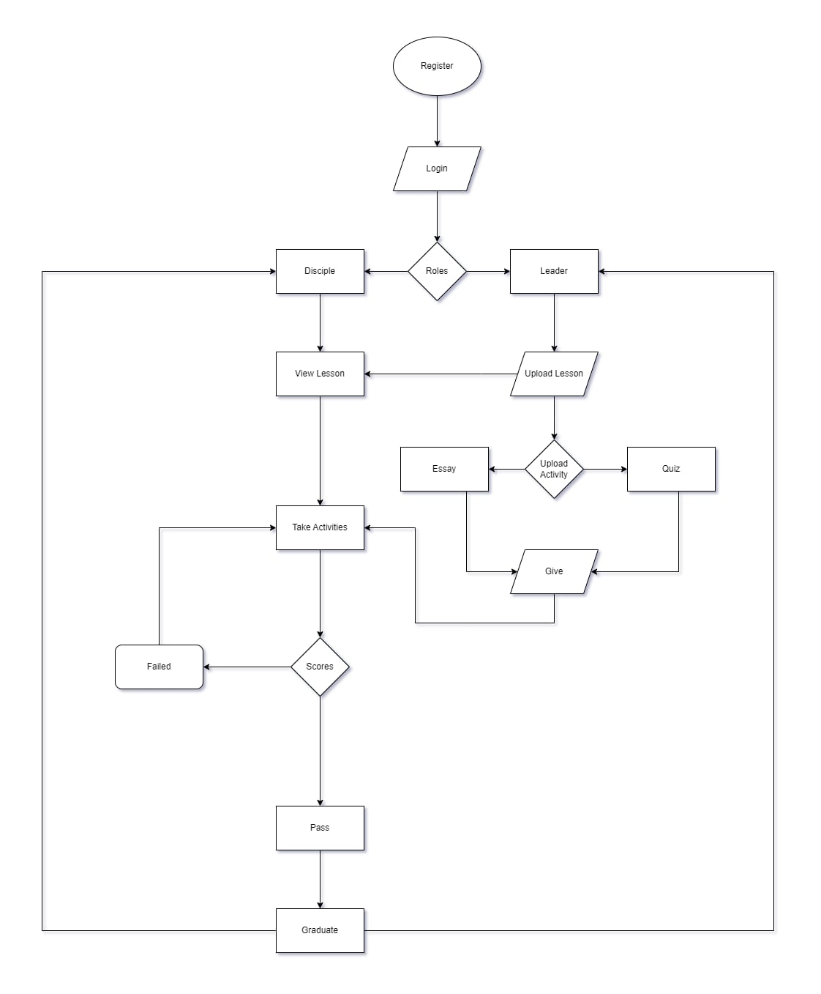

*Figure: Website Flowchart*

APPENDIX C. EVALUATION TOOL/TEST DOCUMENTS

APPENDIX D. SAMPLE INPUT/OUTPUT/REPORTS

APPENDIX E. USER’S GUIDE