How to change disciple password.

1. Click your name on the dropdown.

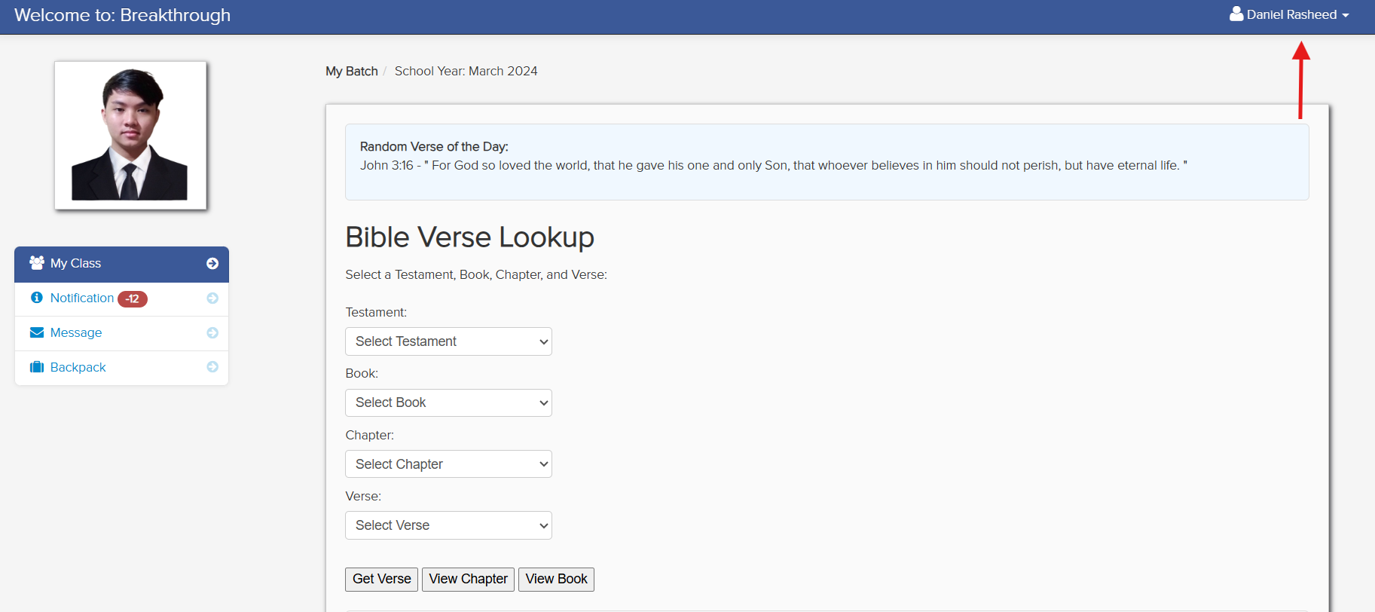

1. Select change password.

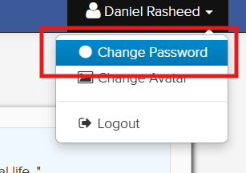

1. Then type your current password, new password and re-type password, to confirm that your new password is correct.

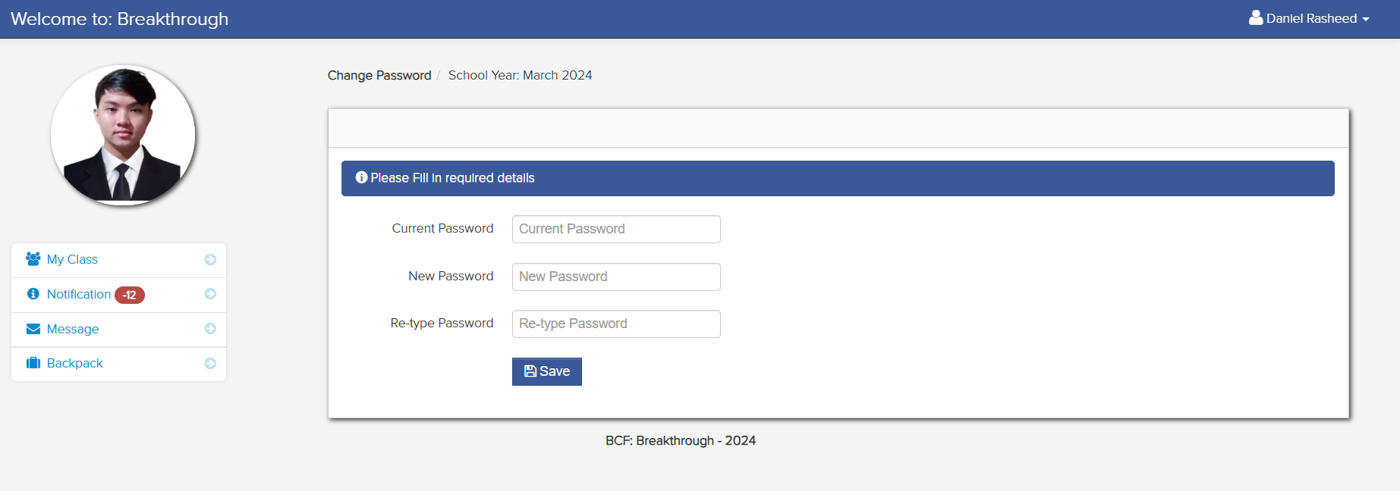

1. Click save.

