**Chapter 3**

**RESEARCH DESIGN AND METHODOLOGY**

This chapter outlines the systematic approach for developing and evaluating the embedded safety system. It details the research design, the specific procedures for data gathering, the environment where the study will be conducted, and the statistical methods for data analysis.

**Research Design**

This study employs a mixed-method research design combining developmental and experimental approaches. The research follows a sequential process of system design, prototype development, and empirical validation. The design incorporates both quantitative data from sensor measurements and qualitative insights from localized accident statistics to create a comprehensive safety solution.

**Research Process Flow**

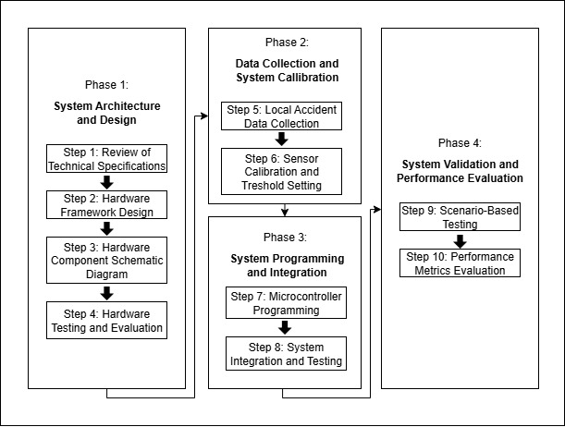

Figure 1. Research Process Flow

Figure 1 illustrates the research process flow followed by the researcher. It includes Phase 1: System Architecture and Development, Phase 2: Data Collection and Callibration, Phase 3: System Programming and Integration, and Phase 4: System Validation and Performance Evaluation.

**Phase 1: System Architecture and Development**

The initial phase focuses on testing and validating the functionality of hardware components. This stage involves reviewing technical specifications, designing the system framework, assembling components, and testing each part to ensure optimal operation.

Step 1: Review of Technical Specifications

The first step in hardware development involves a detailed examination of the technical specifications of primary components: Each element is assessed for its suitability to meet the study’s requirements, with particular attention paid to four key components: Arduino Nano Microcontoller, MQ-3 Alcohol Sensor, Pressure Sensor for Helmet Detection, and the 5V Relay Module.

Figure 2. Arduino Nano Microcontroller

For this project, an Arduino Nano was selected for its compact size, low power consumption, and sufficient I/O capabilities for sensor integration. As demonstrated in previous studies (Neelakanteshwaralu et al., 2024), its compatibility with various sensors makes it ideal for embedded safety systems.

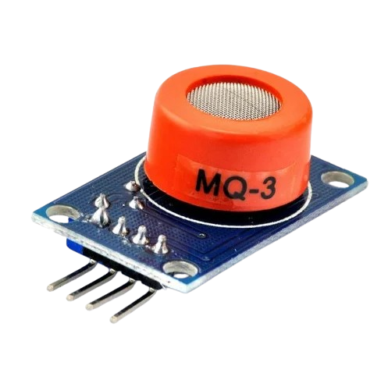

Figure 3. MQ-3 Alcohol Sensor

The MQ-3 sensor is specifically designed for alcohol detection with high sensitivity to ethanol vapor (Hanwei Electronics Co., Ltd., n.d.). This semiconductor sensor provides analog voltage output proportional to alcohol concentration.

*<--di ko sure specifics neto-->*

Figure 4. Pressure Sensor for Helmet Detection

A flexible pressure sensor will be integrated into the helmet lining to detect proper wearing, following the methodology validated by Shravya et al. (2019) for helmet usage monitoring.

Figure 5. 5V Relay Module

The relay module (Pololu Corporation, n.d.) serves as the ignition control switch, capable of handling the motorcycle's 12V ignition circuit while being controlled by the 5V Arduino output.

Step 2: Hardware Framework Design

*<--Dito diko sure kung pedes yang malagay sa loob ng helemet-->*

Figure 5. System Enclosure Design

The enclosure is designed to house the Arduino Nano, relay module, and connection terminals. With dimensions of 100mm × 80mm × 50mm, it provides protection from environmental factors while allowing proper ventilation and easy maintenance access.

Step 3: Hardware Component Schematic Diagram

*<--bagi mali ini-->*

Figure 6. System Schematic Diagram

Figure 6 shows the Arduino Nano as the central processing unit, connected to various components for comprehensive helmet safety and ignition control. It interfaces with the pressure sensor on Digital Pin 2 to detect helmet presence, the MQ-3 alcohol sensor on Analog Pin A0 for monitoring alcohol levels, and the relay module on Digital Pin 3 to manage ignition control. Additionally, an RGB LED connected to Pins 5, 6, and 7 provides visual status indication, while a buzzer on Digital Pin 4 offers audible alerts. The entire system is powered by the motorcycle’s 12V battery through a voltage regulator to ensure stable 5V operation for the Arduino and sensors.

Step 4: Hardware Testing and Evaluation

This step entails comprehensive testing of both individual components and the integrated system to ensure reliability and accuracy. The pressure sensor undergoes response accuracy verification through 10 trials, while the MQ-3 alcohol sensor is calibrated using known alcohol concentrations. The relay's switching performance is tested under load conditions to confirm dependable operation, and power consumption is measured to assess the system’s efficiency.

**Phase 2: Data Collection and System Calibration**

This phase focuses on gathering operational data and calibrating the system for accurate performance.

Step 5: Local Accident Data Collection

This step involves collecting motorcycle accident statistics from the PNP Virac and gathering helmet compliance and alcohol-related incident data from the LTO Virac. The collected data is analyzed to identify patterns and establish baseline safety metrics. These metrics are then used to validate the system requirements and set appropriate threshold levels for detection and response.

Step 6: Sensor Calibration and Threshold Setting

This step involves establishing baseline MQ-3 sensor readings in an alcohol-free environment to ensure accurate measurement. The optimal alcohol threshold is determined, typically corresponding to a 0.04% BAC equivalent. The pressure sensor sensitivity is calibrated to account for different helmet types. Finally, system response parameters are set based on the collected calibration data to ensure reliable detection and response.

**Phase 3: System Programming and Integration**

This phase involves developing the control software and integrating all system components.

Step 7: Microcontroller Programming

*<--no info-->*

Step 8: System Integration and Testing

This step involves integrating all hardware components with the control software to ensure seamless operation. The complete system is tested end-to-end to verify functionality and responsiveness under real conditions. Safety protocols and fail-safe mechanisms are validated to guarantee reliable performance in critical situations. Additionally, power management is optimized to support continuous operation, maximizing system efficiency and uptime.

*<--flowchart and description to be inserted here-->*

**Phase 4: System Validation and Performance Evaluation**

This final phase focuses on comprehensive testing and performance assessment of the entire system to ensure it meets all functional and safety requirements. It includes validating the integration of hardware and software components through rigorous end-to-end testing, simulating real-world scenarios to verify system responses.

Step 9: Scenario-Based Testing

The test scenarios are designed to verify system behavior under different rider conditions. For Test Scenario 1, with the helmet properly worn and the rider in a sober state, a green LED indicates compliance and the ignition is enabled. In Test Scenario 2, when no helmet is worn but the rider is sober, a blue LED activates along with a buzzer alert, and the ignition is locked. Test Scenario 3 simulates an impaired rider wearing a helmet, triggering a red LED, continuous buzzer, and ignition lock. Finally, Test Scenario 4 addresses multiple violations, no helmet and alcohol detected—resulting in combined alerts and ignition lock to ensure safety.

Step 10: Performance Metrics Evaluation

The key performance metrics used to evaluate the system include accuracy, which measures the percentage of correct detection outcomes. Response time assesses the delay between sensor input and corresponding system action. Reliability is gauged by the consistency of performance across multiple test cycles. Power efficiency involves analyzing current consumption to optimize energy use. Environmental robustness evaluates the system's performance under varying external conditions to ensure dependable operation in real-world scenarios.

**Implementation Timeline**

*<--gantt chart?-->*

The project timeline is structured to ensure systematic development and thorough testing of the system. During Weeks 1-2, component specifications are defined and all necessary parts are acquired. Weeks 3-4 focus on hardware assembly and testing individual components to guarantee proper functionality. In Weeks 5-6, software development is carried out alongside hardware integration to build a cohesive system. Weeks 7-8 are dedicated to comprehensive testing and calibration to refine accuracy and reliability. Field validation and performance evaluation occur in Weeks 9-10 to assess real-world operation and effectiveness. Finally, Week 11 is reserved for data analysis and documentation, providing detailed reports and insights to guide further improvements and implementation.

**Locale of the Study**

This study will be conducted in Virac, Catanduanes. The development and testing of the embedded motorcycle safety system will be carried out within the municipality. Virac, as the capital of Catanduanes province in the Bicol Region of Luzon, Philippines, provides an ideal setting for this research due to its representative urban-rural environment that reflects common motorcycle usage patterns in provincial municipalities.

The study will utilize local motorcycle accident data to be obtained from the Virac Municipal Police Station and Land Transportation Office (LTO) Virac District Office. System testing and validation will be conducted in selected locations throughout Virac that represent typical motorcycle operating environments, including urban streets and residential areas where motorcycle usage is prevalent.

This location has been selected as it provides a suitable setting for evaluating the embedded safety system's effectiveness in real-world conditions typical of Philippine municipalities, while allowing access to official traffic incident data and appropriate testing environments necessary for comprehensive system validation.

**BLOCK DIAGRAM**

Figure 7. Block Diagram

Figure 7 illustrates the flow of operations from the motorcycle’s power source to the system controller, which processes inputs and produces outputs. The system begins when the power is supplied. The Arduino Nano (as the central processor, if we decide to keep it) collects data from helmet detection and alcohol monitoring. Based on these inputs, the system makes decisions for ignition control and provides feedback to the user through an LCD display (status, warnings, or results).

**Statistical Approach**

The performance evaluation metrics used in this study are adapted from the established methodology of Sharma et al. (2020), who applied these techniques in assessing smart helmet systems integrating alcohol detection. These metrics enable objective analysis of classification results by quantifying the system’s ability to correctly identify helmet usage and alcohol presence. The following confusion matrix and formula-based metrics provide a structured framework for evaluating prediction accuracy, precision, recall, and overall system effectiveness based on true and false detection outcomes.

Table 1. Confusion Matrix for System Evaluation

|  |  |  |
| --- | --- | --- |
| **Actual \ Predicted** | **Positive Detection** | **Negative Detection** |
| Positive Cases | True Positives (TP) | False Negatives (FN) |
| Negative Cases | False Positive (FP) | True Negatives (TN) |

The confusion matrix in Table 1 displays the distribution of correct and incorrect predictions for the helmet detection and alcohol monitoring subsystems. This matrix provides the foundation for measuring classification performance as established by Sharma et al. (2020).

**Performance Metrics**

The system’s effectiveness will be quantified by the following standard classification metrics:

**ACCURACY**

Measures the overall correctness of the system’s predictions.

**PRECISION**

Indicates the fraction of positive identifications that were actually correct.

**RECALL (SENSITIVITY)**

Reflects the ability of the system to correctly identify all actual positive cases.

**FL-SCORE**

The harmonic mean of Precision and Recall, representing balance between the two.

True Positive (TP) - Correct positive detection (e.g., helmet correctly identified as worn/with alcohol detected).

True Negative (TN) - Correct negative detection (e.g., helmet correctly identified as not worn/no alcohol detected).

False Positive (FP) - Incorrect positive detection (e.g., helmet falsely detected/alcohol wrongly identified).

False Negative (FN) - Missed positive detection (e.g., helmet worn or alcohol present but not detected).

Total Tests - Sum of all samples tested across categories.

References:

Retrieved from <https://www.sparkfun.com/alcohol-gas-sensor-mq-3.html>

Pololu Corporation. (n.d.). *Relay modules product documentation*. Retrieved from <https://www.pololu.com/product/2480>