HTML
TUGAS 1 : CSS
Nama /Nim | : | Panji Jagat Satria(2518033)
Kelas | : | C
Pengajar | : | IKHAWAAN PRATAMA (2418060)

Tujuan
- Praktikan dapat
- Praktikan dapat
- Praktikan dapat
- Alat dan Bahan

Alat dan Bahan
- Laptop/pc
- Modul Praktikum Web 2026
- TextEditor (Visual Studio Code / Sublime Text)

Langkah-langkah
- Buat folder transaction, categories dan css pada folder CatShop yang telah dibuat sebelumnya
- Buat file baru dengan nama style.css, dan letakkan dalam folder css yang telah dibuat.
Source code style.css :
* {
margin: 0;
padding: 0;
box-sizing: border-box;
}

.container {
width: 80%;
margin: 0 auto;
}

body {
font-family: "Poppins", sans-serif;
}

/* new nav */
nav {
display: flex;
height: 80px;
width: 100%;
align-items: center;
justify-content: space-between;
flex-wrap: wrap;
}
nav ul {
display: flex;
flex-wrap: wrap;
list-style: none;
}
nav ul li {
margin: 0 5px;
}
nav ul li a {
color: #111;
text-decoration: none;
font-weight: 500;
padding: 8px 15px;
transition: all 0.3s ease;
}
nav ul li a.active,
nav ul li a:hover {
color: #ffb72b;
}
nav .menu-btn i {
color: #000;
font-size: 22px;
cursor: pointer;
display: none;
}
input[type="checkbox"] {
display: none;
}

.btn_login {
background-color: #ffb72b;
width: 100%;
padding: 8px 16px;
border-radius: 10px;
border: none;
cursor: pointer;
color: white;
}

.btn_login:hover {
background-color: #eba416;
color: #fff;
}

/* style jumbotron */
.jumbotron {
display: flex;
background-color: #ffb72b;
border-radius: 20px;
padding: 20px 0;
justify-content: space-around;
align-items: center;
margin-bottom: 50px;
}

.jumbotron-text {
width: 30%;
font-weight: 500;
}

.jumbotron-text p {
color: white;
margin: 20px 0;
}

.jumbotron-text button {
padding: 10px 18px;
border: none;
border-radius: 10px;
background-color: white;
color: #ffb72b;
cursor: pointer;
}

/* style card-categories */
.cards-categories {
display: flex;
flex-direction: column;
align-items: center;
}

.cards-categories h2 {
font-family: "Roboto", sans-serif;
font-size: 24px;
margin-bottom: 20px;
text-align: center;
}

.card-categories {
display: grid;
gap: 1.5rem;
grid-template-columns: repeat(auto-fit, minmax(20rem, 1fr));
}

.card {
box-shadow: 0 10px 20px rgba(0, 0, 0, 0.1);
border-radius: 15px;
overflow: hidden;
transition: transform 0.3s ease-in-out;
}

.card:hover {
transform: scale(1.05);
}

.card .card-image {
overflow: hidden;
border-radius: 15px 15px 0 0;
}

.card img {
width: 100%;
height: auto;
object-fit: cover;
border-radius: 15px 15px 0 0;
}

.card-content {
padding: 20px;
}

.card h5 {
margin-bottom: 10px;
font-family: "Roboto", sans-serif;
font-size: 22px;
font-weight: 600;
color: #333;
}

.card p.description {
font-size: 14px;
color: #666;
margin-bottom: 15px;
}

.card p.price {
font-size: 18px;
font-weight: bold;
color: #ffb72b;
margin-bottom: 15px;
}

.card .btn_belanja {
background-color: #ffb72b;
padding: 12px 20px;
border-radius: 8px;
border: none;
cursor: pointer;
color: white;
font-size: 16px;
transition: background-color 0.3s ease;
}

.card .btn_belanja:hover {
background-color: #eba416;
}

/* footer */
footer {
display: flex;
justify-content: center;
align-items: center;
margin: 40px 0;
}

/* style page login */

.center {
display: flex;
justify-content: center;
align-items: center;
height: 500px;
}

.form-login {
display: flex;
flex-direction: column;
align-items: center;
width: 30%;
background-color: white;
padding: 30px;
margin: 0 auto;
box-shadow: 0 6px 12px 4px rgba(0, 0, 0, 0.15);
border-radius: 10px;
}

.input {
width: 100%;
margin: 10px 0;
padding: 10px;
border-radius: 10px;
border: 1px solid rgb(148, 148, 148);
}

.link-register {
text-decoration: none;
margin-top: 10px;
}

/* responsive */
@media screen and (max-width: 1023px) {
.container {
width: 100%;
margin: 0 auto;
}
/* navbar responsive */
nav {
padding: 0 40px 0 50px;
position: relative;
}

nav .menu-btn i {
display: block;
}
#click:checked ~ .menu-btn i:before {
content: "\f00d";
}
nav ul {
position: absolute;
top: 80px;
left: -100%;
background: rgba(0, 0, 0, 0.85);
width: 100%;
text-align: center;
display: block;
transition: all 0.3s ease;
}
#click:checked ~ ul {
left: 0;
}
nav ul li {
width: 100%;
margin: 40px 0;
}
nav ul li a {
width: 100%;
margin-left: -100%;
display: block;
font-size: 20px;
color: #fff;
transition: 0.6s cubic-bezier(0.68, -0.55, 0.265, 1.55);
}
#click:checked ~ ul li a {
margin-left: 0px;
}
nav ul li a.active,
nav ul li a:hover {
color: #ffb72b;
}

/* jumbotron responsive */
.jumbotron {
flex-direction: column-reverse;
border-radius: 0px !important;
justify-content: center;
}
.jumbotron-img img {
width: 100% !important;
}

.jumbotron-text {
width: 100% !important;
padding-left: 20px;
}

/* card-categories responsive */
.card-categories {
flex-direction: column;
gap: 20px;
margin: 0 10px;
}

.card {
width: 100% !important;
}

/* form-login responsive */
.form-login {
width: 80%;
}
.modal-content {
width: 80%; /* Sesuaikan ukuran modal untuk layar kecil */
}
}
- Ubah isi dari file index.html
<!DOCTYPE html>
<html lang="en">
<head>
<link rel="icon" href="assets/icon.png" />
<title>Home</title>
<link rel="stylesheet" href="css/style.css" />
<link rel="preconnect" href="https://fonts.googleapis.com" />
<link rel="preconnect" href="https://fonts.gstatic.com" crossorigin />
<link
href="https://fonts.googleapis.com/css2?family=Poppins:wght@400;500;700&family=Roboto:wght@500;700&display=swap"
rel="stylesheet"
/>
<link
rel="stylesheet"
href="https://cdnjs.cloudflare.com/ajax/libs/font-awesome/5.15.3/css/all.min.css"
/>
<link rel="stylesheet" href="style.css" />
</head>

<body>
<div class="container">
<header>
<nav>
<div class="logo">
<img src="assets/logo.png" alt="" />
</div>
<input type="checkbox" id="click" />
<label for="click" class="menu-btn">
<i class="fas fa-bars"></i>
</label>
<ul>
<li><a href="#">Home</a></li>
<li><a href="#">Categories</a></li>
<li><a href="login.html" class="btn_login">Login</a></li>
</ul>
</nav>
</header>
<main>
<div class="jumbotron">
<div class="jumbotron-text">
<h1>Find Your New Little Cat, Make a New Friend</h1>
<p>
Teman barumu yang lucu menunggu mu, ayo temukan mereka sekarang
</p>
<button type="button" class="btn_getStarted">Get Started</button>
</div>
<div class="jumbotron-img">
<img src="assets/jumbotron.png" alt="" />
</div>
</div>
<div class="cards-categories">
<h2>Cat Categories</h2>
<div class="card-categories">
<div class="card">
<div class="card-image">
<img src="assets/anggora.png" alt="gambar tidak ditemukan" />
</div>
<div class="card-content">
<h5>Anggora</h5>
<p class="description">
Anggora turki adalah salah satu ras kucing domestik alami
tertua. Ras ini berasal dari Ankara, Turki. Kucing ini sangat
populer dan terkenal di Indonesia.
</p>
<p class="price"><span>Rp.</span>50,000</p>
<button class="btn_belanja" type="submit">Beli</button>
</div>
</div>
<div class="card">
<div class="card-image">
<img src="assets/persia.png" alt="gambar tidak ditemukan" />
</div>
<div class="card-content">
<h5>Persia</h5>
<p class="description">
Kucing persia adalah ras kucing domestik berbulu panjang
dengan karakter wajah bulat dan moncong pendek. Namanya
mengacu pada Persia.
</p>
<p class="price"><span>Rp.</span>50,000</p>
<button class="btn_belanja" type="submit">Beli</button>
</div>
</div>
<div class="card">
<div class="card-image">
<img src="assets/british.png" alt="gambar tidak ditemukan" />
</div>
<div class="card-content">
<h5>British Shorthair</h5>
<p class="description">
Kucing bulu pendek britania adalah salah satu ras kucing
tertua di inggris. Kucing ini adalah kucing berbadan sedang
dengan bulu yang pendek.
</p>
<p class="price"><span>Rp.</span>50,000</p>
<button class="btn_belanja" type="submit">Beli</button>
</div>
</div>
</div>
</div>
</main>
<footer>
<h4>&copy; Lab Pemrograman Komputer 2026</h4>
</footer>
</div>
</body>
</html>
Hasil Tampilan di Laptop atau PC:
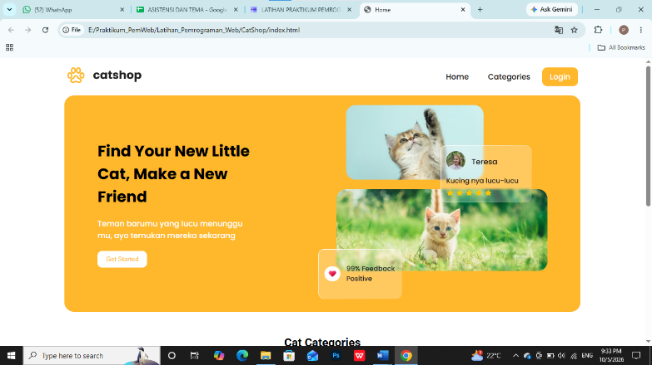
Gambar. 1.

- Ubah isi dari file login.html
Source code login.html :
<!DOCTYPE html>
<html lang="en">
<head>
<title>Login</title>
<link rel="icon" href="assets/icon.png" />
<link rel="stylesheet" href="css/style.css" />
<link rel="preconnect" href="https://fonts.googleapis.com" />
<link rel="preconnect" href="https://fonts.gstatic.com" crossorigin />
<linkhref="https://fonts.googleapis.com/css2?family=Poppins:wght@400;500;700&family=Roboto:wght@500;700&display=swap"
rel="stylesheet"
/>
<link
rel="stylesheet"
href="https://cdnjs.cloudflare.com/ajax/libs/font-awesome/5.15.3/css/all.min.css"
/>
<link rel="stylesheet" href="style.css" />
</head>
<body>
<div class="container">
<header>
<nav>
<div class="logo">
<img src="assets/logo.png" alt="" />
</div>
<input type="checkbox" id="click" />
<label for="click" class="menu-btn">
<i class="fas fa-bars"></i>
</label>
<ul>
<li><a href="index.html">Home</a></li>
<li><a href="#">Categories</a></li>
<li><a href="login.html" class="btn_login">Login</a></li>
</ul>
</nav>
</header>
<main>
<div class="center">
<div class="form-login">
<h3>Login</h3>
<form action="">
<input
class="input"
type="text"
name="username"
placeholder="Username"
/>
<input
class="input"
type="password"
name="password"
placeholder="Password"
/>
<button type="submit" class="btn_login" name="login" id="login">
Login
</button>
</form>
<a href="register.html" class="link-register"> Register Disini</a>
</div>
</div>
</main>
<footer>
<h4>&copy; Lab Pemrograman Komputer 2026</h4>
</footer>
</div>
</body>
</html>
Hasil Tampilan di Laptop
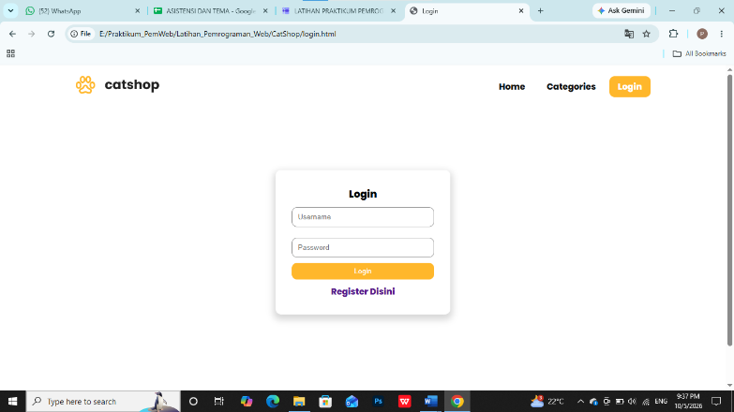
- Ubah isi register.html
<!DOCTYPE html>
<html lang="en">
<head>
<title>Register</title>
<link rel="icon" href="assets/icon.png" />
<link rel="stylesheet" href="css/style.css" />
<link rel="preconnect" href="https://fonts.googleapis.com" />
<link rel="preconnect" href="https://fonts.gstatic.com" crossorigin />
<link
href="https://fonts.googleapis.com/css2?family=Poppins:wght@400;500;700&family=Roboto:wght@500;700&display=swap"
rel="stylesheet"
/>
<link
rel="stylesheet"
href="https://cdnjs.cloudflare.com/ajax/libs/font-awesome/5.15.3/css/all.min.css"
/>
<link rel="stylesheet" href="style.css" />
</head>
<body>
<div class="container">
<header>
<nav>
<div class="logo">
<img src="assets/logo.png" alt="" />
</div>
<input type="checkbox" id="click" />
<label for="click" class="menu-btn">
<i class="fas fa-bars"></i>
</label>
<ul>
<li><a href="index.html">Home</a></li>
<li><a href="#">Categories</a></li>
<li><a href="login.html" class="btn_login">Login</a></li>
</ul>
</nav>
</header>
<main>
<div class="center">
<div class="form-login">
<h3>Register</h3>
<form action="">
<input
class="input"
type="email"
name="email"
placeholder="Email"
/>
<input
class="input"
type="text"
name="username"
placeholder="Username"
/>
<input
class="input"
type="password"
name="password"
placeholder="Password"
/>
<button
type="submit"
class="btn_login"
name="register"
id="register"
>
Register
</button>
</form>
</div>
</div>
</main>
<footer>
<h4>&copy; Lab Pemrograman Komputer 2026</h4>
</footer>
</div>
</body>
</html>
Hasil Tampilan di Laptop:
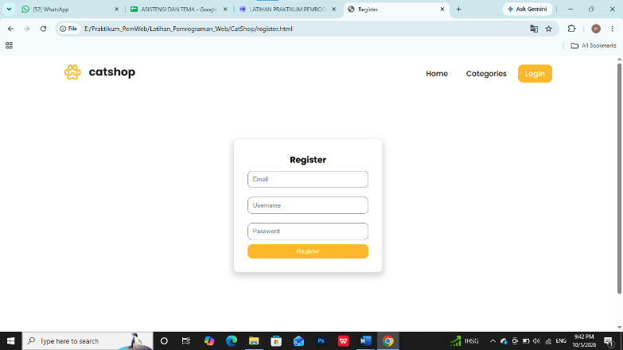
- Buatlah file css baru dengan nama admin.css dan simpan kedalam folder css yang telah dibuat sebelumnya. Kemudian tambahkan baris code dibawah ini
Source code admin.css:
@import url("https://fonts.googleapis.com/css2?family=Poppins:wght@200;300;400;500;600;700&display=swap");
* {
margin: 0;
padding: 0;
box-sizing: border-box;
font-family: "Poppins", sans-serif;
}
/* sidebar */
.sidebar {
position: fixed;
height: 100%;
width: 240px;
background: #ffb72b;
transition: all 0.5s ease;
}
.sidebar.active {
width: 60px;
}
.sidebar .logo-details {
height: 80px;
display: flex;
align-items: center;
}
.sidebar .logo-details i {
font-size: 28px;
font-weight: 500;
color: #fff;
min-width: 60px;
text-align: center;
}
.sidebar .logo-details .logo_name {
color: #fff;
font-size: 24px;
font-weight: 500;
}
.sidebar .nav-links {
margin-top: 10px;
}
.sidebar .nav-links li {
position: relative;
list-style: none;
height: 50px;
}
.sidebar .nav-links li a {
height: 100%;
width: 100%;
display: flex;
align-items: center;
text-decoration: none;
transition: all 0.4s ease;
}
.sidebar .nav-links li a.active {
background: #eba416;
}
.sidebar .nav-links li a:hover {
background: #eba416;
}
.sidebar .nav-links li i {
min-width: 60px;
text-align: center;
font-size: 18px;
color: #fff;
}
.sidebar .nav-links li a .links_name {
color: #fff;
font-size: 15px;
font-weight: 400;
white-space: nowrap;
}

/* main content */
.home-section {
position: relative;
background: #f5f5f5;
min-height: 100vh;
width: calc(100% - 240px);
left: 240px;
transition: all 0.5s ease;
}
.sidebar.active ~ .home-section {
width: calc(100% - 60px);
left: 60px;
}
.home-section nav {
display: flex;
justify-content: space-between;
height: 80px;
background: #fff;
display: flex;
align-items: center;
position: fixed;
width: calc(100% - 240px);
left: 240px;
z-index: 100;
padding: 0 20px;
box-shadow: 0 1px 1px rgba(0, 0, 0, 0.1);
transition: all 0.5s ease;
}
.sidebar.active ~ .home-section nav {
left: 60px;
width: calc(100% - 60px);
}
.home-section nav .sidebar-button {
display: flex;
align-items: center;
font-size: 24px;
font-weight: 500;
}
nav .sidebar-button i {
font-size: 35px;
margin-right: 10px;
}

.home-section nav .profile-details {
display: flex;
align-items: center;
justify-content: center;
background: #f5f6fa;
border: 2px solid #efeef1;
border-radius: 6px;
height: 50px;
min-width: 190px;
}
.table-data {
text-align: center;
border-collapse: collapse;
width: 100%;
overflow-x: auto;

}

.btn-edit,
.btn-delete {
padding: 8px 16px;
margin-right: 8px;
border: none;
border-radius: 4px;
cursor: pointer;
font-size: 14px;
transition: background-color 0.3s;
}

.btn-edit {
background-color: #4caf50; /* Green */
color: white;
}

.btn-delete {
background-color: #f44336; /* Red */
color: white;
}

.btn-edit:hover,
.btn-delete:hover {
background-color: #45a049; /* Darker green */
}

nav .profile-details .admin_name {
font-size: 15px;
font-weight: 500;
color: #333;
white-space: nowrap;
}
.home-section .home-content {
position: relative;
padding-top: 104px;
padding-left: 20px;
padding-right: 20px;
}

.btn {
background-color: #ffb72b;
color: white;
padding: 10px 20px;
border: none;
border-radius: 5px;
cursor: pointer;
}

.btn a {
text-decoration: none;
color: white;
}

.btn-tambah {
margin: 10px 0;
}

.btn-simpan {
width: 100%;
}

.btn:hover {
background-color: #eba416;
}

.table-data {
text-align: center;
border-collapse: collapse;
width: 100%;
}
th, td {
border: 1px solid black;
padding: 5px 20px;
}
.form-login {
display: flex;
flex-direction: column;
align-items: center;
background-color: white;
padding: 30px;
margin: 10px auto;
border-radius: 10px;
}
.input {
width: 100%;
margin: 10px 0;
padding: 10px;
border-radius: 10px;
border: 1px solid rgb(148, 148, 148);
}
/* waran status transaksi */
.success {
background-color: #4CAF50; /* Green */
color: white;
border-radius: 5px;
padding: 5px 10px;
}

.pending {
background-color: #FFC107; /* Yellow */
color: black;
}

.expire {
background-color: #f44336; /* Red */
color: white;
}

.cancel {
background-color: #607D8B; /* Blue Grey */
color: white;
}

.settlement {
background-color: #2196F3; /* Blue */
color: white;
}
.btn_detail {
background-color: #2196F3; /* Blue */
color: white;
padding: 5px 10px;
border-radius: 5px;
border: none;
}
.btn_detail:hover {
background-color: #0d8bf0; /* Blue */
}

/* Responsive Media Query */
@media (max-width: 1240px) {
.sidebar {
width: 60px;
}
.sidebar.active {
width: 220px;
}
.home-section {
width: calc(100% - 60px);
left: 60px;
}
.sidebar.active ~ .home-section {
/* width: calc(100% - 220px); */
overflow: hidden;
left: 220px;
}
.home-section nav {
width: calc(100% - 60px);
left: 60px;
}
.sidebar.active ~ .home-section nav {
width: calc(100% - 220px);
left: 220px;
}
}
@media (max-width: 700px) {
nav .profile-details {
display: none !important;
}
.home-section nav .profile-details {
height: 50px;
min-width: 40px;
}
}
@media (max-width: 550px) {
.profile-details {
display: none !important;
}

}
@media (max-width: 400px) {
.sidebar {
width: 0;
}
.sidebar.active {
width: 60px;
}
.home-section {
width: 100%;
left: 0;
}
.sidebar.active ~ .home-section {
left: 60px;
width: calc(100% - 60px);
}
.home-section nav {
width: 100%;
left: 0;
}
.sidebar.active ~ .home-section nav {
left: 60px;
width: calc(100% - 60px);
}
}
- Buat file baru dengan nama admin.html
Source Code admin.html :
<!DOCTYPE html>
<html lang="en">

<head>
<meta charset="UTF-8" />
<link rel="icon" href="assets/icon.png" />
<link rel="stylesheet" href="css/admin.css" />
<link href="https://unpkg.com/boxicons@2.0.7/css/boxicons.min.css" rel="stylesheet" />
<meta name="viewport" content="width=device-width, initial-scale=1.0" />
<title>Catshop Admin</title>
</head>

<body>
<div class="sidebar">
<div class="logo-details">
<i class="bx bx-category"></i>
<span class="logo_name">CatShop</span>
</div>
<ul class="nav-links">
<li>
<a href="#" class="active">
<i class="bx bx-grid-alt"></i>
<span class="links_name">Dashboard</span>
</a>
</li>
<li>
<a href="categories/categories.html">
<i class="bx bx-box"></i>
<span class="links_name">Categories</span>
</a>
</li>
<li>
<a href="transaction/transaction.html">
<i class="bx bx-list-ul"></i>
<span class="links_name">Transaction</span>
</a>
</li>
<li>
<a href="#">
<i class="bx bx-log-out"></i>
<span class="links_name">Log out</span>
</a>
</li>
</ul>
</div>
<section class="home-section">
<nav>
<div class="sidebar-button">
<i class="bx bx-menu sidebarBtn"></i>
</div>
<div class="profile-details">
<span class="admin_name">Catshop Admin</span>
</div>
</nav>
<div class="home-content">
<h1>Selamat Datang Admin</h1>
</div>
</section>
<script>
let sidebar = document.querySelector(".sidebar");
let sidebarBtn = document.querySelector(".sidebarBtn");
sidebarBtn.onclick = function () {
sidebar.classList.toggle("active");
if (sidebar.classList.contains("active")) {
sidebarBtn.classList.replace("bx-menu", "bx-menu-alt-right");
} else sidebarBtn.classList.replace("bx-menu-alt-right", "bx-menu");
};
</script>
</body>

</html>
Hasil Tampilan di Laptop:
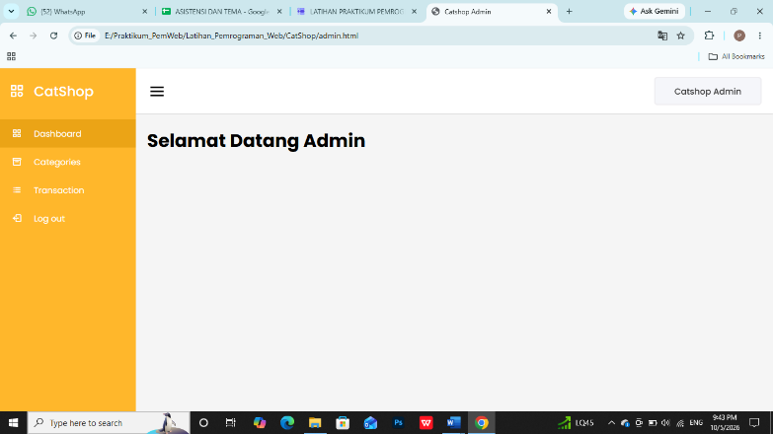

- Buat file baru dengan nama categories.html kemudian simpan ke dalam folder categories.
Source Code categories.html:
<!DOCTYPE html>
<html lang="en" dir="ltr">

<head>
<meta charset="UTF-8" />
<link rel="icon" href="../assets/icon.png" />
<link rel="stylesheet" href="../css/admin.css" />
<!-- Boxicons CDN Link -->
<link href="https://unpkg.com/boxicons@2.0.7/css/boxicons.min.css" rel="stylesheet" />
<meta name="viewport" content="width=device-width, initial-scale=1.0" />
<title>Catshop Admin | Categories</title>
</head>

<body>
<div class="sidebar">
<div class="logo-details">
<i class="bx bx-category"></i>
<span class="logo_name">CatShop</span>
</div>
<ul class="nav-links">
<li>
<a href="../admin.html" class="active">
<i class="bx bx-grid-alt"></i>
<span class="links_name">Dashboard</span>
</a>
</li>
<li>
<a href="../categories/categories.html">
<i class="bx bx-box"></i>
<span class="links_name">Categories</span>
</a>
</li>
<li>
<a href="../transaction/transaction.html">
<i class="bx bx-list-ul"></i>
<span class="links_name">Transaction</span>
</a>
</li>
<li>
<a href="#">
<i class="bx bx-log-out"></i>
<span class="links_name">Log out</span>
</a>
</li>
</ul>
</div>
<section class="home-section">
<nav>
<div class="sidebar-button">
<i class="bx bx-menu sidebarBtn"></i>
</div>
<div class="profile-details">
<span class="admin_name">Catshop Admin</span>
</div>
</nav>
<div class="home-content">
<h3>Categories</h3>
<button type="button" class="btn btn-tambah">
<a href="categories-entry.html">Tambah Data</a>
</button>
<table class="table-data">
<thead>
<tr>
<th scope="col" style="width: 20%">Photo</th>
<th>Categories</th>
<th scope="col" style="width: 20%">Description</th>
<th scope="col" style="width: 15%">Price</th>
<th scope="col" style="width: 30%">Action</th>
</tr>
</thead>
<tbody>
<tr>
<td><img src="../assets/thumbnail/anggora.png" alt="" /></td>
<td>Anggora</td>
<td>Anggora turki adalah salah satu ras kucing domestik alami tertua. Ras ini berasal dari
Ankara, Turki. Kucing ini sangat populer dan terkenal di Indonesia.</td>
<td>450,000</td>
<td>
<button class="btn-edit" onclick="editCategory()">Edit</button>
<button class="btn-delete" onclick="deleteCategory()">Hapus</button>
</td>
</tr>
</tbody>
</table>
</div>
</section>
<script>
let sidebar = document.querySelector(".sidebar");
let sidebarBtn = document.querySelector(".sidebarBtn");
sidebarBtn.onclick = function () {
sidebar.classList.toggle("active");
if (sidebar.classList.contains("active")) {
sidebarBtn.classList.replace("bx-menu", "bx-menu-alt-right");
} else sidebarBtn.classList.replace("bx-menu-alt-right", "bx-menu");
};
</script>
</body>

</html>

Hasil :
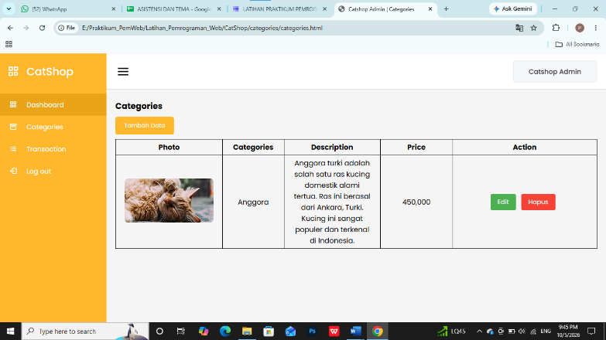
- Buat file baru dengan nama categories-entry.html, kemudian simpan ke dalam folder categories.
Source code categories-entry.html :
<!DOCTYPE html>
<html lang="en" dir="ltr">

<head>
<meta charset="UTF-8" />
<link rel="icon" href="../assets/icon.png" />
<link rel="stylesheet" href="../css/admin.css" />
<!-- Boxicons CDN Link -->
<link href="https://unpkg.com/boxicons@2.0.7/css/boxicons.min.css" rel="stylesheet" />
<meta name="viewport" content="width=device-width, initial-scale=1.0" />
<title>Catshop Admin | Categories Entry</title>
</head>

<body>
<div class="sidebar">
<div class="logo-details">
<i class="bx bx-category"></i>
<span class="logo_name">CatShop</span>
</div>
<ul class="nav-links">
<li>
<a href="../admin.html" class="active">
<i class="bx bx-grid-alt"></i>
<span class="links_name">Dashboard</span>
</a>
</li>
<li>
<a href="../categories/categories.html">
<i class="bx bx-box"></i>
<span class="links_name">Categories</span>
</a>
</li>
<li>
<a href="../transaction/transaction.html">
<i class="bx bx-list-ul"></i>
<span class="links_name">Transaction</span>
</a>
</li>
<li>
<a href="#">
<i class="bx bx-log-out"></i>
<span class="links_name">Log out</span>
</a>
</li>
</ul>
</div>
<section class="home-section">
<nav>
<div class="sidebar-button">
<i class="bx bx-menu sidebarBtn"></i>
</div>
<div class="profile-details">
<span class="admin_name">Catshop Admin</span>
</div>
</nav>
<div class="home-content">
<h3>Input Categories</h3>
<div class="form-login">
<form action="">
<label for="categories">Categories</label>
<input class="input" type="text" name="categories" id="categories" placeholder="Categories" />
<label for="categories">Price</label>
<input class="input" type="text" name="price" id="price" placeholder="Price" />
<label for="categories">Description</label>
<input class="input" type="text" name="Description" id="Description" placeholder="Description" />
<label for="photo">Photo</label>
<input type="file" name="photo" id="photo" style="margin-bottom: 20px" />
<button type="submit" class="btn btn-simpan" name="simpan">
Simpan
</button>
</form>
</div>
</div>
</section>
<script>
let sidebar = document.querySelector(".sidebar");
let sidebarBtn = document.querySelector(".sidebarBtn");
sidebarBtn.onclick = function () {
sidebar.classList.toggle("active");
if (sidebar.classList.contains("active")) {
sidebarBtn.classList.replace("bx-menu", "bx-menu-alt-right");
} else sidebarBtn.classList.replace("bx-menu-alt-right", "bx-menu");
};
</script>
</body>

</html>
Hasil :
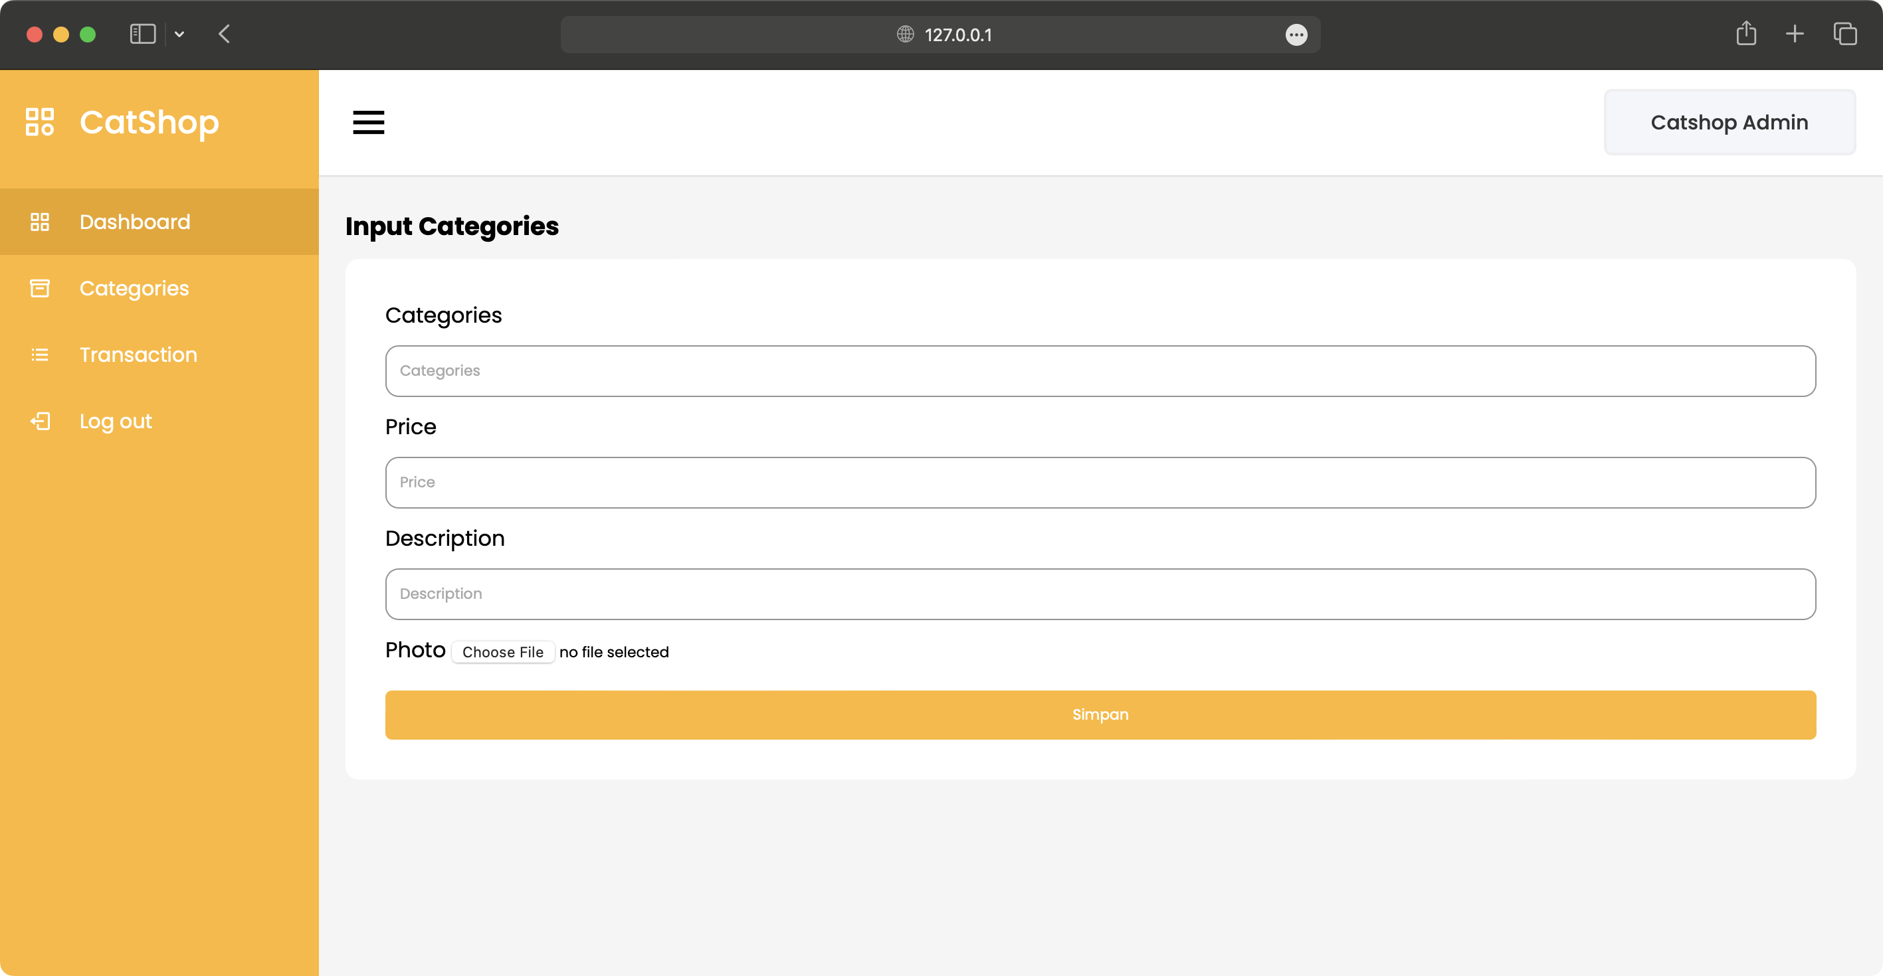
- Buat file baru dengan nama transaction.html, dan di masukkan ke dalam folder transaction.
Source code transaction.html :
<!DOCTYPE html>
<html lang="en">

<head>
<meta charset="UTF-8" />
<link rel="icon" href="../assets/icon.png" />
<link rel="stylesheet" href="../css/admin.css" />
<!-- Boxicons CDN Link -->
<link href="https://unpkg.com/boxicons@2.0.7/css/boxicons.min.css" rel="stylesheet" />
<meta name="viewport" content="width=device-width, initial-scale=1.0" />
<title>Catshop Admin | Transaction</title>
</head>

<body>
<div class="sidebar">
<div class="logo-details">
<i class="bx bx-category"></i>
<span class="logo_name">CatShop</span>
</div>
<ul class="nav-links">
<li>
<a href="../admin.html" class="active">
<i class="bx bx-grid-alt"></i>
<span class="links_name">Dashboard</span>
</a>
</li>
<li>
<a href="../categories/categories.html">
<i class="bx bx-box"></i>
<span class="links_name">Categories</span>
</a>
</li>
<li>
<a href="../transaction/transaction.html">
<i class="bx bx-list-ul"></i>
<span class="links_name">Transaction</span>
</a>
</li>
<li>
<a href="#">
<i class="bx bx-log-out"></i>
<span class="links_name">Log out</span>
</a>
</li>
</ul>
</div>
<section class="home-section">
<nav>
<div class="sidebar-button">
<i class="bx bx-menu sidebarBtn"></i>
</div>
<div class="profile-details">
<span class="admin_name">Catshop Admin</span>
</div>
</nav>
<div class="home-content">
<h3>Transaction</h3>
<table class="table-data">
<thead>
<tr>
<th>Tanggal</th>
<th>Nama</th>
<th>Kategori</th>
<th>Harga</th>
<th>Status</th>
<th>Action</th>
</tr>
</thead>
<tbody>
<tr>
<td>02-03-2023</td>
<td>Raflizar</td>
<td>Anggora</td>
<td>450000</td>
<td>
<p class="success">Success</p>
</td>
<td>
<button class="btn_detail"
onclick="showDetails('02-03-2023', 'Raflizar', 'Anggora', '450000', 'Success')">Detail</button>
</td>
</tr>
<!-- Add more rows as needed -->
</tbody>
</table>
</div>
</section>
<script>
let sidebar = document.querySelector(".sidebar");
let sidebarBtn = document.querySelector(".sidebarBtn");
sidebarBtn.onclick = function () {
sidebar.classList.toggle("active");
if (sidebar.classList.contains("active")) {
sidebarBtn.classList.replace("bx-menu", "bx-menu-alt-right");
} else sidebarBtn.classList.replace("bx-menu-alt-right", "bx-menu");
};
function showDetails(tanggal, nama, kategori, harga, status) {
alert(`Tanggal: ${tanggal}\nNama: ${nama}\nKategori: ${kategori}\nHarga: ${harga}\nStatus: ${status}`);
}
</script>
</body>

</html>
Hasil :
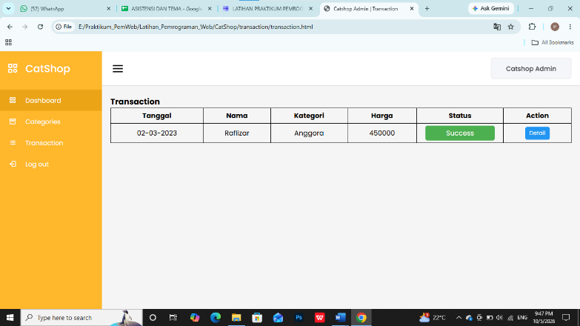

Analisa :

