2019150445 통계학과 신백록

1.

a) 0.4, 0.24, 0.88, 1.00, 0.99, 0.91 for each variable

b) 0.5981, 0.7586, 0.1204, 0.0050, 0.0062, 0.0949 for each variable

c) 0.05

d)

[,1] [,2] [,3] [,4] [,5] [,6]

[1,] 0.000139 0.193441 -0.016785 0.001237 -0.000329 0.000736

[2,] 0.193441 -0.000221 -0.031715 0.002203 -0.000451 -0.017116

[3,] -0.016785 -0.031715 0.000475 0.000845 -0.000765 0.003060

[4,] 0.001237 0.002203 0.000845 -0.000129 0.000293 -0.000312

[5,] -0.000329 -0.000451 -0.000765 0.000293 0.001219 0.002004

[6,] 0.000736 -0.017116 0.003060 -0.000312 0.002004 0.001864

Every row & column is very close to zero.

a’) 0.40, 0.24, 0.88, 1.00, 0.99, 0.91 for each variable

b’) 0.5981, 0.7586, 0.1204, 0.0050, 0.0062, 0.0949 for each variable

c’) 0.32

d’)

[,1] [,2] [,3] [,4] [,5] [,6]

[1,] 0.0034 0.1962 -0.0142 0.0039 0.0032 0.0018

[2,] 0.1962 0.0021 -0.0304 0.0026 0.0038 -0.0158

[3,] -0.0142 -0.0304 0.0012 0.0020 0.0010 0.0020

[4,] 0.0039 0.0026 0.0020 0.0021 0.0018 -0.0008

[5,] 0.0032 0.0038 0.0010 0.0018 0.0042 0.0006

[6,] 0.0018 -0.0158 0.0020 -0.0008 0.0006 -0.0025

Every row & column is very close to zero. But bigger than rotate=’none’.

2.

a)

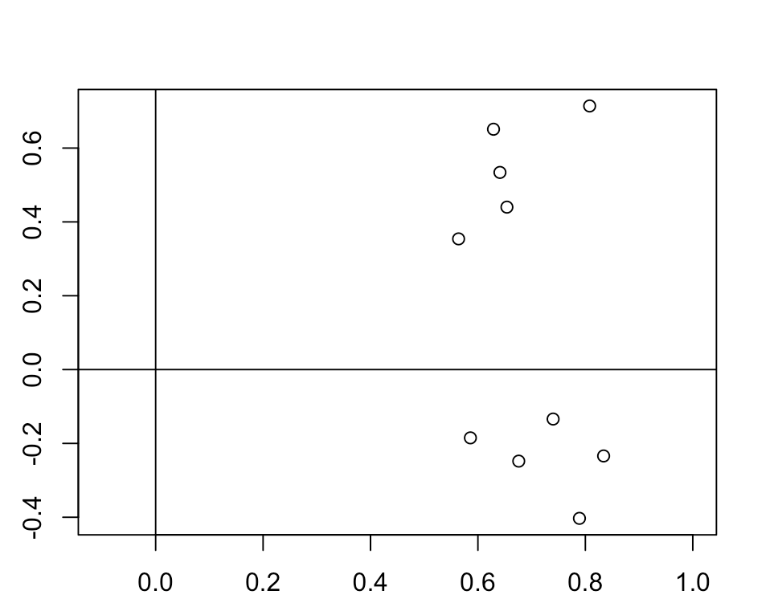

[,1] [,2]

[1,] 0.8239994 0.5665907

[2,] -0.5665907 0.8239994

About 0.82, 0.57.

b)

f1<-x1,x2,x3,x4,x5

f2<-x6,x7,x8,x9,x10

3.

For maximum likelihood, M1=1.00, 0.33, 0.33

For principal anlaysis, PA1=0.98, 0.34, 0.34

Cause we don’t know n.obs, we wil conduct pa.

> princomp(covmat=R,cor=T)$sdev^2

Comp.1 Comp.2 Comp.3

1.5240488 0.9000000 0.5759512

We have to select only one component and it is correct since we select only one-factor solution.

4.

a)

f1<-X1, X2, X3, X6, X7

f2<-X4, X5

f1은 sales에 대한 능력, f2는 창의적인 능력에 대한 measure이다.

Communalities=0.93, 0.93, 0.88, 1, 0.53, 0.39, 0.97이고,

Specific variances=0.069, 0.070, 0.123, 0.005, 0.474, 0.614, 0.029이다.

X1 X2 X3 X4 X5 X6 X7

X1 0.9998085 0.9295185 0.8834713 0.5720627 0.6642314 0.5543376 0.9311883

X2 0.9295185 0.9996175 0.8749727 0.5413952 0.6547844 0.5624010 0.9373106

X3 0.8834713 0.8749727 0.9996897 0.6996404 0.6751659 0.4798313 0.8449575

X4 0.5720627 0.5413952 0.6996404 1.0000121 0.5918666 0.1504776 0.4126431

X5 0.6642314 0.6547844 0.6751659 0.5918666 1.0004117 0.3412918 0.6189365

X6 0.5543376 0.5624010 0.4798313 0.1504776 0.3412918 1.0003628 0.6017606

X7 0.9311883 0.9373106 0.8449575 0.4126431 0.6189365 0.6017606 1.0001828

b)

f1<-X1, X2, X3, X5, X7

f2<-X4

f3<-X6

f1은 sales에 관한 능력, f2는 창의성, f3는 추상적인 사고에 관한 measure이다.

Communalites=0.96, 0.97, 0.91, 1, 0.55, 1, 0.96

Specific Variances=0.039, 0.034, 0.088, 0.005, 0.447, 0.005, 0.038

X1 X2 X3 X4 X5 X6 X7

X1 1.0004286 0.9228132 0.9120900 0.5714373 0.6949346 0.6738835 0.9255325

X2 0.9228132 0.9995182 0.8471023 0.5417814 0.6799445 0.4654561 0.9481931

X3 0.9120900 0.8471023 0.9998757 0.6991263 0.6969684 0.6402870 0.8255831

X4 0.5714373 0.5417814 0.6991263 1.0000434 0.5910467 0.1469508 0.4130097

X5 0.6949346 0.6799445 0.6969684 0.5910467 1.0003805 0.3841949 0.6425632

X6 0.6738835 0.4654561 0.6402870 0.1469508 0.3841949 1.0000317 0.5669006

X7 0.9255325 0.9481931 0.8255831 0.4130097 0.6425632 0.5669006 1.0004913

C)

I prefer three-factor model. Communalities are bigger than two-factor model & interpretation is better.

D)

Both of two & three-factor models are not adequate. Since p-value is very significant both of the model. So we have to add factors. Three-factor model is better than two-factor model.

E)

$scores

ML2 ML1

[1,] -0.86288507 -0.44207987

[2,] -1.17538519 -0.90503168

[3,] -0.22205438 -0.79478486

[4,] -0.13640449 0.48423974

[5,] 0.40665543 -0.36962803

[6,] -0.73944040 -0.20034064

[7,] -0.39319904 -0.51383740

[8,] 1.51969565 1.50942456

[9,] 0.41697990 -0.36442007

[10,] 0.78697654 0.58616049

[11,] 0.29924822 0.16051109

[12,] 0.28370806 -0.35154454

[13,] 0.09445898 1.21144685

[14,] 0.57239264 -0.91541423

[15,] 0.05433039 0.43356990

[16,] -1.38344667 -0.88556211

[17,] 0.19428237 -0.08967132

[18,] 0.57427848 -0.14303420

[19,] 0.56521867 -1.66709766

[20,] -0.71830309 1.58950715

[21,] -1.47489872 -0.09735094

[22,] 1.61917360 -1.83569672

[23,] -1.41138793 -0.36781786

[24,] 0.76202605 0.08769452

[25,] 0.73786158 1.12102954

[26,] -0.65995849 -0.21671643

[27,] 0.83749784 0.58969159

[28,] 1.85029030 -0.59941450

[29,] -0.99700848 -0.67250456

[30,] 1.67045843 -0.81609158

[31,] 0.68466173 1.62758716

[32,] -2.13446067 0.77021129

[33,] 0.10438389 -1.09015789

[34,] -0.98294920 -0.16633005

[35,] 0.69360463 1.63189252

[36,] 1.90173183 -1.11169605

[37,] -1.79699467 2.00312533

[38,] -0.32209868 0.49887134

[39,] 1.02249669 0.82203947

[40,] 0.75013750 0.60996836

[41,] 0.59843962 -0.64658417

[42,] -0.98087780 0.59557190

[43,] -0.12474833 1.50464803

[44,] -0.82300552 -2.49193247

[45,] -0.15031821 -1.04937759

[46,] 0.10769164 1.71588510

[47,] -1.07901129 -0.90856942

[48,] -1.89412470 -0.54669082

[49,] 0.36568659 0.65226431

[50,] 0.98859381 0.05403743