**Unit 4 Project  
Lab Report**

Part 1 & Part 2 – Requirement #1 (80 points)

From the Bayside server, open the Group Policy Management console and take a screenshot of your password policy. Click the password policy that you created, click the settings tab, click show all and take a screenshot of the configured options:  
  
The screenshot should clearly show the following:

* Enforce password history
* Minimum password age
* Maximum password age
* Minimum password length
* Password must meet complexity requirements
* Store passwords using reversible encryption (Leave this at default)  
  
  
  
Part 1 & Part 2 – Requirement #2   
From the Bayside server, open the Group Policy Management console and take a screenshot of your additional policies you chose in the planning phase. The screenshot should show the name as well as configuration.

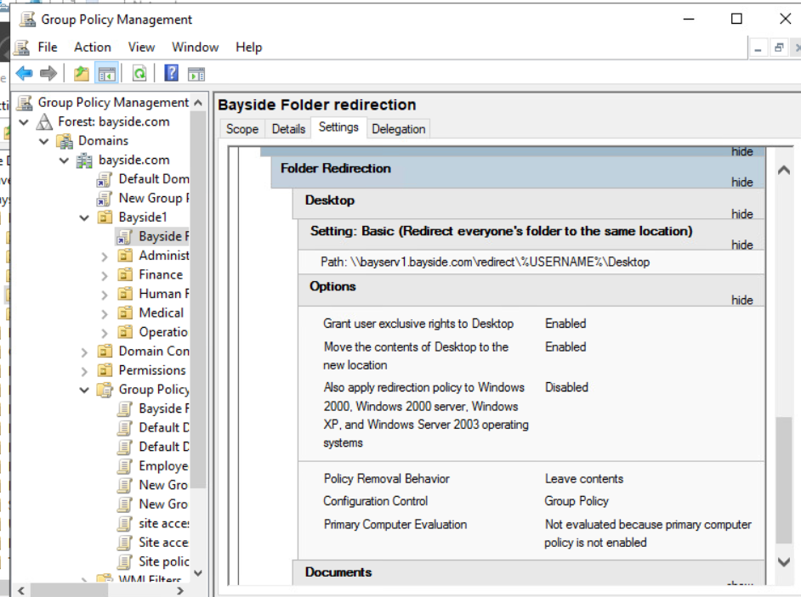  
  
  
Part 3 (20 points)

Log into the client with 3 different users to validate folder access as follows:  
(Validate through the process of mapping a drive)

User 1: Should have access to the EMR share

* Attempt to map to the EMR share and provide a screenshot

User 2: Should not have access to the EMR share

* Attempt to map to the EMR share and provide a screenshot (You should receive an access error)

User 3: Should have access to their respective department’s share

* Attempt to map to the share and provide a screenshot
* Attempt to map to another department share (You should receive an access error)

  
  
  
  


