Guided Practice Lab Report

Before completing this guided practice report, you should have completed the associated procedure.

# Screenshots

*As you complete the procedure for the guided practice, add your screenshots below.*

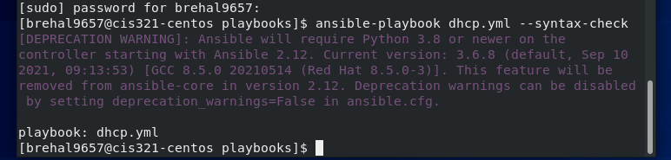

# Guided Practice Questions

*After you have completed the procedure for the guided practice, provide your answers to the guided practice questions here.*

1. A subnet is a way to separate network addresses to secure network transmissions.
2. An address pool is a designated block of IP addresses that can be utilized by assigning devices to those specific IP addresses within that pool, further separating a network.
3. The subnet mask specifies a range of addresses on a particular subnet, thereby separating the network range into smaller ranges.
4. Lists the IP address of the workstation, the hardware address of the dhcp client, and the start and end time of the dhcp lease.
5. That command takes what is in the /etc/dhcp/dhcp.conf.subnet file and copies it into the /etc/dhcp/dhcpd.conf file.