**Contents:**

1. **Knowledge requirements**
2. **Forward kinematics**
3. **Inverse kinematics**
4. **Forward velocity kinematics**

Note: This post covers a specific aspect of kinematics, mainly focus for my practice robot. Sections 2, 3, and 4 discuss one method for solving kinematics problems, but many other methods exist. A 6 degrees of freedom (DOF) robot is the most common type due to its full spatial control, which robots with fewer DOFs lack. Additionally, a 6-DOF base allows for easier implementation of robots with higher DOFs, so the definitions and my practice robot will mainly about 6-DOF robot.

**1. Knowledge requirements**

First of all, you may want to know this information before process to kinematics, it helps you aware of definitions and have a base calculation for kinematics.

Robot components: Link, joint, manipulator, twist, end-effector

Degrees of freedom

Rotation about Global Cartesian Axes

Rotation about Local Cartesian Axes

Axis-Angle Rotation and Orientation kinematics

Rigid Body Motion

Homogeneous Transformation

**2. Forward kinematics**

Kinematics is a field of science that studies the motion of objects without considering the forces that cause those motions. Within the scope of kinematics, researchers focus on the position, velocity, acceleration, and higher-order derivatives of position variables (with respect to time or any other variables) for the links in a static system. Therefore, studying the kinematics of actuators involves addressing all the geometric and time-based properties of motion. The relationship between these motions and the forces and torques that cause them forms the subject of dynamics, which examines the velocity and acceleration factors in greater depth.

A fundamental problem in the study of mechanical control is forward kinematics. Forward kinematics is the problem of determining the position and orientation of all links on a robot, including the end-effector, based on the kinematic variables of the given joints. In forward kinematics, we assign a working coordinate space to each individual link of the object and calculate its configuration in adjacent coordinate spaces using the method of "rigid motion." The analysis of determining the relative positions and motions of all the robot's links to each other is called forward kinematics. Generally, the most basic task of forward kinematics is to determine the position and orientation in space of the end-effector within the base coordinate system. Sometimes, this is akin to transforming the representation of the actuator's position in ordinary space into a representation in Cartesian coordinate space.

The problem of this task can be solved by determining the transformation matrix $T_{i}$ to describe the kinematic information of joint (i) in the base coordinate workspace. The traditional method for constructing forward kinematic equations for robot manipulators is to link them using the Denavit-Hartenberg notation. Therefore, the forward kinematics problem essentially involves the manipulation and establishment of these transformation matrices.

Basically, forward kinematics involves determining the final position of the robot from its initial position and the rotation angles of its joints. By using these inputs, we can calculate the robot's end position.

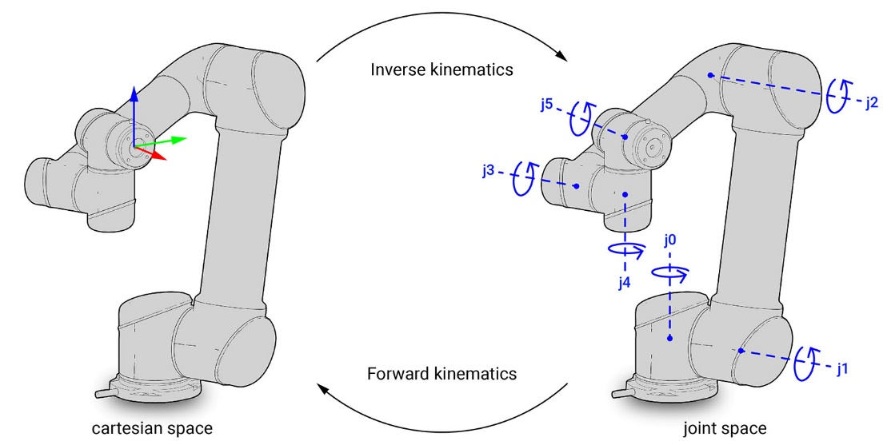

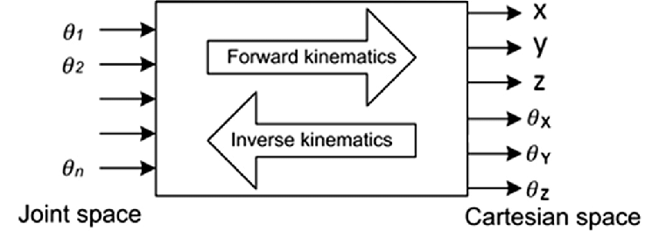

The transformation matrix from one coordinate system to another in space is established as follows, derived from rotations around the x, y, z axes, and translations. For a 6-degree-of-freedom robot, we have six successive transformation matrices from 1 to 6.

Forward kinematics – DH table:

**+ Step 1:** Determine the number of joints and the number of links.

**+ Step 2:** Attach the coordinate frames from 0 to n onto the links.

Method for determining the Zi axis: It is the axis around which joint i+1 rotates or along which it translates. (i = 1 to n-1)

Method for determining the Xi axis: The X-axis is typically aligned with the common normal and points from joint i to i+1. If the joint axes intersect, X is chosen as the cross product of Zi-1 and Zi.

Method for determining the Yi axis: Determined following the right-hand rule.

**Special cases:**

If Zi intersects Zi-1, Xi is perpendicular to both Z axes, with direction and position arbitrarily chosen.

If Zi and Zi-1 are parallel, any Xi can be chosen, typically passing through the origin of Zi-1.

If Zi and Zi-1 are not coplanar, Xi points from Zi-1 to Zi in 3D space, forming the coordinate system intersection.

**+ Step 3:** Determine the relationship between two coordinate frames i and i-1 and create the Denavit-Hartenberg (DH) table.

The general transformation matrix 𝑇06​ is obtained by multiplying the individual transformation matrices:

T06=T01×T12×T23×T34×T45×T56 ​

If we have the joint angles 𝜃1, 𝜃2, 𝜃3, 𝜃4, 𝜃5, 𝜃6, we can calculate the 𝑇06​ matrix as a 4x4 matrix. Then, by substituting the coordinate position of the end point in its own coordinate system (body), we obtain its position in the original global coordinate system (global), the 4th parameter of coordinate is 1 to match 4x4 matrix.

Gr = GTB.Br

**3. Inverse kinematics**

Inverse kinematics is found when we have the initial and final positions of the robot in the entire local space, along with the configuration and dimensions of the robot. We then determine the appropriate rotation angles for the robot to reach the desired position.

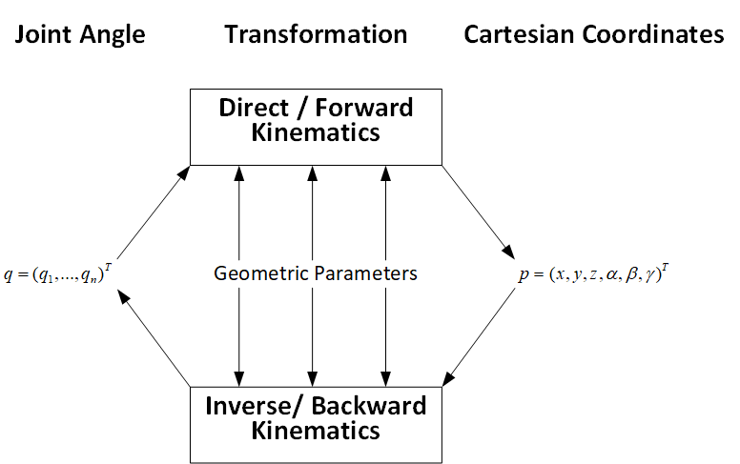

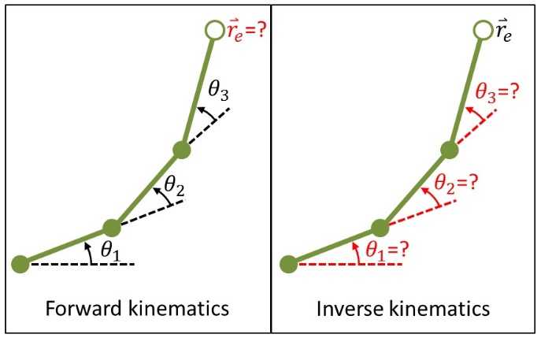

With the decoupling method, we consider the joint between the arm and the end effector as the wrist. Thus, we have the wrist joint at the intersection of the three final axes, dividing the problem into positional analysis for the wrist joint and rotation angle from the wrist to the end effector.

Provide the desired general homogeneous matrix, input is the position and orientation of end-effector.

$H=\left[\begin{matrix}R_{6}^{0} & d_{6}^{0} \\ 0 & 1\end{matrix}\right]$

We calculate end-effector base on wrist point $\left[\begin{matrix}x_{c} \\ y_{c} \\ z_{c}\end{matrix}\right]=\left[\begin{matrix}O_{x}-d_{6}r_{13} \\ O_{y}-d_{6}r_{23} \\ O_{z}-d_{6}r_{33}\end{matrix}\right]$

d6 is distance from end-effector to wrist point.

From $R_{3}^{0}$ calculated with DH three first matrix we have

$$R_{6}^{0}=R_{3}^{0}.R_{6}^{3}$$

Then

$$R_{6}^{3}={{[R}_{3}^{0}]}^{-1}.R_{6}^{0}$$

With $R_{6}^{3}$ we can calculate last three joint angles.

$$R_{6}^{3}=\left[\begin{matrix}q_{11} & q_{12} & q_{13} \\ q_{21} & q_{22} & q_{23} \\ q_{31} & q_{32} & q_{33}\end{matrix}\right]$$

We can get joint angle directly by:

Solution 1:

$$θ_{4}=atan2(q_{23},q_{13})$$

$$θ_{5}=atan2(\sqrt{q_{23}^{2}+q_{13}^{2}},q_{33})$$

$$θ_{6}=atan2(-q_{32},q_{31})$$

Note that $0≤θ_{5}≤π$ and $θ_{4}<π$

Solution 2:

$$θ_{4}^{'}=θ_{4}+π$$

$$θ_{5}^{'}= -θ_{5}$$

$$θ_{6}^{'}=θ_{6}+π$$

$$θ_{4}^{'}=atan2({-q}_{23},-q_{13})$$

$$θ_{5}^{'} =atan2(-\sqrt{q_{23}^{2}+q_{13}^{2}},q_{33})$$

$$θ_{6}^{'}=atan2(-q_{32},-q_{31})$$

**4. Forward velocity kinematics**

Calculate forward velocity kinematics to determine the velocity of the end point for use in path planning, motion control, sensor calibrating, etc.

The input parameters for kinematics are the joint angles and their velocities (derivatives of joint angles with respect to time).

**Steps to follow:**

* Define joint angles and velocities:

Get the joint angles $(θ_{1},θ_{2},θ_{3},θ_{4},θ_{5},θ_{6})$ and joint velocities $(\dot{θ_{1}},\dot{θ_{2}},\dot{θ_{3}},\dot{θ_{4}},\dot{θ_{5}},\dot{θ_{6}})$

* Define DH parameters:

Establish the Denavit-Hartenberg (DH) parameters for the robotic arm.

* Compute Forward Kinematics:

Using the DH parameters and joint angles, compute the transformation matrices from the base frame to each subsequent joint frame

$$T_{i-1}^{i}=\left[\begin{matrix}cosθ_{i} & -sinθ_{i}cosα_{i} & sinθ_{i}sinα_{i} & a_{i}cosθ_{i} \\ sinθ_{i} & cosθ_{i}cosα_{i} & -cosθ_{i}sinα_{i} & a_{i}sinθ_{i} \\ 0 & sinα_{i} & cosα_{i} & d_{i} \\ 0 & 0 & 0 & 1\end{matrix}\right]$$

The transformation matrix $T_{i-1}^{i}$ transform coordinate frames $B_{i}$ to $B_{i-1}$.

Calculate the overall transformation matrix from the base to the end-effector by multiplying the individual transformation matrix

$$T_{0}^{6}=T_{0}^{1}.T_{1}^{2}.T_{2}^{3}.T_{3}^{4}.T_{4}^{5}.T_{5}^{6}$$

Extract the position components from the transformation matrix

$$P_{x}=T_{0}^{6}\left(1,4\right), P_{y}=T_{0}^{6}\left(2,4\right), P_{z}=T_{0}^{6}(3,4)$$

* Compute the Jacobian Matrix

Calculate the Jacobian matrix, which consists of the position and orientation components

$$J=\left[\begin{matrix}\frac{∂P_{x}}{∂θ_{1}} & \frac{∂P_{x}}{∂θ_{2}} & \frac{∂P_{x}}{∂θ_{1}} & \frac{∂P_{x}}{∂θ_{4}} & \frac{∂P_{x}}{∂θ_{5}} & \frac{∂P_{x}}{∂θ_{6}} \\ \frac{∂P_{y}}{∂θ_{1}} & \frac{∂P_{y}}{∂θ_{2}} & \frac{∂P_{y}}{∂θ_{3}} & \frac{∂P_{y}}{∂θ_{4}} & \frac{∂P_{y}}{∂θ_{5}} & \frac{∂P_{y}}{∂θ_{6}} \\ \frac{∂P_{z}}{∂θ_{1}} & \frac{∂P_{z}}{∂θ_{2}} & \frac{∂P_{z}}{∂θ_{3}} & \frac{∂P_{z}}{∂θ_{4}} & \frac{∂P_{z}}{∂θ_{5}} & \frac{∂P_{z}}{∂θ_{6}} \\ T_{0}^{1}(1,3) & T_{0}^{2}(1,3) & T_{0}^{3}(1,3) & T_{0}^{4}(1,3) & T_{0}^{5}(1,3) & T_{0}^{6}(1,3) \\ T_{0}^{1}(2,3) & T_{0}^{2}(1,3) & T_{0}^{3}(2,3) & T_{0}^{4}(2,3) & T_{0}^{5}(2,3) & T_{0}^{6}(2,3) \\ T_{0}^{1}(3,3) & T_{0}^{2}(1,3) & T_{0}^{3}(3,3) & T_{0}^{4}(3,3) & T_{0}^{5}(3,3) & T_{0}^{6}(3,3)\end{matrix}\right]$$

* Substitute joint angles into the Jacobian:

Substitute the given joint angles into the Jacobian matrix to obtain a numerical Jacobian matrix.

* Calculate end-effector velocities:

Compute the end-effector velocities by multiplying the Jacobian matrix with the joint velocity vector

$$V=J\left[\begin{matrix}\dot{θ_{1}} \\ \dot{θ_{2}} \\ \dot{θ_{3}} \\ \dot{θ_{4}} \\ \dot{θ_{5}} \\ \dot{θ_{6}}\end{matrix}\right]$$

For example robot, see 6DOF-robot/readme_en.txt for more information.