-- =============================================
-- COMPANY DATABASE STORED PROCEDURE LAB
-- Beginner Level MySQL Stored Procedure Examples
-- =============================================

-- =============================================
-- STEP 1: CREATE DATABASE
-- =============================================

CREATE DATABASE IF NOT EXISTS company_db;

USE company_db;

-- =============================================
-- STEP 2: CREATE EMPLOYEES TABLE
-- =============================================

CREATE TABLE IF NOT EXISTS employees (

employee_id INT AUTO_INCREMENT PRIMARY KEY,

employee_name VARCHAR(100) NOT NULL,

department VARCHAR(100),

salary DECIMAL(10,2),

address VARCHAR(255),

phone_number VARCHAR(20),

created_at TIMESTAMP DEFAULT CURRENT_TIMESTAMP

);

-- =============================================
-- STEP 3: INSERT SAMPLE DATA
-- =============================================

INSERT INTO employees
(employee_name, department, salary, address, phone_number)
VALUES
('Aung Aung', 'IT', 800000, 'Yangon', '091111111'),
('Su Su', 'HR', 600000, 'Mandalay', '092222222'),
('Kyaw Kyaw', 'Finance', 900000, 'Naypyitaw', '093333333'),
('Mya Mya', 'Marketing', 700000, 'Yangon', '094444444'),
('Ko Ko', 'IT', 850000, 'Bago', '095555555');

-- =============================================
-- VIEW CURRENT EMPLOYEE DATA
-- =============================================

SELECT * FROM employees;
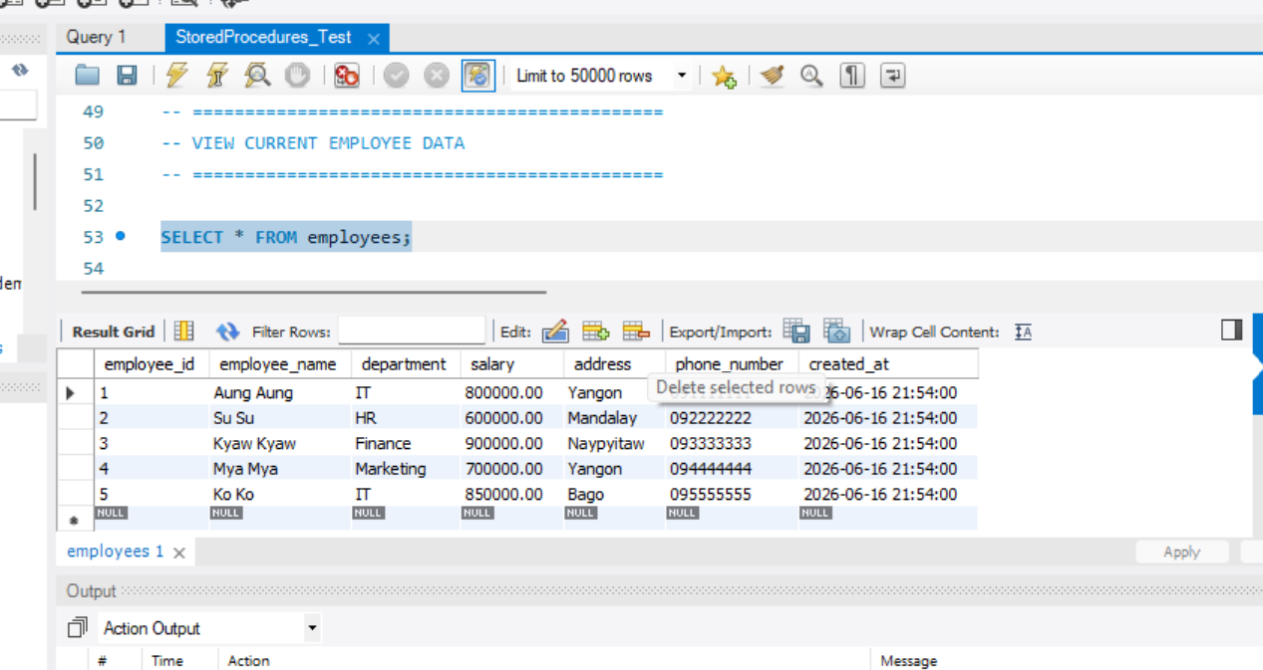
-- =============================================
-- STORED PROCEDURE 1:
-- InsertEmployee
-- PURPOSE:
-- Insert new employee records
-- PARAMETER TYPE:
-- IN PARAMETERS
-- =============================================

DELIMITER $$

CREATE PROCEDURE InsertEmployee(

IN p_employee_name VARCHAR(100),

IN p_department VARCHAR(100),

IN p_salary DECIMAL(10,2),

IN p_address VARCHAR(255),

IN p_phone_number VARCHAR(20)

)

BEGIN

INSERT INTO employees(

employee_name,

department,

salary,

address,

phone_number

)

VALUES(

p_employee_name,

p_department,

p_salary,

p_address,

p_phone_number

);

END $$

DELIMITER ;

-- =============================================
-- EXECUTE InsertEmployee PROCEDURE
-- =============================================

CALL InsertEmployee(

'Hla Hla',

'Admin',

500000,

'Yangon',

'096666666'

);

-- =============================================
-- VIEW DATA AFTER INSERT
-- =============================================

SELECT * FROM employees;
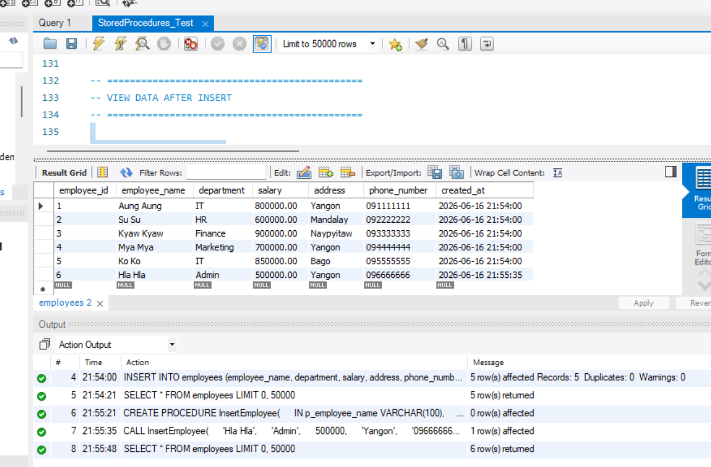
-- =============================================
-- STORED PROCEDURE 2:
-- DeleteEmployee
-- PURPOSE:
-- Delete employee using employee ID
-- PARAMETER TYPE:
-- IN PARAMETER
-- =============================================

DELIMITER $$

CREATE PROCEDURE DeleteEmployee(

IN p_employee_id INT

)

BEGIN

DELETE FROM employees

WHERE employee_id = p_employee_id;

END $$

DELIMITER ;

-- =============================================
-- EXECUTE DeleteEmployee PROCEDURE
-- Delete employee with ID = 3
-- =============================================

CALL DeleteEmployee(3);

-- =============================================
-- VIEW DATA AFTER DELETE
-- =============================================

SELECT * FROM employees;
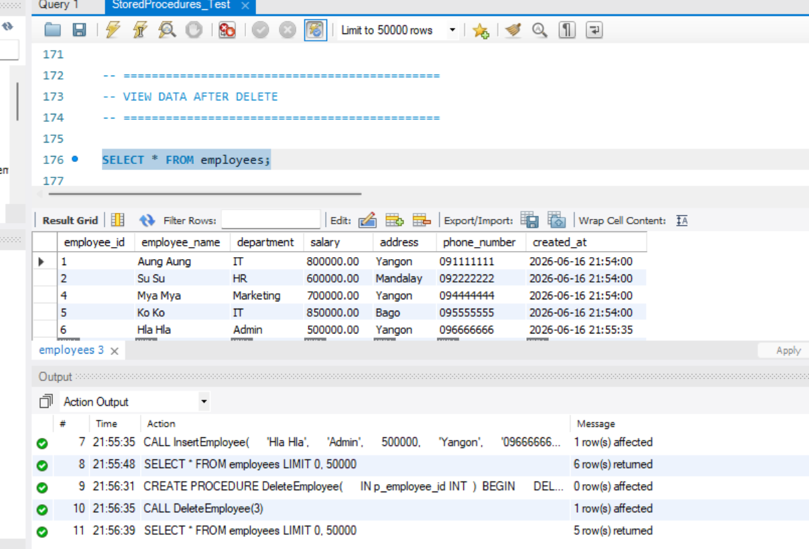
-- =============================================
-- STORED PROCEDURE 3:
-- UpdateEmployeeAddress
-- PURPOSE:
-- Update employee address
-- PARAMETER TYPE:
-- IN PARAMETERS
-- =============================================

DELIMITER $$

CREATE PROCEDURE UpdateEmployeeAddress(

IN p_employee_id INT,

IN p_new_address VARCHAR(255)

)

BEGIN

UPDATE employees

SET address = p_new_address

WHERE employee_id = p_employee_id;

END $$

DELIMITER ;

-- =============================================
-- EXECUTE UpdateEmployeeAddress PROCEDURE
-- =============================================

CALL UpdateEmployeeAddress(2, 'Taunggyi');

-- =============================================
-- VIEW DATA AFTER UPDATE
-- =============================================

SELECT * FROM employees;
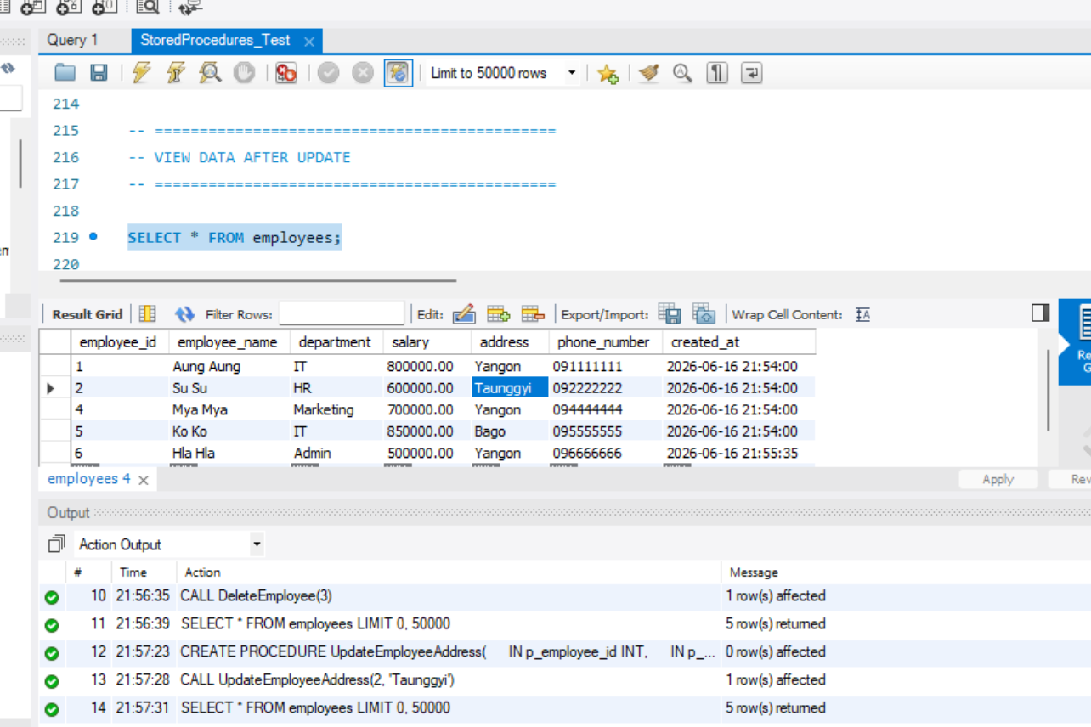
-- =============================================
-- STORED PROCEDURE 4:
-- GetEmployees
-- PURPOSE:
-- Retrieve all employee records
-- PARAMETER TYPE:
-- NO PARAMETERS
-- =============================================

DELIMITER $$

CREATE PROCEDURE GetEmployees()

BEGIN

SELECT *

FROM employees;

END $$

DELIMITER ;

-- =============================================
-- EXECUTE GetEmployees PROCEDURE
-- =============================================

CALL GetEmployees();
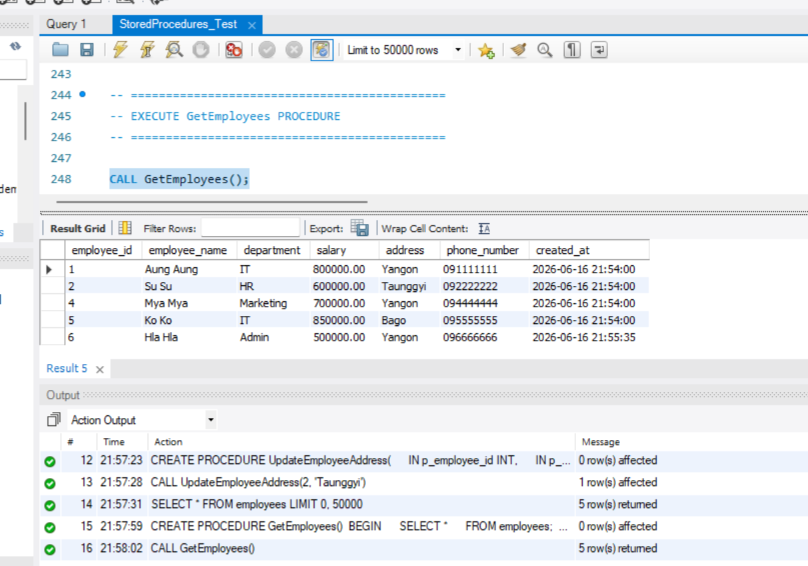
-- =============================================
-- STORED PROCEDURE 5:
-- GetEmployeeCount
-- PURPOSE:
-- Return total employee count
-- PARAMETER TYPE:
-- OUT PARAMETER
-- =============================================

DELIMITER $$

CREATE PROCEDURE GetEmployeeCount(

OUT p_total_employees INT

)

BEGIN

SELECT COUNT(*)

INTO p_total_employees

FROM employees;

END $$

DELIMITER ;

-- =============================================
-- EXECUTE GetEmployeeCount PROCEDURE
-- =============================================

CALL GetEmployeeCount(@total);

-- =============================================
-- DISPLAY OUTPUT VARIABLE
-- =============================================

SELECT @total AS total_employees;
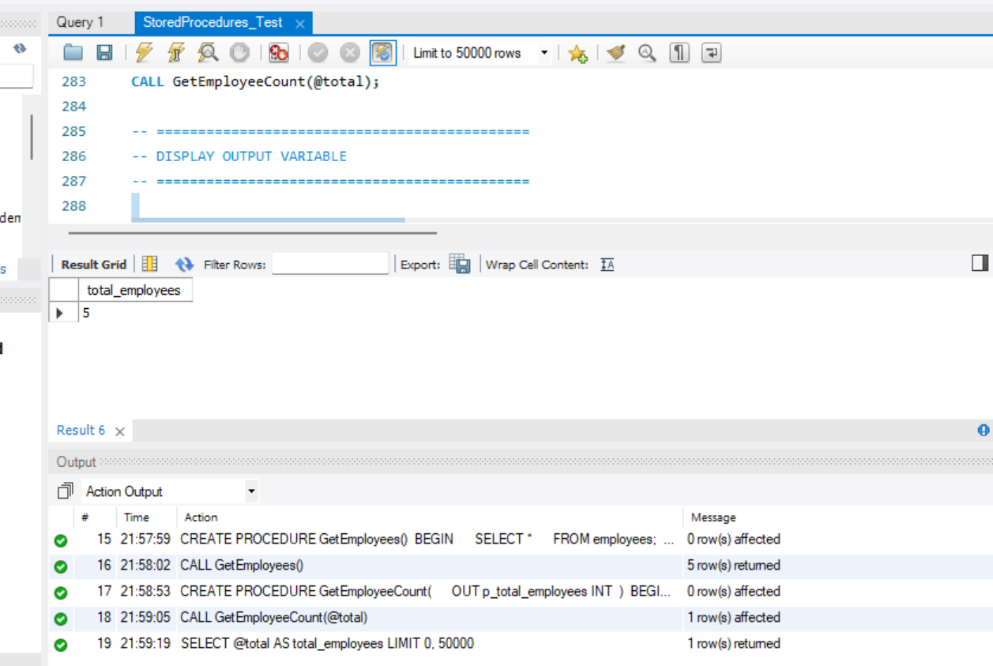
-- =============================================
-- STORED PROCEDURE 6:
-- IncreaseSalary
-- PURPOSE:
-- Increase employee salary and
-- return updated salary
-- PARAMETER TYPE:
-- INOUT PARAMETER
-- =============================================

DELIMITER $$

CREATE PROCEDURE IncreaseSalary(

IN p_employee_id INT,

INOUT p_increment DECIMAL(10,2)

)

BEGIN

-- Increase salary

UPDATE employees

SET salary = salary + p_increment

WHERE employee_id = p_employee_id;

-- Return updated salary

SELECT salary

INTO p_increment

FROM employees

WHERE employee_id = p_employee_id;

END $$

DELIMITER ;

-- =============================================
-- EXECUTE IncreaseSalary PROCEDURE
-- =============================================

SET @new_salary = 50000;

CALL IncreaseSalary(1, @new_salary);

-- =============================================
-- DISPLAY UPDATED SALARY
-- =============================================

SELECT @new_salary AS updated_salary;
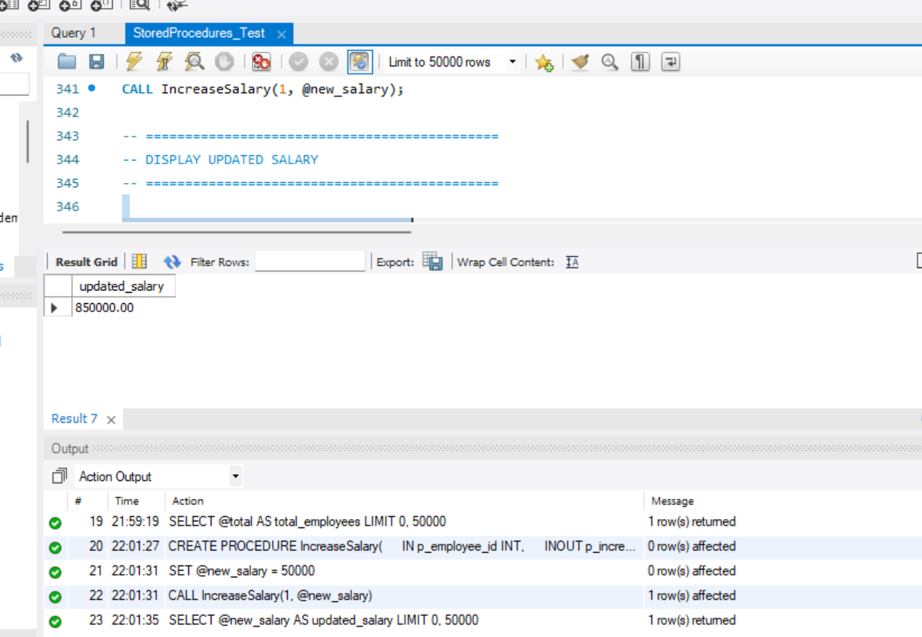
-- =============================================
-- SHOW ALL STORED PROCEDURES
-- =============================================

SHOW PROCEDURE STATUS

WHERE Db = 'company_db';
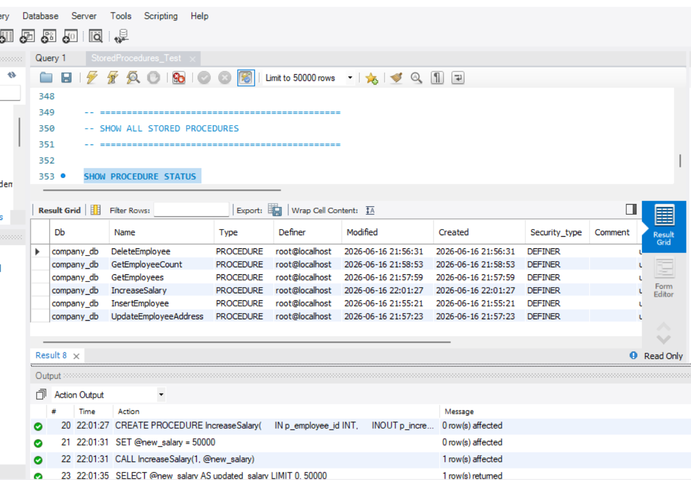
-- =============================================
-- OPTIONAL:
-- DROP PROCEDURE EXAMPLES
-- =============================================

-- DROP PROCEDURE IF EXISTS InsertEmployee;
-- DROP PROCEDURE IF EXISTS DeleteEmployee;
-- DROP PROCEDURE IF EXISTS UpdateEmployeeAddress;
-- DROP PROCEDURE IF EXISTS GetEmployees;
-- DROP PROCEDURE IF EXISTS GetEmployeeCount;
-- DROP PROCEDURE IF EXISTS IncreaseSalary;

-- =============================================
-- END OF LAB SCRIPT
-- =============================================

