LAB 7

Name: Disha Agarwal Registration number: 210905412 Branch: CSE A

DESIGN 1

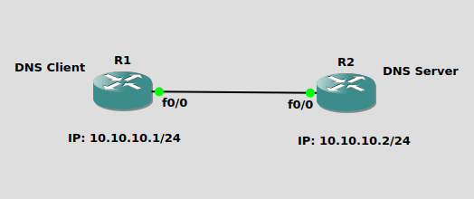

R1:
R1#conf t
R1(config)#hostname R1
R1(config)#int f0/0
R1(config-if)#ip address 10.10.10.1 255.255.255.0
R1(config-if)#no shut
R1(config-if)#do wr
R1(config-if)#end

R2:
R2#config t
R2(config)#hostname R2
R2(config)#int f0/0
R2(config-if)#ip address 10.10.10.2 255.255.255.0
R2(config-if)#no shut
R2(config-if)#do wr
R2(config-if)#end

Configuring R2 as DNS Server:
R2#conf t
R2(config)#ip dns server
R2(config)#ip host loopback.R2.com 2.2.2.2
R2(config)#int loopback 1
R2(config-if)#ip address 2.2.2.2 255.255.255.255
R2(config-if)#end

R2#ping loopback.R2.com
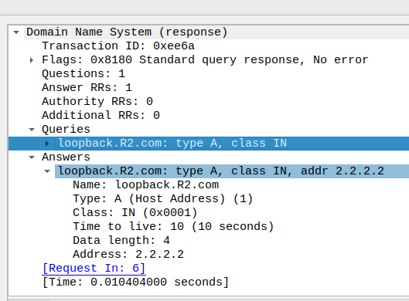
Configuring R1 to resolve hostnames using R2:
R1#conf t
R1(config)#ip domain lookup
R1(config)#ip name-server 10.10.10.2
R1(config)#ip route 0.0.0.0 0.0.0.0 10.10.10.2
R1(config)#end
R1#ping loopback.R2.com repeat 3

DESIGN 2
10.0.0.2

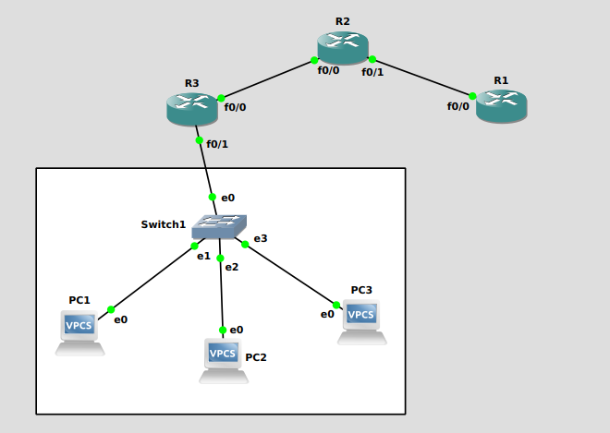
Network address: 30.0.0.0
Gateway address: 30.0.0.254
Subnet mask: 255.255.255.0
30.0.0.1/24
30.0.0.2/24
30.0.0.3/24
20.0.0.1

20.0.0.2

10.0.0.1

DNS Server

PC1> ip 30.0.0.1/24 30.0.0.254
PC2> ip 30.0.0.2/24 30.0.0.254
PC3> ip 30.0.0.3/24 30.0.0.254

R1
R3#conf t
R3(config)#hostname R1
R1(config)#int f0/0
R1(config-if)#ip address 20.0.0.1 255.255.255.0
R3(config-if)#no shut
R3(config-if)#exit

R3(config)#do wr
R3(config)#end

R2
R2#conf t
R2(config)#hostname R2
R2(config)#int f0/0
R2(config-if)#ip address 10.0.0.2 255.255.255.0
R2(config-if)#no shut
R2(config-if)#exit
R2(config)#int f0/1
R2(config-if)#ip address 20.0.0.2 255.255.255.0
R2(config-if)#no shut
R2(config-if)#exit
R2(config)#do wr
R2(config)#end

R3
R3#conf t
R3(config)#hostname R3
R3(config)#int f0/0
R3(config-if)#ip address 10.0.0.1 255.255.255.0
R3(config-if)#no shut
R3(config-if)#exit
R3(config)#int f0/1
R3(config-if)#ip address 30.0.0.254 255.255.255.0
R3(config-if)#no shut
R3(config-if)#exit
R3(config)#do wr
R3(config)#end

Routing paths
R1(config)#ip route 10.0.0.0 255.255.255.0 20.0.0.2
R1(config)#ip route 30.0.0.0 255.255.255.0 20.0.0.2
R2(config)#ip route 30.0.0.0 255.255.255.0 10.0.0.1
R3(config)#ip route 20.0.0.0 255.255.255.0 10.0.0.2

Configuring R1 as DNS Server:
R1#conf t
R1(config)#ip dns server
R1(config)#ip host PC1.com 30.0.0.1
R1(config)#ip host PC2.com 30.0.0.2
R1(config)#ip host PC3.com 30.0.0.3
R1(config)#do wr
R1(config)#end
R1#ping PC1.com
R1#ping PC2.com
R1#ping PC3.com

Configuring PCs to resolve hostnames using R1:
PC1> ip dns 20.0.0.1
PC2> ip dns 20.0.0.1
PC3> ip dns 20.0.0.1

Configuring Routers to resolve hostnames using R1:
R2(config)#ip name-server 20.0.0.1
R3(config)#ip name-server 20.0.0.1

Pinging PC2.com from PC1:
PC1> ping PC2.com -c 3

