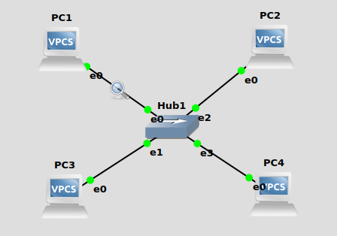

Based On Lab Question 1
• What is the destination MAC address of an ARP Request packet? (ff:ff:ff:ff:ff:ff)
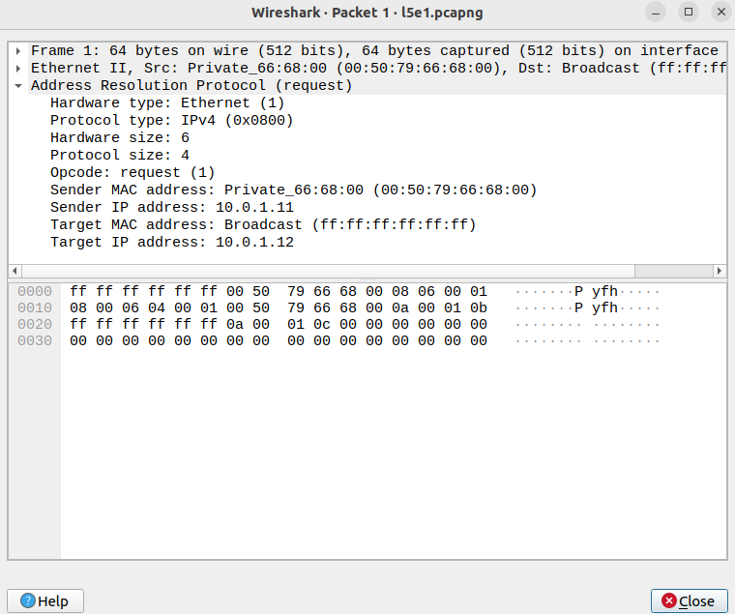

• What are the different Type Field values in the Ethernet headers that you observed? ARP(0x0806)
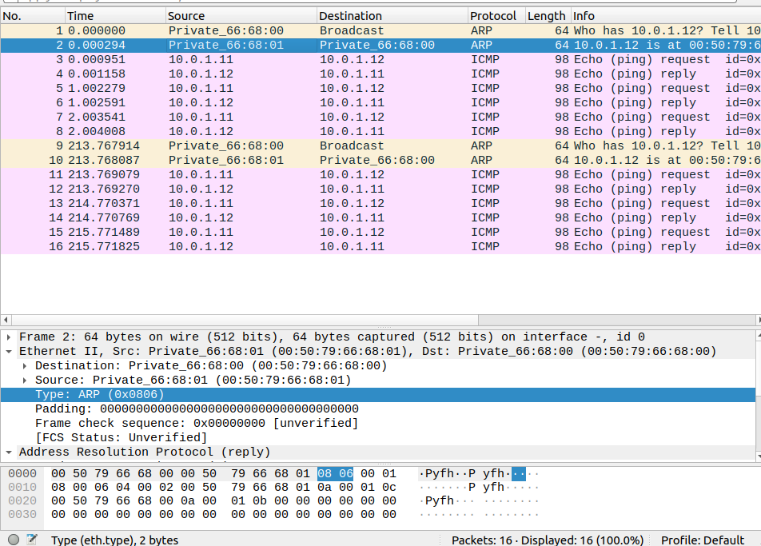

• Use the captured data to analyze the process in which ARP acquires the MAC address for IP
address 10.0.1.12.

PC1:10.0.1.11 sends an Arp request broadcast first, to which the requested ip responds with an Arp reply with its MAC address

Based On Lab Question 2

[Hosts cannoct have the same ip addresses]

• Explain how the ping packets were issued by the hosts with duplicate addresses.
• Did the ping command result in error messages?
• How can duplicate IP addresses be used to compromise the data security?
• Give an example. Use the ARP cache and the captured packets to support your explanation.

Based On Lab Question 3
• Use your output data and ping results to explain what happened in each of the ping commands.
• Which ping operations were successful and which were unsuccessful? Why?

i. From PC1 ping PC3. (successful)

ii. From PC1 ping PC2. (successful)

iii. From PC1 ping PC4.
Pings result in timeout. We can see through wireshark that the ping request is sent successfully from PC1. A reply to the request is seen.
10.0.1.100/24 (PC1) is not considered to be on the same subnet by 10.0.1.121/28 (PC4).
For PC4, the valid IP range on its subnet is 10.0.1.112 to 10.0.1.127 (last 4 bits).
Hence, PC4 tries to look for the default gateway (10.0.1.122), but since it has not been configured, it cannot find it, and results in ping timeout.

- Address
10.0.1.121
00001010.00000000.00000001.0111 1001
- Netmask
255.255.255.240 = 28
11111111.11111111.11111111.1111 0000
- Wildcard
0.0.0.15
00000000.00000000.00000000.0000 1111

- Network
10.0.1.112/28
00001010.00000000.00000001.0111 0000
Class A
- Broadcast
10.0.1.127
00001010.00000000.00000001.0111 1111
- First IP
10.0.1.113
00001010.00000000.00000001.0111 0001
- Last IP
10.0.1.126
00001010.00000000.00000001.0111 1110
- Hosts/Net
14

iv. From PC4 ping PC1.
Error: host (10.0.1.122) not reachable
We can see ARP requests by PC4 to try to find the default gateway (instead of trying to find PC1).
This is because 10.0.1.100/24 (PC1) is not considered to be on the same subnet by 10.0.1.121/28 (PC4). For PC4, the valid IP range on its subnet is 10.0.1.112 to 10.0.1.127 (last 4 bits).
Hence, PC4 tries to look for the default gateway (10.0.1.122), but since it has not been configured, it cannot find it.

v. From PC2 ping PC4. (successful)

vi. From PC2 ping PC3.
host (10.0.1.102) not reachable
We can see ARP requests by PC2 to try to find the default gateway (instead of trying to find PC3).
This is because 10.0.1.120/24 (PC3) is not considered to be on the same subnet by 10.0.1.101/28 (PC2). For PC2, the valid IP range on its subnet is 10.0.1.96 to 10.0.1.111 (last 4 bits).
Hence, PC2 tries to look for the default gateway (10.0.1.102), but since it has not been configured, it cannot find it.

