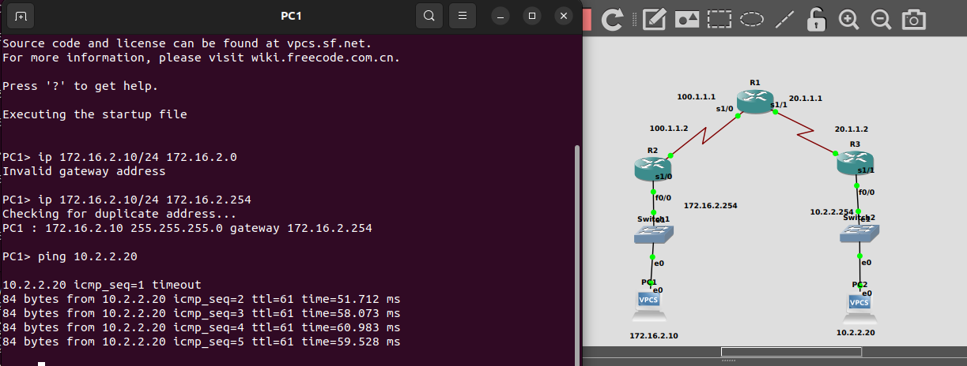
Config r1:

R1#config t
R1(config)#int s1/0
R1(config-if)#ip address 100.1.1.1 255.255.255.0
R1(config-if)#do wr
R1(config-if)#no shutdown
R1(config-if)#exit
R1(config)#int s1/1
R1(config-if)#ip address 20.1.1.1 255.255.255.0
R1(config-if)#do wr
R1(config-if)#no shutdown
R1(config-if)#exit
R1(config)#router rip
R1(config-router)#version 2
R1(config-router)#network 20.1.1.0
R1(config-router)#network 100.1.1.0
R1(config-router)#exit

config r2:
R2(config)#router rip
R2(config-router)#version 2
R2(config-router)#network 172.16.0.0
R2(config-router)#network 100.1.1.0

config r3:
R3(config)#router rip
R3(config-router)#ver 2
R3(config-router)#network 10.2.2.0
R3(config-router)#network 20.1.1.0

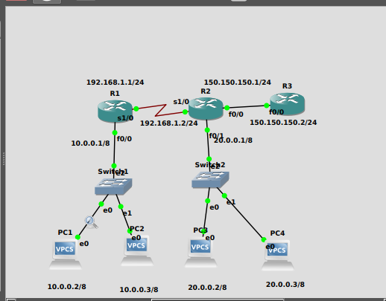

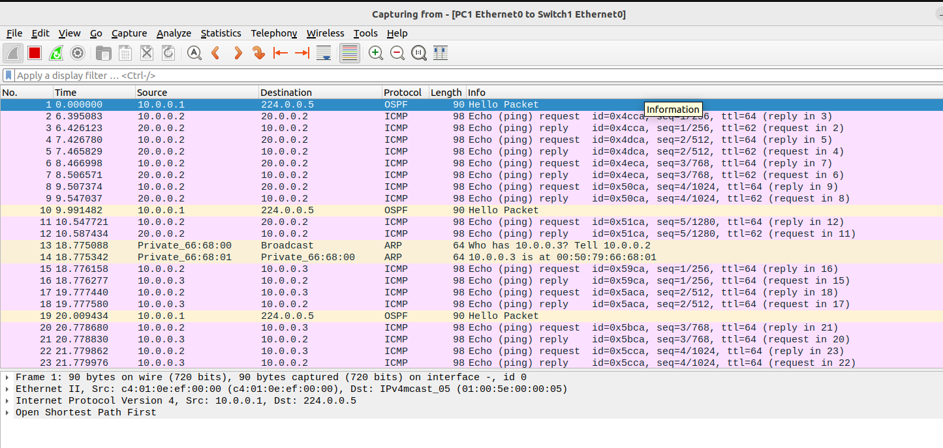
Configuration for R1

R1(config)#router ospf 200
R1(config-router)#network 10.0.0.0 0.255.255.255 area 0
R1(config-router)#network 192.168.1.0 0.0.0.255 area 0.0.0.0
R1(config-router)#exit

Configuration for R2

R2(config)#router ospf 200
R2(config-router)#network 20.0.0.0 0.255.255.255 area 0
R2(config-router)#network 192.168.1.0 0.0.0.255 area 0
R2(config-router)#network 150.150.150.0 0.0.0.255 area 1
R2(config-router)#exit
R2(config)#exit
Configuration for R3

R3(config)#router ospf 200
R3(config-router)#network 150.150.150.0 0.0.0.255 area 1
R3(config-router)#exit
R3(config)#exit

OSPF Verification:

show ip route
show ip ospf neighbor
show ip ospf database

