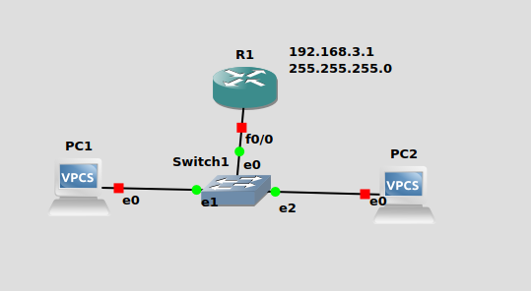
configure our router as a DHCP server-

R1(config)#IP dhcp pool NAME
R1(dhcp-config)#Network 192.168.3.0 255.255.255.0
R1(dhcp-config)#Default-router 192.168.3.1

configure the fastethernet 0/0 interface which will
connect to our switch-

R1(config)#Interface fastEthernet 0/0
R1(config-if)#No shutdown
R1(config-if)#ip address 192.168.3.1 255.255.255.0

PC1>dhcp
PC2>dhcp

ip dhcp helper //when you dont know where the dhcp server is at the router terminal

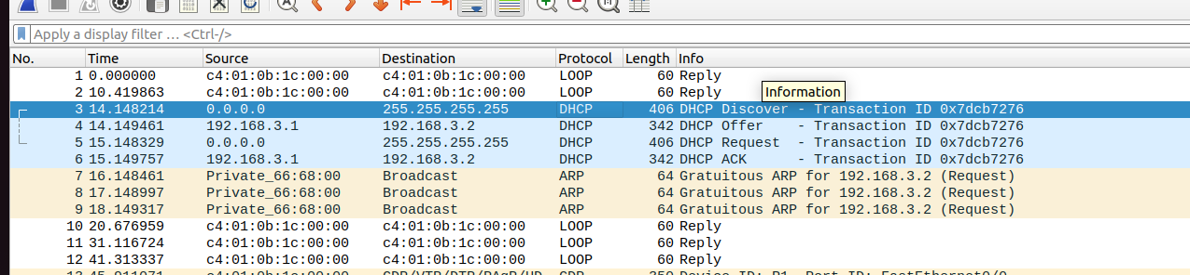

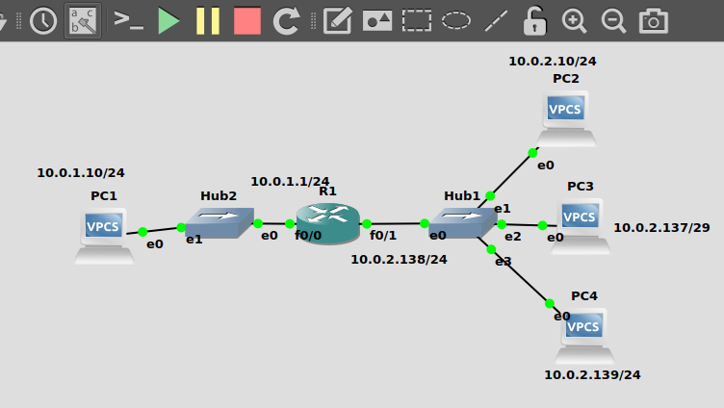
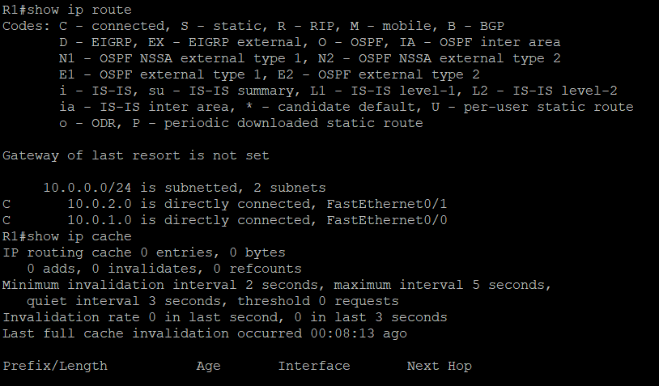
24

