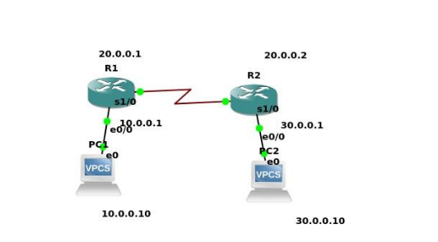
Commands to config router:

Enable
configure terminal
hostname R1
interface e0/0
ip address 10.10.10.1 255.255.255.0
no shut
end
In Router R1, just give this command, in this case Destination is 30.0.0.0 and its subnet mask is
255.0.0.0 next hop address is 20.0.0.2
R1(config)#ip route 30.0.0.0 255.0.0.0 20.0.0.2
In Router R2
R2(config)#ip route 10.0.0.0 255.0.0.0 20.0.0.1

