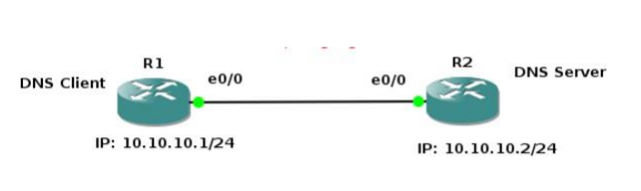
Setting up R2 as DNS Server
config t
ip dns server
ip host loopback.R2.com 2.2.2.2
We mapped loopback.R2.com to ip address 2.2.2.2. Currently, we don’t have 2.2.2.2, we could
create loopback interface on R2 and assign ip 2.2.2.2.
interface loopback 1
ip address 2.2.2.2 255.255.255.255
end

to setup R1 to resolve hostnames using R2. On R1 type;
config terminal
ip domain lookup
ip name-server 10.10.10.2
Set R1 to use R2 as default gateway to get to loopback interface on R2. So that after R1
resolves loopback.R2.com, it can reach 2.2.2.2 through its default route (R2).
on R1 type:
config t
ip route 0.0.0.0 0.0.0.0 10.10.10.2
end
This tells our router that to get to any network not in it’s routing table, it’s next hop is 10.10.10.2
which is R2
