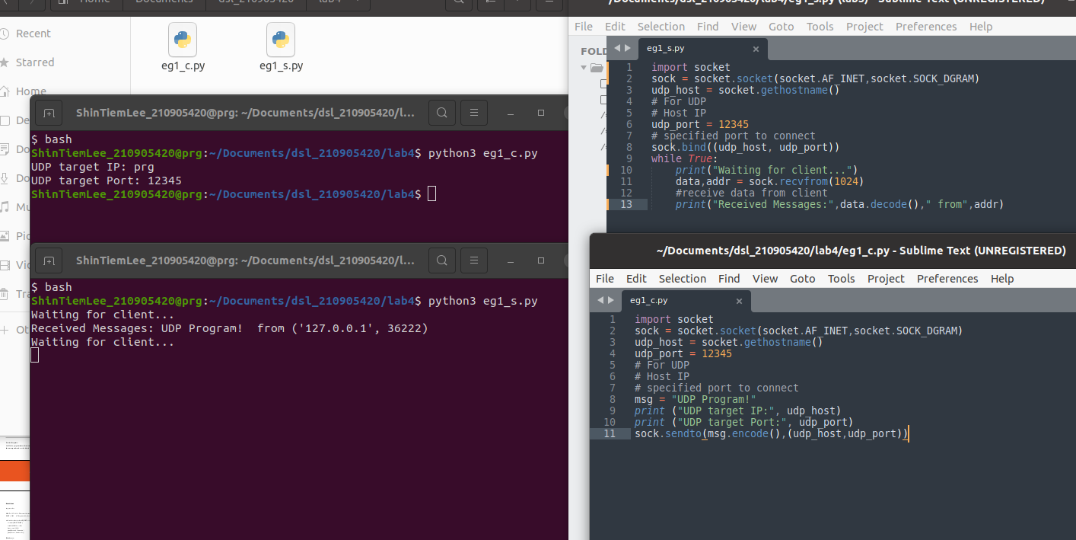
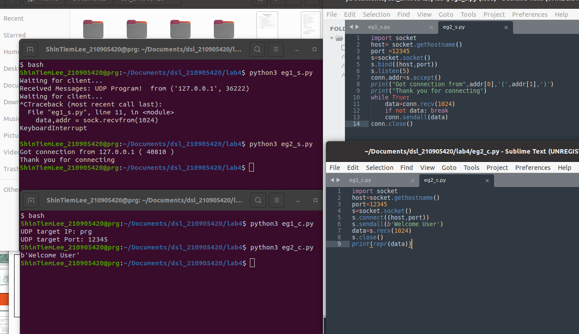
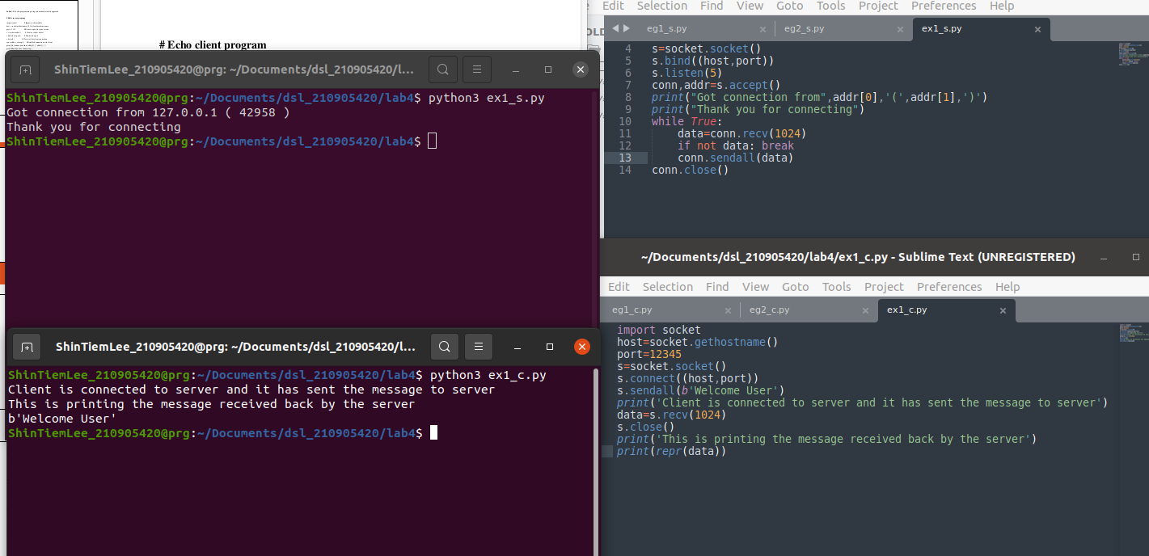

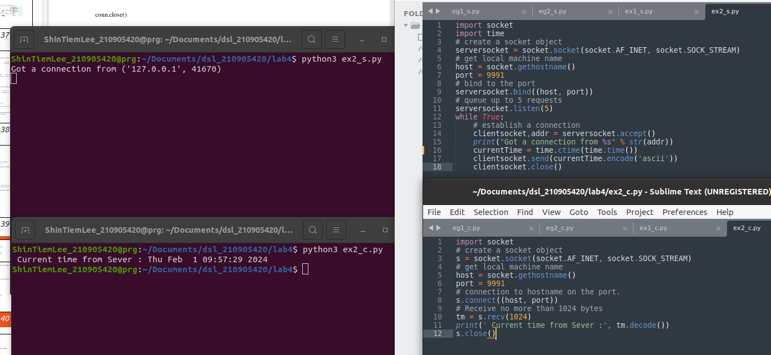
Server:

import socket
HOST = '127.0.0.1' # Standard loopback interface address (localhost)
PORT = 3162 # Port to listen on (non-privileged ports are > 1023)
s = socket.socket()
s.bind((HOST, PORT))
s.listen()
print("\nWaiting for incoming connections...\n")
conn, addr = s.accept()
print("Received connection from ", addr[0], "(", addr[1], ")\n")
s_name = conn.recv(1024)
s_name = s_name.decode()
print(s_name, "has connected to the chat room\nEnter [e] to exit chat room\n")
name = input(str("Enter your name: "))
conn.send(name.encode())
while True:
message = input("Me : ")
if message == "[e]":
message = "Left chat room!"
conn.send(message.encode())
print("\n")
break
conn.send(message.encode())
message = conn.recv(1024)
message = message.decode()
print(s_name, ":", message)

Client:

import socket
HOST = '127.0.0.1' # Standard loopback interface address (localhost)
PORT = 3162
# Port to listen on (non-privileged ports are > 1023)
s = socket.socket()
name = input(str("\nEnter your name: "))
print("\nTrying to connect to ", HOST, "(", PORT, ")\n")
s.connect((HOST, PORT))
print("Connected...\n")
s.send(name.encode())
s_name = s.recv(1024)
s_name = s_name.decode()
print(s_name, "has joined the chat room\nEnter [e] to exit chat room\n")
while True:
message = s.recv(1024)
message = message.decode()
print(s_name, ":", message)
message = input("Me : ")
if message == "[e]":
message = "Left chat room!"
s.send(message.encode())
print("\n")
break
s.send(message.encode())

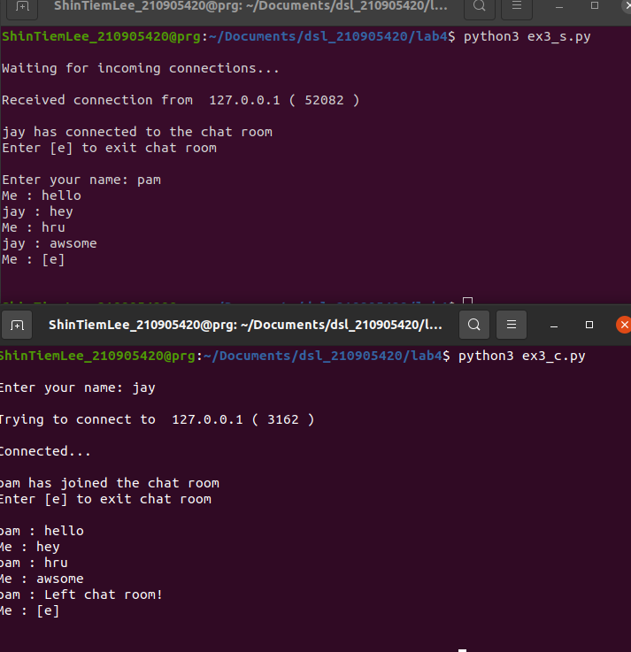
Server:

import socket
import os
from _thread import *
ServerSocket = socket.socket()
host = '127.0.0.1'
port = 11596
ThreadCount = 0
try:
ServerSocket.bind((host, port))
except socket.error as e:
print(str(e))
print('Waitiing for a Connection..')
ServerSocket.listen(5)
def threaded_client(connection):
connection.send(str.encode('Welcome to the Server'))
while True:
data = connection.recv(2048)
print('Received from client :' + str(ThreadCount) +data.decode())
Inputs = input('Server Says: ')
if not data:
break
connection.sendall(Inputs.encode())
connection.close()
while True:
Client, address = ServerSocket.accept()
print('Connected to: ' + address[0] + ':' + str(address[1]))
start_new_thread(threaded_client, (Client, ))
ThreadCount += 1
print('Thread Number: ' + str(ThreadCount))
ServerSocket.close()

Client:

import socket
ClientSocket = socket.socket()
host = '127.0.0.1'
port = 11596
print('Waiting for connection')
try:
ClientSocket.connect((host, port))
except socket.error as e:
print(str(e))
Response = ClientSocket.recv(1024)
while True:
Input = input('Client Say Something: ')
ClientSocket.send(str.encode(Input))
Response = ClientSocket.recv(1024)
print('From Server : ' + Response.decode())
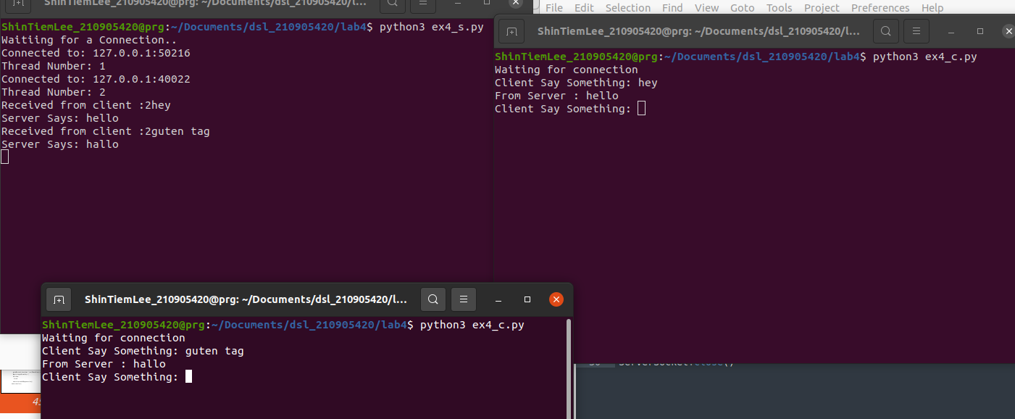
ClientSocket.close()

Ex1:
Server:

import socket
import time
sock = socket.socket(socket.AF_INET,socket.SOCK_DGRAM)
udp_host = socket.gethostname()
# For UDP
# Host IP
udp_port = 12345
# specified port to connect
sock.bind((udp_host, udp_port))
while True:
print("Waiting for client...")
data,addr = sock.recvfrom(1024)
#receive data from client
print("Received Messages:",data.decode()," from",addr)
msg = str(time.ctime(time.time()))
sock.sendto(msg.encode(),addr)

Client:

import socket
import time
sock = socket.socket(socket.AF_INET,socket.SOCK_DGRAM)
udp_host = socket.gethostname()
udp_port = 12345
# For UDP
# Host IP
# specified port to connect
msg="hello"
print ("UDP target IP:", udp_host)
print ("UDP target Port:", udp_port)
sock.sendto(msg.encode(),(udp_host,udp_port))
msg,addr=sock.recvfrom(1024)
print(msg)

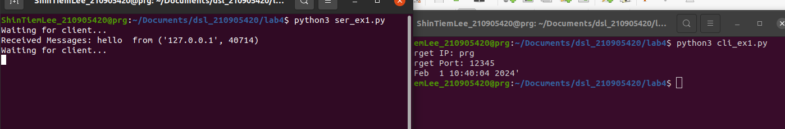
Ex2:

Server:

import socket
sock = socket.socket(socket.AF_INET,socket.SOCK_DGRAM)
udp_host = socket.gethostname()
# For UDP
# Host IP
udp_port = 12345
# specified port to connect
sock.bind((udp_host, udp_port))
print("Enter ctrl+c to exit ")
while True:
print("###### SERVER is LISTENING ###### ")
data,addr = sock.recvfrom(1024)
#receive data from client
print("server received: ",data.decode())
msg=input(str("Server says: "))
sock.sendto(msg.encode(),addr)

Client:

import socket
import time
sock = socket.socket(socket.AF_INET,socket.SOCK_DGRAM)
udp_host = socket.gethostname()
udp_port = 12345
# For UDP
# Host IP
# specified port to connect
print("Enter ctrl+c to exit ")
while True:
msg=input(str("Client says: "))
sock.sendto(msg.encode(),(udp_host,udp_port))
msg,addr=sock.recvfrom(1024)
print("Client receives: ",msg.decode())
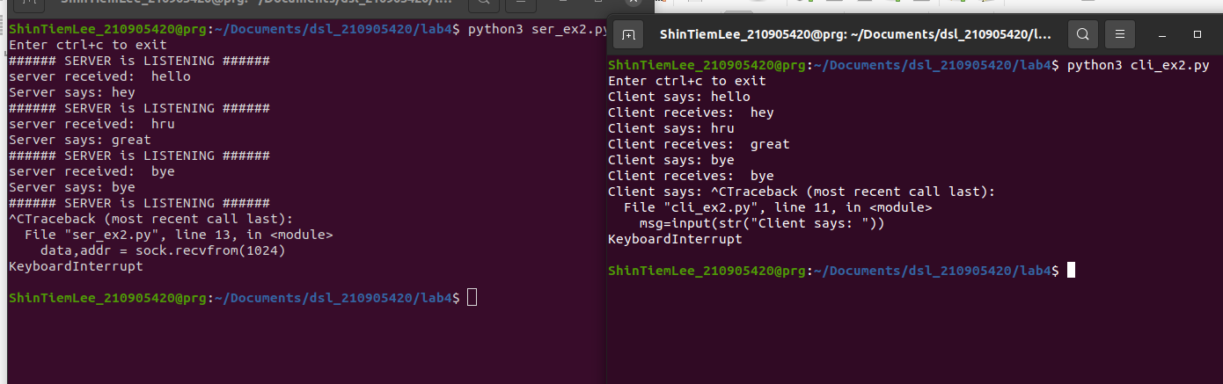
Ex3:
Server:

# 3. Write a TCP/UDP peer to peer chat system between two different machines.

import socket
HOST = "172.16.59.28"
PORT = 31001
s = socket.socket(socket.AF_INET,socket.SOCK_DGRAM)
s.bind((HOST, PORT))

print("\nWaiting for incoming connections...\n")

s_name, addr = s.recvfrom(1024)
s_name = s_name.decode()
print(s_name, "has connected to the chat room\nEnter [e] to exit chat room\n")
name = input(str("Enter your name: "))
s.sendto(name.encode(), addr)
while True:
message = input(str("Me : "))
if message == "[e]":
message = "Left chat room!"
s.sendto(message.encode(), addr)
print("\n")
break
s.sendto(message.encode(), addr)
message,addr = s.recvfrom(1024)
message = message.decode()
print(s_name, ":", message)

Client:

import socket
HOST = socket.gethostname()
PORT = 31001
addr = (HOST, PORT)
s = socket.socket(socket.AF_INET, socket.SOCK_DGRAM)
name = input(str("\nEnter your name: "))
s.sendto(name.encode(), addr)
s_name, _ = s.recvfrom(1024)
s_name = s_name.decode()
print(s_name, "has joined the chat room\nEnter [e] to exit chat room\n")
while True:
message, _ = s.recvfrom(1024)
message = message.decode()
print(s_name, ":", message)
message = input(str("Me : "))
if message == "[e]":
message = "Left chat room!"
s.sendto(message.encode(), addr)
print("\n")
break
s.sendto(message.encode(), addr)

