Ex4:
sepmap.py:

import sys
def read_input(file):
for line in file:
# split the line into words
yield line.split(',')
def main(separator=','):
# input comes from STDIN (standard input)
data = read_input(sys.stdin)
for words in data:
# write the results to STDOUT (standard output);
# what we output here will be the input for the
# Reduce step, i.e. the input for reducer.py
# tab-delimited; the trivial word count is 1
for word in words:
print ('%s%s%d' % (word,separator,1))
if __name__== "__main__":
main()

sepred.py:

from itertools import groupby
from operator import itemgetter
import sys
def read_mapper_output(file, separator=','):
for line in file:
yield line.rstrip().split(separator, 1)
def main(separator=','):
# input comes from STDIN (standard input)
data = read_mapper_output(sys.stdin, separator=separator)
# groupby groups multiple word-count pairs by word,
# and creates an iterator that returns consecutive keys and their group:
# current_word - string containing a word (the key)
# group - iterator yielding all ["&lt;current_word&gt;", "&lt;count&gt;"] items
for current_word, group in groupby(data, itemgetter(0)):
try:
total_count = sum(int(count) for current_word, count in group)
print ("%s%s%d" % (current_word, separator, total_count))
except ValueError:
# count was not a number, so silently discard this item
pass
if __name__== "__main__":
main()
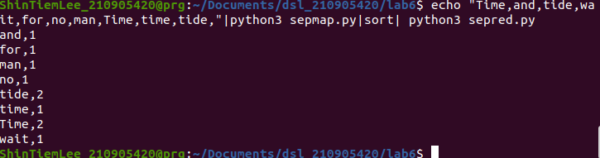
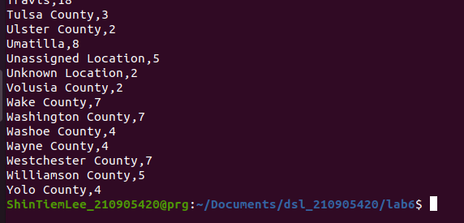

Ex5:
itemmap_expensive.py:

import fileinput
for line in fileinput.input():
data = line.strip().split("\t")
if len(data)==6:
date, time, location, item, cost, payment = data
print("{0}\t{1}".format(location, cost))

itemred_expensive.py:

import fileinput
max_value = 0
old_key = None
for line in fileinput.input():
data = line.strip().split("\t")
if len(data) != 2:
# Something has gone wrong. Skip this line.
continue
current_key, current_value = data
# print(current_key, current_value)
# Refresh for new keys (i.e. locations in the example context)
if old_key and old_key != current_key:
print(old_key,"\t", max_value)
max_value = 0
if float(current_value) > float(max_value):
max_value = float(current_value)
old_key = current_key
if old_key != None:
print (old_key, "\t", max_value)

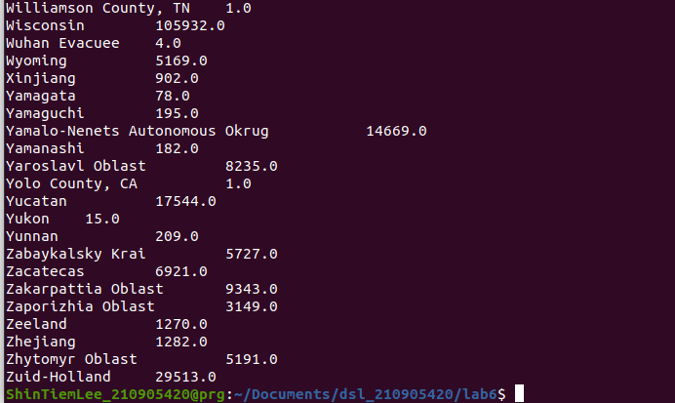
Ex6:
Reading the csv:

import pandas as pd
import numpy as np
import matplotlib.pyplot as plt

df=pd.read_csv('covid_19_data.csv')

for ind in df.index:
print(df['Country/Region'][ind],"\t", df['Confirmed'][ind])

map.py:

import fileinput
for line in fileinput.input():
data = line.strip().split("\t")
if len(data)==2:
d1,d2 = data
print("{0}\t{1}".format(d1,d2))

red.py:

import fileinput
max_value = 0
old_key = None
for line in fileinput.input():
data = line.strip().split("\t")
if len(data) != 2:
# Something has gone wrong. Skip this line.
continue
current_key, current_value = data
# print(current_key, current_value)
# Refresh for new keys (i.e. locations in the example context)
if old_key and old_key != current_key:
print(old_key,"\t", max_value)
max_value = 0
if float(current_value) > float(max_value):
max_value = float(current_value)
old_key = current_key
if old_key != None:
print (old_key, "\t", max_value)

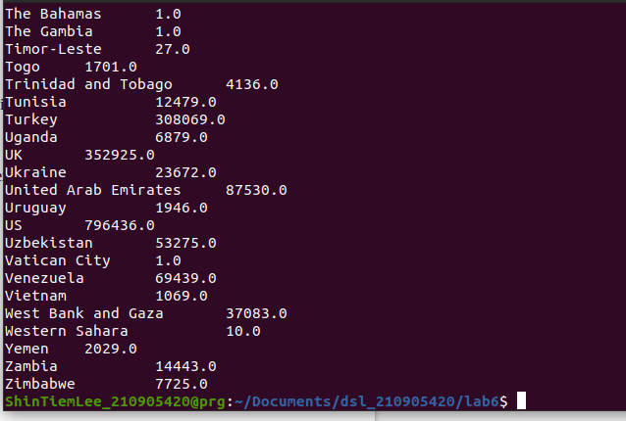
Ex7:

Creating input:
import random
n=random.sample(range(1,10000),100)
for i in n:
print(i)
map.py:

import sys

for line in sys.stdin:
line=line.strip()
print(line,"\t",1)

red.py:

import sys

c_odd=0
c_even=0
old=None
for line in sys.stdin:
line=line.strip().split("\t")
num,count = line
count=int(count)
if old and old!=num:
if int(old)%2==0:
c_even=count+c_even
else:
c_odd=count+c_odd
old=num
else:
old=num
if int(old)%2==0:
c_even=count+c_even
else:
c_odd=count+c_odd
print("Odd: ",c_odd,"\nEven: ",c_even)

